Interview with Dick Lamb 23/10/2014

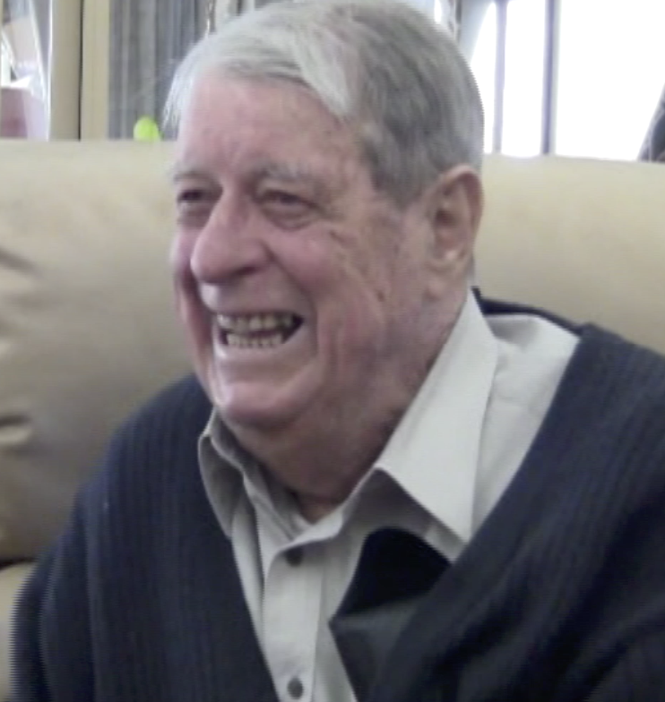

I was the head of Maths at Kwinana Senior High, and I applied for a position of science and maths lecturer, secondary at Mount Lawley. It was just down the road from me. I lived in Dianella and I was on the executive of the Teachers’ Union.

Traylen didn’t want me, as I was from the Teachers’ Union, so I challenged the decision and had to go to court. A young bloke applied and got the job, but I found out that he was primary trained. I was told by our head of the union to be polite, so I was very polite but forceful, and I won. Traylen said, “well done, we’ll look at you more seriously next year.” There was no question he would lose.

When I commenced work, I ran a secondary elective, mathematics. I introduced that and I had to develop all of the electives. Jack was second in charge. They held his job for him as he went to America to get his doctorate. I said, “you haven’t a qualification except in geography. Get overseas and get a doctorate or something”. He did it and enjoyed it.

I was at MLTC for around 12 years. Bob Peter made me safety officer and I complained about the massive panels of glass, which in a panic people would bulldoze through and the glass would fall on them. Then a bloke at Jandakot airport, went upstairs to get a report on the order and ran downstairs straight through a plate glass window. A bit came down like a guillotine chopped him so he sued the Commonwealth Government for a million dollars.

I went and saw Bob and I said, “have you got a million dollars in case we need it?”
He said, “what for?” He said; “you’ve frightened the hell out of me”. He put a rail around it. It cost him a bloody fortune. He should have had one. It was a bad design.

I ran the fire. I found out how to make smoke. The Fire Brigade told me how to do it. I got in the door of the air conditioner and lit it in there. So the next thing we had smoke everywhere. The kids all thought it was funny until they had to go through a darkened corridor to find their way outside.

There was a student, who had sinus issues and I had to tell him to come to see Bill Purvin, in his office, at 9 o’clock. He told him if it was on or not. I didn’t want him wandering around telling everyone it was on.

Len McKenna asked me what I wanted to do. I wanted an eco design with an internal garden. Len said, “let’s do it”. Len McKenna was a terrific bloke. Len talked to the architect every week and asked what I wanted to do. He had very fixed views.

I designed the physics department and the chemistry department as I wanted peninsula benches, so everyone could get around them. And water at every bench. I got them all.

Bob Peter asked me to come with him. He walked me around the playing field and said, “I want someone to look after money, who can recognize crooks and has the courage to let them know.” I said, “why me? What about my department?” He said, “your department can freewheel for a while. The college is more important.”

He put me in charge of all the money. The first thing I did was to cut out the machine time on and off. One of the blokes wouldn’t believe me and said, “who are you? How can you tell me to sign the book?” You sign in when you arrive and leave and if anyone starts fiddling, we will revert back to the machine.

The video of “The Restless Third” I ended up not being able to use it because they brought a new ruling. I made every student see that. It was the best overview of the universe that I had ever seen and it was based on the power of 10. Ten numbers went from 10 to 100 to a thousand, you know. Also it went in 10s for distances. It was terrific.

We built solar energy reflectors, in the groups doing a physics major. All the students built reflectors and solar cookers.

I asked the Department of Aviation if they had a spare jet engine. The bloke said; “well I’ve got two.” We only wanted one. I ended up with the engine out of a Meteor jet, the first jet engine fighter. We had them in Korea.

I said, “I’ll have one of those”. He said, “OK, they have one in Melbourne. I said, “hang on you must have lots of aeroplanes coming across to here. What about getting it to Western Australia, and I’ll handle it then.

The next thing is I get a phone call from Pearce aerodrome. “There’s a bloody jet engine waiting for you.” I contacted the head of maintenance and one of his helpers to get a truck and get it, so they had a field day. They brought it in and I put it in the back.

I got on well with the support staff and had three of them in the lab. They had everything organized for when we needed it.

Bob Peter fascinated me because he had tons of ideas and he was confident. I told Bob that my father was in the Merchant Marines and they had no medals. I said that everyone in the air force got issued with one on their 19th birthday. He sent me a copy of the Australian War Records.

His own staff had put him in there, the crew of the Lancaster because he got hit. He was on fire. He worked out where Lake Konstanz was, and which boundary was Switzerland, landed the aeroplane in the water, rode everyone to the shore that was Switzerland and surrendered.

He was swapped for a German, months later. He went through Nazi Germany in his uniform. And here’s me saying he got it on his nineteenth birthday and he wasn’t nineteen anyway, he was 26. Dad was in the Merchant Marines and they all slung off at anyone, who got a medal.

One of the staff we had, was very aggressive about microteaching. He made all the kids work two at a time and do microteaching. He is now a professor. Microteaching really worked. CCTV was also bloody terrific.

I liked the open door policy. I had it with Edith Cowan at Bunbury. The door was shut and a piece of paper saying “will be available for interviews next Wednesday.” I didn’t like that at all. Mount Lawley never had that and I think that was a good idea. Bob Peter had a lot of beaut ideas. He’s the best boss I ever had in education and he was very fair.

We were trying to build up staff for electives and we ended up with more electives than anyone. It was good because you could plan the next year’s electives well in advance.

Continuous assessment was reasonable. As long as you did your homework, it was quite good. I didn’t mind it. In the beginning it may have been a bit much.

I was on a selection panel one of four involved with art acquisition. I’d have long discussions with Bryant McDiven. I did a burglar alarm for him because he was in the Festival of Perth. He was away during the night, at meetings, and his wife got a bit nervous.

I designed the burglar alarm so she could switch it on from her bed. It turned on a green light to frighten off kids or potential burglars. So he said, you grab a painting that you want. I didn’t like the picture of Neil Stewart as it was purple. There was a lot of good art there.

External studies was pretty well done and I had a lot of time for it, but I never kept a copy of the bloody stuff. We did a lot of field trips. I said to them, “I’ll feed them. You teach them. I had a meal where staff could have two wines, at the luncheon”. I noticed one of the students was a bit drunk. I thought hang on, all they’ve got is orangeade. I said that the orangeade must have something in it. I saw them giggling because they had put vodka in the orangeade.

We went down to Margaret River and I had a physical elective and anyone else who wanted to go and could get away. There was an eclipse, where the moon got in the way of the sun, best viewed at Margaret River.

I took them to the top of the hill to look at it the morning it was going to happen because they reckon the sunrise is different. It was terrific. We did a fair bit of star gazing too. That was beaut and we had some school kids involved too. We had a good few telescopes.

I had a bit of a talk with Bob Peter and said the reason that we get old is the Hawthorne effect. He said, “what’s that?” So I told him and he said, “you should teach that”. So the next thing you know, I am at Perth Tech teaching the thing. I got into trouble for the thing because they got quite argumentative as they said, “who said that and why is that?” They weren’t polite or anything.

