Lynne Hardy and Mt Lawley Teachers’ College (MLTC) 1970-1980

Written by Professor Lynne Hunt (Née Hardy)

I arrived in Perth in August 1973 after backpacking from the UK via the Trans-Siberian Railway and Asia. I was interviewed for a temporary lecturing job at Mount Lawley Teachers’ College (MLTC) on Thursday 13 September and began a full teaching load on Monday 17 September 1973. It was rushed, but the Social Science Department urgently needed a replacement lecturer to teach sociology because the current staff member, John Sherwood, was required to lead the development of the new Aboriginal Teacher Education Program (ATEP). I’d arrived in a period of significant educational innovation at MLTC, which provided a vibrant training ground for young staff members, like me, and for students, many of whom went on to make significant contributions to education and to the community in Western Australia and beyond.

Before arriving in Australia, I taught sociology for two years in an experimental four-term-year unit in a Teachers’ College in Liverpool, UK, so I was primed to take an interest in creative curriculum development and teaching innovation. In 1973, there were two dirty words at MLTC. These were ‘lectures’ and ‘exams.’ New ways of focusing on student learning rather than on didactic lectures were encouraged. MLTC’s Principal, Bob Peter, had a clear vision about student-centred teacher training based on active learning and continuous assessment. However, it wasn’t all plain sailing. While students applauded the disappearance of exams, they came to object to the unrelenting pressure of continuous assessment. So, in the mid-1970s, they downed tools in a very polite rebellion referred to as ‘ID (Identity) Week’. In response, some staff sat down with the students and listened whilst others tried to make things ship-shape again. An overarching curriculum framework and a tighter organisational structure might have obviated the issues that gave rise to ID week, but the pace of change was too fast – and too interesting.

The new MLTC building had been planned to include television studios and a Learning Resources Centre. Not long after I arrived, I developed my first ever audio-visual aid with the assistance of the producer, John Pannel. It was a synchronised slide and tape set about family life on the Kibbutz in Israel, where I’d lived for six months. The Learning Resource Centre also employed an artist, so I asked him to draw pictures illustrating sociological concepts such as social class and social status. My development of audio-visual aids accelerated with the development of MLTC’s External Studies Department. It delivered courses to teachers working in rural and remote locations, so I addressed their learning needs through the development of workbooks, audiotapes, and, eventually, videos. This proved to be a springboard for my approach to teaching in years to come. By 2005, when I stopped teaching in Perth, I’d made 38 educational videotapes. Eventually, I was able to document my development of learning resources as evidence of teaching excellence in my applications for teaching awards. In the 1990s I won three university-level teaching awards and, in 2002, I won the national award for University Teaching in the Social Sciences and also the Prime Minister’s Award for University Teacher of the Year. The seeds of this teaching success were sewn at MLTC in the 1970s.

My rushed advent to teaching on Monday 17 September 1973 was complicated by the fact that the topic that week was Aboriginal education. I’d been in Australia for only five weeks and had not yet met anyone of Aboriginal descent. I grabbed some books from the library and worked solidly during the four days between my interview for the job and my first day of teaching. I’d taught race relations in the UK, but I was aware that my knowledge in this area didn’t directly translate to Indigenous education. However, it seemed to me that the sociological concepts of labelling, stereotyping, marginalisation, and discrimination had sufficient universal relevance for me to discuss with MLTC students. This approach enabled me to fall across the line and start teaching on the Monday. I did get a chance to look at some school social studies textbooks, one of which was called ‘The Settlement of the Swan River Colony.’ So, I could, at least, ask students which words Western Australian Aboriginal populations might use instead of ‘settlement’. This was quite a political issue in subsequent years. In Queensland, for example, words such as ‘invasion’ or ‘colonisation’ were forbidden for use in school classrooms.

I did my best in that first week of teaching at MLTC, but I still wonder what my first year Noongar students thought when they were taught about Aboriginal education by someone who’d been in Australia for only five weeks. Some of my Noongar students, like Colleen Hayward, went on to achieve great things so they were, hopefully, not too scarred by their brief contact with my early efforts at teaching in Australia. Later in my career I mentored a group of Yolngu academics to become the first Indigenous university teachers to win the Prime Minister’s Award for University Teaching in 2005, and, in the two editions of the textbook, ‘University Teaching in Focus’, which I co-edited with my colleague, Denise Chalmers, there is a chapter on ‘Indigenous Knowers and Knowing’, so I hope that I’ve recompensed for a faltering start on this topic.

In 1973 everything was new to me. As far as I was concerned, I was in Perth because that’s where the plane landed. I was backpacking, so I could have fetched-up anywhere in Australia. At that stage, I intended to stay in English-speaking Australia for two years to earn enough money to continue my back-packing trip around the world. I’d arrived with only $300 in my pocket, but it seemed everything, such as rent and the bond on my apartment, needed to be paid in advance, yet I wasn’t paid until after each fortnight of work. I was broke. In this context, I was a bit miffed, in my first weeks of work at MLTC, when my Head of Department asked if I had a couple of quid for the keg for Murray’s show. I had no idea what the man was talking about. I knew what a quid was in the UK (£1), but I didn’t know that Australia had decimalised based on half a pound (10 shillings). So, a couple of quid, somehow, meant AUS$4. I thought a keg was something in which beer is kept, but I didn’t know you could go to one. I knew about a Murray River, but I didn’t know that Murray could be a man’s name – and a show, in the UK, normally involved a stage, curtains, performers and an audience. It transpired that the Social Science Department was holding a party for a member of staff (Murray) who was about to be married. Everyone was invited except me (understandably), but I was still expected to contribute. So, this was my introduction to the all-male Social Science Department at MLTC – and to Australian culture and idiomatic expression more generally.
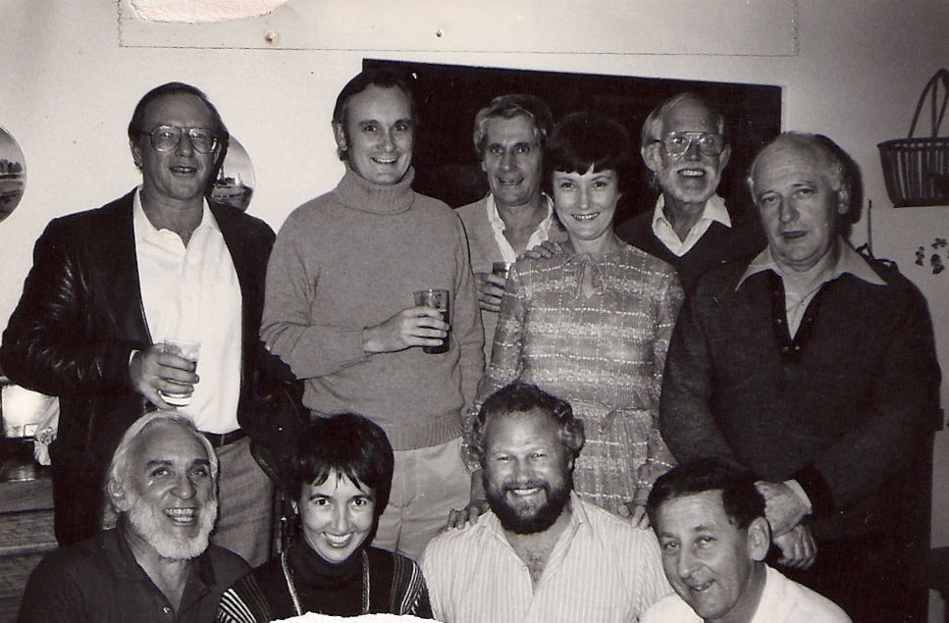

Social Science Department
Back Row L-R John Prestage, Russell Catomore, David Hedges, Beryl Thomas (Secretary), Doug Markey, Brian O’Sullivan
Front Row L-R Lyall Hunt, Lynne Hunt (Née Hardy), Alan May, Jack Caddy

There had been a female lecturer in the Department before I arrived in Australia, but I was the only female academic when I arrived in 1973, and it stayed that way until the department folded in the early 1980s with the advent of the Western Australian College of Advanced education (WACAE). So, my awareness of Australian society and women’s role in it was forged in this working environment. There was a majority of female students at MLTC – many of them were mature-aged. Through them I learned about the life of well-educated Australian women. I discovered that until 1969 women teachers had to resign from the permanent teaching workforce when they married. They could be re-employed as casual staff, but this severely affected their rights to conditions of service such as long service leave and superannuation because many workers’ rights pertained only to permanent staff. This meant that women teachers of the pre-1969 generation carried these inequities into retirement and to the grave.

When the regulations changed to permit married women equal permanent employment opportunities, all teachers were required to become three-year trained. Yet many married female teachers, who’d been employed in casual appointments for years, were only two-year trained. Hence, they appeared at MLTC in large numbers to upgrade their qualifications. For some, returning to study was a chore that was difficult to accomplish alongside ongoing work and family commitments. For others, the experience of college was transformational. New-found skills in critical thinking with consequent awareness of social justice issues illuminated new paths as one student indicated to me 25 years after graduation:

I was a student of sociology with you at Mount Lawley Teachers’ College … You challenged me to learn about and understand my society and, most importantly, its underbelly – disadvantaged and minority groups. After teaching for some years the social justice values you helped me develop led me to study social work.

Although mature-age, female students enjoyed and benefitted from their return to study, they weren’t as supported by MLTC as they might have been. For instance, there were no childcare services. So, my MLTC colleague, Janina Trotman, and I conducted the first survey ever of students’ childcare needs. Decades later, we wrote ‘Claremont Cameos,’ which told the stories of earlier generations of female graduates of a sister teacher training college, showing how their skills and leadership qualities were diverted from children’s education by discriminatory legislation associated with women’s marital status.

I was part of the Social Science Department’s Yilgarn project which enjoined staff and students in community-based research resulting in the publication of a shire history. Students such as Shirley Leahy, Jessie Hardy, and Wendy Braddow gained analytical and research skills that led to postgraduate qualifications and feminist activism. By the mid-1970s, second wave feminism was well underway and Australian authors such as Germaine Greer (The Female Eunuch) and Anne Summers (Damned Whores and God’s Police) raised the feminist consciousness of female staff and students at MLTC. I can remember a student appealing to me about a male staff member in the Social Science Department who’s use of language deliberately excluded women. I spoke with the male lecturer, but he refused to budge, so she quit her studies in protest. It was anger-making.

From my perspective, as a teenager of the ‘Swinging Sixties’, and an undergraduate in 1968 – the year of student revolutions, I found the work culture at MLTC to be socially conservative and macho. I was astonished to find that the college had the vestiges of the old ‘women’s warden’ role. I’m told that she kept files on female (only) students, and I know that she saw herself as a gatekeeper of moral standards because she reprimanded one female staff member for not wearing stockings (pantihose) in the heat of a Perth summer. When the Academic Staff Association circulated the draft conditions of service for study leave, I was seen as an amusing oddity for objecting to clauses such as: ‘A member of staff may take his wife and children on study leave with him.’ This meant, of course, that ‘his wife and children’ would have transport costs covered.

Most students were bonded to the Education Department, which meant that they paid no tuition fees. They also received a living allowance. In return, they had to work where they were placed for their first few years of employment. This meant that the Education Department could ensure a supply of teachers to rural and remote schools. Compulsory rural appointments were seen as draconian but financial support for teacher training did provide access to tertiary education for students whose families might not have been able to support them financially. Teacher training was, therefore, an avenue of social mobility. As a consequence, I taught a lot of ‘first-in family’ students, many of whom were from non-English speaking backgrounds. MLTC staff had to record attendance at lectures and workshops because students were being paid to be at college. They had to be accountable to their future employer. Taking the register made me aware of the preponderance of Italian names occasioned by the massive post World War II migration to Australia from Europe. However, diversity hid in plain sight because MLTC student camps and assemblies, in which I witnessed a senior member of staff leading students in singing the College song (‘You are my Sunshine’), created an ethos of ‘enforced camaraderie,’ which reinforced a spirit of joining-in with the status quo. This was probably good preparation for working in potentially conservative rural communities. Despite this, students did what they could to remain in the city. For example, married women teachers were not required to go bush, so there was a flurry of young marriages among the predominantly female final-year student population. I remain intrigued about the extent to which Education Department regulations influenced marriage and family patterns in Western Australia.

My impressions of MLTC 1970-80 were influenced by that fact that I was an early career staff member and a migrant. I learned a lot about curriculum innovation, student-centred learning and feminism, all of which served me in my future career. For students, I hope that true to the College song, their studies did cast some rays of sunshine over their intellectual development.

