Staff Experience Book Draft 1.0

Introduction
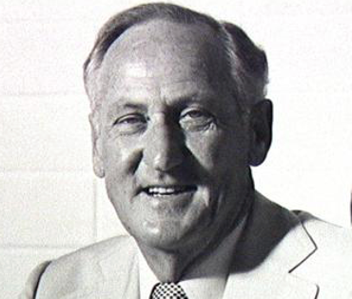
There was a lot of movement behind the scenes prior to the development of Mount Lawley Teachers College. During 1969, the last year at Graylands, much time was taken up with the many committee meetings and informal discussions. It was a very thrilling time according to Charles Staples. Staff were encouraged to write their thoughts for new ideas in the Graylands Education News. This was because Graylands Teachers College was providing the core of staff to Mount Lawley Teachers College. According to Bob Peter, the staff that transferred were interested in changing the face of teacher education, without the problem of an existing tradition or history”.
Bob Peter
Bob Peter was set on a path for teacher education reform, using modern learning experiences and eliminating outdated practices. Academic autonomy was encouraged in the areas of teaching; designing courses; and assessing the effectiveness of the teaching.
Exodus from Graylands
The move from Graylands to Mount Lawley was planned in great detail by a proliferation of committees for management. According to Charles Staples, these included a: “Timetable Committee, Continuous Assessment Committee, Assessment and Assignment Regulation Committee, Courses Committee, Information on Teacher Education Committee, Library Committee, Calendar Committee, Publications Committee, Social Committee, and Staff Advisory Committee. This was a foretaste of management by cooperation by all staff members”.
One of the major changes in policy was the introduction of a scheme of continuous assessment to replace examinations, a semester system to enable greater contact time for less subjects at a time, and a reduction of the lecture system in favour of more student-orientated practices, as well as various types of class sizings. Educational technology, teaching aids and student support were emphasized. Any problems were to be resolved through negotiation and cooperation. Departments were to consider fewer examinations, more accreditation, and the simplification of accreditation techniques. There was also a greater emphasis on “the marriage between theory and practice”.
The semester system was designed to minimise interruptions to the course; improve motivation and involvement; reduce conflict between the large number of subjects to be studied; and provide regular personal guidance.
Teaching was to be varied according to set class sizes of: 250 in the large lecture theatre; 140 in the small theatre; 60 in the double classroom; 30 in the single classroom; and 15 in the seminar room. Smaller groups were supposedly catered for, but in reality “lecturers could be found with their small groups, at the head of the stairs, in passageways, in their offices, or in corners around the place”.
Bob Peter insisted that all staff modify their teaching styles to reflect the changes in education and to show students how it should be done. To achieve this, Bob Peter placed teaching practice and preparation at the core of the instructional program. He proposed “Teaching Practice Workshops” take place a week before teaching practice, in order to fully prepare students for the experience. The Practice (Prac) Department was responsible for this and also such activities as demonstration lessons in schools, micro-reaching (3-4 students) and peer group analysis of the recorded lesson and discussion.
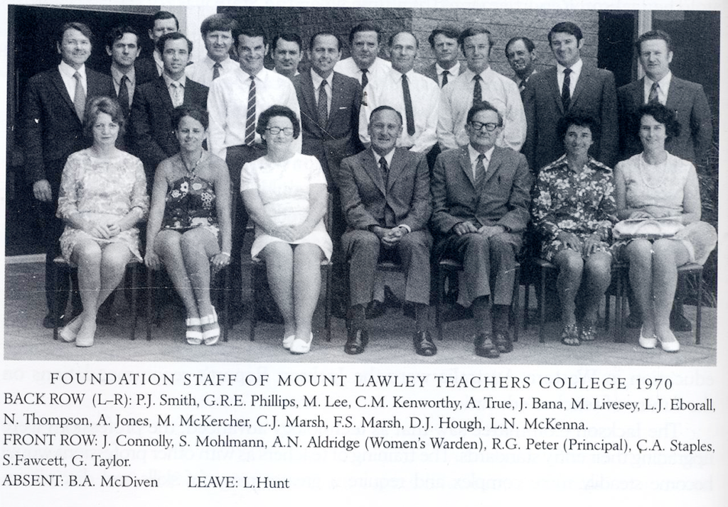
The inaugural teaching staff at MLTC included former Graylands teachers such as: Len McKenna, Bryant McDiven, Glen Phillips, Colin Kenworthy, Colin Marsh, John Caddy and Charles Staples.
Mount Lawley Inaugural Staff. Photo ECU

Settled in Subiaco

Glen Phillips
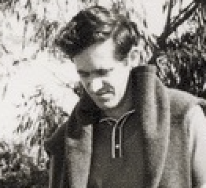
When we were ready to start the new three-year teacher education course at the beginning of 1970, having enrolled our first students, and staff, we found out there we would have to spend at least half or more of our first year in temporary quarters in the Education Department's Further Education Centre in Subiaco. It was in Bagot Road, next to the Subiaco Primary School. The Subiaco headmaster was horrified at the plan because he believed these ‘big’ students coming through the schoolgrounds would knock over the small children Thus we were strictly advised as to how we were to keep our students separate.
Glen Phillips

Although it was a little bit difficult for our new students and staff to find parking in Subiaco, we used shopping centres and places like that, and gradually adapted. And we didn't knock over any children in the in the playground. Because of the shared adversity, I think there was a good early spirit developing among our first intake of student teachers.

Alan True
It was very interesting, once I got the job to turn up to Bagot Road, I was totally unprepared to find that the entire staff, shared one room of an old junior primary school. Each one of us had a desk, a bookcase and a chair. Sometimes, we’d steal each other’s stuff, then have to give it back when the owner “complained”. I crossed swords with one of the social science guys, one of the Marshes, because I had trespassed on his area.

Within that, it was a hotbed of creativity. We could bounce ideas off each other, because we were all in that confined space together. We didn’t have to agree, but it opened your mind up to what was going to happen.

During this time, we were given the Tribulations Endurance award, which included the Sub-Order of the Sardonic Sardine, because we were all jammed in like sardines and quite a few of my classes were actually held outdoors, which was a relief to those who actually loathed the sound of a recorder.

Charles Staples:
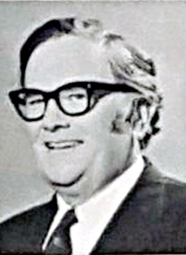
We could fit into Subiaco as we only had a first-year intake. The Teaching Aids section, where we were housed, was altered. Temporary lecture rooms were set up on the tennis court and we had the use of part of the adjacent church building. The staff accommodation was just fantastic. Everybody had to fit into just one classroom and we had temporary partitions put up in the room.
Charles Staples

Support Staff
Bill Pervan was appointed at the beginning of 1970 and remained the registrar for the first ten years of MLTC. Administration in the non-academic sector was a shared activity between the Registrar and his staff and the academic staff, including the Principal, and other senior personnel.
Students began to arrive at MLTC in first semester 1971. At this time a permanent office had been set up and organised. There was also a bookshop, and the printing room was able to print College publications.
Grace Taylor, the librarian, took up her appointment in April 1970. Accommodation was made available for her in the Library Services Branch, where she was joined by a typist. Approximately 3,500 books requisitioned by MLTC were stored in the basement of the Education Department, which was broken into while the books were stored there.
Books could only be moved gradually, due to lack of space and by the time the College had opened, 2,500 had been processed. The Library opened on 18th September, soon after the College moved to Bradford St. A lecture room was furnished temporarily as a Library and an adjoining lecture room was used as a reading room.
A long-awaited move into a new Library came on 29th May, 1972. The main entrance was not finished, and temporary arrangements had to be made to use the emergency exit as a Library entrance from May to September. A small counter was the control centre for issuing and returning books. Reserved books were also distributed from here. The process was very difficult and continued until 22nd September, 1972, until the main entrance was completed.
Grace Taylor, later Grace Rigg, was the senior librarian for the first ten years of MLTC.
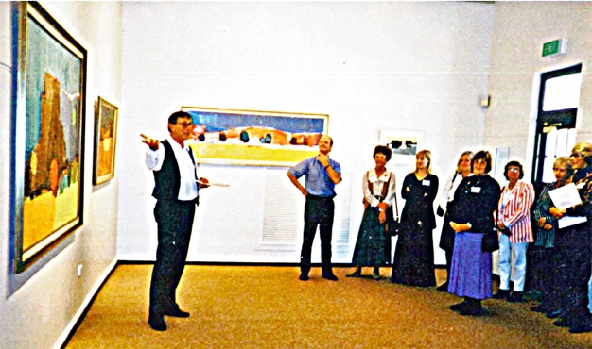
Robert Vallis, the former Director of Bunbury Art Galleries became a part-time Art Curator of the MLTC Collection, until the position became full-time. He proved to be an imaginative and innovative curator, who set a pattern for the activities of the Collection to the present day. One of his first tasks was to see Art as a Social Document to its end.
Robert Vallis showing off the art collection
In his own words: "The Art collection has survived and prospered, being now recognised as a useful tool in the marketing and development and educational requirements associated with the University. Without the gallery walls how does an art collection earn its keep? What initiatives can bed down to strong foundations associated with adding more art works? Where do we get the bright lights and spin of tangible reflections which guarantee a legitimate place for the art collection in the scheme of
things?"
"A university is like a bad novel, too many characters with no plot. A lasting impression when I arrived having spent most of my working life in small schools and organisations. I had trained as a teacher thirty years previously and what a shock - the abundance of everything - vehicles, media gear, in-house help for this that and anything, however, patience is the key. Eventually you will find someone who can help advise you what to do-but, you have to be very patient."
After noting the initial surge of interest in providing a gallery, Vallis formed the considered opinion that the Collection should be permanently present in the community. He gave little or no consideration to the need for a permanent gallery on campus.
Moving to Mt Lawley

Charles Staples: In terms of innovation, Mount Lawley had distinctive equipment. As to the buildings, apart from the purple carpet, there was nothing much there. The building was a bare structure, with walls supporting an upper floor and roof. The ceilings and interior walls were unpainted. The carpet was the king hit. It fascinated everybody including the thieves, who stole that magnificent strip of carpet.

The week the college was to open, they had just put in the carpet from Bob’s office, down the long corridor, to where the present lecture theatre is, a very wide corridor. Came Monday morning, it had vanished. They took the carpet from the Principal’s office, rolled it down the corridor, hoisted it onto a truck, and away it went. It was never recovered. A replacement was laid immediately.

Alan True
The main building had a magnificent purple carpet, combining deliciously, horribly with the red panels outside. It made us all shudder, especially Bryant McDiven, the Head of the Art Department! He couldn’t believe it, but never mind; he wasn’t consulted.

Glen Phillips
We told the students that their campus was going to be lovely, new and completely modern. Unfortunately, when we did move there much later in the new year, there was no air conditioning, although the building with its fixed windows was designed anticipating air conditioning. So initially, we had to put big fans all over the place to blow air into corridors so we could actually breathe in the rooms.

We did have a library, situated in part of what was going to be our staff room, but all in this one major building. I'm trying to remember how on earth we catered for, for the students’ food because one problem with Mount Lawley was its isolation. There were no sorts of shops anywhere in the vicinity. We couldn't use the high school tuck-shop, so to go and to get any food was quite a quite an adventure for students and staff. We staff could easily bring our lunches, but it wasn't so simple for the students, I guess.

Alan True
My music room was 1.12, at the very end of the corridor, next to where the steps led down to where the lecture theatre rooms were to be built. They weren’t built yet. The room looked south over what would become gardens. The gardens were actually the responsibility of each particular group, under one particular lecturer. My particular group had to plant one of the window boxes, along that wing and we all took part in planting the trees, which has been very carefully planned out by landscape architects from the Public Works Department. They chose the trees. They chose the layout. We put them in place. That’s one reason why the spirit of Mt Lawley was so creative and vital and invigorating because the students and staff all worked together to make it a reality.

The problem was that not a single window opened and they were all tinted a browny colour, so the sun wouldn’t penetrate too much. But heat could: and that’s what we got. Problem – there was no air conditioning, because the air conditioning was a hole in the ground, on the bit of the building that hadn’t been built yet. We had to endure 18 months of no air conditioning. It became a little bit rugged in summer, I’m telling you. That’s why I took a lot of classes outside, as much as possible.

This led to the second part of the Tribulations Endurance award – the Sub-Order of the Anaerobic Troglodyte, which was awarded to Foundation staff for “surviving the battle for air, conducted in the dark airless corridors of the Mount Lawley Teachers College (Stage 1).

Camps and Field Trips

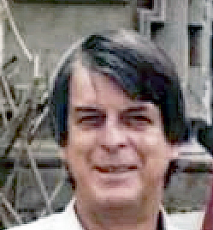
Dick Lamb
Dick Lamb
We did a lot of field trips. I said to them, “I’ll feed them. You teach them. I had a meal where staff could have two wines, at the luncheon”. I noticed one of the students was a bit drunk. I thought hang on, all they’ve got is orangeade. I said that the orangeade must have something in it. I saw them giggling because they had put vodka in the orangeade.

We went down to Margaret River and I had a physical elective, and anyone else who wanted to go and could get away. There was an eclipse, where the moon got in the way of the sun, best viewed at Margaret River. I took them to the top of the hill to look at it the morning it was going to happen because they reckon the sunrise is different. It was terrific. We did a fair bit of star gazing too. That was beaut and we had some school kids involved too. We had a few good telescopes.

Irene Froyland
One of the lecturer’s responsibilities was take the “First Years” away for a camp. If managing school kids at camp is tricky, try managing adolescents. Day time was easy but nights??? In the remote campsite at Araluen the noise of their high jinks was so loud that the locals, mostly far away, complained. My consolation is that in their careers as teachers they, in turn, would have difficult, sleepless nights on school camps.

Somehow it was easier when we went to Point Peron. At least no one lived nearby so noise was not an issue. I remember the “students” making clay pots that they fired overnight in a homemade kiln, dug into the beach sand.

Standards

Lynne Hardy (Hunt)
From my perspective, as a teenager of the ‘Swinging Sixties’, and an undergraduate in 1968 – the year of student revolutions, I found the work culture at MLTC to be socially conservative and macho. I was astonished to find that the college had the vestiges of the old ‘women’s warden’ role. I’m told that she kept files on female (only) students, and I know that she saw herself as a gatekeeper of moral standards because she reprimanded one female staff member for not wearing stockings (pantihose) in the heat of a Perth summer.

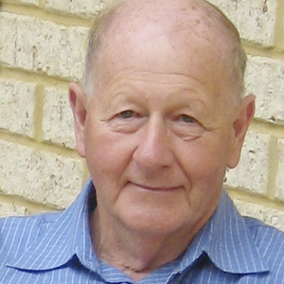
Sybe Jongeling
For years Bryant kept asking staff if they had any knowledge of a small Pablo Picasso’s paintings of a woman. It was lost, and no one had any idea of where it was … until years later, when the “Warden of Women Students”, Alison Aldridge, retired that the missing artwork re-appeared. It was a typical Picasso painting, all disproportioned parts of the human body and face all over the place, and she “did not like it!” It was taken off the wall in her office and stuck in the back of the wardrobe in her room, where it stayed hidden for many years.
Sybe Jongeling

Our original library at Mount Lawley was situated in Room 1, just down the main corridor. All books had a library card at the back and staff were diligently asked to sign the card when taking out a book and put it in the allocated place. When returning the book, staff took the card from the box and placed it back into the back of book for the next reader. Talking about Miss Aldridge, little did she know that one special, leather-bound book, “The Rationale of the Dirty Joke” was read by most male staff, but the card at the end of the book showed that it was “borrowed” time and again by the same person – Alison Aldridge! None of the male staff were game enough to write down their own name!

Irene Froyland
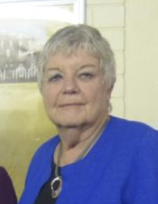
Dress requirements for staff were quite formal. I have a clear recollection of the “Warden of Women Students” rebuking a junior staff member for not wearing stockings. Try enforcing that now.

The College was very new and quite small, so it was a dream position where everyone knew everyone else and we were involved in each other’s efforts. We shared morning tea and lunch in the staff room (I am embarrassed to remember that it was the ACADEMIC STAFF ROOM. So-called SUPPORT STAFF had their tea at their desks!!!!)
Irene Froyland

Janina Trottman
Dick Lamb was asked to show me around the place. He asked me: did I have a cigarette? At that stage, I was a smoker. I had one cigarette left, so he took it and he said: “Never mind, I'll show you where to buy some more,”namely, the vending machine. What really interested me was that at Mount Lawley campus our female student membership would have been about at least 80%. While there were vending machines for cigarettes, there were none for personal things like tampons, and pads, not a thing, cigarettes, but not period equipment. And, it said something about catering for needs.

Practicum Dept
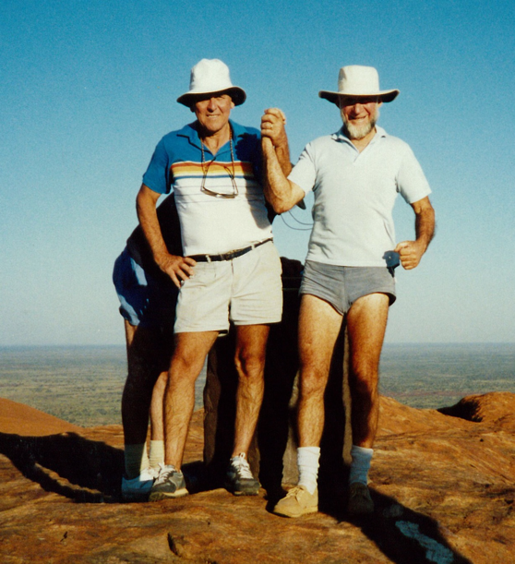
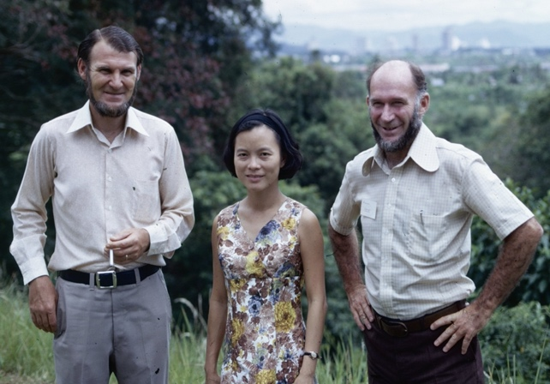
John Love and Allan Jones in Kuala Lumpur. Photo Tom K. Jones
Lew Eborall and Alan Jones at Uluru. Photo Tim K. Jones

Unlike, other departments, the Prac department had a fluctuating staff population. This was largely due to the fact that MLTC was under the auspices of the Education Department of Western Australia, and therefore various teachers were seconded to this department for periods of 2-3 years.
The constant in this arrangement, in the first four years, was Alan Jones, who was permanently assigned to MLTC. Lew Eborall was appointed in 1973 and John Love in 1974. Both of these joined Alan Jones as permanent staff members, until at least 1979.
The use of seconded staff supplied a variety of highly experienced teachers, who excelled in teaching and could impart their skills to the students. This also advantaged the staff involved, as it allowed them to continue employment with the Education Department and apply for promotional opportunities at the same time. Seven years after the opening of MLTC, Terry Watt and Gail Shannahan, two of the original MLTC students were employed in this role.
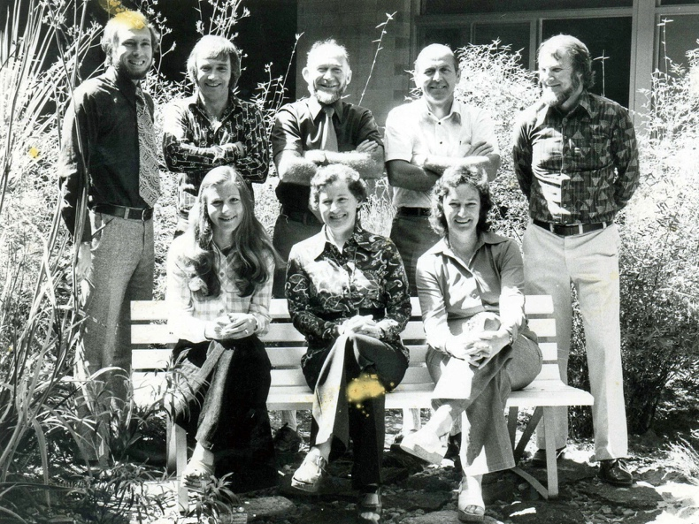
Ian Robbins, Shaun Walsh and Karen Yaxley (sitting), all great teachers and seconded to the Prac Staff in the mid 70s with Alan Jones, Lew Eborall, and John Love standing. The lady on the right of the bench was the wonderful Irene Beattie the Prac Team’s secretary. Everyone depended on her, staff and students. Photo Tim K. Jones

Irene Froyland: When “Teaching Prac” was on, it was all hands on deck. Because of my interactions with the “Aboriginal Ed” program I had the privilege/challenge of supervising students at Cue, Meekatharra, Wiluna and Giles, and these were not the bustling centres they are today. I set out along unsealed roads in a hire car with directions that were usually something like “after about X kms, turn right at the gate with the old fridge …. Travelling to Giles was a little different. I had a seat on a tiny, tiny plane, spent the night by the campfire with the local Aboriginal Group, enjoyed the status as “Aunt” of our student, and was privileged to eat a special part of that night’s kangaroo. Fortunately, I have always liked my meat rare.

Educational Psychology

English, Oral English, Drama

Glen Phillips: I set up the Department of English with a few subsets. First of all, Speech and Drama were made the responsibility of Colin Kenworthy and Margaret Erneste. I had Lou Eborall as an English Method lecturer to look after the specialized teaching of reading and that sort of thing in the classrooms. He had to interact with Teaching Practice Department, which had overall responsibility to reflect what schools wanted our students to teach, when out in schools. We had altogether about 10 staff, which eventually rose to about 16 or 18. It was quite a big department. Our new courses all first had to be written, and, and of course, taught to our new students in 1970.

My English teaching staff in the early years at Mt Lawley were an amazing group, youthful, full of fresh ideas, and a range of talents. They included Viv Evans a drama and literature specialist from Wales, Oliver Deacon, Glenys and David Nicholson, Gillian Hogben and, as previously stated, Margaret Erneste, Lew Eborall, and Colin Kenworthy. David Hough was initially part of the Department as a Drama and Speech specialist, but soon had his own department with Margaret Erneste. Later, as I became more involved with administrative duties, the English Department was taken over by Ian Malcolm, who introduced foreign languages as elective studies.
Margaret Erneste

Maths and Science

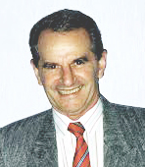
Jack Bana: I was a lecturer in math education at Claremont Teachers College in 1969. Then I transferred to Mount Lawley because I was interested in a new institution, and also, because it was quite close to home, as I lived in Morley about 10 to 15 minutes away from the college. So, I was a foundation staff member.
Jack Banner
The early days were really very collegial, with lots of camaraderie because we only had 200 students to start with in the first year. That filled up in 1971 and grew fairly quickly. One thing I do remember is that we had a busy bee day. It might have been even two days, when all students and staff shovelled compost and sand around and made gardens, planted trees and a lot of the gardens and trees that are there at Mount Lawley now are a result of that busy bee day.
We had a lot of fun at Mount Lawley Teachers College. We used to have a lot of social events, particularly in the 70s when we were small. We'd have dinner together as staff. We used to have a boat race with canoes and concocted boats, which was good fun. Lyall Hunt organised cricket matches in the weekend with staff. There were a lot of social activities, which kept a good morale among the staff, kept them united. It was good fun.
Dick Lamb: I asked the Department of Aviation if they had a spare jet engine. The bloke said; “well I’ve got two.” We only wanted one. I ended up with the engine out of a Meteor jet, the first jet engine fighter. We had them in Korea.

I said, “I’ll have one of those”. He said, “OK, they have one in Melbourne. I said, “hang on you must have lots of aeroplanes coming across to here. What about getting it to Western Australia, and I’ll handle it then.

The next thing is I get a phone call from Pearce aerodrome. “There’s a bloody jet engine waiting for you.” I contacted the head of maintenance and one of his helpers to get a truck and get it, so they had a field day. They brought it in and I put it in the back.

Social Sciences

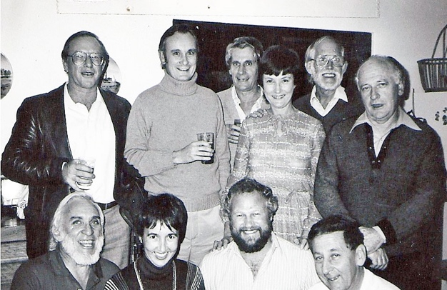
Back Row L-R John Prestage, Russell Catomore, David Hedges, Beryl Thomas (Secretary), Doug Markey, Brian O’Sullivan
Front Row L-R Lyall Hunt, Lynne Hunt (Née Hardy), Alan May, Jack Caddy
Photo: Lynne Hardy (Hunt)

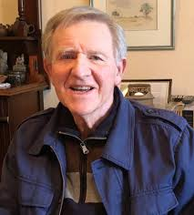
Music
Alan True
For Mt Lawley, you had to have demonstrated primary teaching experience. That was the clincher.

Practical teaching experience got you the job. I rang the Superintendent of Music saying: “what do you expect me to provide for people going out to teach?” Then I’d talk to other people outside the area and of course from within the Australian Society of Music Education. I was involved there, so I got ideas as well.
Alan True. Photo Rivka Niesten

The job description said that the recorder was supposed to be a core part of it. I didn’t necessarily agree. I’d taught recorder, but never mind, I did it and it did prove very useful, because through playing the recorder you learn to read music. It was my key aim that the basics of music reading, should be there. Of course - Kodaly, Suzuki, Orff – they all agreed on this sort of thing. Eventually, fluent reading of music is a must to open the child to further musical expression, otherwise they would be totally limited, in what they could do. So, that’s what we did.

It was an absolute revelation to go into a system, which Bob Peter had created which was ‘semesterisation’. I think we were the first tertiary institution in the country to do that along with our reticulated TVs to every room. Also, continuous assessment was an innovation at this level. We were absolutely ecstatic about this, as it opened our minds to a different form of teaching. Not having to set these classical exams was revelatory. It made us think about our own subjects, much more closely.

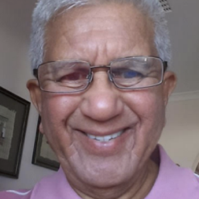
As we grew, we added staff. The music department gained Jean Farrant after one year, from Claremont. Two years later, we got Basil Jayatilaka from Kuala Lumpur. He had a completely different skill set from Jean, who was vocal. I was general. Basil had this glorious composition/dance, you name it background.
Basil Jayatilaka

Two years later we got Cornelius de Munck, who had come straight from the highlands of New Guinea, where he had been on a special teaching project for several years. He brought further skills, as he was a consummate guitarist, as well as Australian level singer – bass baritone.

He also had extensive face-to-face teaching experience, with a wide range of students from the highlands of New Guinea down to secondary kids at Mt Lawley High School, down to other schools. That made a nice complementary group.

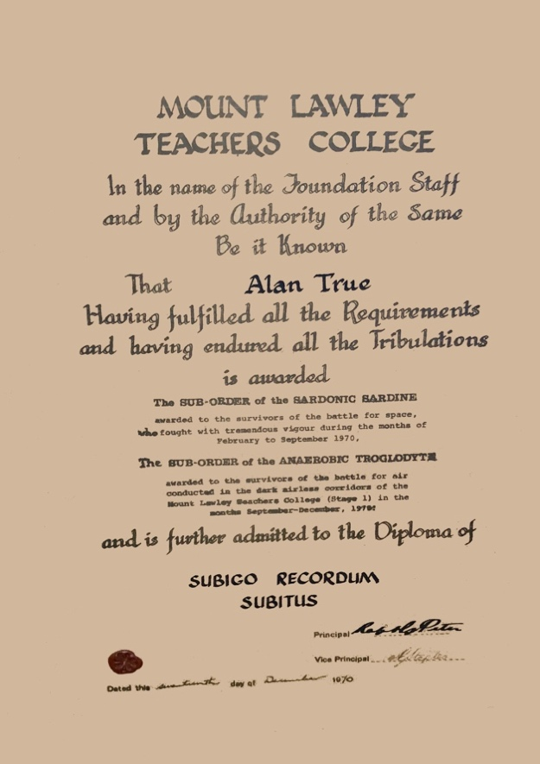
Provided by: Alan True
Every foundation member of the staff was given a diploma. This diploma was really quite magnificent. You had the sub-order of the Sardonic Sardine because we were crammed into the one room in Subiaco, then the sub-order of the Anaerobic Troglodyte, because the new building in Mt Lawley had no airconditioning unit in place yet, and no windows that opened, making for rather a breathless environment. Each of us received a further sub-order and mine was Subigo Recordum Subitus, which roughly translates, I believe it is you can shove your recorder, where it does the most good. I’m not good at Latin and I haven’t asked any Latin experts, but anyhow we’ll leave it there.

Junior Primary

Art

Bryant McDiven
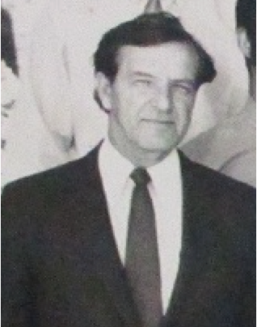
In 1970 I was appointed Senior Lecturer at the newly completed purpose-built Mount Lawley Teachers' College. I accepted the rather daunting task of establishing a brand-new art collection worthy of this new facility, but with the familiar situation for me of little money available. The Principal, Dr. Robert Peter, was sympathetic to our needs but could only allocate small amounts of money.
Again, as at Graylands, I adopted the scheme of promising to donate one of my paintings in return for a regular commitment to an established art purchase fund. In this instance the Student Council eventually agreed to set aside a percentage of student fees on the understanding that it would be matched by the College Administration.
Sybe Jongeling
Much of the establishment of our Art Collection is due to Bryant McDiven. He donated several of his own works to the collection and wanted it to encourage staff, students and the surrounding community to appreciate, view, and value the works we have on show. On one occasion, Bryant showed me the paint brush that Nolan used to sign the commemorative plaque, and he kept it as a valuable souvenir. He was proud to point out the signed plaque above the door of the art studio, but I am sure he would be devastated that it is now lost and no-one knows where it has gone.
In the Art Department, Bryant McDiven directed the theoretical section. He was heavily involved in the College art collection and in the creation of the official MLTC crest. Bryant was active on a number of committees including: National Vice Chairman of the Australian Society for Education through the arts as well as chairman of the planning committee; member of the Festival of Perth committee as well as convener of the art sub-committee; and member of W.A.I.T. advisory committee on associateships in art teaching and industrial arts.
Mel Livesy ran the practical workshops. His duties also entailed receiving and storing acquisition materials as well as providing assistance with the MLTC calendar and preparing silk-screened labels for the gardening project. He completed advanced certification in the areas of ceramics and jewellery making. He also conducted Raku pottery demonstration in York, Darlington and Hyde Park.
David Jones had exceptional artistic, teaching and organizational skills. He was popular with the students and made an outstanding contribution to graphic design for publication and general purposes. Examples of his work included: the cover design for the 1972 calendar, letter-head layouts and College crest designs for the Identification Committee and printing of the student club insignia.
The Art Department was responsible for designing the MLTC logo as well as for its collections of art.

Physical and Health Education
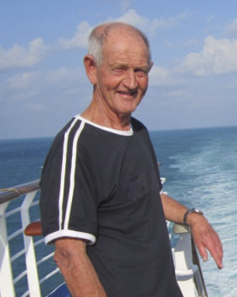
The Physical & Health Education Department was somewhat of an anomaly as its program spanned all the semesters instead of taking place over specific ones. As games instruction needed to be incorporated into this area, the time required was greater than for other disciplines. The compromise arrived at, was that one afternoon per week, would be a sports afternoon, based on the activity rather than normal class groupings. Games taught included golf, squash, tennis, badminton, gymnastics and basketball.
Brian Churchward
Students were required to learn the rules for each of the areas studied in order to be able to run these activities within the school. PE classes also encompassed dance, cricket and football and were largely unsegregated, except for body contact sports.
The Physical & Health Education was also responsible for a number of activities surrounding College camps at Point Peron and Rottnest. Activities at the camps included dancing, games, canoeing and water sport.
Initially, Physical Education took place under basic conditions, firstly at Subiaco and then in the early days of MLTC. At MLTC students used the change rooms adjacent to the car park and undertook activities at the park across the road from the College. They also used the Inglewood swimming pool as a place to ensure that students would know how to rescue someone from the water.
Sports clubs were set up in men’s and women’s International Rules basketball, men’s and women’s hockey, women’s netball and men’s night hockey as well as football. A number of canoe trips were conducted and students were involved with the Royal Life Saving Services carnival at Beatty Park.
In Health Education there was emphasis on providing first aid for simple problems that might occur in a school setting and were trained in responding to emergencies and bandaging.
Mt Lawley CAE

Joan Gruskin
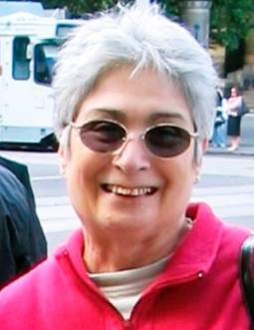
I commenced working in the department in February 1974 and continued working there until 1982. My role in the Education and Psychology Department was as a Secretary. I was responsible to Sybe Jongeling who was Deputy Head of Department and Mike Lee, Head of Department.
My office was G.03, which was originally designed to be a storeroom, but converted into an office. It was rather dull with only artificial light until a window was finally erected to give a view into the passage. The main reason for cutting a window in the wall was not to give the occupant a view to the outside, but to stop unscrupulous persons from removing equipment from the room. Early, rather clumsy and heavy, tape recorders were used more often in lectures and tutorials, and they used to disappear quite often from my office. Maintenance thought it would be a good idea to install a window so anyone walking past could see any intruders “borrowing” expensive equipment. It was also a good idea to have a window as it was less claustrophobic.
Joan Gruskin
At one stage the department had 18 lecturers and I did work for 10 staff. While I was working at Mount Lawley, I also helped to organise a curriculum conference geared for special education teachers. I also did work for representatives from the WA Fire Brigade, a specialist course organized by Laurie Summers and Sybe Jongeling. This increased their knowledge of modern lecture design, presentation and examination procedures, which they could introduce into their own training programs. It was also a time when early computers gained importance in tertiary education.
I fondly remember that on the final day of the Fire Brigade course, Sybe got them all in a small room in the Maths/Science building to show them how a rather big, clumsy, early IBM computer would operate. When Sybe tried to turn it on – nothing happened. He checked all connections and was about to give up, when one of the Fire Brigade staff told him, with a smile on his face, that he had forgotten to turn on the power switch on the wall. On the final graduation ceremony, Sybe was presented with a 3-point power plug mounted on a specially designed board! How embarrassing!
I was very happy working with members of the Education and Psychology Department and was very sad when I had to leave.

The WAAPA Story

Alan True
A letter from the Premier’s Department lobbed on Bob Peter’s desk, revealing that Sir Charles Court’s wish was the establishment of an institution to teach the performing arts, in Western Australia. Not just the conservatorium of music, it had to be broader than that. They were inviting applications from every tertiary institution in the State, to put in a submission.

Bob Peter said: “Oh well, this is a write off, I don’t know if we’ll bother with this”. One of the others said: “You can’t have this, we can’t have these people declaiming Shakespeare, under the trees and disturbing our teaching students, who are doing serious education studies”. Max Collins, the new Deputy Director to Bob Peter said: “Oh No! This is a wonderful idea”. Glen Phillips said: “Oh No! This is a wonderful idea”. And I said: “This is a wonderful opportunity”. As Secretary, I breached the rules. “This is too good an opportunity to miss! We tick all the boxes. We were the first institution in Australia to be built with a designated music wing, a dedicated drama wing, a dedicated art wing.” That’s where it went and it was agreed. We should do this.

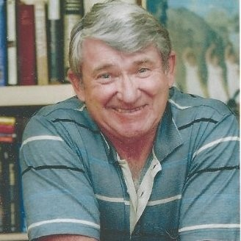
My job then was to set up the subcommittees. Jean Farrant was put in charge of the Music Committee. Bryant McDiven, who was on SAGE, was in charge of the Art Committee. David Hough, bless his socks, was in charge of the Drama Committee. They then had to report back to me and I had to draw it all together.
David Hough

It came time. Bob Peter, of course, was going to present it, but who was going to present it with him? Sir Frank Callaway turned up with a bevy of four. Bob said: “I’m only taking one.” Glen wanted to be it. Bryant wanted to be it. But no, it was me. Bob said: “It’s Alan!” I even remember what I wore. Bob was like Ming the inscrutable. We got in there and Dr Dolph Zink was the Chairman of this panel. There was this line of luminaries like Vaughan Hanly, Leader of the WASO, and people like that with him. He was one of our consultants, by the way.

We didn’t have time to actually bind our submission into a book, so we just had our 5 booklets, because I said that we’ve got to include jazz. Horror of horrors – jazz! I said: “Look, jazz is a respected discipline in its own right. Of course we have to have jazz. I don’t know of any other institution in Australia, which has it formerly in its program and I want it to be there.” I won that one. There was one on jazz, one on music, drama, art, whatever.

We only had time to do a folder for each one, and put it in an overall folder. We recycled the program folder from the performance of the Beggars Opera, which we’d done a few years earlier, because it was there. We didn’t have to do anything extra. It saved time. We handed these out. I thought I wish I could hide under a rock and die. Then one of the women on the panel said: “This is wonderful! Where did you get this idea from? We can take it apart. We can look at the music. We can look at the drama. We can look at the art. They thought it was the greatest thing since sliced bread, so we won.

The way it happened was that Bob would be asked a question and just say: “I will let my assistant here answer that” and it went like that all the darned time. Every time there was something specific to answer, I had to do it. When it came to administration, of course, Bob had to answer it, because that was not my strength. So, we pulled it off.

This was 1978. It helped that Jean Farrant was already running a program with the Music Teachers Association, to train suburban music teachers, to a higher level so they could teach better. That was an Associate Diploma, which we’d been running for a couple of years. It was presented as part of the brief. We were informed that was the first course that was to be offered by WAAPA. The name was suggested by Dr Zink himself and we happily agreed.

Aboriginal Education
In the 1970s there only existed a single standardised course to prepare every student teacher for every classroom in Western Australia, regardless of context, location, demography or the particular needs and strengths of students.
Early in 1973, two separate and serious complaints were brought by parents of graduates to Charles Staples, Acting Principal of the then Mount Lawley Teachers College (MLTC), claiming that the College had not adequately prepared these two graduates for their first teaching positions. One had been appointed to teach in a remote Aboriginal community and the other in the school in a town with a significant Aboriginal enrolment, both in the far north of WA.
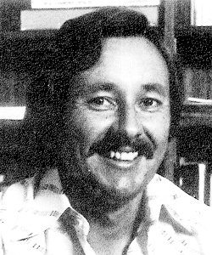
They employed John Sherwood, who had anthropology and sociology qualifications, to help rectify this problem. He had no previous experience in teacher education but was taken in because of his academic attainment. Luckily for John, the Whitlam government had ample funding for this endeavour.
With the strong support of Charles Staples as Acting Principal, a submission for a comprehensive Aboriginal Teacher Education Program (ATEP) was undertaken. It funded the employment of six full time staff, the creation of new undergraduate and postgraduate courses, purchases of equipment, frequent travel all over Australia, research, publications, multi-media productions, and involvement of Aboriginal people in all aspects of ATEP.
John Sherwood
On the obverse side, John Sherwood was involved in the Aboriginal Student Teacher Intake (ASTI), the first Aboriginal Teacher project of its kind in Australia. John realised they had to get a group of Aboriginal students entering and studying together to combat the isolation problem Aboriginal students had encountered in the past resulting in withdrawal. With a support system established, assistance could be given not only to the individual students, but the group could supply its own mutual support system.

WACAE

