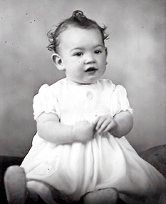
Jeanette Connolly
Jeanette Helen Connolly was born on 5 March, 1937. She spent her childhood in Boyup Brook, a WA country town, where her father Reg Connolly was Chair of the Road Board. Jeanette’s primary education was in Boyup Brook but she started high school as a boarder at Kobeelya, an Anglican Girls’ School in Katanning, before her family moved to Geraldton when she was about 14.
About a year later, Jeanette’s dad Reg died intestate. Jeanette and her mum had few financial reserves and an uncertain future. Jeanette started working as a book keeper but Kobeelya’s Headmistress Nancy Russell offered her the chance to complete her two-year leavers’ course in twelve months, with a fee waiver if she managed to do so. This kindness enabled Jeanette to become a teacher.
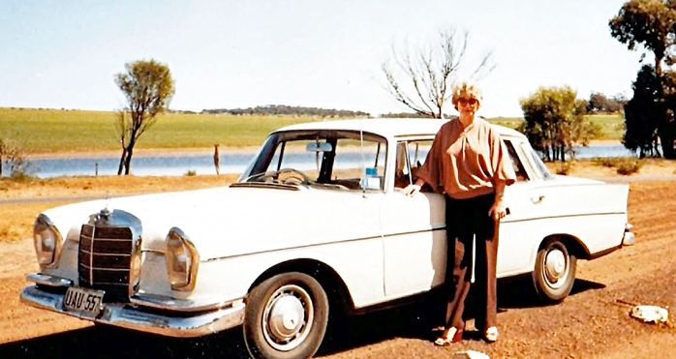
In 1970, after 15 years’ or so teaching across several primary schools, Jeanette became the inaugural Head of Department, Junior Primary, at the newly built Mount Lawley Teachers’ College. She trained generations of Primary teachers and is remembered as providing an excellent grounding in early childhood education. Jeanette also formed a close friendship with Vivian Evans in the Mount Lawley English Department. Although the relationship didn’t last forever Vivian was, in essence, the love of Jeanette’s life.
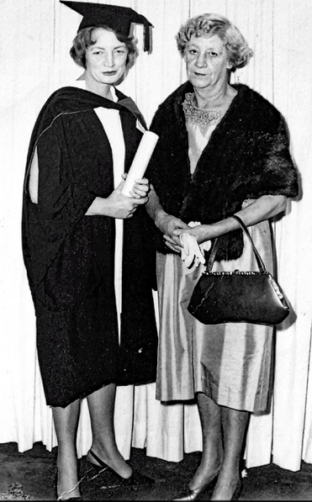
Jeanette fought hard to overcome the widespread financial prejudice against working women. She was eventually offered a mortgage, even though she also had financial responsibility for her blind mother. Across her career, Jeanette was to own a succession of homes in Mount Lawley including the beautiful Federation-style house at 56, Queen’s Crescent.
From 1978-79 Jeanette spent a year of Study Leave at London University, making lifelong friends and completing a Masters’ in Education. She also worked for some time at different WA College of Advanced Education campuses: Claremont, Nedlands and Churchlands. As well as a range of Primary-related WACAE positions, Jeanette had a 2-year secondment to the WA Department of Education.
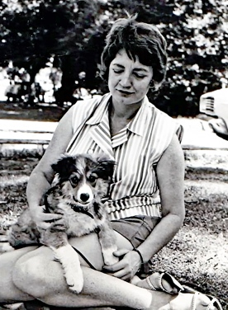
Jeanette took a redundancy from ECU in 1995 to clear her mortgage, but she still loved teaching and was offered a succession of short-term contracts at TAFE. In 1997, she won a fractional time ongoing appointment with Central TAFE, which was to become North Metropolitan TAFE, principally working in the areas of Adult Education, Literacy, and English as a Second or Additional Language.
Jeanette worked at TAFE until she was 75, retiring in 2012 to pursue a range of hobbies including gardening, books and reading, Mahjong, supporting children’s educational dreams, and working with friends who were Australian immigrants. She also had a succession of much-loved rescue pets: dogs when she was younger, cats as she matured.
Jeanette was an Anglican – a Church Council member at her church of 25-years, St Columba’s in Scarborough – and she had several godchildren. When a Uniting Church friend Shirley Ellis was diagnosed with cancer, in about 2014, Jeanette suggested that Shirley stay with her while she had chemo. As part of her care for Shirley, Jeanette took her friend to United Church services. Shirley lived at Jeanette’s house until her death in 2017, but the stress of caring for Shirley, and then administering her estate, took a toll on Jeanette, who had her first stroke soon after Shirley’s passing, and never fully returned to the Scarborough congregation although she kept in touch with her many Anglican friends.
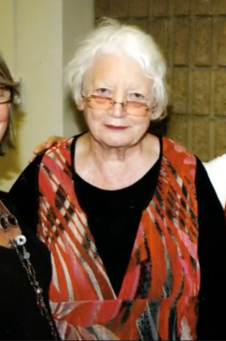
Jeanette’s health continued to deteriorate over the years that followed, especially during COVID, but she lived independently in her own home until 27 June 2025 when she had a second stroke. Jeanette died 16 weeks later, having spent the intervening time in hospitals and, for about 10 days, high needs aged care. Jeanette’s many friends kept up a daily roster of visits throughout this time. About 150 people attended Jeanette’s funeral on Friday 7 November 2025, with many more taking part online.
Biography and images provided by Lelia Green
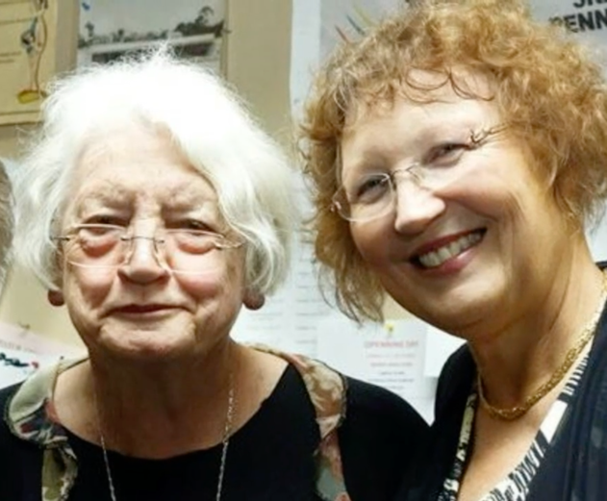
Jeanette and Lelia

