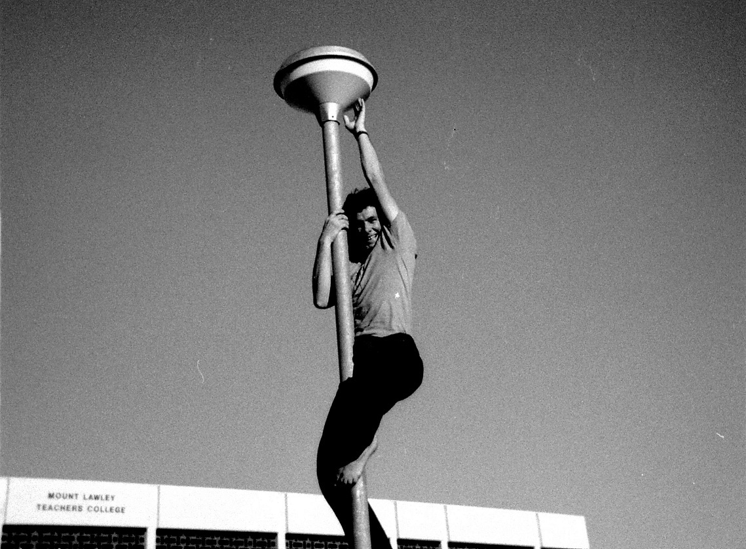
Mt Lawley Teachers’ College
The Student Story
Photo: Neil Kidd

Foreword
In order to fully understand the student experience at Mount Lawley Teachers’ College (MLTC), it is first necessary to focus in on the backdrop of events that were happening at the time. The 1970s was a decade of great economic, political, social, and technological change. It was also a period in Australian, following on from world-wide student protest movements seeking to gain real student participation in the governance of higher education.
In 1970-71, when the first and second intakes arrived at MLTC, post-secondary education was mostly only available for the wealthy. Teachers’ colleges, under the auspices of the Education Department, bonded their students.
Bonded students were “employed” by the Education Department and had to abide by the rules such as: observing the dress code, attending classes, being punctual, and providing medical certificates if sick. Classes ran from 9am-5pm on weekdays and students were expected to attend camps and other compulsory organised activities in their own time, of a weekend. Class rolls were taken every day and attendances were recorded.
The Education Department provided a small stipend, which increased annually throughout the course, but which was below the “dole”. Those from the country also received a living-away-from-home allowance. This made post-secondary education more affordable, as students did not have to pay for their education.
However, if after graduation the student did not teach for a time equivalent to the length of their course, they were required to repay the money. The Education Department, organised jobs for graduate teachers and supplied many of them with Government Employees’ Housing Act (GEHA) accommodation, in country areas. Once the Whitlam government brought in free education, the bond money, for those unsuited to teaching, was waived or partially waived.
In the early 1970s, women were still largely just expected to marry and have children in their teens. This trend may be seen within the students in the first and second intakes, who often married during their course or shortly afterwards.
It was noted in the 1970 Annual Report, that three women had resigned for marriage. At this time, the Department would not accept married women as bonded students and the employment of married women in WA schools was not encouraged.
By the second intake, as shown in the 1971 Annual Report, married students, who numbered 11, could continue their course with allowances. It should be noted that in the Education Department, women graduates, who did resign from teaching to marry had to pay back the ‘bond’ or an amount equivalent to their training stipend.
In 1964, the National Service Act introduced a scheme of selective conscription in Australia, designed to create an army of 40,000 full-time soldiers. Many of them were sent on active service to the war in Vietnam.
Despite there being a greater number of women to men in primary teaching, male students going to Mount Lawley Teachers’ College, in 1970, could be conscripted. Any of the males in first and second intakes were at risk. However, should they have been conscripted, they would have been allowed to complete their Teaching Certificate, and then sent to Officer School.
In May 1970, more than 150,000 people participated in a Moratorium march, to protest against Australia’s involvement in the Vietnam War. These were the largest street demonstrations in Australia’s history. Popular opinion had turned against the war, and nightly television reports showed graphic footage of the realities of the conflict.
Thankfully, at the end of 1972, Gough Whitlam led the Australian Labor Party (ALP) to election victory for the first time in 23 years. In the first days of government, Whitlam abolished conscription, and ended all military involvement in Indochina, which must have been a great relief for males in the first and second intakes.
The White Australia Policy was finally dismantled by the Whitlam government, which removed any ethnically specific criteria for evaluating prospective migrants adding to the idea of a multicultural Australia. The early 1970s must be remembered as a time when large liners arrived from Italy, Greece, and the former Yugoslavia.
There were also a number of refugees, from World War 11, who came to Australia to make a new life. However, in the early years of MLTC, immigrants’ children were largely Europeans, as evidenced by the surnames of the students of the first two intakes.
As mentioned previously, education was expensive, thus MLTC was a way for the children of the less well-to-do, and immigrants to pursue an upwardly mobile route in their employment. Many of these children, took education seriously and worked hard to achieve a qualification.
At the time of students starting at MLTC, there were not many roles for women. The main career choices were: hairdresser, secretary, shop assistant, waitress, nurse, librarian and teacher. These roles were the traditional roles ascribed to women. At the time, a woman, such as a teacher, would get considerably less than a man with the same qualifications, working in the same job.
In December 1972, under the new Whitlam government, the Commonwealth Conciliation and Arbitration Commission approved the principle of equal pay for work of equal value. There was also greater support for single parents, for those whose marriage may not have worked out. From June 1973, maternity leave was granted to women employees in the public service.
Whitlam reforms also focused on the area of “self-determination” for Indigenous Australians and land rights. MLTC, started off with two Indigenous students, one of who was Ken Wyatt, a Noongar, Yamatji and Wongi man. Ken went on to teach primary school from 1973 to 1986.
In the early 1990s, he moved into leadership roles in Aboriginal education for the Department of Education of WA serving as the Director of Aboriginal Education. He later became the Minister for Indigenous Australians.
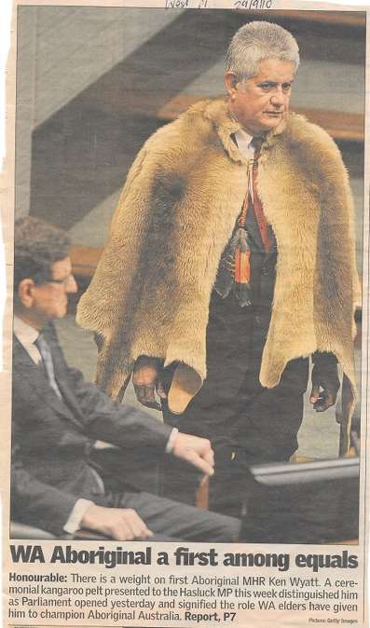 | 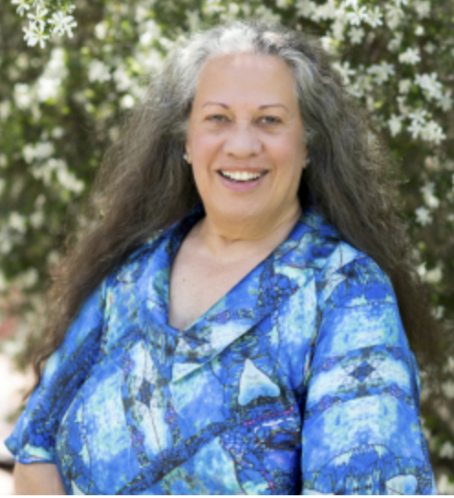  Colleen Hayward
Photo: West Australian newspaper – Ken Wyatt | Photo: ECU
Another Aboriginal student, who was enrolled in the third intake was Colleen Hayward. She ended up as the head of ECU’s Centre for Indigenous Education and Pro-Vice-Chancellor. Her father was the first Aboriginal teacher then Principal in WA.
Because of the lack of knowledge of how to teach in Aboriginal children more effectively in schools, the Whitlam government granted a large amount of money to be spent rectifying this issue.
Other major changes in the early 1970s included: the dropping of the drinking and voting age to 18, and the sexual revolution, due to the availability of the contraceptive pill.
With education fees abolished, university became available for everyone, so students from MLTC could add to their qualifications if they wished to do so. When MLTC changed to WA College of Advanced Education, it was possible to undertake additional courses such as a Post Graduate Diploma of Intercultural Studies, which focused on Aboriginal and migrant education.

Chapter 1 – The first day at Claremont
For many of us, no matter how our teaching and educational careers evolved, our three years at Mount Lawley Teachers College were significant, very social, thoroughly enjoyable and still indelibly etched in our minds. Friendships were established and kept for decades. Many graduates would fundamentally shape and impact the lives of thousands of children they taught or interacted with. Others would go on to become key members of our government agencies and communities making a difference and “the world a better place for kids.”
Those who were 1970 Foundation Students are now in their 70s and the students that followed in 1971 – 1973 are now mostly retired. We started college came at a time in our lives when almost all of us were just seventeen years of age. A few of us were mature age students and an even smaller number were parents with the skill and experience of managing children in a family environment.
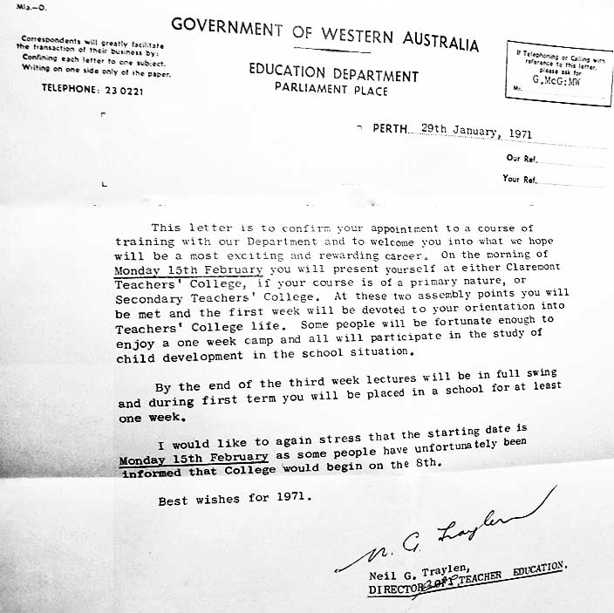
Photo: Neil Kidd – Claremont letter
Our story starts with everyone gathered at Claremont campus on the first day of term. We were given relevant information about the various campuses and courses. By the end of the session, we were first allowed to select, which teachers’ college we preferred, after which there was further sorting to ensure that each teachers’ college would have the correct allocation of students. From this point, students went by car or bus to their allocated campus.
Student thoughts about day one
In her first year, 1970, as teacher trainee, Sue Hennessy remembered: “prospective students, in the intake for teaching (primary) meeting at Claremont Teachers College campus, were milling around in some confusion and bewilderment, looking for others who we knew. We were then directed to form three lines depending on which campus we wished to attend, and then by home location. Having initially opted for Graylands, I was soon moved to the Mt Lawley line for which I am now so grateful”.
Ian Francis said: “I wasn’t really that keen on teaching when I first left school and took a couple of years to make it to MLTC. I chose MLTC because it was closest to home and it was newer. My sisters had both been to Graylands so I thought somewhere different would be good”.
Ruth Shean: “We were all corralled at Claremont Teacher’s College. It was explained to us — outside because we were a large group — that there would be two- year training intakes and three-year training intakes. I thought carefully about this and decided if I was ever going to upgrade to something else, it made sense to do the longer course. Whole groups of us were then directed to MLTC and off we set, in a range of available cars”.
Bobbie Smith 1971: “I chose Mt Lawley Teachers’ College as it was close to my childhood home in Yokine, plus it had continuous assessment and no exams… fantastic”!
Neil (Robert) Kidd 1971: “Why MLTC? – well the 2-year course was going to finish and we sat on the lawn at Claremont and were put into groups … I’m not sure whether they told us that M.L.T.C. hadn’t been fully built at that stage …
I listened to an address at Applecross Senior High School in 5th year where they said they wanted a very large number [2/3 or 70%?] of the successful Leaving candidates to become teachers. It didn’t change my mind as I had planned to become a teacher since I was 10 years of age”!
Rivka Finley 1971: “I remember the first day at Claremont. There were a number of people milling around, and some boring speeches. I looked around and didn’t see anyone I knew, so I felt very alone. At the end they spruiked Mt Lawley. I didn’t like Claremont and Graylands looked pretty grim, so for me there was no choice. It was also convenient for me to get to MLTC, as my parent worked in the city and I only needed to catch one bus. I joined the small line of people, who elected to go to Mount Lawley. After that there was a selection, which involved moving people from the other lines into my line.
I believe some students went to Mt Lawley by car, but I didn’t have a car. I believe they arranged a bus for us. The biggest surprise on arriving at Mt Lawley and being put into groups was the number of people, who I went to Applecross High with, who were in my class. They were as follows: Robert Kidd, Claire Pippet, Betty Granger, Judith Dinham, Sandy King, Sue Caporn and Jenny Tod”.
Marjorie Bly 1970: “On the first day, a group of us from the same high school stayed together during the proceedings. Not many people were choosing MLTC as an option. As soon as one person from our group was assigned to MLTC, the rest of us followed. Mt Lawley chose us”!
Looking back to 1972, Colleen Hayward recalls:
“Having been accepted into teaching, everyone met at Claremont Teachers College, from where we nominated our preference from each of the three primary colleges. Mt Lawley was entering its third-year and Churchlands was in its inaugural year, so that was quite tempting. The real clincher for me was that Mount Lawley’s strategy was continuous assessment rather than big exams, together with the fact that a few other students I knew from high school were also selecting Mount Lawley – it was an easy choice”.
Margaret Harris 1971:
“I was “lucky” to attend as I was one of the very last students to be offered a place at a Teachers’ College. I had not done well in my year 12 exams. I had a phone call about 9am on the Thursday morning before college started. Some students had not taken up their offer. I had to reply by 4pm that afternoon. I am so happy I was given, and then accepted, that opportunity.
When I had completed my year 12 exams, I thought I would not get to Teachers’ College. I had completed year 12 Shorthand and Typing so during January had several interviews with different banks. I was deciding which I would work for. I was so happy that I received that phone call offering me a place. I had, since being very young, wanted to be a teacher.
The next Monday morning – I still remember the large group assembled at Claremont Teachers’ College. I had been advised that I should do the three-year course. So, when having to move to choose where you wished to study, I was not going to choose Graylands. The newest campus MLTC line was the smallest. I chose MLTC because I had grown up in Coolbinia and attended Coolbinia Primary School, so knew the area very well. My family had moved out of that suburb when I was in year 10 but it was still the easiest campus to attend. I also felt like I was going back to a very familiar area.
Continuous assessment was so much better for me than exams. When I graduated from MLTC, I was not at risk of not graduating as I really improved during the three years. The exam stress disappeared and I enjoyed the assessments being handed in during the semesters”.

Chapter 2 – The early days
The college at Mount Lawley was not fully functional at the time of the first intake. Accordingly, staff and students were temporarily housed in Bagot Road Subiaco at the Western Australian Education Department In-service Centre. They made do with a double-demountable classroom and any available resources available. It was not until 15th of September 1970, that students moved to Mt Lawley.
Bagot Rd
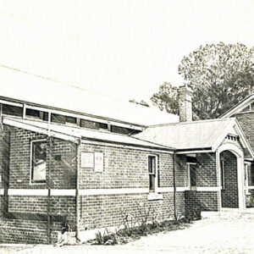
Photo: Sybe Jongeling

The first Mt Lawley College students enrolled for a three-year Diploma of Teaching course commencing in 1970, not at the proposed Mt Lawley site but temporally for the first year on a primary school campus at Bagot Road, Subiaco. College was five days per week, eight hours per day.
The first intake of 142 women and 51 men entered the temporary accommodation at the Western Australian Education Department In-service Centre. They used a double demountable classroom, as well as a nearby hall and playing fields. They also used the Education Department Library, as well as libraries of the other three colleges.
In the words of Sue Hennessy:
“We were the inaugural students we didn’t have any older students to talk to for what to expect, we were naïve students straight out of high school, the lecturers were also new to this teaching diploma – so I think I was a happy guinea pig prepared to see what this 3-year course would involve. Staff were all very enthusiastic about the courses and I’m sure that enthusiasm flowed onto us. Everyone helped/supported each other.
The lectures at Bagot Road were all a very new way of learning, sitting at those chairs with a side flap to write on was novel, having to be out of the Centre by 4pm because of the after-school courses for teachers were happening was what we did, the semester system was how we were going to learn and no exams – just a continuous assessment program – very different to what we’d had at high school”.
Bagot Road also had some advantages as indicated by another student:
“Being located in Subiaco we were able to shop, have lunch or wander around the town during breaks or free periods. I remember buying my first outfit with my own money from a small boutique in the main street of the shopping precinct.
The Bagot Road buildings were not very extensive, but were able to accommodate the first-year intake of students and the foundation staff. For the time we used these premises, staff and students shared spaces and developed a very communal, friendly and relaxed atmosphere. Some lectures would take place in the gardens or in the little church within the grounds. Art theory tutorials frequently took place in the small church or in the outdoors if the weather permitted. This enabled a strong bond between the students and between students and staff to develop”.
John Oliver: began his teacher training in 1970, again, not at Mt Lawley but at the old Subiaco Primary School in Bagot Road. “I was allocated to Mt Lawley because my temporary home was in Bayswater. We had no information about the courses, though we knew we were enrolling for a 3- year education diploma compared with the 2-year certificate course at Graylands or Claremont.
In that first year the lecturers did their best to overcome the constraints of the temporary site and we did things like a week’s camping on Rotto and excursions to the new building site at Bradford Street where we helped to establish the grounds and gardens. The temporary campus at Subiaco meant catching a couple of trains each day and a couple of kilometres of walking at either end until I managed to purchase my first motorbike, a Honda CD175”. John took leave from teacher training in1971 and resumed in 1975, completing in 1978.
Ruth Hutchison recalls: “those attending Mt Lawley met at an Education Department building in Bagot Road, Subiaco, a building used for other purposes in the evening. Our days started at 9.00 in the morning and finished about 4.00pm. Being located in Subiaco, we were able to shop, have lunch or wander around the town during breaks or free periods”. Meanwhile, the new Mt Lawley Campus was under construction on the corner of Alexander Drive and Bradford Street.
The Bagot Road buildings were not very extensive, but were able to accommodate the first-year intake of students and the foundation staff. For the time we used these premises staff and students developed a very communal, friendly and relaxed atmosphere. Some lectures would take place in the gardens or in the little church within the grounds.
Marjorie Bly: “During the months at Subiaco, I remembered not the classrooms but the little church hall with the most amazing atmosphere, down the long path, and the lovely lush council gardens surrounding the school. We shopped in Rokeby Rd during lunch times, when it was a fascinating street full of interesting boutiques and shops. We also enjoyed the early winter morning starts at Rosalie Park for PT/sport”.
MLTC
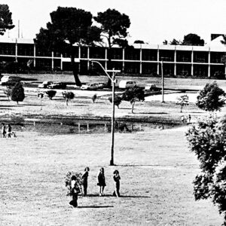
Photo: ECU - Early days at MLTC showing the park opposite, where we did our P.E.

On the 15th of September 1970, the south wing of the main teaching and administration block of the new building was ready for accommodation. Spaces were cramped and staff had to share offices. Lectures were conducted in temporary locations and some lecture rooms were used for the college office, library, bookshop and student government.
As Terry Watt reminisces: “After six months at Bagot Road In-Service Centre Mt Lawley Teachers College’s main building was complete and “in our hundreds we came. We arrived in Minis, Morris Minors, Austin Lancers, Volkswagens and Holdens. Some were in psychedelic colours, emblazoned with flowers. Some were equipped with surf board racks but generally our vehicles were conservative with small capacity engines that could run for a week on $2.
Very few were new and most had been purchased as a result of part time employment through our high school years or very recently from a solid two months of work post our TEEs on CBH’s wheat bins, teaching swimming, attending service stations or working as retail assistants. Some were provided by parents to assist in the process of getting through three years of academic commitment. Most of these cars had a value of under $1,000.
There was however, a sparkling new purple GTR XU1 Torana that was the property of a country student from an exclusive livestock breeding farm south of Margaret River that stood out from all other vehicles including those owned by staff members. One of these staff vehicles that one never parked too close to was a classic Jaguar owned by David J Hough, senior member of the Drama department”.
Initially, the campus was a barren, sandy area with very few trees for shade and little vegetation, as gardens had yet to be established. However, the buildings looked amazing and impressive. They stood out among the traditional architecture of the Mount Lawley community. By 1971, the college population comprised first and second year students only”.
According to Neil (Robert) Kidd (now an environmental artist): “The site had been a swamp, a rubbish tip and the Scadden pine plantation; so many lecturers had interesting collections of artifacts such as ceramic containers, dolls and glass bottles”.
Sue Hennessy: “When staff and students initially moved in, the building was still largely under construction and the eastern end of the ground floor was completely open. The section being used was painted, carpeted and furnished. Rich purple carpet and modern tables and purple and chrome chairs. However, we all returned one Monday morning to discover that over the weekend someone had taken advantage of the open construction site and had carefully removed the wide purple carpet for the passageway by cutting it at each doorway and rolling it up and removing it, along with a selection of comfy chairs and tables! Someone now had a uniquely styled home”!

Ian Francis said: “It proved to be a great three years with a structured timetable and strong prac expectations, in all enabling us to grow up a bit – fantastic fun too with a great group of people, many of whom have remained lifelong friends and colleagues. As I look back, none of us had a lot of money so we were all in the same boat. Campus life involved, sports and other clubs, for me particularly hockey – I was captain and coach of our hockey team for two years and sports president in my final year. In that same year, 1974, we won the 1D premiership, beating Curtin University. Campus life improved in my final year when the Ref and Gym were finished”.
Ruth Shean: “In the first few days, we were sorted into class groups, ours being primarily students who had matriculated in maths and science. I think that the intent behind this was to offer us a place at STC/UWA to convert to high school maths and science teachers. I recall that at least one of our classmates did this — Clive Choate.
I was happy to keep going on the MLTC pathway. I was really enjoying the course, and liked the fact that I could work flat out while I was there but do my extra-curricular activity such as music and yachting during other times. Looking back, I think we were well taught for a whole range of classes and circumstances, down to Jean Farrant who taught us how to conduct a choir with either a tennis ball or darts action! This came in handy when I later became a music teacher.
The bonding arrangements suited me, because I felt that I would need to teach for at least three years to earn some money and gain experience. And I loved kids, and believe in the teaching profession. I had some excellent teachers of my own at primary and high school. These teachers were great role models for this profession and my own teaching career”.
Neil (Robert) Kidd: “We didn’t know that M.L.T.C. was different from other teacher’s colleges as it was the only one we knew. Having been in contact with this project team I can now appreciate that it was different. More than just air conditioning, continuous assessment and a new building!
We had a G.L.O. for each ‘class’ – Group Liaison Officer. Ours was Margie Tyrer and she was good-natured and very reliable”.

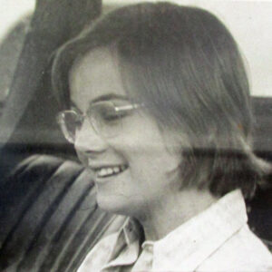
Photo Neil Kidd - Margie Tyrer our G.L.O.

As an aside, a G.L.O. was a person from each group, with the responsibility of passing messages from the administration to the class. There was even a G.L.O. box in the main foyer to facilitate this. G.L.O.’s from each year had regular meetings with the student council and by this means, students’ views could in turn be directed back to the MLTC administrative body.
Neil (Robert) Kidd: “Photo-copying was a big expense on our $18/19 dollar/week student allowance! My first school didn’t have one … but we fund-raised for it!
I was overwhelmed by the ratio of girls to boys, something in the vicinity of 7 to 1. I made some amazing friendships at MLTC and have a couple of my former peers, who I still keep in contact with. I enjoyed the ‘get together’ organized by the alumni over a decade ago where I caught up with Marg Harris (nee Saunders) and some of those who had gone on to alternative career pathways; like Bill McKenzie of Kalgoorlie”.
Looking back to 1972, Colleen Hayward recalls: “Up to my third year, we barely had adequate student amenities in Building 3.
But in 1975, the Ref was up and running – until then, just one sandwich machine for the college, filled once a day.
I absolutely loved my time at Mount Lawley in every regard. There was never a day when I doubted what I was doing or why I was there. The student bond was really strong. Importantly, there was a confidence about our futures because everyone knew they’d have a job at the end of their studies”.

Environment and facilities
Initially, the campus was a barren, sandy area and the new campus was somewhat primitive. Looking back on it, the only functional building was Building 3, which came to an abrupt end, like a gaping sore. Beyond this were weeds, which students laboured to remove; and sand in which they planted shrubs and trees, which are here to this day. There was a food dispenser, which produced somewhat stale sandwiches, crisps and confectionary as well as a drink dispensing machine.
As recalled by Ruth Hutchison: “The community feel and spirit was maintained by that initial intake of students throughout the years of our course. Events such as the landscaping of the front street verge and surrounding areas of the new buildings built strong bonds. All students and staff spent a complete day planting, digging, mulching etc to establish the initial gardens, which are still seen today. Len McKenna organised choosing, purchasing and planning this venture. I now tell my grandchildren as we pass the Bradford Street corner that my friends and I helped plant the huge trees and bushes back in the early 1970s.
Camps at Rottnest and other venues further fostered our bonds, friendships and collegiality throughout our teacher training”.
Gail Gadeke Martin 1971-73, (with input from Susan Batten Dalby 1971-73, and Helen Gaye Hassell - Moses 1970-72).
“There was a tip cleaning area between the college and Mt Lawley High School and we collected and sorted bottles for recycling. There was a massive tree planting in the college grounds as there was no oval and this was Sports activity. Purple Carpet. When the 1970 cohort moved in, in September, the whole college’s purple carpet had been stolen. Friday lunch was at Dianella Tavern, as there was no canteen. We often never went back for afternoon lectures”.
Bobbie Smith: “I helped plant the initial trees on the site”.
Ruth Shean: “Of the standout events at MLTC, I am almost ashamed to say that the one thing that sprang to mind was the establishment of the coffee shop! When we came back from long-term prac in 1973, there was a coffee shop on campus. We all quickly became coffee junkies. Because we were all doing different things course-wise, we would meet in the coffee shop daily and exchange news.
But there were other similarly important developments. The new lecture theatre was a huge attribute to the college although by the time that was built, we were mainly into small group lectures and learning. I certainly appreciated it when studying for my B. Ed. When we started at MLTC, the Bradford Street building was by no means complete. Indeed, the only playing fields were in the park over the road. I remember us all planting trees early on. I am delighted to see that these are still standing — around the car park off Bradford Street”.
Rivka Finley: “When I got to MLTC, there was a single building (building 3), with an open-ended quadrangle. I remember weeding that open end and wondering why they didn’t employ someone to do this. In retrospect, this was a bonding exercise, as you get closer sharing the misery of it all. Did I mention that I detested weeding? We also planted the trees and shrubs, now in existence, on Arbor Day, under the auspices of Len McKenna (naturalist and science teacher).
In 1971, there were no real facilities. There was a drink/food dispenser in the foyer, where you could buy a stale egg and lettuce sandwich, or a packet of crisps, if you didn’t bring lunch or drive. Those fortunate, with a car could go to Cannela’s on Walter Rd or the Dianella Plaza for a more substantial lunch.
Physical education took place across the road at a small park (now called Ron Stone Park), with a lake. We used the outside changerooms, that butted onto the front carpark. I had to resist the urge to change on the way to the park, to save time. For swimming, we went to the Inglewood (Terry Tyzack) pool. I was not greatly into some of the Phys Ed requirements. I was particularly useless at duck diving and diving from a diving board. Thankfully, my good friend Robert (Neil) Kidd had a car and the ability to talk my shaky legs into walking the plank, as it were. I did manage to attempt dives from this board, but remembered some spectacular belly flops. I am not sure that I ever managed a proper dive, like Robert, but thankfully my duck diving and diving skills, allowed me to scrape a pass for Phys Ed”.
Marjorie Bly: “The college was the quintessential building site during those early years. I remember becoming a labourer and helping to fill the garden beds with compost and plants under Len McKenna’s watchful eye. The mystery of the missing carpet, as has already been noted by several students. The thieves must have been wearing sunglasses when they took it”.
The whole gardening/weeding experience was still going strong in 1972, as evidenced in these wonderful photos, from Kerry Paddon.
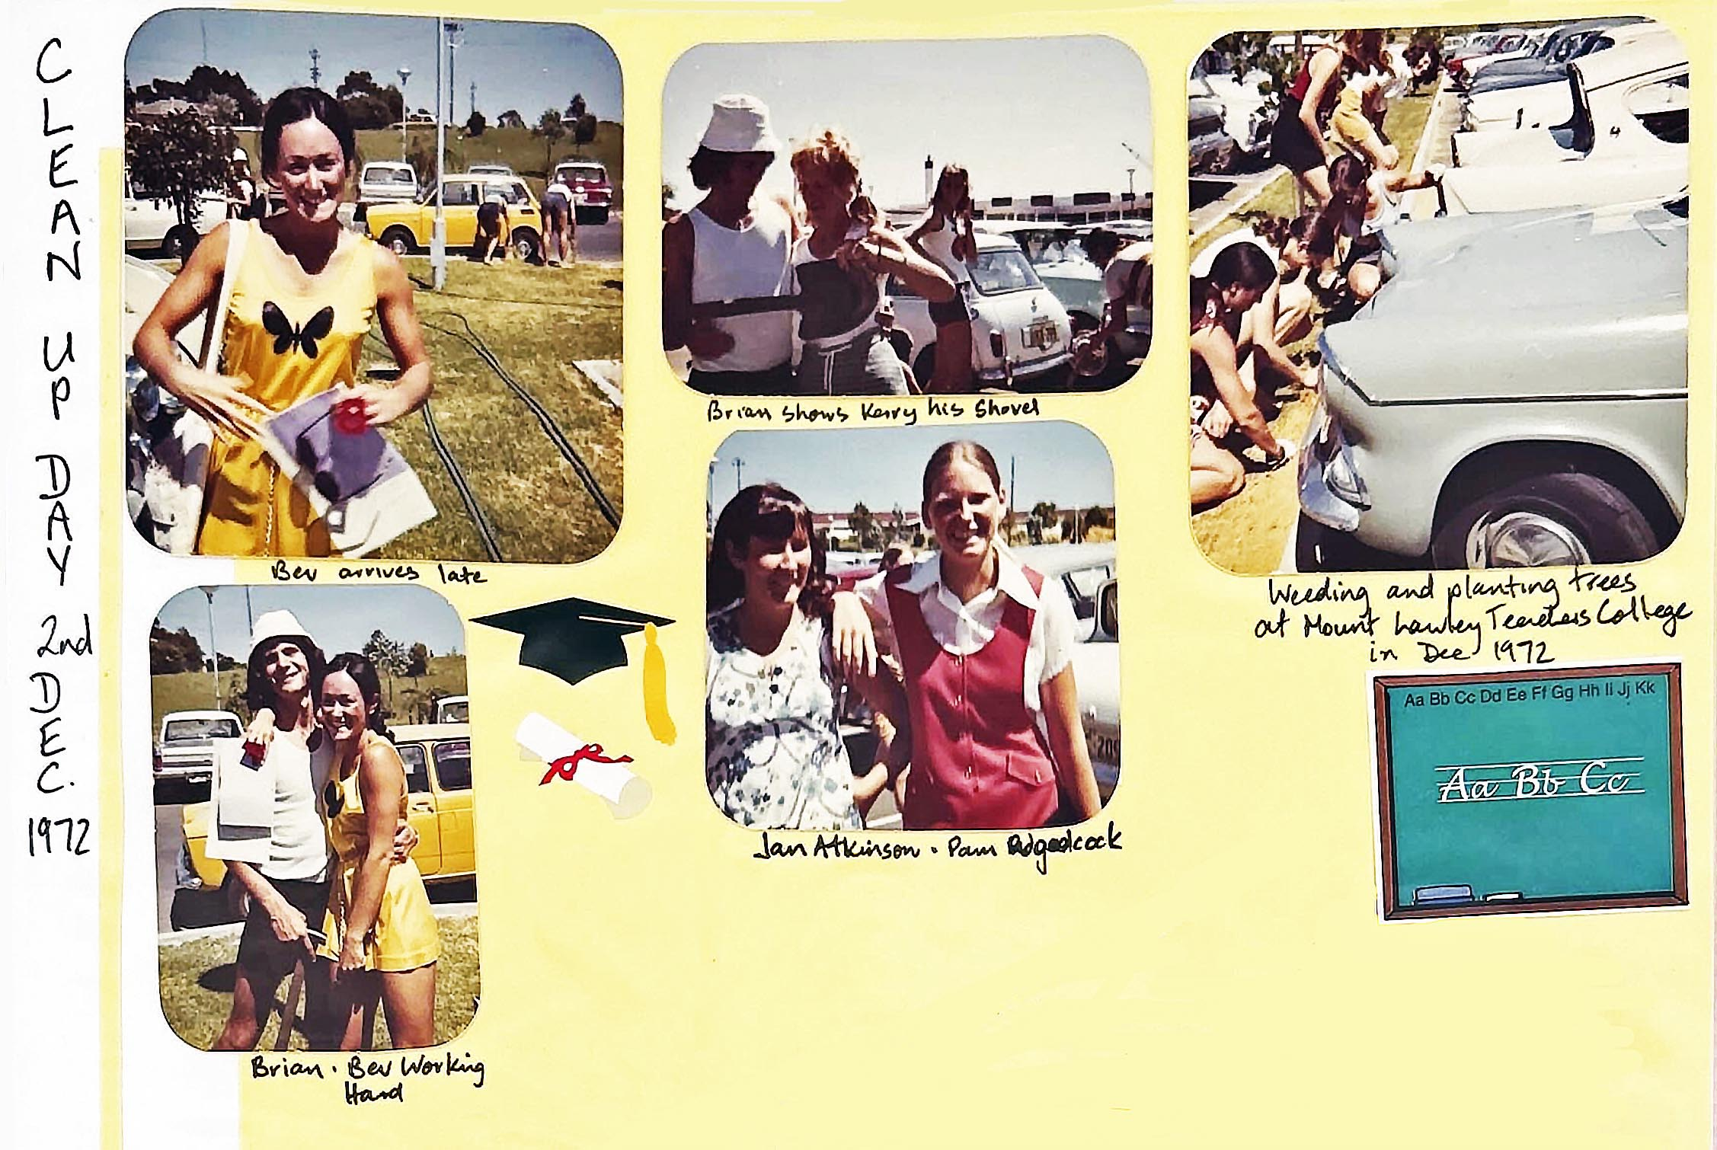
Photo: Kerry Paddon

Chapter 3 – MLTC Branding

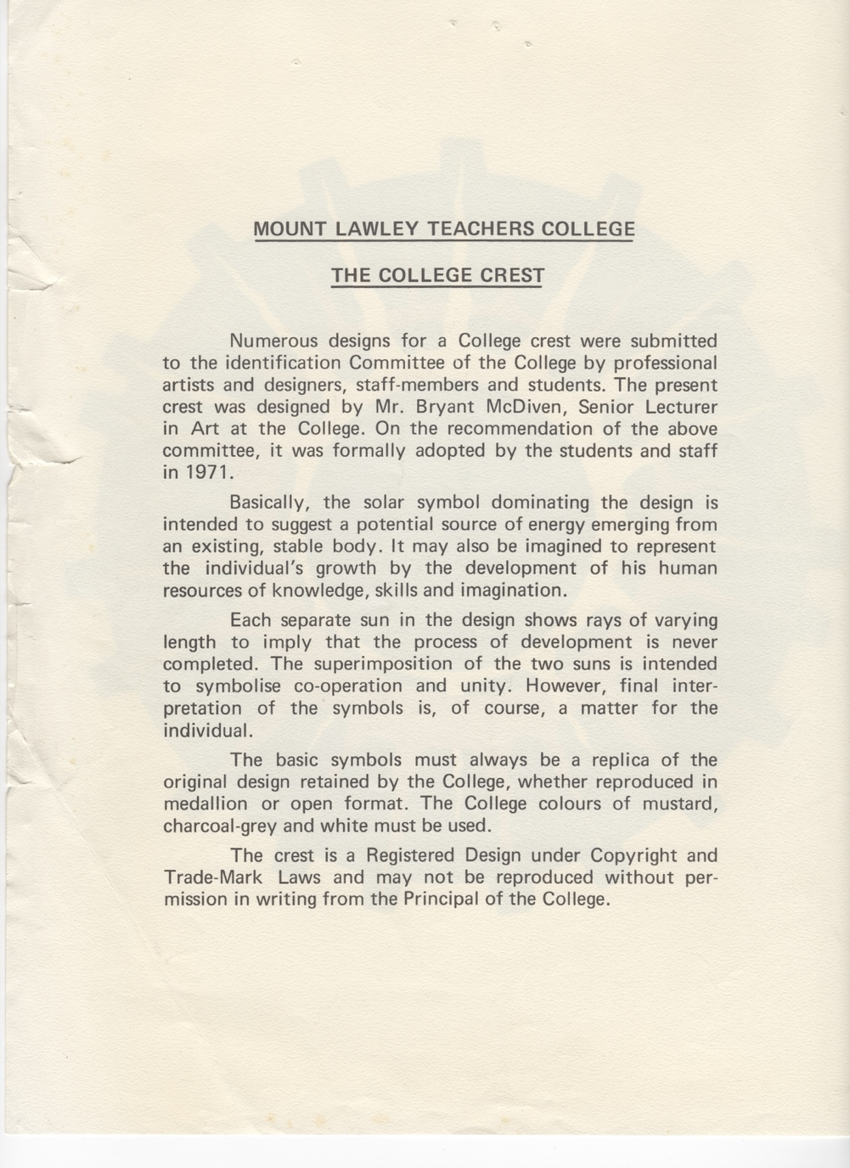
College Crest
Explanation of the crest's design

Photo: ECU
This logo was the basis for the majority of the marketing during MLTC. The design was so popular, that a number of students still have a shirt or memorabilia with this logo over 50 years later. Gail Gadeke even brought her shirt to the MLTC book launch!
This logo hung over the main stairs in the foyer of MLTC for many years, in the form of a tapestry, which was constructed by Jenny Allen and her art students. Diane (Johnston) Evans was one of the volunteers who helped to weave the tapestry of the logo. Diane was related to our registrar, Bill Pervan.

Early students will remember this tapestry well as we constantly saw this when transversing the steps.

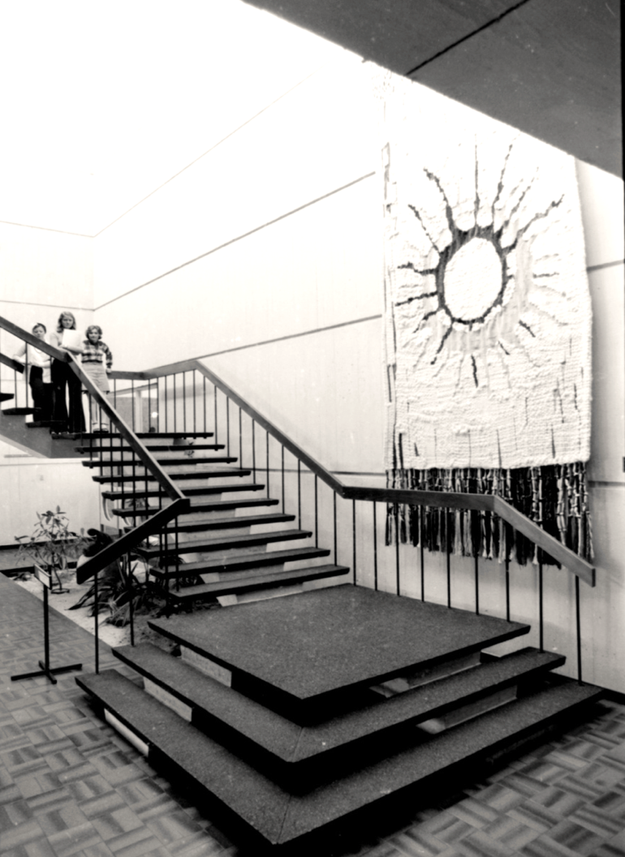
Photo: ECU
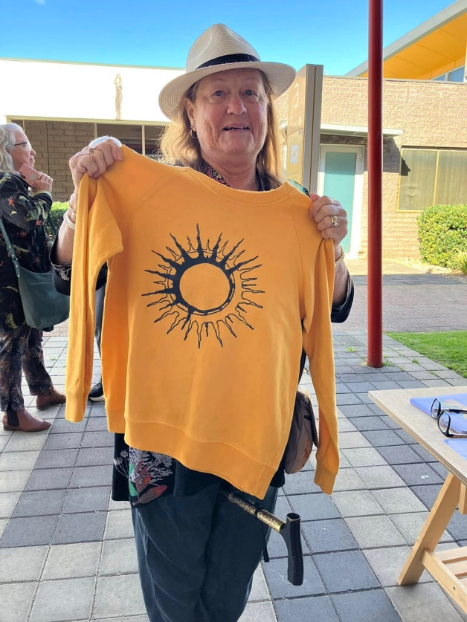 | 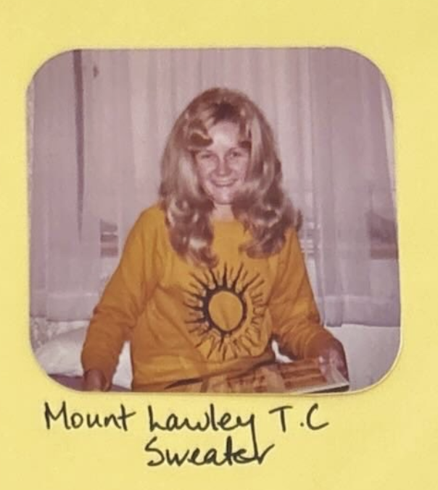
Photo: Rivka Finley – Gail Gadeke at the book launch | Photo: Kerry Paddon – in her MLTC sweater
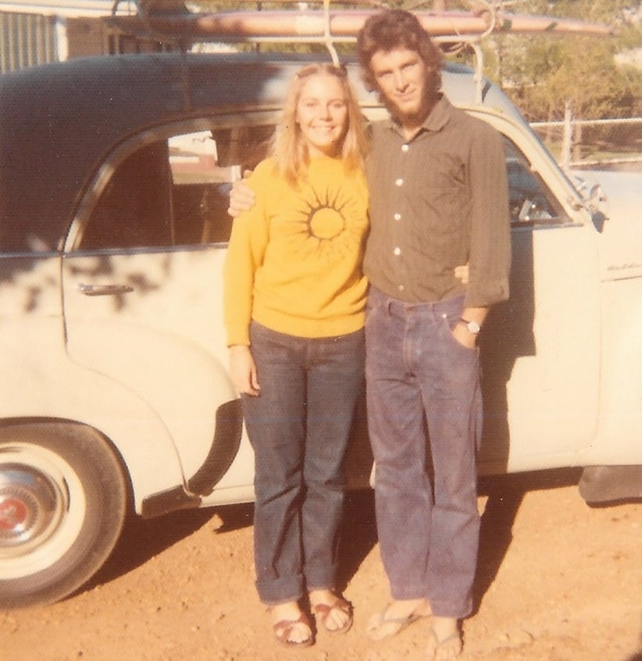
Photo: Neil Kidd – with Bobbie in her MLTC shirt
The shirt changed as the college transitioned. Initially the logo stood alone. In this version, the college had moved to MLCAE, and the branding indicated that this was specifically the version of the shirt for Mt Lawley, prior to moving to WACAE.

Photo: Christine Hatzon
In addition to the ubiquitous shirt were other symbols such as badges, jewellery and cufflinks. Here are the prices 1973-4.
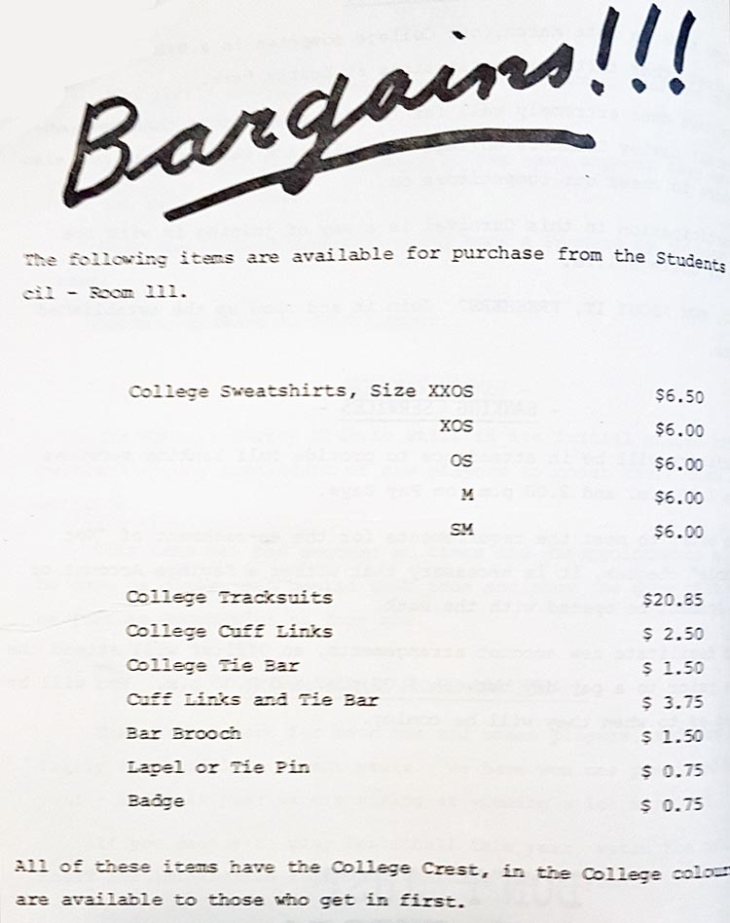
Photo taken from the MLTC year book

Photo: Annette Finlay – MLTC badge from 1972
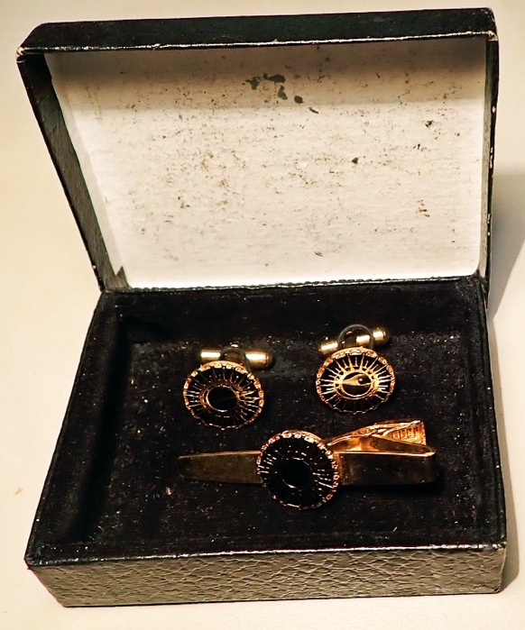
Photo Neil Kidd: cufflinks and tie bar

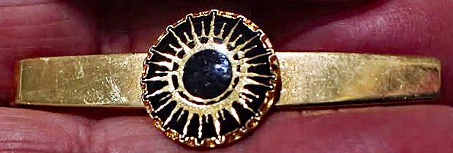
Photo Neil Kidd: tie pin
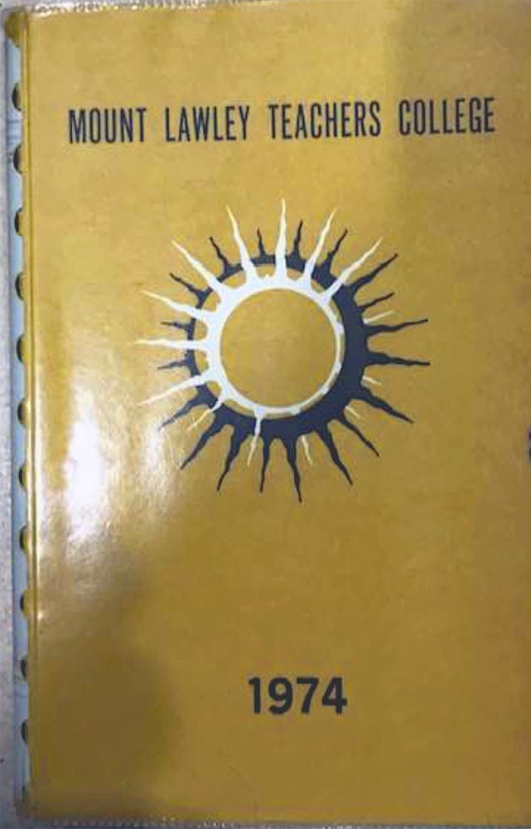 | 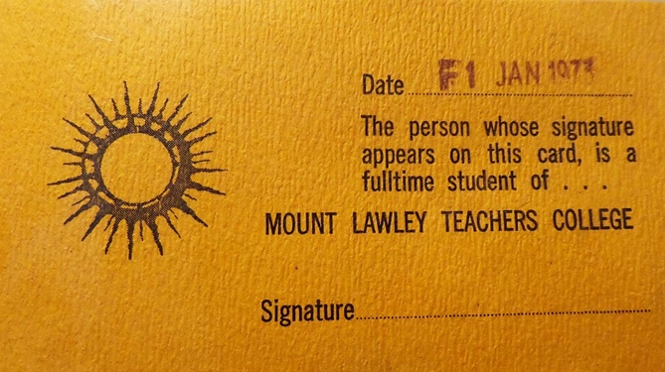
 | 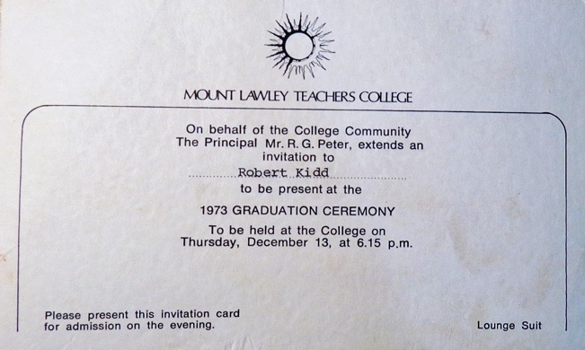
Photo: Teresa Taverniti | Photos: Neil Kidd – ID card and graduation invitation
Chapter 4 – Our mentors and our studies
Ian Francis: “We had some great lecturers. Jack Bana was a source of inspiration as was Bruce Sinclair, Jill Westwood and Addy Hayes. Len McKenna was a wizard”.

Steven Salamon: “Lew Eborall”.

Julie Hopkins: “I liked them all, but David Hough in particular. I did Oral English and Theatre Arts with him. I don’t know how he put up with me, but he did”.

Margot Parker: “What about Jack Bana and his maths classes, with programmed jokes. From memory they were fairly lame. One issue was we were fourth group he used them on. We would get prior knowledge and laugh enthusiastically. You could see Jack thinking I didn't think it was that funny”.

Ruth Shean: “I have very fond memories of many lecturers, chief among whom was Sybe Jongeling. Mr Jongeling was a superb lecturer, with a dry sense of humour and an enduring belief in our capacity. Others for whom I had tremendous admiration included Lew Eborall, Len McKenna and Addy Hayes — later Addy Carroll.
Addy was a compassionate phys. ed. lecturer for us, and especially welcomed by me for whom my academic strengths did not include phys. ed. I remember Addie teaching us the song Bingo and despairing — with good humour — at the folk dancing capability of us all, but especially one classmate who could not skip!
Most of all, I remember swimming lessons with Addy at the Inglewood pool. We had to do various strokes and other things to pass swimming. The only one that filled me with utter terror was the diving board dive. A dive for me — a good Aussie kid — was to jump in the water holding my nose. The compromise — jumping from the 3m diving board holding my nose. I am eternally grateful to Addy for this gesture. She remains a friend to this day. And let's add Mike Lee to the list.”
Bobbie Smith: “I undertook Music studies with the very dedicated Jean Farrant who organised and inspired our intimate Recorder Ensemble. Due to Jean’s positivity and role modelling, I later became a Primary Music Specialist and excelled with my Recorder Bands, Ensembles and Consorts in many of the schools throughout my teaching career. I had the privilege of performing in our Recorder Ensemble at Colin Kenworthy’s wedding.
I really appreciated the depth of knowledge and practical instruction I received in my Junior Primary Method course, run by Jean Connolly. She gave me a solid foundation upon which I then built upon and extended my teaching skills over the next 40 wonderful years. I’m so grateful to both of those wonderfully, dedicated women”! 

Neil (Robert) Kidd: “Len McKenna was classic! Fave Subjects? - I enjoyed doing the Mentor [student newspaper] LOL! There was a fire drill and those in Film and Television were to record it. There were flashing lights and fake smoke. I recall Colin Kenworthy rushing out then going back to his office to rescue his artworks while I was filming! Colin Kenworthy also once made us wait for him to appear and then surprised us with a grand entrance as we were considering leaving”.
Rivka Finley: “To work in primary education, you needed to be an all-rounder. Unfortunately, I was not. My mentors were largely in areas, which I was good at. I was in the advanced English group with Glen Phillips, who was an excellent mentor and encouraged us to extend ourselves. He operated out of a big office near Bob Peter, which was very handy for groups to meet. I enjoyed the Oral English crew, particularly Colin Kenworthy, who was a lovely, gentle, creative master of his craft. Despite the squeaky recorders, I really enjoyed working with Alan True and Jean Farrant, who were wonderful.
Maths was never my thing and I ended up in the remedial group, which was absolutely wonderful. I had sat through 5 years of high school maths and could not understand it at all, except the basic operations. In the remedial class, we had a textbook, which broke down all the mathematical concepts and could be worked through at your own pace. There were answers in the back too. As a result of working through this book, many areas of complete incomprehensibility, suddenly became clear.
However, the “new” subject Educational Psychology really engaged me. I remember a film about autism, which I found fascinating. Needless to say, my mentors in this area were Phil Smith (not a popular choice) and Mike Lee. I had many fruitful discussions with Phil Smith and was interested in pursuing a course in psychology.
I left for Secondary Teachers’ College at the end of 1971 (as I would have failed Phys Ed), and ended up at WAIT, where I continued with psychology in my English degree. I also found linguistics. Needless to say, I also wished to pursue a career in linguistics. (After the many hours of working on continuous assessment in about eight subjects at a time, the demands of university were inconsequential –a mere 15 hours of contact per week.) Later I attended the Mount Lawley WACAE, which introduced me to another exceptional mentor, in the form of Toby Metcalfe. To make a long story short, this encouraged me to become a Ph. D. of Applied Linguistics”.
Margaret Harris: “I enjoyed many of classes at MLTC. In particular, I loved physical education and had a great relationship with those staff members. I had thought of leaving MLTC and enrolling in the Secondary Physical Education course for my second and third years of study.
Bruce Sinclair convinced me to stay at MLTC. I had gained so much confidence in my abilities to achieve so completed the three years at Mt Lawley. The Phys Ed staff were always so positive and caring towards me. They encouraged me to stay at Mt Lawley and not go to Secondary Teachers College. I am still happy that I made that decision. I did become a secondary physical education teacher. Addy Hayes and Brian Churchward were also lecturers, who inspired me to continue with my dream of being a physical education teacher.

I vividly remember one lecture when David Hough arrived late for the lecture – he was never late! He walked in very seriously and impeccably dressed in a dark suit and tie. He then explained in detail why he was late. We all listened intently to his story, and then the punch line. He was a drama teacher and it was all an act. There had not been any major incident which had occurred. We were asked to not inform the other classes.
I loved Education Psychology and many years later completed a Post Graduate Diploma in Social Science (Counselling)”.

Chapter 4 – Student groups and participation in MLTC life
Mount Lawley encouraged student involvement and participation in the running of the college. The Student Council was established as a formal body to deal with student affairs and members of the Student Council were represented on the Courses Sub-Committee, the Publication and Research Committee and Campus Affairs Committee.
Students also had a voice in the form of the Mentor magazine, and were actively encouraged to participate in writing articles. This led to the Mentor Cup, which students also eventually took over.
Students also participated in a number of projects which included: the Loot Songbook, and Talus.
Student Council
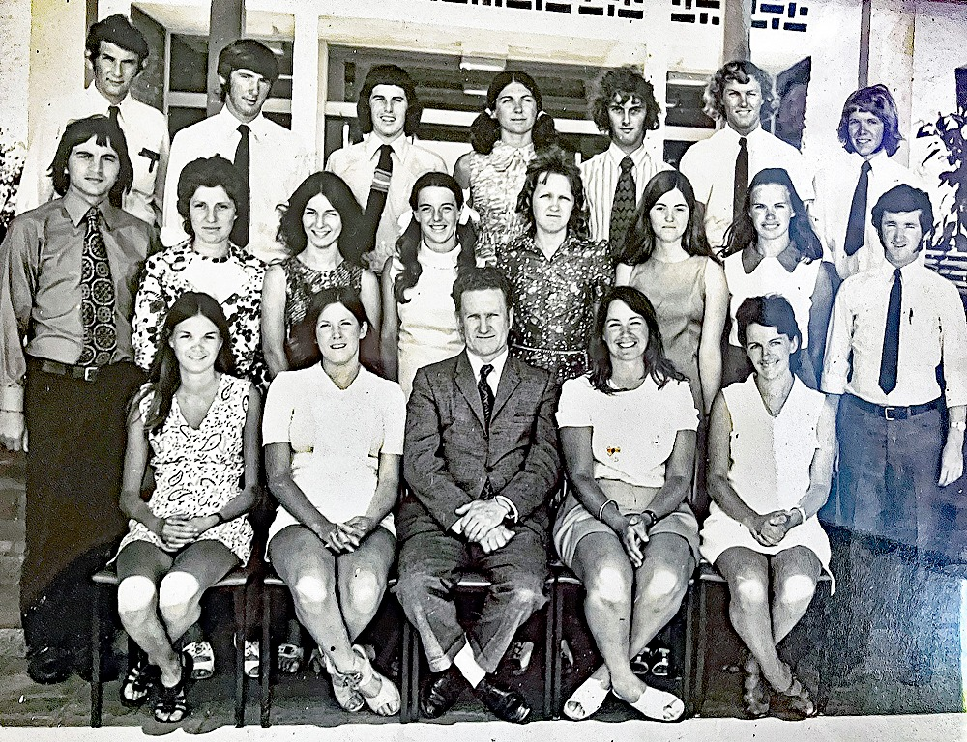
Photo: ECU – Student Council 1970
Back row: xxx, Bill Grogan, Peter Westall, xxx, Les Smith, Bruce Blay, Gavin Macoboy
Next row: Don Barba, xxx, xxx, Jan Tredrea, xxx, Dianne Toia, Ann Russell, Terry McNeil
Front row: Carol Povah, xxx, Len McKenna, xxx, Maria Kingma
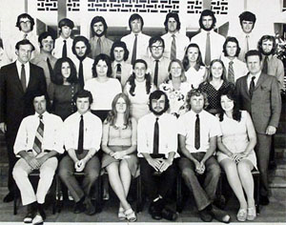
Photo: ECU – Student Council 1971
Back row: John Duzevich, Bill Grogan, Hylton Hayes, Stan Grabski, Rex Starling, Leo Kenny, John Rice
Next row: Bob Buckey, Neville Blampey, Peter Westall, Ross Romeo, Ann Russell, Robert Kidd, Peter Douglas
Next row: Bryant McDiven, Laurie Bendat, xxx, Jan Tredrea, Kerry McCarthy, Bobbie Smith, Len McKenna
Front row: Terry Watt, Terry McNeill, xxx, Hugh Morrison, Bruce Blay, xxx
John Rice was elected foundation Student President and the first Student Council had been formed. A structure was in place to encourage student leadership, student initiative, perhaps using the regular student news-sheet Mentor as a student-wide stimulus for action. The Mentor reveals that in the early years, student parking, the provision of a college canteen, the purchase of a college bus, and drinking alcohol at functions, all received attention by the Student Council. The Council also organized successful ‘dinner and dance’ functions to strengthen awareness of the Mt Lawley college community amongst college students.

Bobbie Smith: “As President of Societies on the Student Council, I helped to organise dances and a car rally, from memory! I also had to go to Court because the company we used for serving the alcohol, was using the wrong licence!! ”.
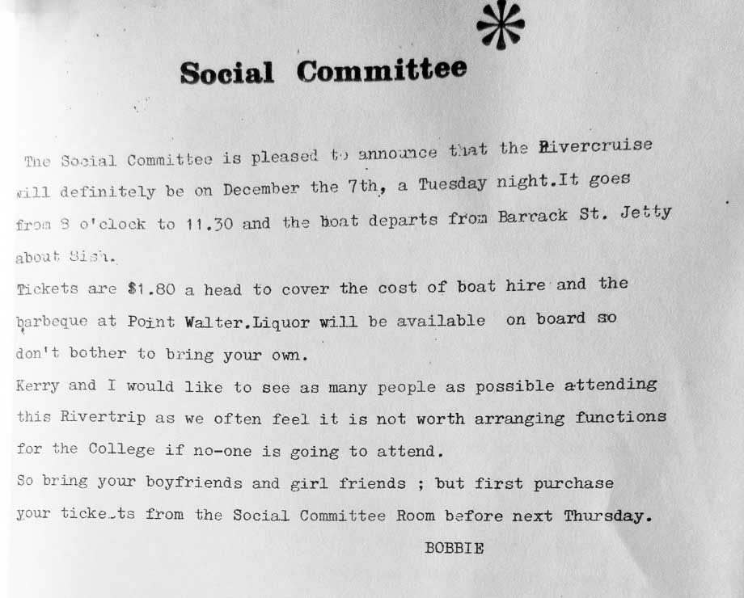
Neil (Robert) Kidd: “I was on the student council for the three years I was there. I recall that Hugh Morrison was our president. I think his girlfriend may have been societies president or secretary.
My ex-wife Bobbie Kidd (Smith) was Societies President … and there was an issue with Liquor Licensing at one of the social events that was very stressful for both of us. I’m sure the reason we are not in the graduation photo collage is that we were busy behind the scenes”.
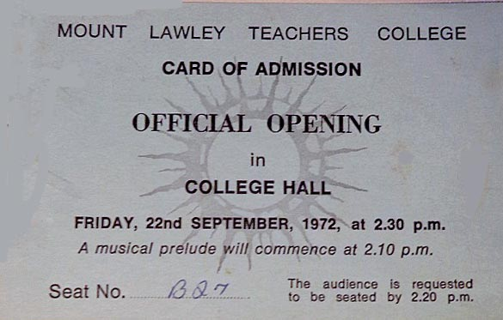 | 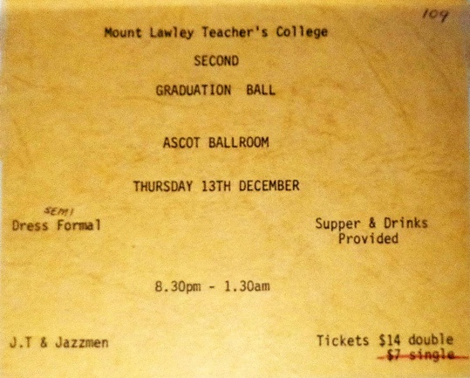
Photos Neil Kidd – Official Opening and Graduation Ball

The Mentor
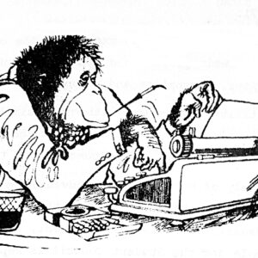
Photo ECU: – Mentor

The fortnightly student newspaper, ‘Mentor’ established by students in 1970 confirms this positive, participative mood by students at Mt Lawley. The Mentor ‘though accepting all copy’ in its early years did not print any criticism of the administration, the education program, or teaching by the Mt Lawley College staff. For their part, the college staff were conscious that they were, launching something new, special and largely untried.
Thus in 1970, after only one semester the social studies staff conducted a self-appraisal of social studies course content and its delivery revealing perhaps some concern amongst college staff that the students were too passive, too accepting.
The Mentor was situated in the last corridor of Building 3, and it was a hive of student activity. We would gather in the room allocated and brain storm. Joining the Mentor was a great way for people of 1st and 2nd year to mingle.
Neil (Robert) Kidd: “I helped with the student newspaper ‘Mentor’ which was edited by Les Smith and Bob Buckee in my 1st year and then I became the editor. This was pre-computers and the stencils were printed on a Gestetner; I do recall it having a scanner that cut the stencils though!
A local senior named Mary was our typist at the student newspaper. She lived across the road and seemed to love the job.
I wanted to print T-Shirts for Mentor and showed the design to David Jones of the Art Department. He told me it was too detailed to cut as a silk screen so I thickened the lines and brought it back. He showed me what to do and I did my first silk-screening”.
“The Mentor provided MLTC staff and students with the news, such as Councillor Terry Watt’s proposal to buy a bus, and Neville Blampey and Peter Douglas’s foray into the realm of Parking Inspectorship”.

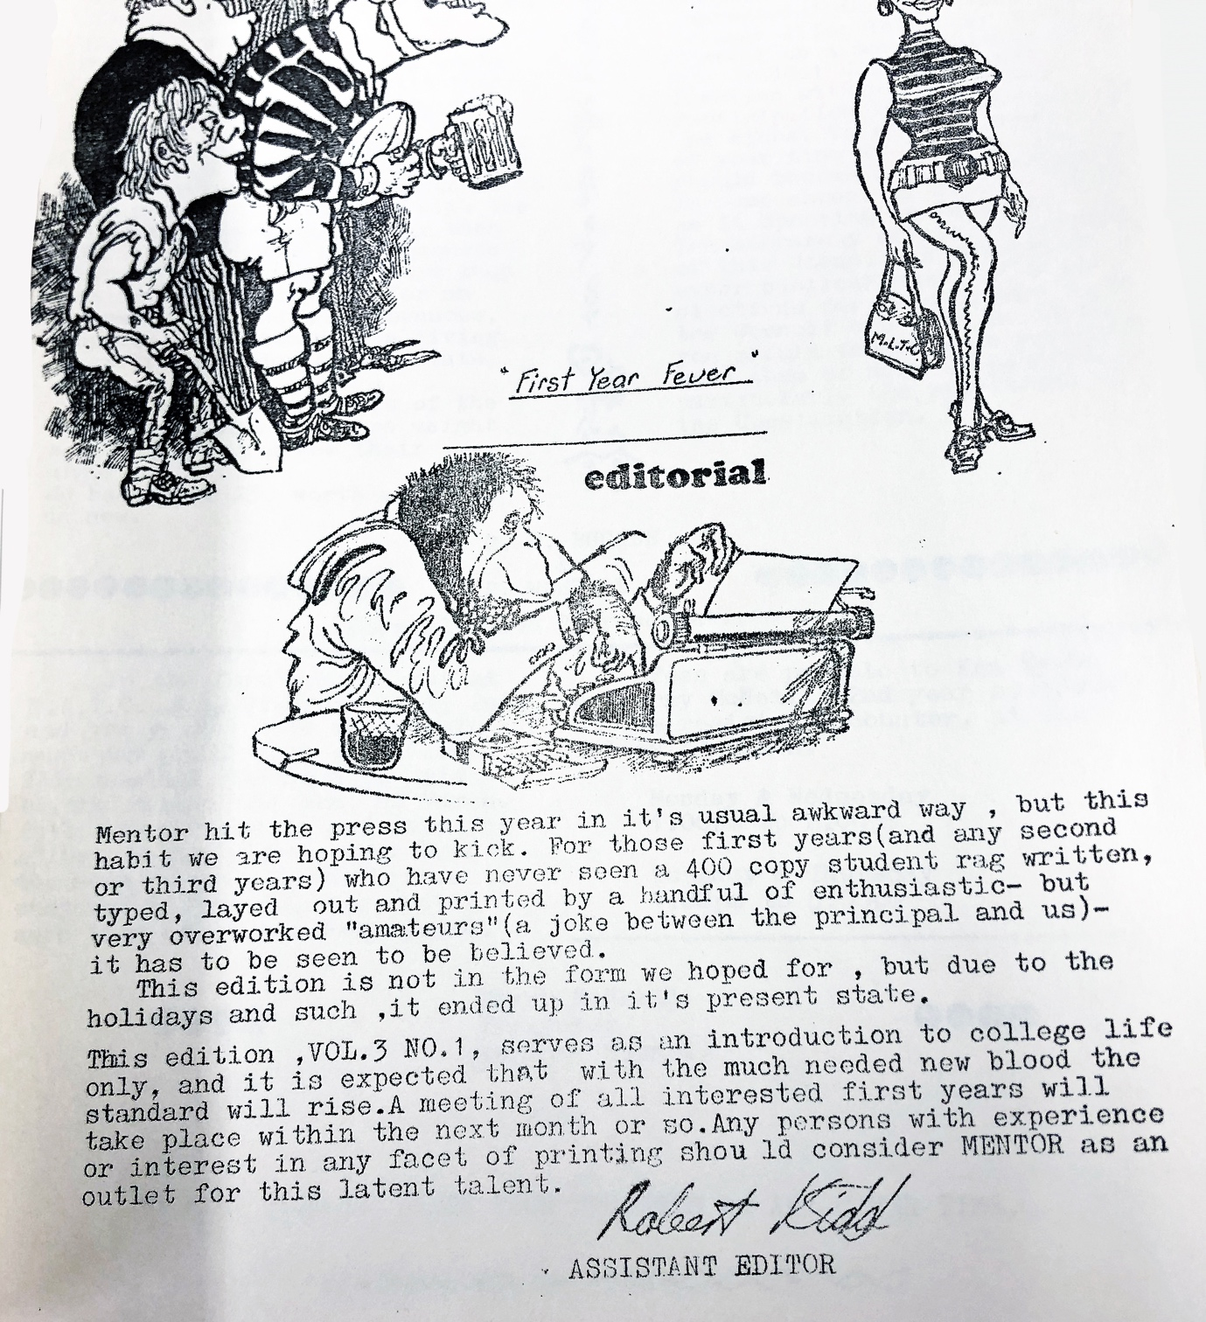
Mentor Vol. 3 No. 1
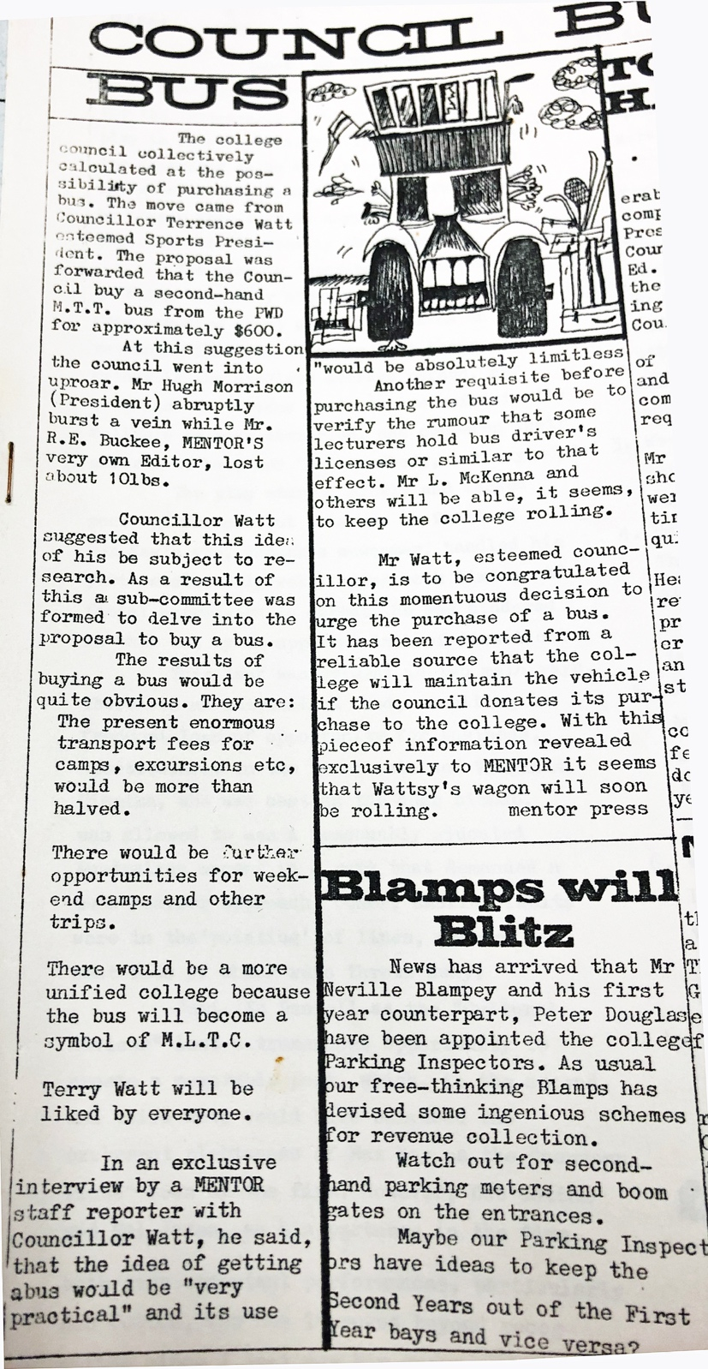
We also had a Quotable Quotes section, where we would quote people, totally out of context and often in a salacious manner.
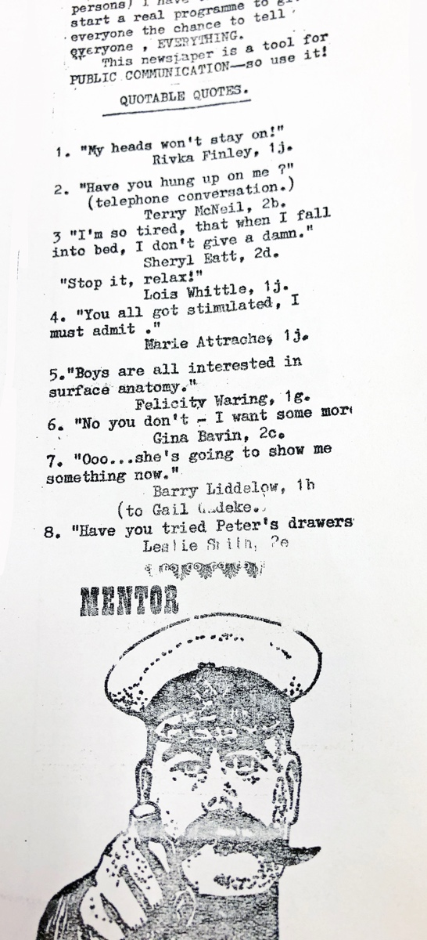
Mentor Cup
The "Mentor Cup" was a social and sporting event at Mount Lawley Teachers College. It may have initially been a college administration inspired event to generate comradery and would have had a crazy mixture of management in getting it going in the early years. The Science or Physical Education Departments were probably the keys to its establishment and later it was taken over by students, particularly those in science and those working on the student newspaper, Mentor.
It involved a weird assortment of ‘home-made’ raft in races on the Swan River near the Garratt Road Bridge, with lectures cancelled for the day. This fun day was a break from the regular college schedule, designed to unite students and provide a fun, relaxing atmosphere. It became an established annual fixture by 1976.
The teams involved in the Cup tended to be keen participants competing in good spirit showing how competitive students could be. For those less competitive, just watching and enjoying the fun was okay too.
Neil (Robert) Kidd: “The Mentor Cup was a fun day at Garret Road Bridge and I recall the Science Department had many ‘secret weapons’ to ensure they won! Mud squirted through bicycle pumps and pack-of-cards sail”.
Jelly squirted through bicycle pumps and an ingenious pack-of-cards sail. When they ran out of jelly the sucked mud up from the bottom of the river and squirted that at their rivals”!
Apparently and an open-air dance was held at the Ascot pub afterwards with free drinks (first drinks only) that he doesn’t recall! The event also included competitions, certificates of participate on and prizes”.

Margaret Harris: “I fondly remember the Mentor Cup Day as being full of fun. We had to make our own boats if I remember correctly. And yes, many did not make the full distance because they fell apart or were sabotaged by other classes”!!!

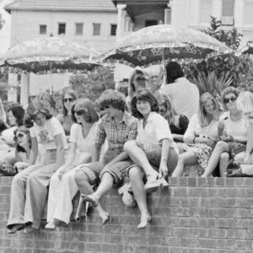
Photo: ECU - Students watching the Mentor Cup

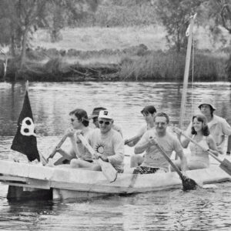
Photo: ECU - Crew of this boat included Bob Peter, Len McKenna and Dick Lamb

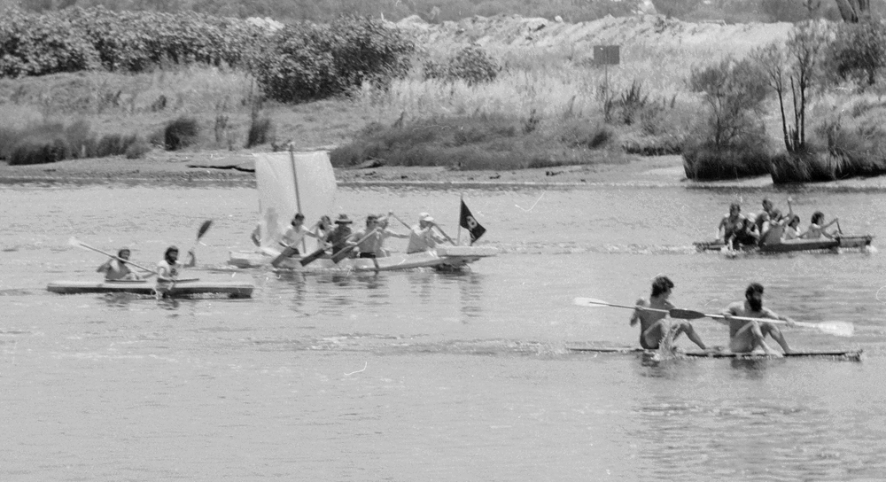
Photo: ECU - the race is on

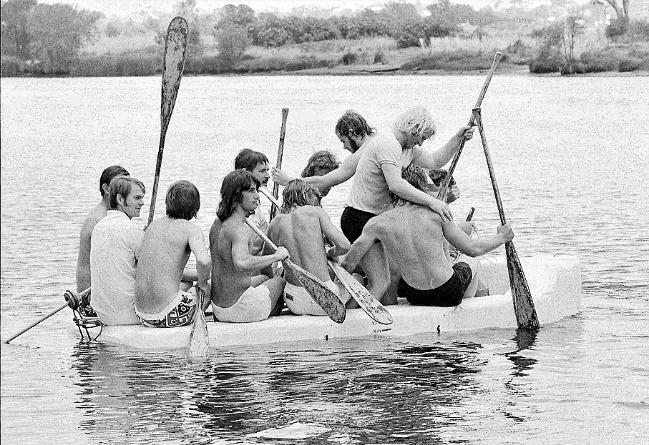
Photo: ECU - the boys are gearing up

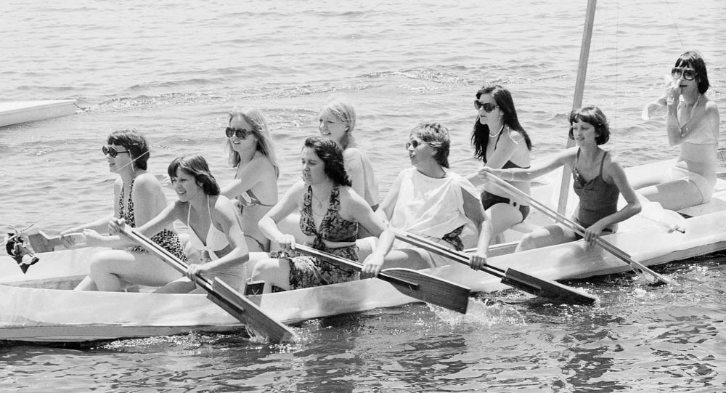
Photo: ECU - the girls looking very organised

Leo Kenny: “I remember standing in the mud after we came ashore. I moved my foot and felt excoriating pain as a piece of glass in the mud almost sliced off my little toe. Bill Reid took me to hospital where an extremely painful flushing and cleaning took place and 4 stitches were inserted. Even the anaesthetic and antibiotic injections hurt. I think we won the race didn’t we”?

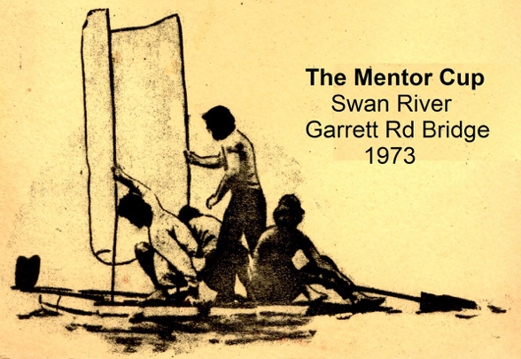
Photo: Neil Kidd

(Robert) Neil Kidd:
“I seemed to do everything!
I designed the 'boat'.
I supplied the materials.
I provided transportation.
I helped the construction.
I press-ganged the crew
and I was Captain Kidd!
So that is why I couldn’t take photos; I was too busy”!

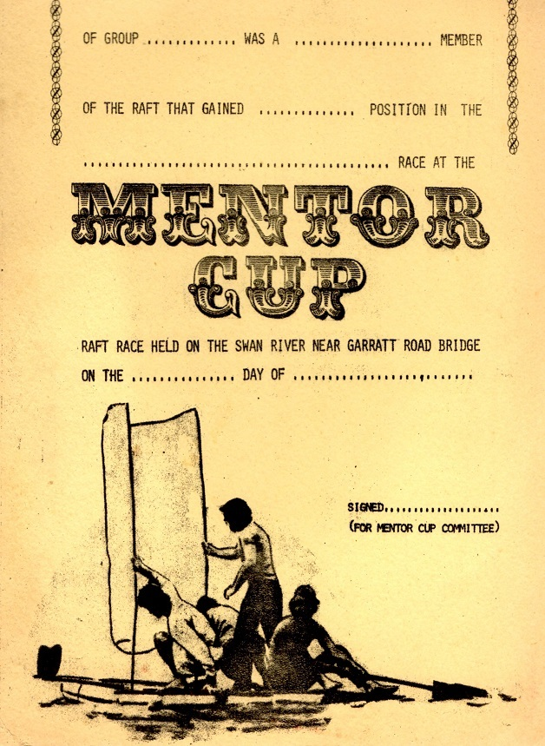
Photo: Neil Kidd

“That craft of mine with the sail pictured on the CERTIFICATE probably had a base of two Coolite [polystyrene] surfboards.

I wrote a couple of poems as I recalled that crazy event;

At Peter Garrett Bridge
Sure, No Beds Were Burning
But beneath us in Black Duck Creek
That stinky mud was stirring”.

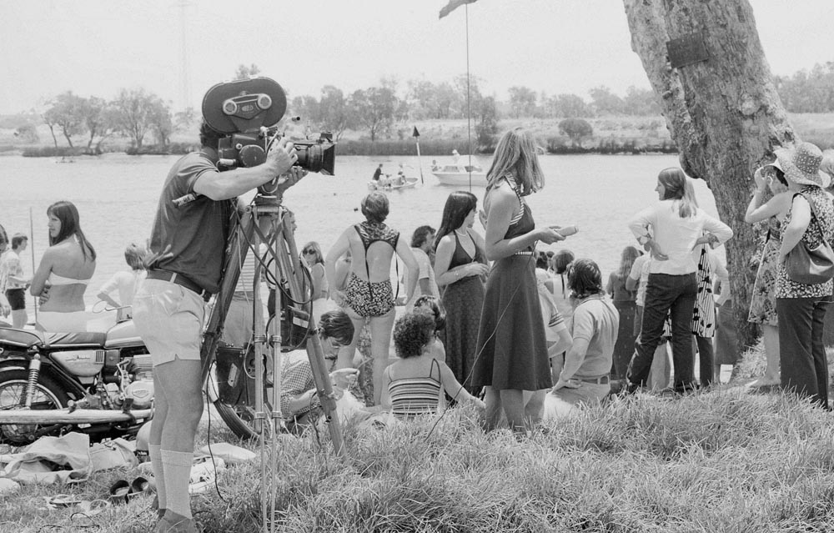
Photo: ECU - filming the event

Wilbur Klein:
It was a lot of fun. Mucky Duck were great. One year we had to deal with Channel 7 who claimed a flour bomb had destroyed their expensive camera. We successfully argued that we did not invite them and it was their responsibility. Dick Lamb took his boat building very seriously!

Loot Songbook
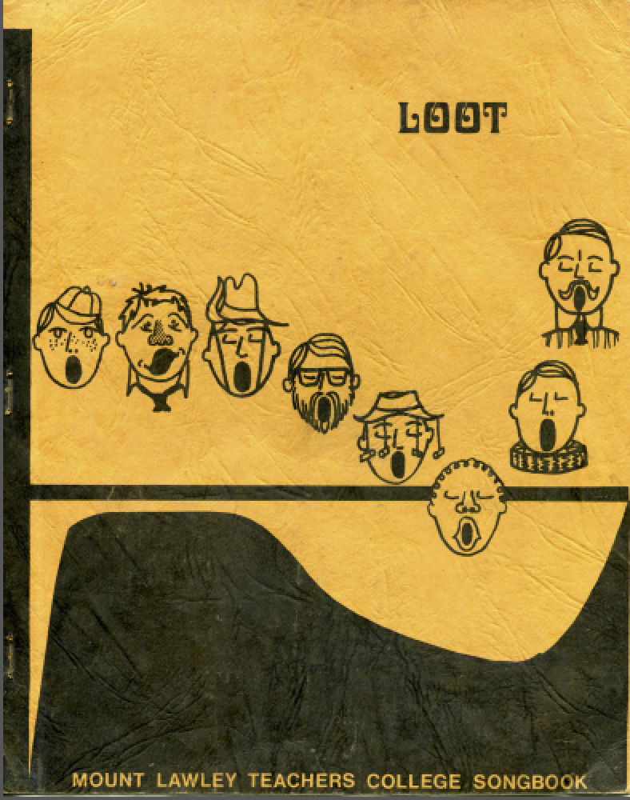
Late in 1970, a staff-student committee was formed to edit a songbook for Mount Lawley Teachers College. Had the size of the task been foreseen, there would have been no songbook.
Over 1,300 man-hours were spent on the production of the book. Some 400 songs were considered by students, by staff and finally by the committee. It is hoped that the diverse tastes of all have been sufficiently catered for, and that among the 230 songs will be many that will appeal to all.
Care was taken to ensure that songs for all College needs were included in the songbook - songs for camps, concerts, and ceremonies, for parties at home and at the K.A. (Knutsford Arms), and for class use.
The following staff and students were involved: Diane Birt; Peter Mitchell; Steven Salamon; Barbara Willis; Colin Kenworthy; Alan True - Songbook Committee 1970-71.
Gardening
One of the first things a MLTC graduate will tell you is that we planted the gardens and weeded, during our course.
Ruth Hutchison: “The community feel and spirit was maintained by that initial intake of students throughout the years of our course. Events such as the landscaping of the front street verge and surrounding areas of the new buildings built strong bonds. All students and staff spent a complete day planting, digging, mulching etc to establish the initial gardens, which are still seen today. Len McKenna organised choosing, purchasing and planning this venture. I now tell my grandchildren as we pass the Bradford Street corner that my friends and I helped plant the huge trees and bushes back in the early 1970s”.
Marjorie Bly: “The college was the quintessential building site during those early years. I remember becoming a labourer and helping to fill the garden beds with compost and plants under Len McKenna’s watchful eye”.
Rivka Finley: “I hated weeding the far end of the initial quadrangle. I just couldn’t see the point in it. I was more receptive to planting shrubs and plants out the front of the building on Arbor Day. Looking back that always gives me a feeling of pleasure and belonging. I always wanted to know why we did the gardening. Couldn’t they employ gardeners?
After we located a then 100 year old Len McKenna, I finally got to ask this question. Why did we have to do the gardening”? Len’s answer: “because that is what we did at Graylands”. So now we know at last.

The gardening “cleanup” was still going in 1972.
Photo: Kerry Paddon
Talus
Talus was a literary and graphic magazine, put out by the students displaying student poetry, prose and art. This journal began in 1970 and included work by: Jeff Aitkin, Naomi Jones, Val Klenowski, John Pope, Delise Houston, Wendy Collins, Greg Osborn, Karen Melzac, Philip Ward-Dickson, Michael King, and Clive Pascoe.
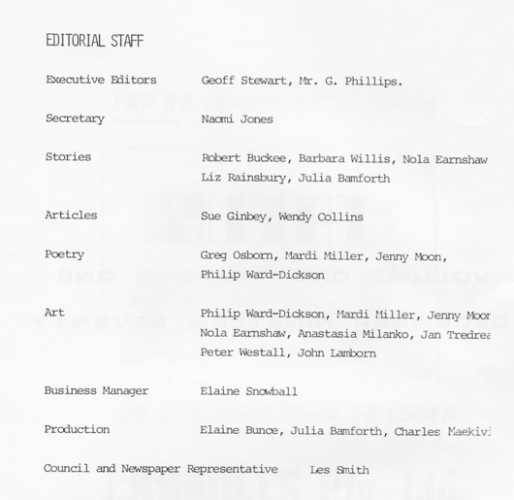
Photo: MLTC – Talus editorial staff
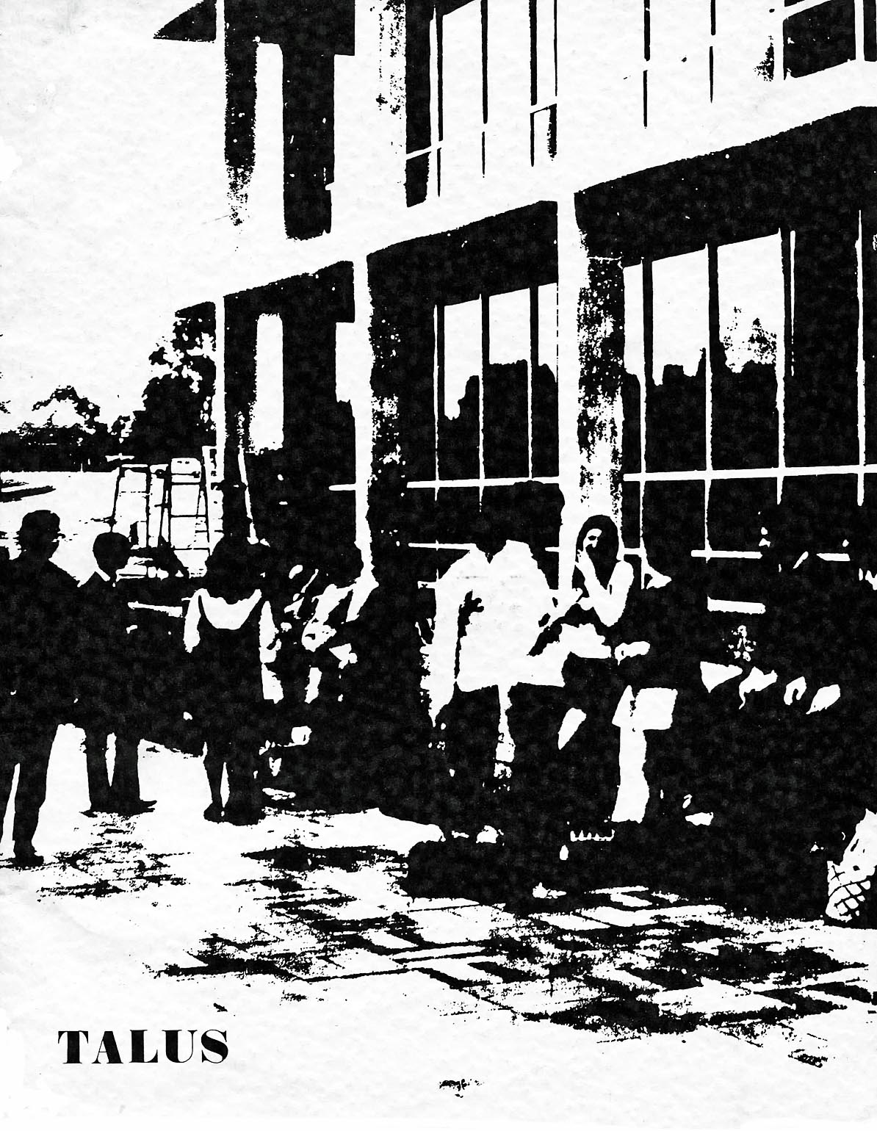
Photo MLTC – First edition in 1970
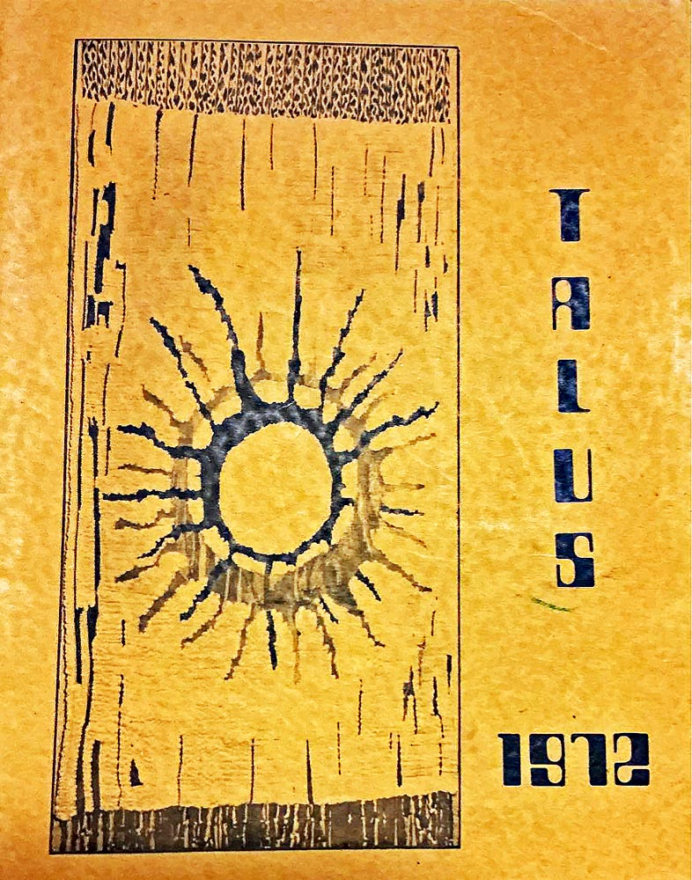
Photo MLTC: Talus 1972
Talus was still running in 1975-76, with seemingly two trendy covers.
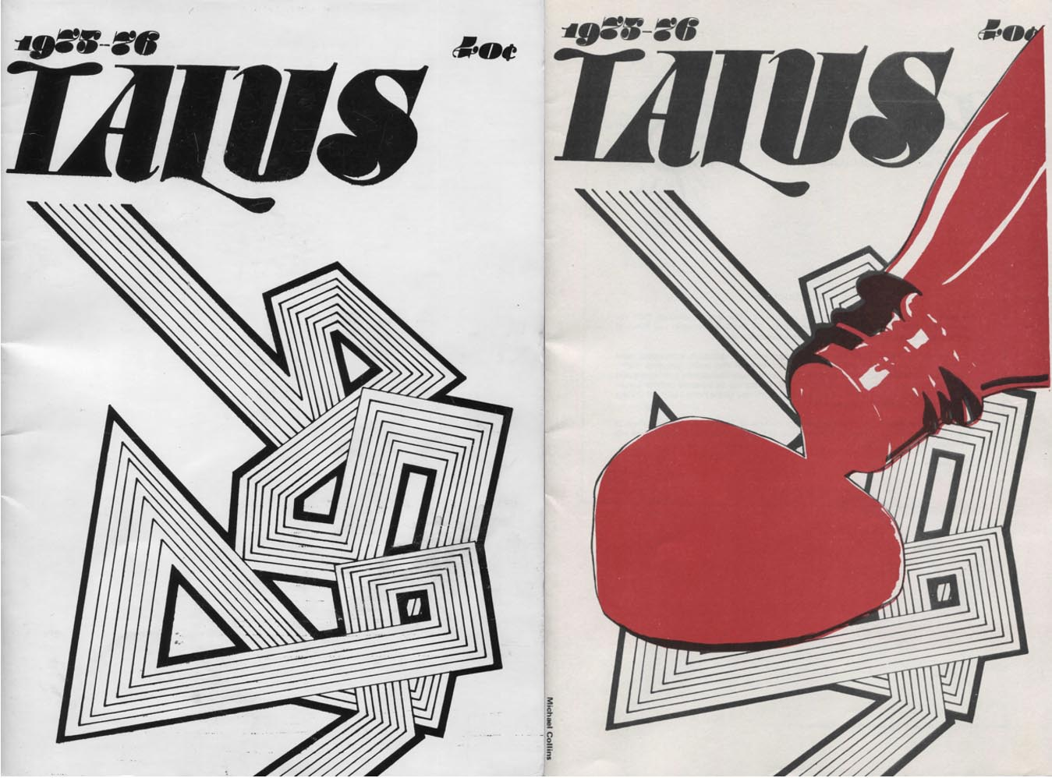
Photo MLTC: Talus 1975-1976
Seedtime
Seedtime, while not a student publication, did feature a number of our students on the covers, as models.
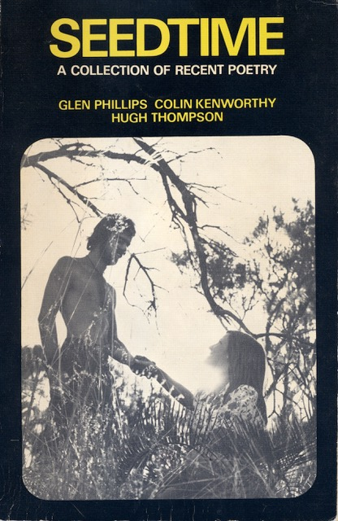 | 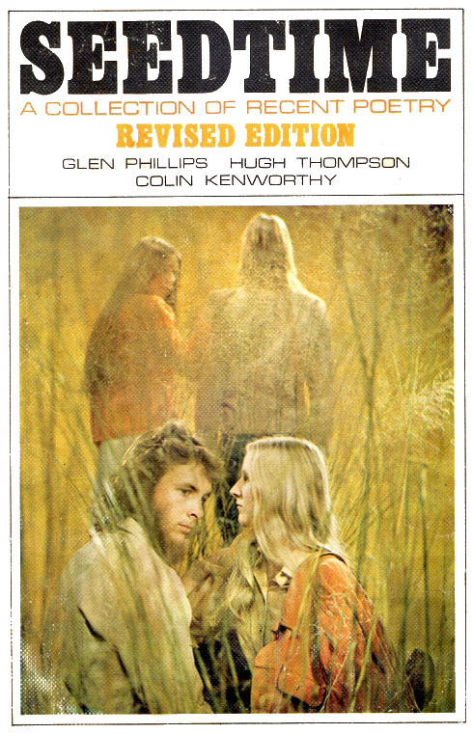
Photo: MLTC – our Seedtime models
The first edition in black and white version featured Jeff Brownrigg and Sue Ware. The coloured version featured Robert Neil Kidd with an unidentified blonde, and Ruth Shean and Kingsley Iddon in the background.

Chapter 5 - Social Life
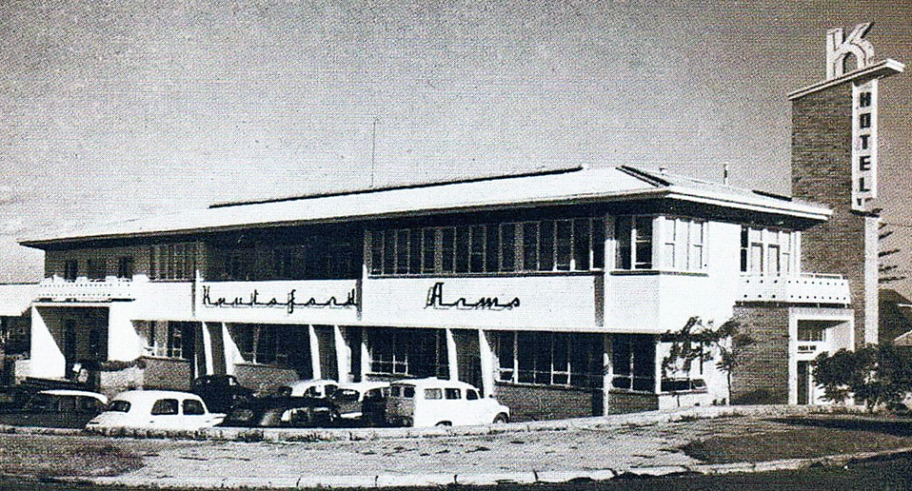
Photo: Museum of Perth
A popular place for students was the Knutsford Arms. Students would often descend on this nearby hotel for a tipple at lunchtime or after finishing up for the day.
Marjorie Bly: “During my time at Mt Lawley Teachers College, the legal drinking age dropped from 21 to 18 in 1970, so timely! There were Friday group lunches at the Knutsford Arms, with fellow students. Alcohol may have been drunk at these lunches and the following art lessons may have been enlivened by the predictable results, including fairly vague and incomprehensible answers to questions about the theory of art. Not sure if Mr McDiven ever cottoned on”.
Margaret Harris: “I have so many memories of Friday afternoon lectures with Mr Marsh in our final year. Some of our friends would go to the Knutsford for lunch and come back for the lecture. We would drive down to Dianella Plaza for our lunch. Those who had not been to the pub had the task of ensuring they kept quiet in class and were not giggling during the lecture”.
Clive Choate: “We enjoyed teaching demonstration mornings. The variety was motivating and presenting teachers were very dedicated. It was a valuable part of our training.
As we gravitated back to college in Bradford Street, we also enjoyed a further ‘debrief’ at the Knutsford Arms which was our local watering hole for MLTC trainees”!

Part of the fabric of MLTC, was the friendship and bonding of students working closely together in an environment, where there was an emphasis on learning the art of teaching. Even in 2026, after an absence of over 50 years, the friendships slotted back into place like a good jigsaw puzzle and people were delighted to reconnect with one another.
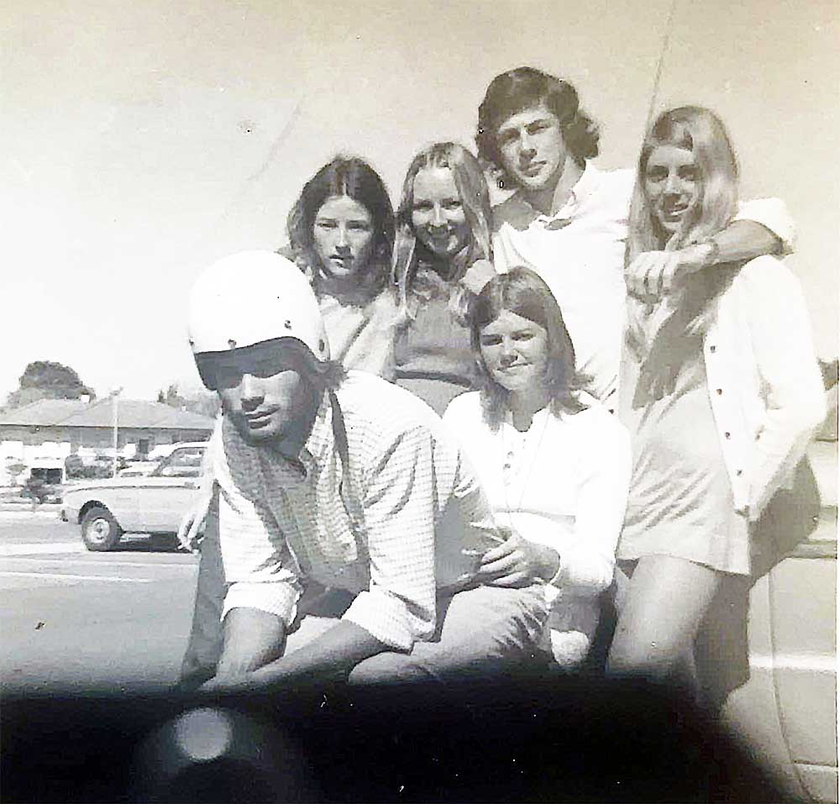
Photo: Neil Kidd - Charlene Cowcher, Trish Harant, Bill Reid, Lorraine Smith, Leo Kenny, Robyn Clutterbuck hanging out in the MLTC carpark
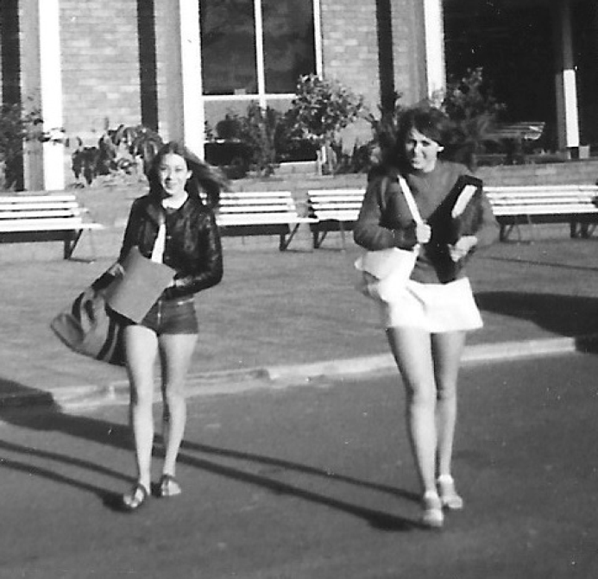
Photo: Neil Kidd – Sandy King and XXX outside MLTC
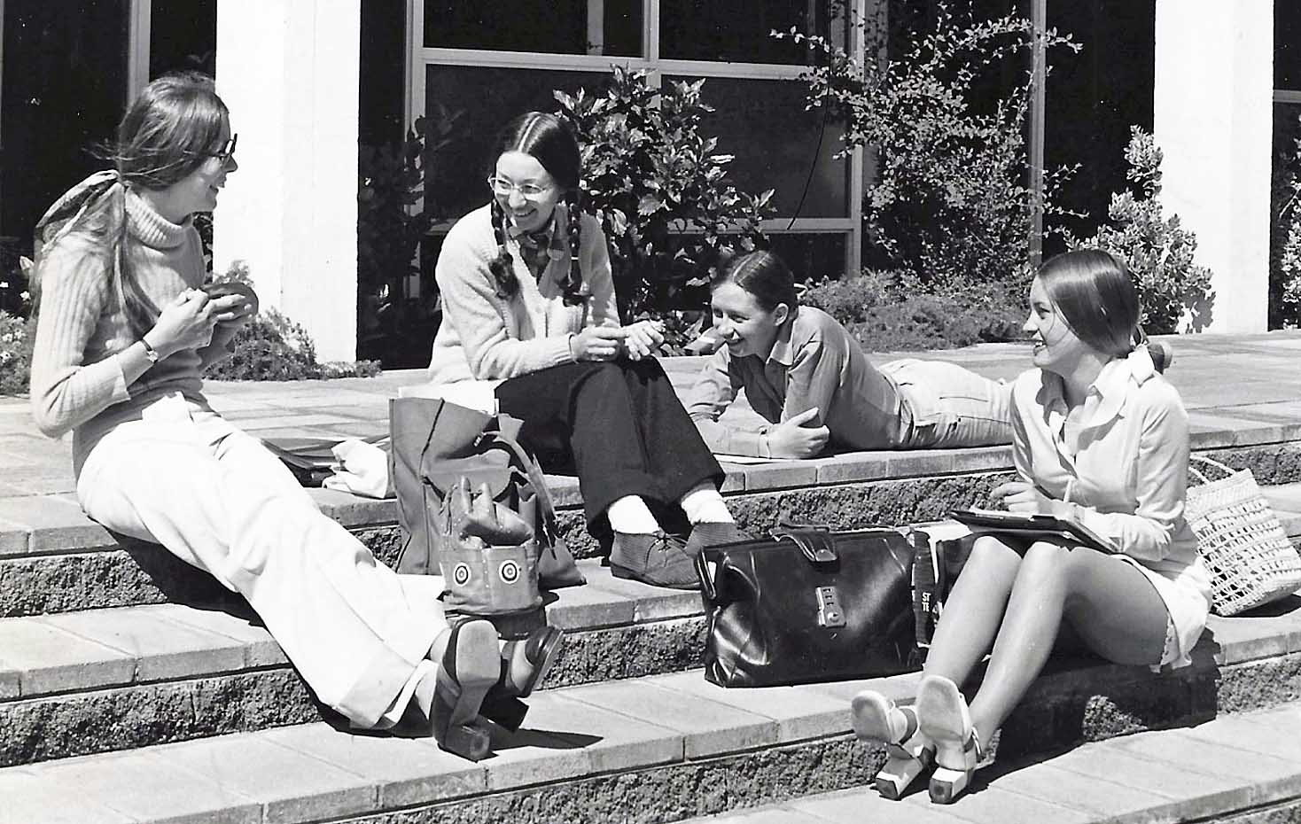
Photo: Ruth Shean
Ruth Shean: “The picture above was taken by Loyd Bolgia again I think, and developed and printed by me. Here we are — from left — me, Heidi Gfeller, Kathy Abe, and Jo Nieuwkerk. I think we are working — Jo had a notebook on her knee and Cathy has paper in front of her too. This was a common scene — lunchtimes, working in the courtyard. This is immediately through the front doors and into the courtyard behind”.

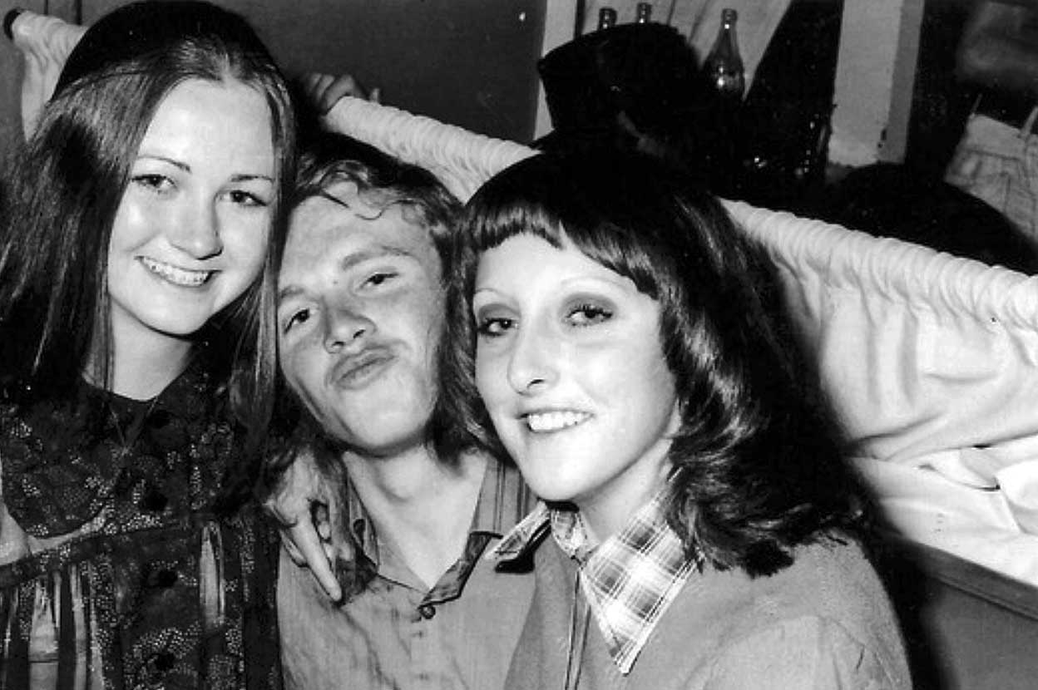
Photo: Maureen Willoughby – with friends
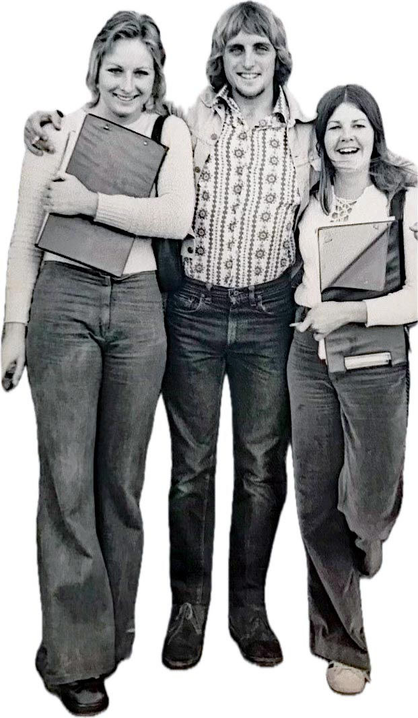
Photo: Robyn Clutterbuck - Trish Harant, Kingsley Iddon, Robyn Clutterbuck
In addition to the Knutsford Arms, there was also a keen interest in music. The Mucky Duck Bush Band, often called Mucky Duck, held performances at MLTC. The band was founded by Stan Hastings, who ran the folk club The Stables in Northbridge, and his son Greg Hastings.

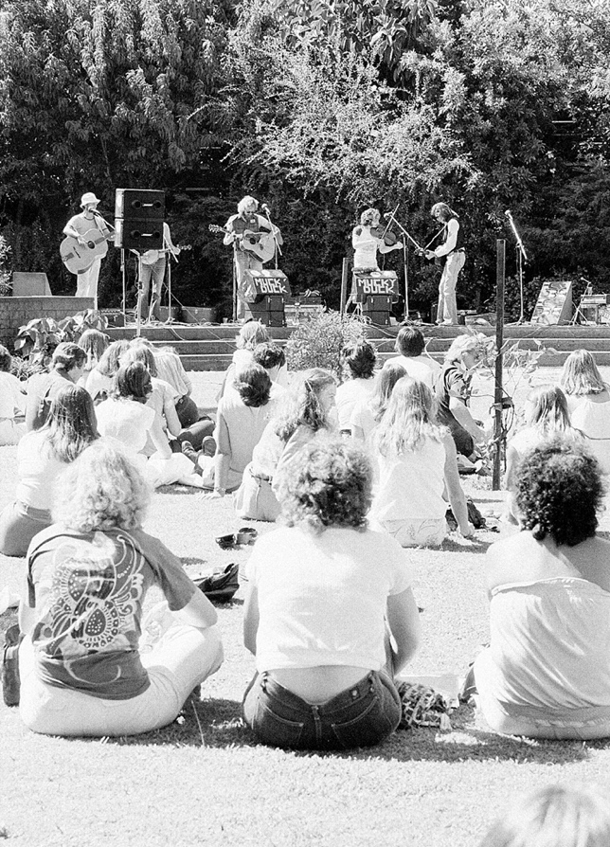
Photo: Sybe Jongeling – Mucky Duck Band performance
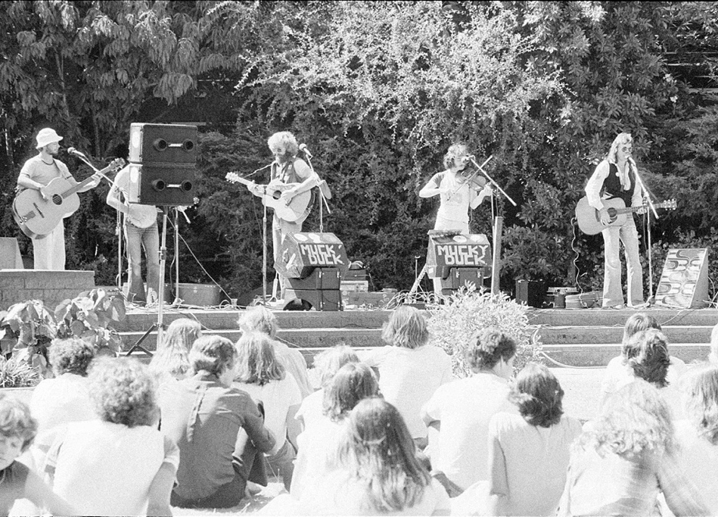
Photo: Sybe Jongeling – Mucky Duck Band performance
There were socials with dancing, such as the one below, which was held at the Mt Hawthorn Civic Centre c.1973. These were organised by the Social Committee, of which Bobbie Smith was the president.
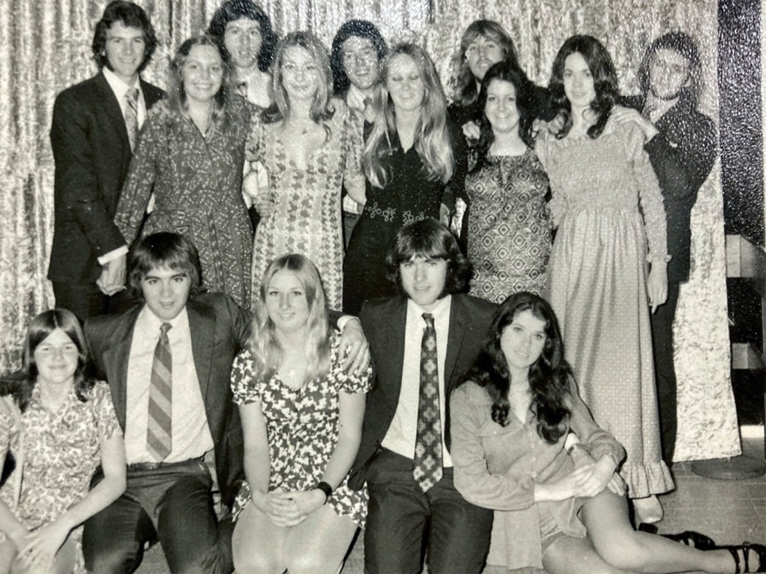
Photo: Neil Kidd – dance at the Mt Hawthorn Civic Centre c.1973
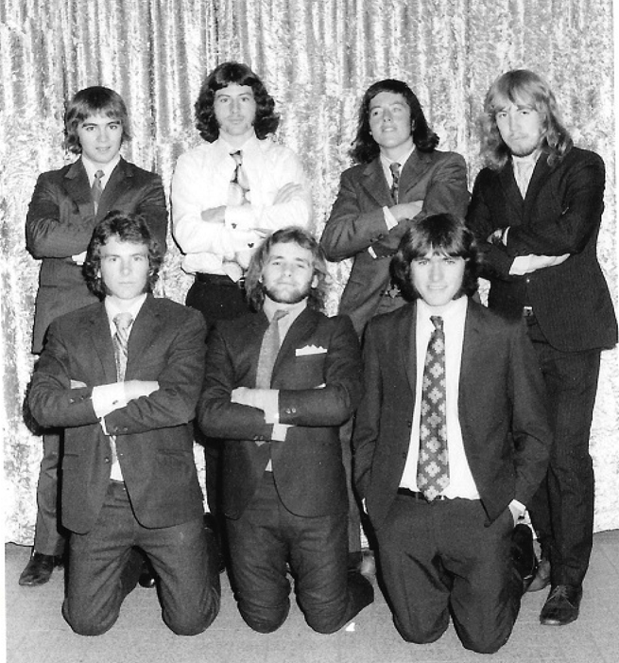
Photo: Neil Kidd – the guys at the dance

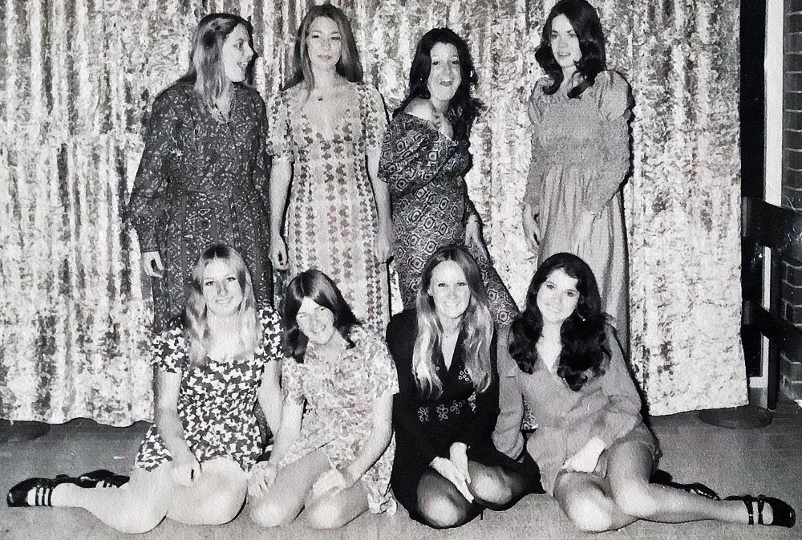
Photo: Trish Harant – girls at the dance
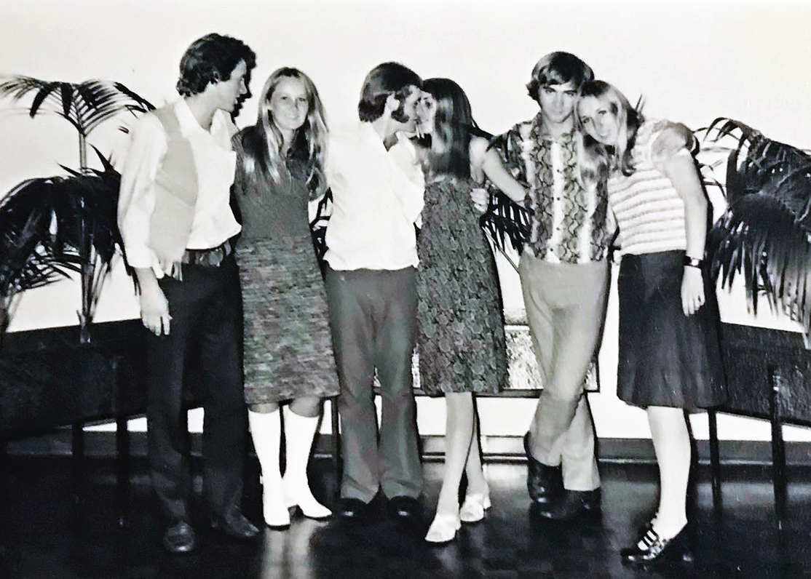
Photo: Trish Harant – Robert Kidd, Lois Whittle, Peter Douglas, Lorraine Smith, xxx, Trish Harant

Terry Watt: “Looks like Lois Whittle second from the left. I should know. We married in 1975, and went off teaching in Albany that year. We have been together since, married 50 years as of Jan this year. I was definitely ‘punching above my weight’ looking at this picture. She still looks great today at 71. Lois retired about five years ago after 20 plus years Team Teaching at Hawker Park Primary with Pamela Barnes.This was the first and last time Robert Kidd dated Lois”.

Marriages
Social events encouraged student relationships and a number of our students married each other. The ones we know about include:
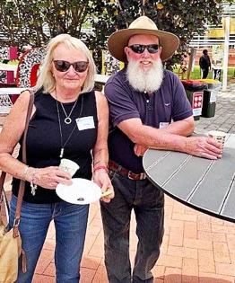 | 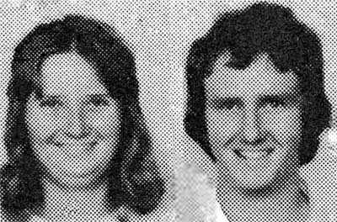
Photo: ECU – Jill and Andy | Photo: ECU – Linda and Anthony

- Andy Durant and Jill Townsend;
- Anthony Maher and Linda Peers;
- Barry Biddiscombe and Marcia Denny;
- Bill Reid and Glenys Humphrys;

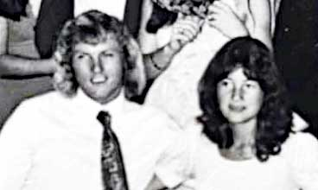
Photo: Claire Pippet - Diane and Bruce

- Bruce Blay and Diane Sweeney;
- Gary Buller and Julie Bashford;
- John Rice and Annette Bylund;
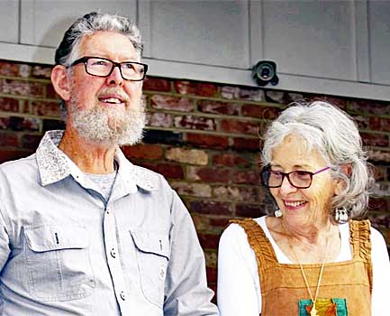
Photo: FB – Lex and Nuala

- Lex Leslie and Nuala Young;
- Kim Ward and Cheryl Hutton;


Photo: FB - Mel and Lee

- Mel Broun and Lee Hopkins;

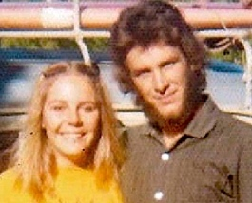
Photo: Neil Kidd – with Bobbie

- Robert (Neil) Kidd and Bobbie Smith;
- Russell Barrington and Viviane Argus;

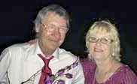
Photo: FB – Stan and Claire

- Stan Grabski and Claire Pippet;
- Terry Coumbe and Carol Povah;
- Terry Watt and Lois Whittle

Chapter 6 Camps and Excursions

Camps were perceived as an important tool in student development and a series of camps were arranged, particularly in the period from 1970-1972, when MLTC was run under the auspices of the Education Department.

1970
In 1970, there were two main camps. These were at Point Peron and Rottnest. There was also a Yanchep Beach expedition.

Pt Peron
The Point Peron camp focused on nature study, canoeing, minor games for use in P.E., social study, drama, and art.

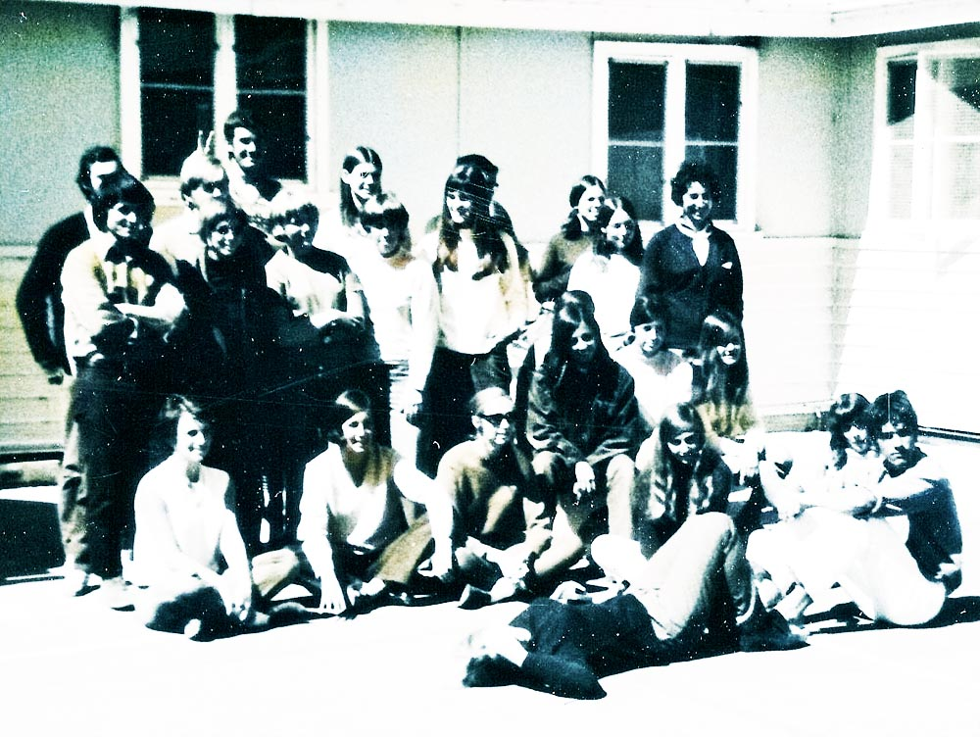
Photo: Annette Finlay

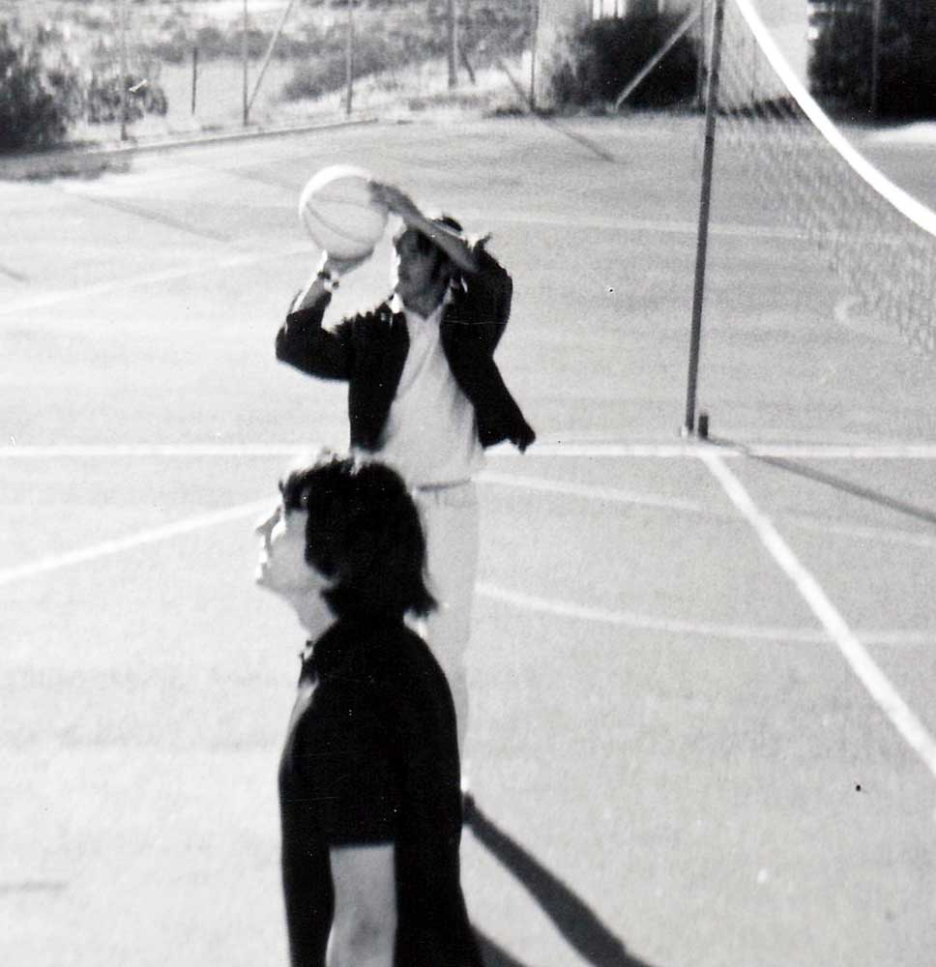 |  | 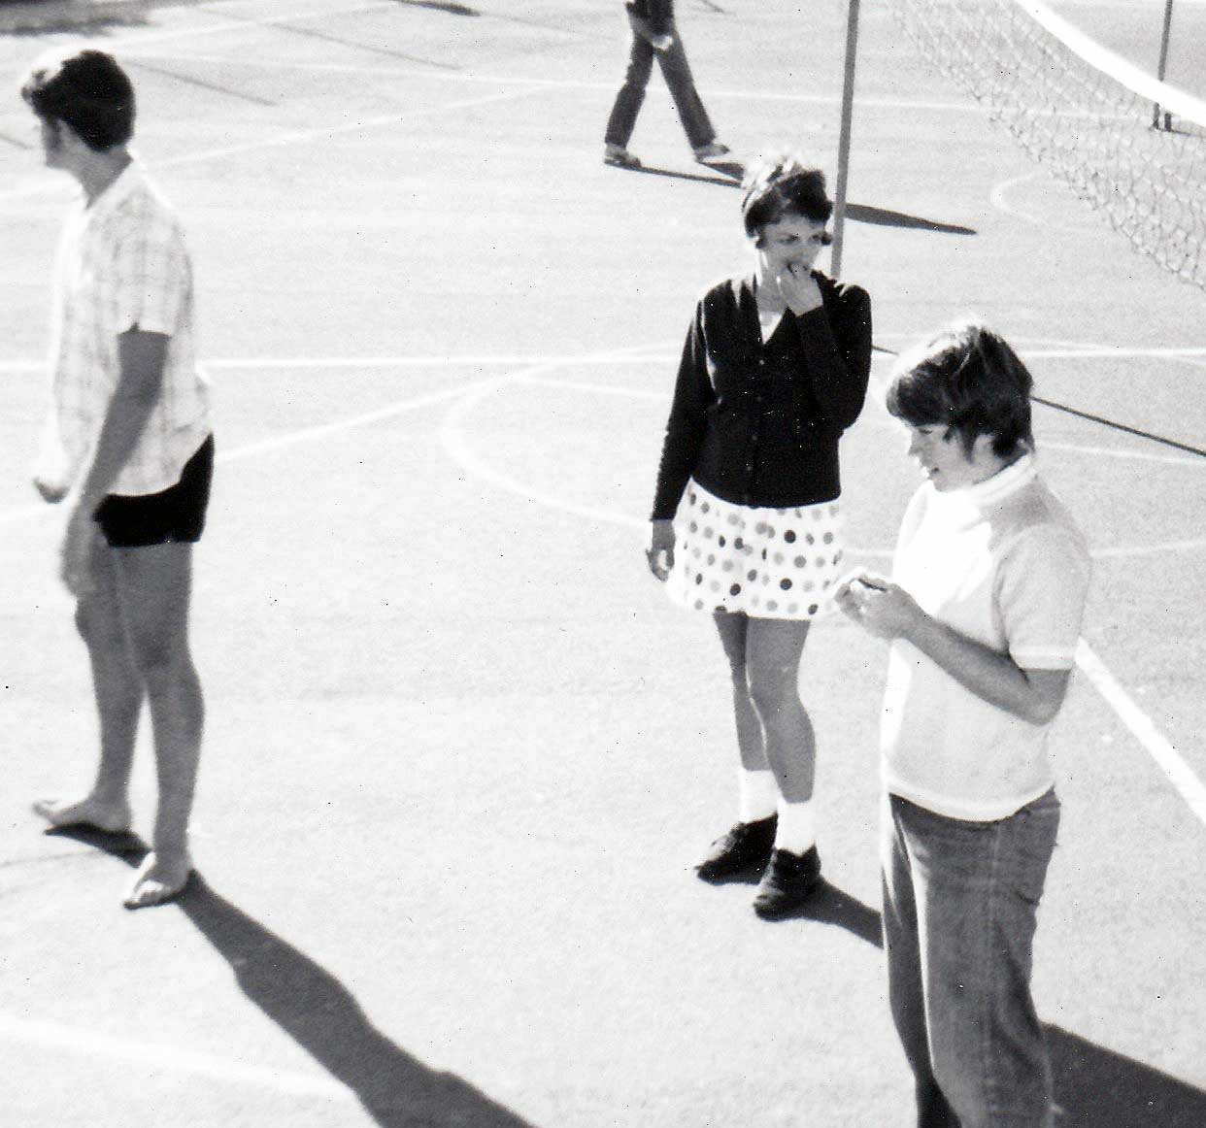
Photos: Annette Finlay – ball games
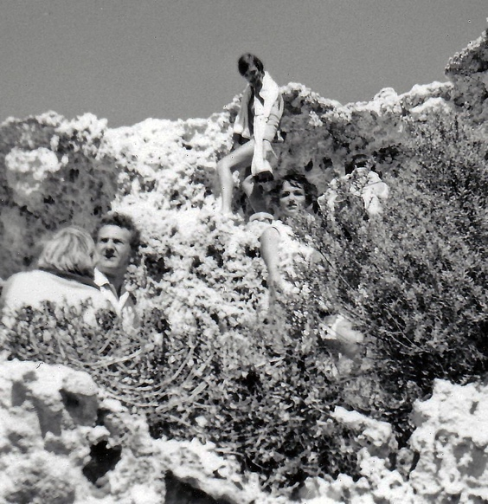 | 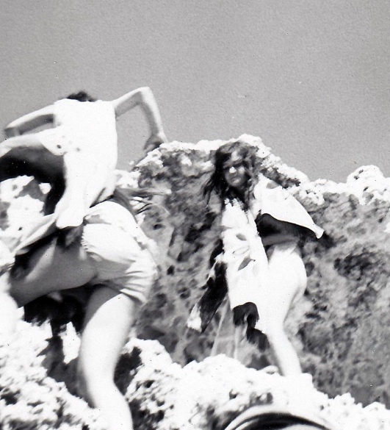
Photos: Annette Finlay – Len McKenna and rock climbing

Rottnest
The Rottnest camp was more artistically inclined and focused on creative dance and drama, publication and script writing, as well as community service, social studies, and nature study.

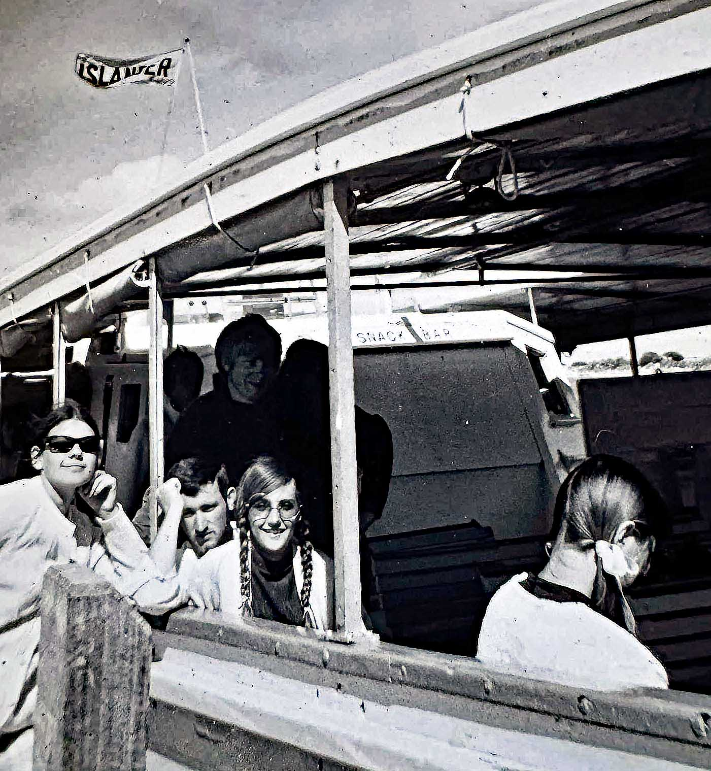
Photo: Maria Kingma - Annette Finlay, Terry McNeill,
Lynette Hill - On the way to Rottnest

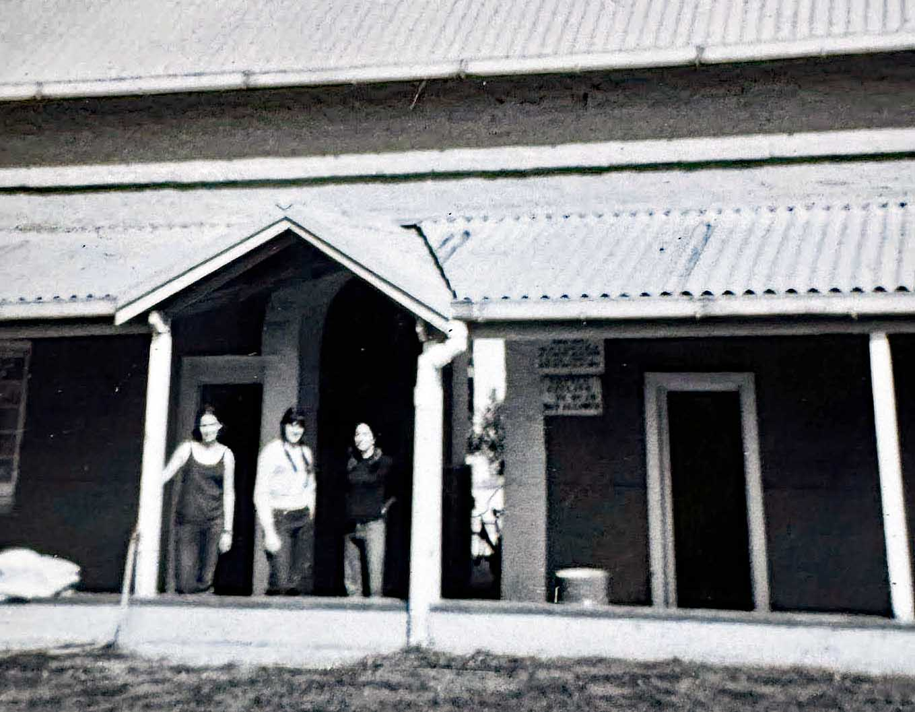
Photo: Maria Kingma – At the Kingston Barracks
Vicki Nix, Lorraine Webster and xxx

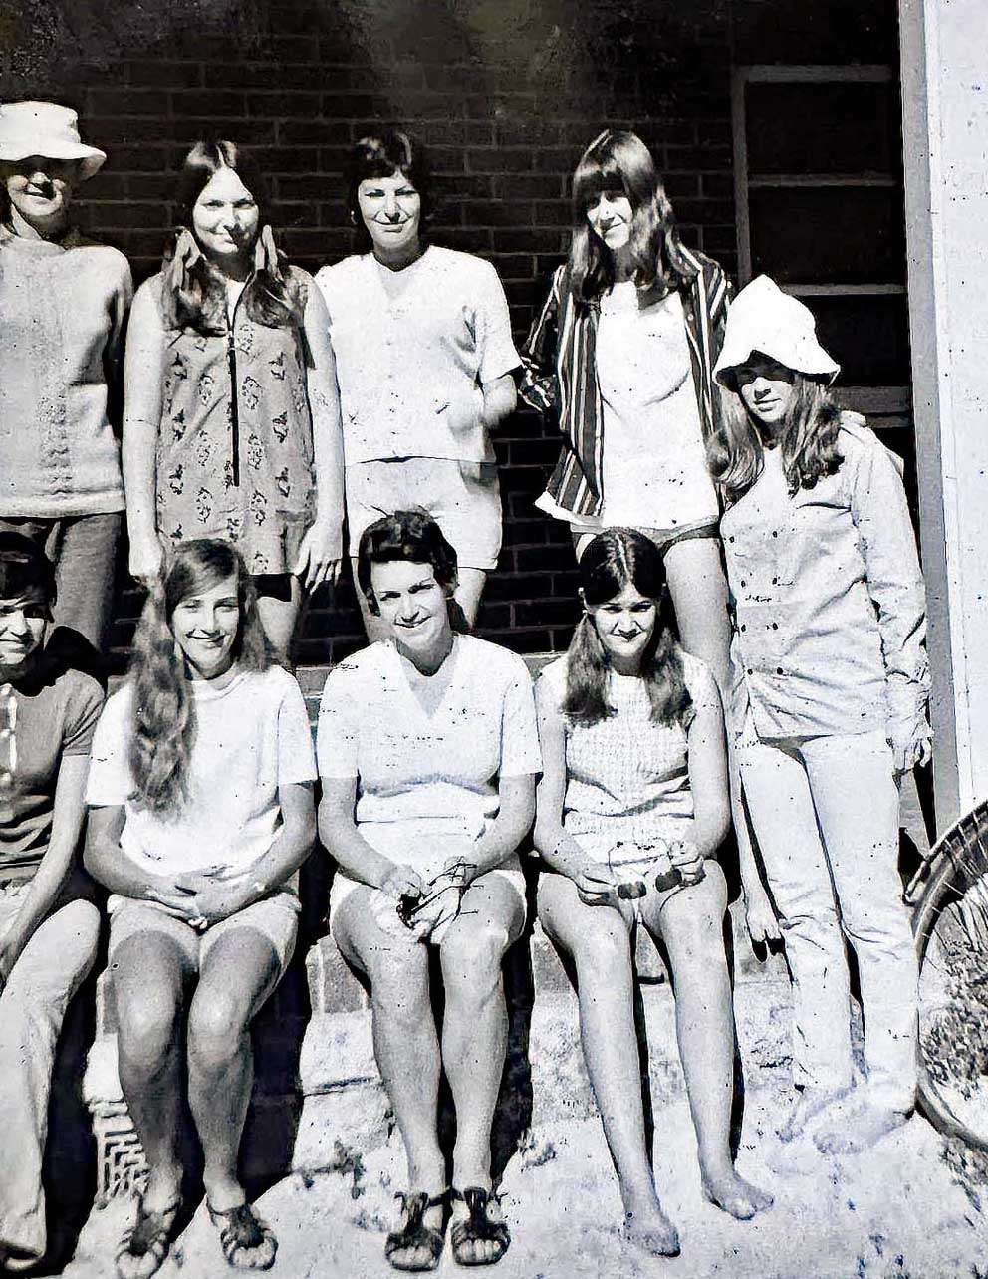
Photo: Maria Kingma –
Students at the Kingston Barracks
Back Row: xxx, xxx, Pamela Dagg, xxx
Front Row: Sabiha Masuk, Lynette Hill,
Maria Kingma, Diane Toia, Linda Wilkinson

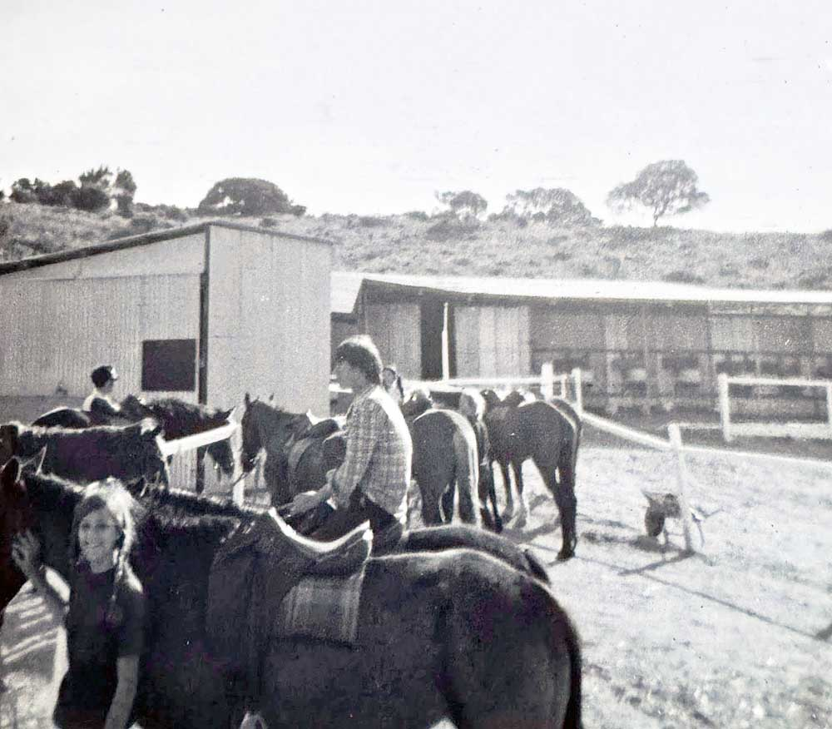
Photo: Maria Kingma – Horse riding -Lynette Hill and
possibly Stan Grabski

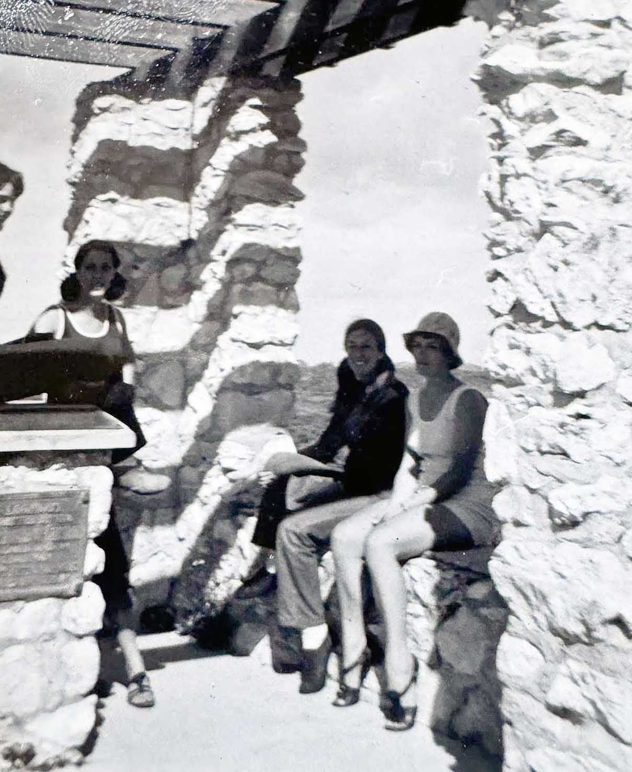
Photo: Maria Kingma – Students at Vlamingh lookout

Yanchep Beach was a picnic day, which was dedicated to aquatic sports.

1971
Pt Peron Camp

In 1971, for the first semester camp, three M.T.T. buses were hired to transport all students, plus their luggage and sporting equipment to Point Peron.
Clive Choate shares his memories of the Point Peron camp:
“Primary school camps engender lifelong memories. School camps and their organisation were highlighted during MLTC training, with pre-camp planning strategies and the implementation of these with our own cohort. In my cohort intake year of 1971, Brian Churchward and Robyn Arnott from the Physical Education Faculty were the leaders of our Point Peron Camp School, which highlighted the facilities available for a multi-discipline Camp School. Staff from all faculties contributed to camp activities.
Our other camp, on Rottnest Island, saw a different approach which promoted community service, the use of dormitory accommodation at Kingston Barracks, the logistics of supervision on the Island, while balancing recreation and formal learning activities. Bruce Sinclair and Sandra Mohlmann led this approach”.
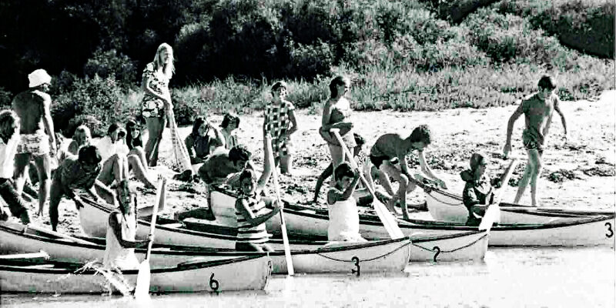
Photo: Clive Choate - Canadian canoe activity off the back beach. (l-r) Kingsley Iddon, Brian Jenkins (white hat), Marilyn Peirce, Roger Baggaley pushing boat 2 with Anne Hetherington in the bow, Roslyn Greatrex, Kathy Abe, Joanna Nieuwkirk, Denise Brown (standing with towel), Ruth Perdie, Peter Ter Steeg, Pat Casey, Sue Hasleby (bow of boat 3), Geoff Jones (pushing end boat), Ruth Shean (2nd from right), Davyn Howard (right).

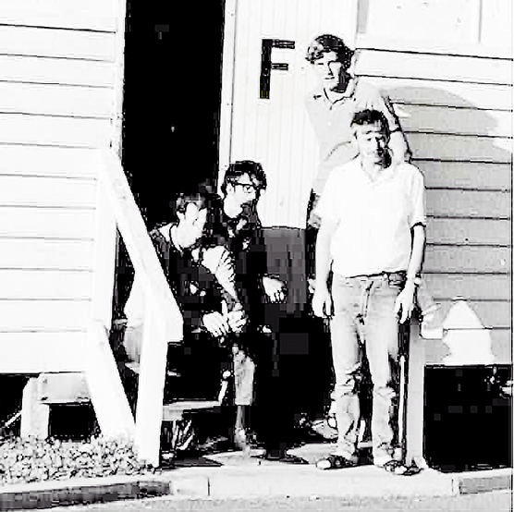
Photo: Clive Choate - F Dorm: (l-r) Chris Elliot (became Mayor of Rockingham), Rodger Baggaley, Clive Choate (Antarctic and 7 continents marathon runner), George Svich

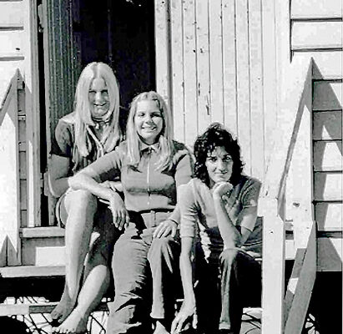
Photo: Clive Choate - (front) B Dorm: (l-r) Denise Brown, Bobbie Smith, Grace Piccardi (champion 100m runner)

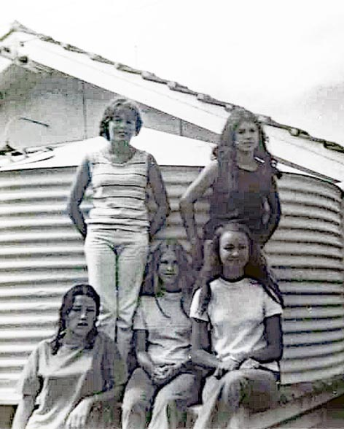

Photo: Trish Harant – at the rain tank
Back row: Robyn Clutterbuck, Coralie Bufton
Front Row: Charlene Cowcher, Claire Pippet, Sue Caporn

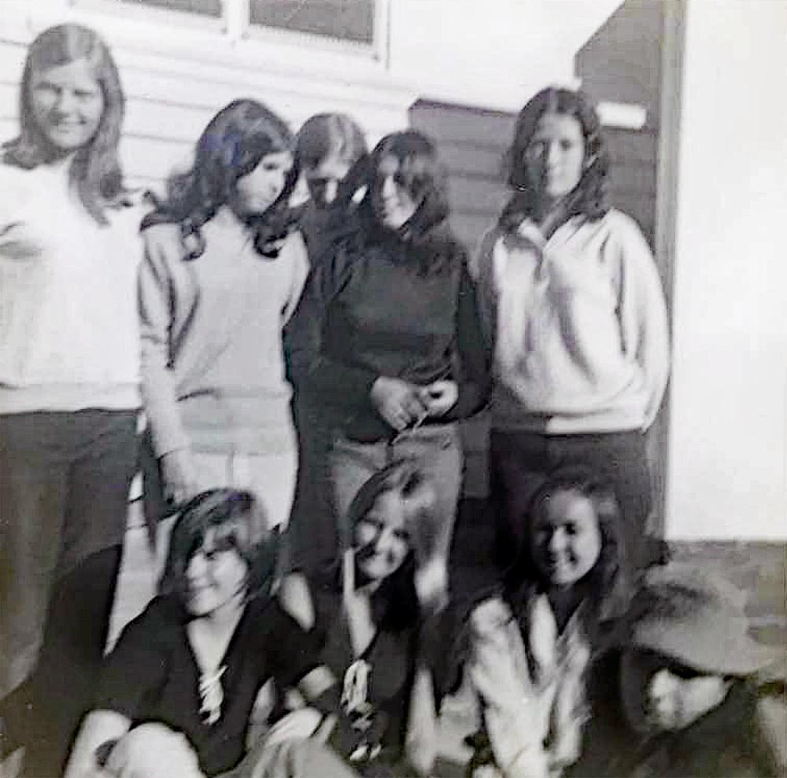
Photo: Trish Harant – dorm mates
Back row: Margaret Harris, Coralie Bufton, Sue Sommers, Angela Kerr, Charlene Cowcher Front Row: Robyn Clutterbuck, Lois Whittle, Sue Caporn, Marie Atrache

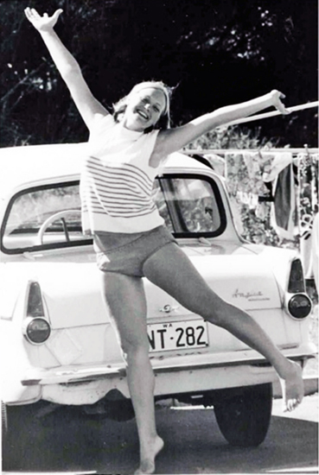
Photo: Clive Choate - Exuberant Roslyn Greatrex

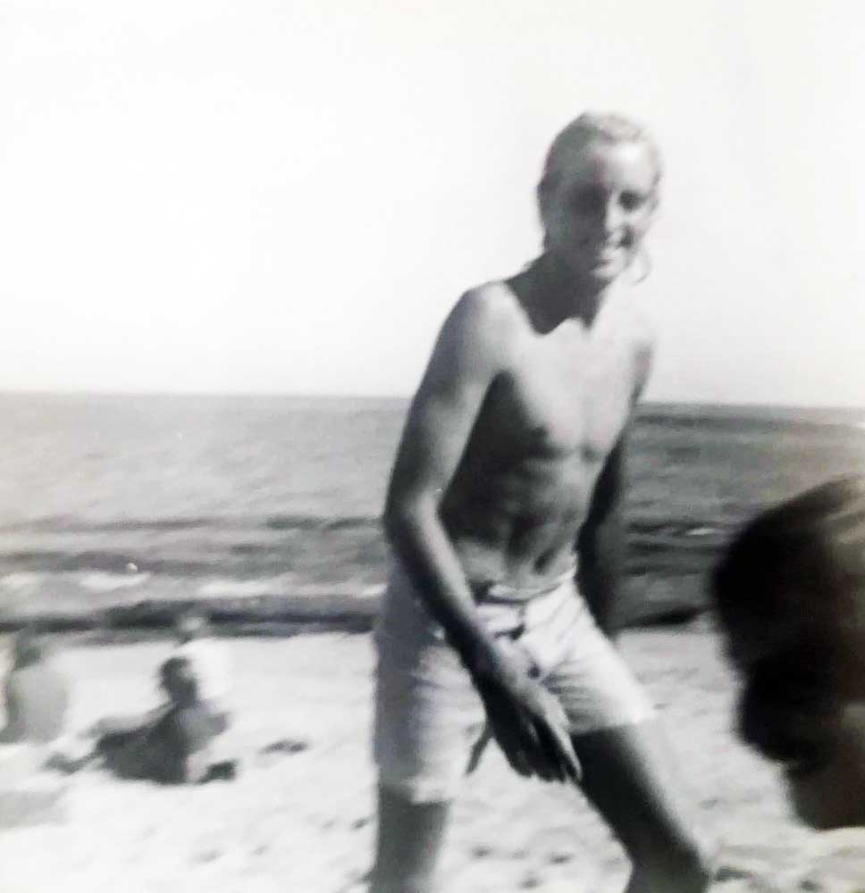
Photo: Trish Harant – Kingsley Iddon

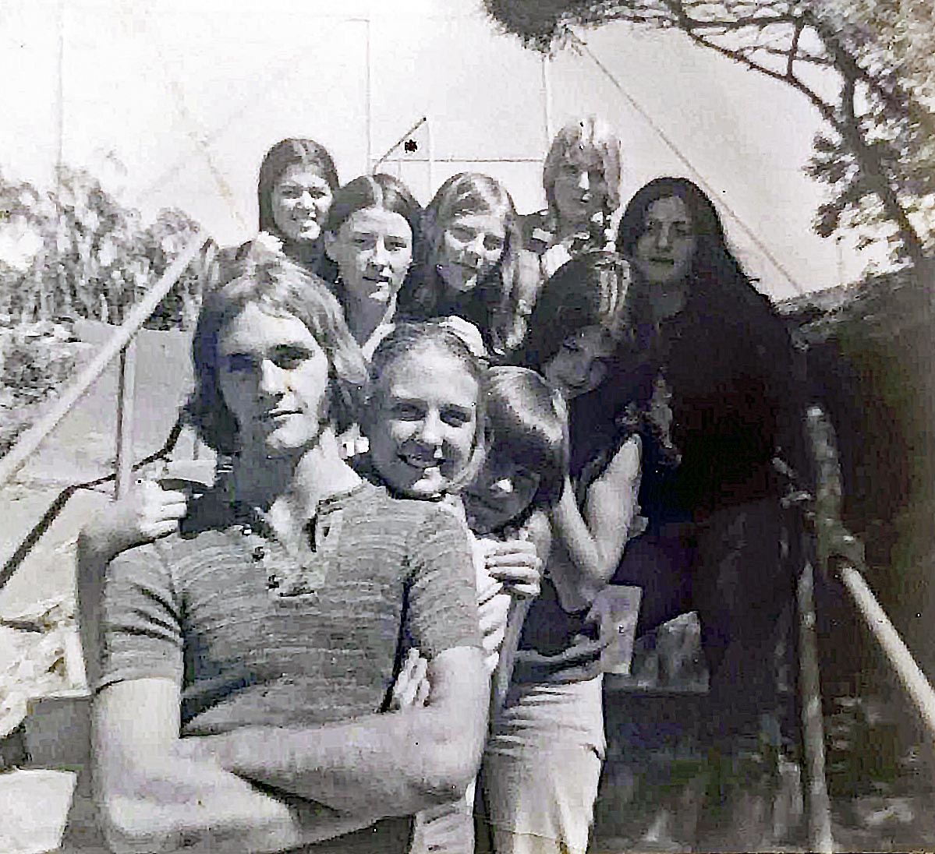
Photo: Trish Harant
Back row: Angela Kerr, Charlene Cowcher, Margaret Harris,
Brenda Marwick, Marie Atrache Front row: Peter Douglas,
Kerry McCarthy, Robyn Clutterbuck, Coralie Bufton

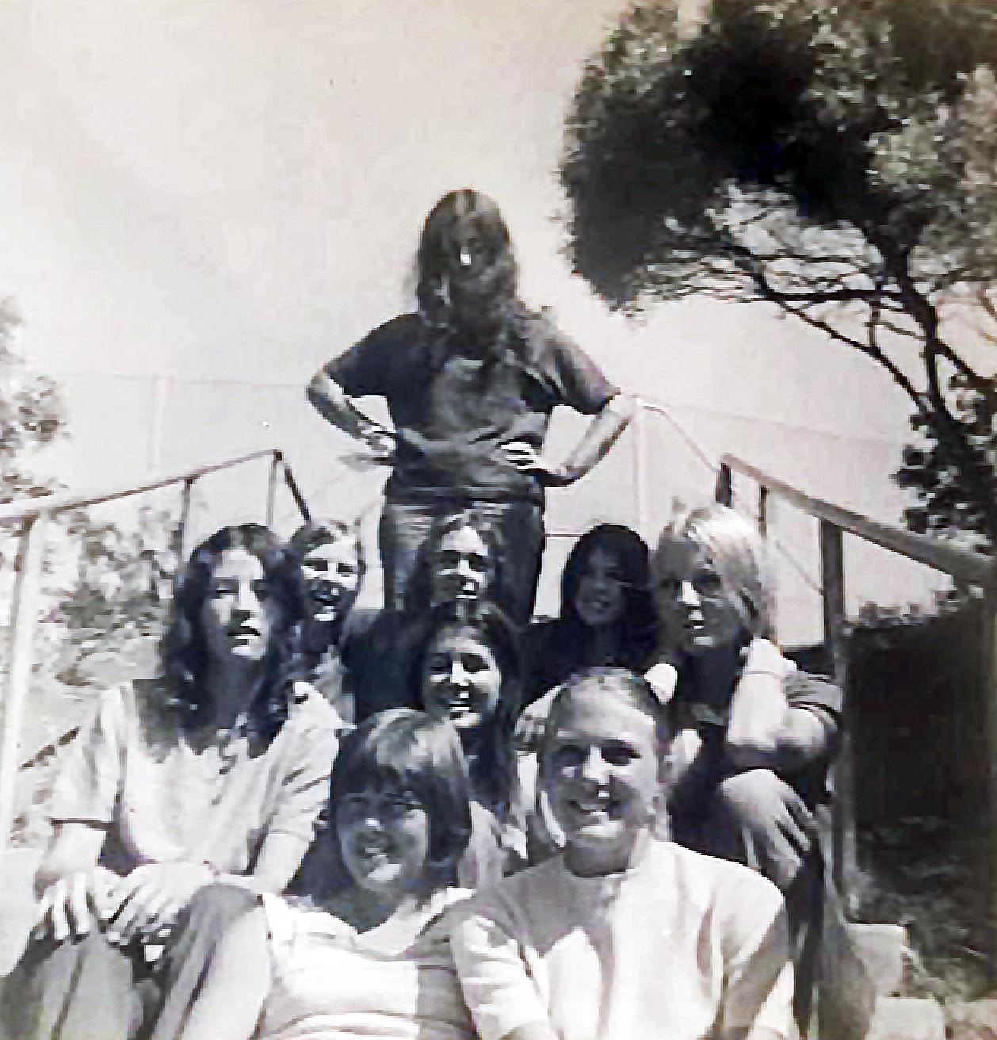
Photo: Trish Harant

Back row: Marie Atrache 3rd row: Margaret Harris, Peter Douglas, Coralie Bufton 2nd row Charlene Cowcher, Angela Kerr, Brenda Marwick
Front row: Robyn Clutterbuck, Kerry McCarthy

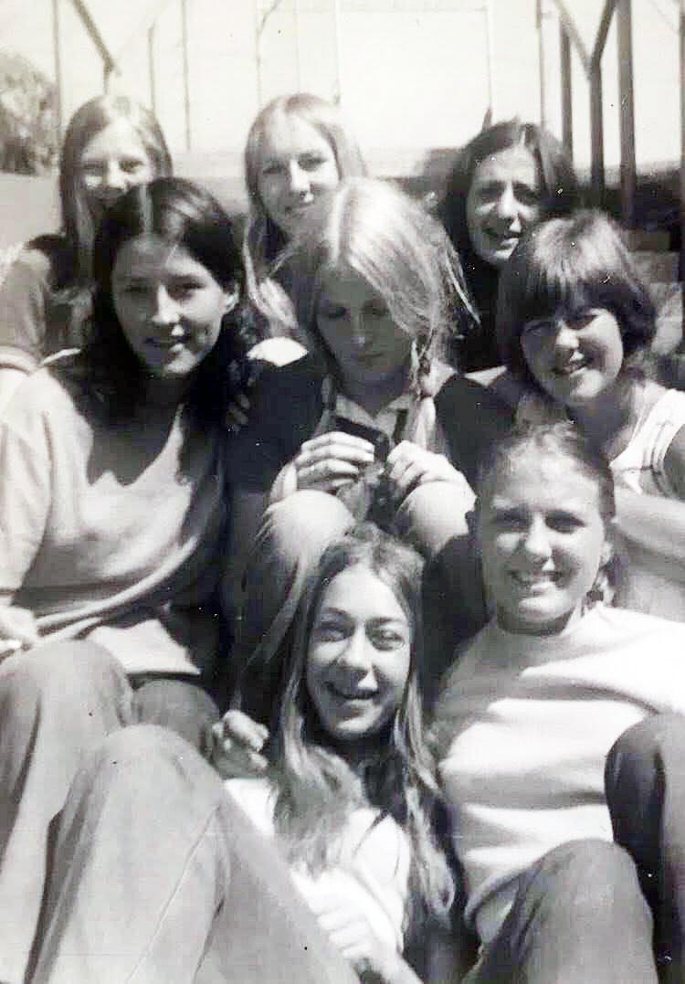
Photo: Trish Harant – Pt Peron crew from original class 1J
Back row: Margaret Harris, Trish Harant, Marie Atrache
Middle row: Charlene Cowcher, Brenda Marwick, Robyn Clutterbuck
Front row: Sandy King, Kerry McCarthy

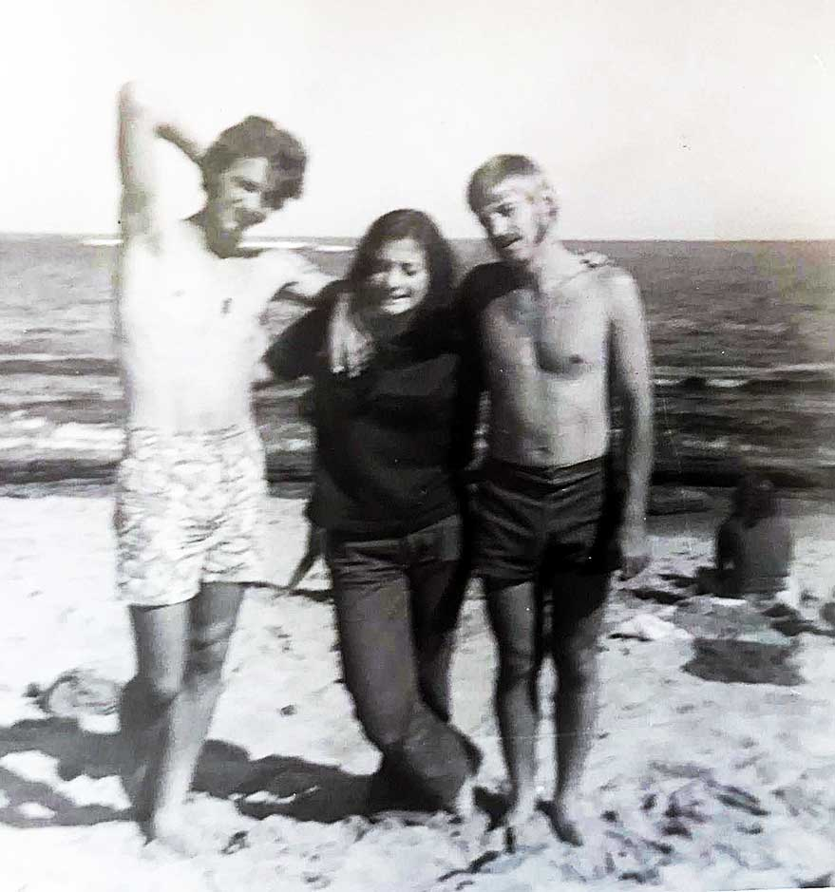
Photo: Trish Harant – Robert Kidd, Marie Atrache, and George Svich
Clive Choate:
“Trainees had to find their own way to Point Peron which I did when I car pooled with Ruth Perdie. After breaking down on the way to the Rockingham Camp, we arrived to join the group being briefed in the Recreation Hall which doubled as the dining room.
After the lunch-break we were thrown into activities which included Canadian canoeing on the ocean boundary, and problem-solving physical activities on the school oval which involved planks, buckets, building a vehicle and transporting it over a gate and other challenges.
Afternoon tea break promoted regrouping and reassignment of tasks where other faculty staff took us to the leeward side of the point to explore science of the ocean, gun tunnels and lookouts, vegetation and animals in the coastal environment, as well as swimming rescues”.

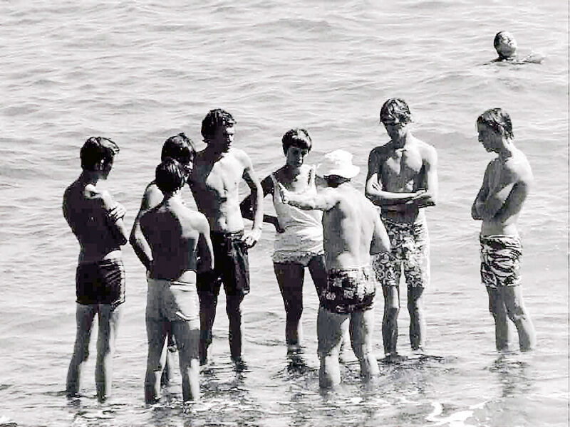
Photo: Clive Choate - Bruce Sinclair (white hat) conducts a lifesaving activity on the back beach. Anne Hetherington is the only female in the group

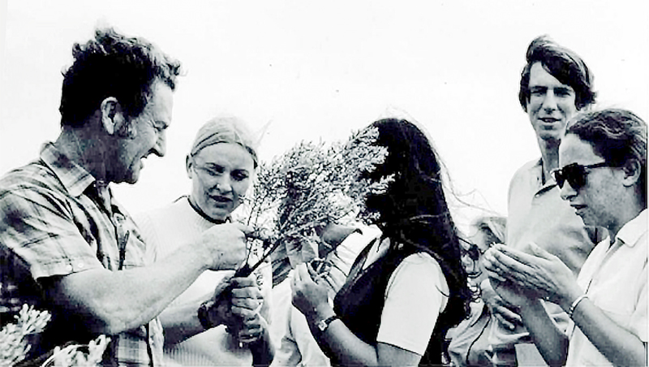
Photo: Clive Choate - Len McKenna (left) telling highly motivated trainees about beach Rosemary — Westringia Zena – Kathy Abe to right with Chris Elliot

Science legend Len McKenna, while not constrained by his philosophy of the timetable or being on time, entertained with his wealth of knowledge to make science fun.
Student Ruth Shean has never forgotten his talks on beach vegetation in this environment. “His talk at that camp has inspired me forever. Talking about the silk of spiders’ webs, and the gall wasp too.
Len showed us their swollen sections of tree branches, but the beach rosemary was an absolute winner for me, because already it was a smell I knew well. I love Westringias!
Camp organisation and how to run camps successfully provided quite a conduit as we enjoyed the company of our peers at Point Peron Camp School”.
Rottnest Camp
The second semester camp was on Rottnest, and students travelled on the “Rottnest Islander” for the discounted sum of $2.50 each, while staff received complementary tickets. All luggage and stores were included in the tickets.
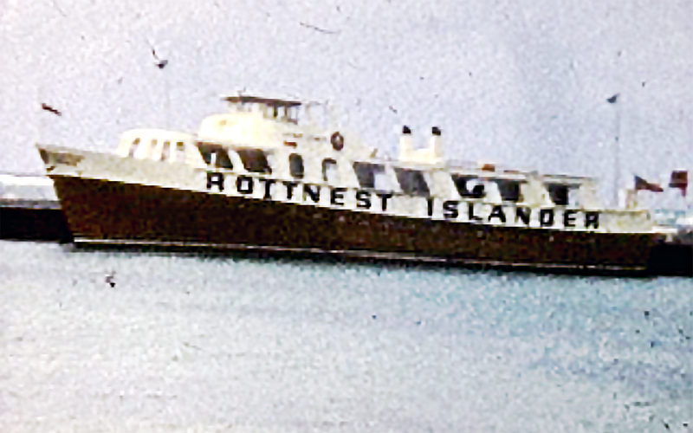
Photo: Clive Choate -The “Rottnest Islander”

Bruce Sinclair and Sandra Mohlmann, from the Physical Education Faculty, led this residential camp at the old Army barracks. Logistics were studied on campus and put into practice as we boarded the “Rottnest Islander” at Barrack Street Jetty in Perth.

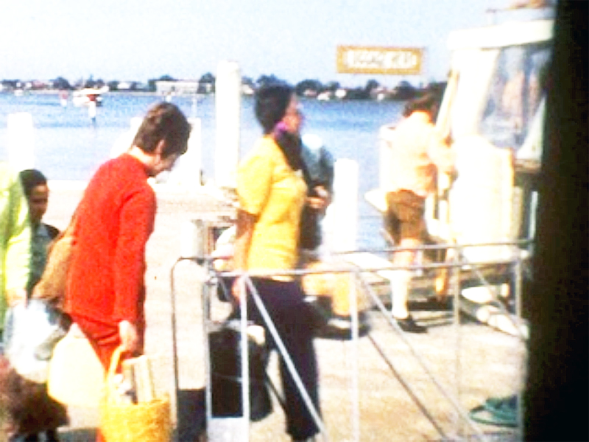
Photo: Clive Choate - Staff Barb Wadley and Sandra Mohlmann board in Perth

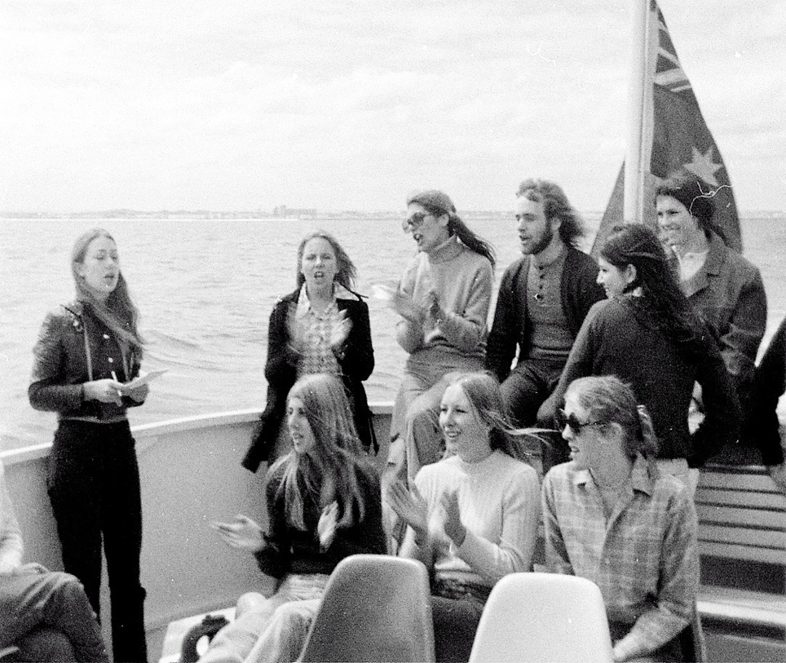
Photo: Neil Kidd – Singing on the way to Rottnest
While singing on the way to and from camps was normal this boat trip was something slightly different. Bobbie Kidd: “we’re all singing our sox off and thoroughly enjoying ourselves”! Margaret Harris: “we had to be outside singing as the swell was huge!! It kept us from feeling very sick”!!
The Rottnest Island camp involved service work such as maintenance tasks including rethatching of shade house in the Basin and Thomson Bay; the painting of tables, seats and railings in the settlement area; collection of broken glass and other refuse from the foreshore; and sorting/stacking building materials.

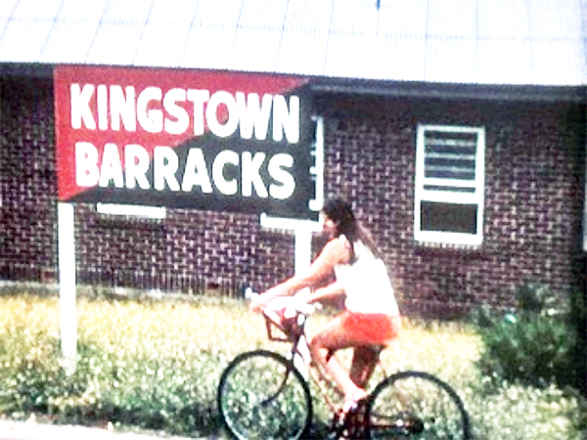
Photo: Clive Choate - Arriving at the Barracks

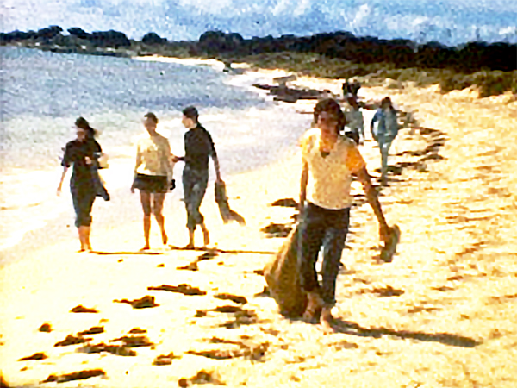
Photo: Clive Choate - Community service at the Army beach

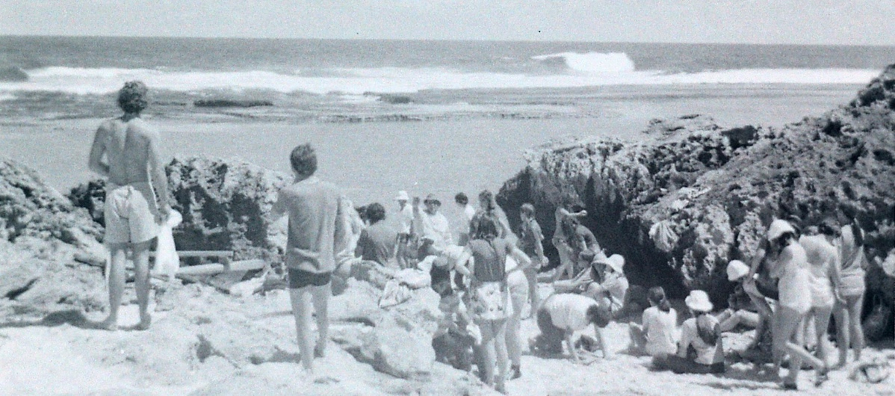
Photo: Neil Kidd – Rottnest beach
Clive Choate shares his memories of the Rottnest camp:
“Bikes procured, we cycled to Kingston Barracks where a mixture of tasks included community service of cleaning beaches, pulling weeds, dormitory organisation, feeding logistics which included a kitchen roster, and then excursions in science, cycle orienteering, map reading, and plenty of history which included: aboriginal hardship, pilot ships for the tall ships, museum activity, and good recreation activities on the island and at Kingston Barracks”.
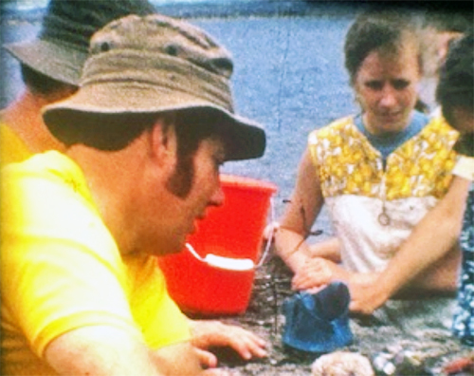
Photo: Clive Choate - Colin Marsh

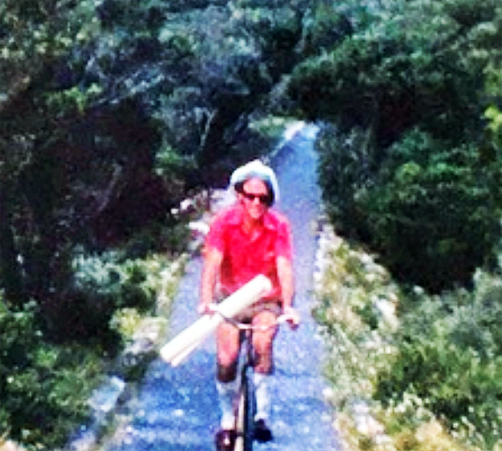
Photo: Clive Choate - Brian Jenkin
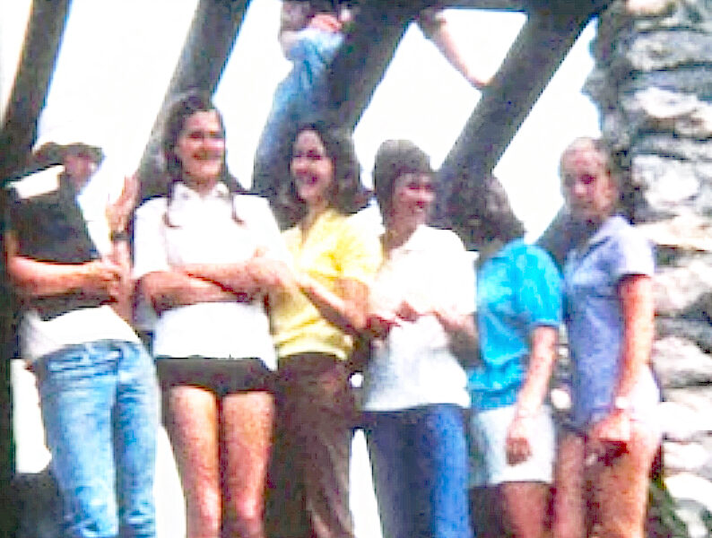
Photo: Clive Choate - Students at Vlamingh lookout

Clive Choate:
“Brian Jenkins took us up to Vlamingh Memorial Lookout for tabletop coordinates and mapping, while Robyn Arnott and Barbara Wadley coordinated cycle group challenges.
One camp at Rottnest taught the whole group a lesson in supervision and an emergency search and first aid, when one of our cohort went missing after the evening meal. Bruce Sinclair and his team set up a search for our student who was medically compromised, but the outcome was successful. It was a real-life situation in handling an emergency which demanded good planning and cool heads. A teaching lesson well learnt”.
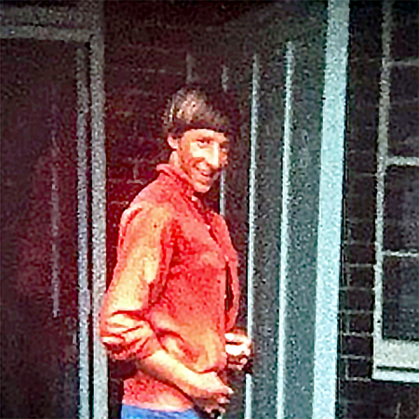
Photo: Clive Choate - Wayne Clarke, future cricket star

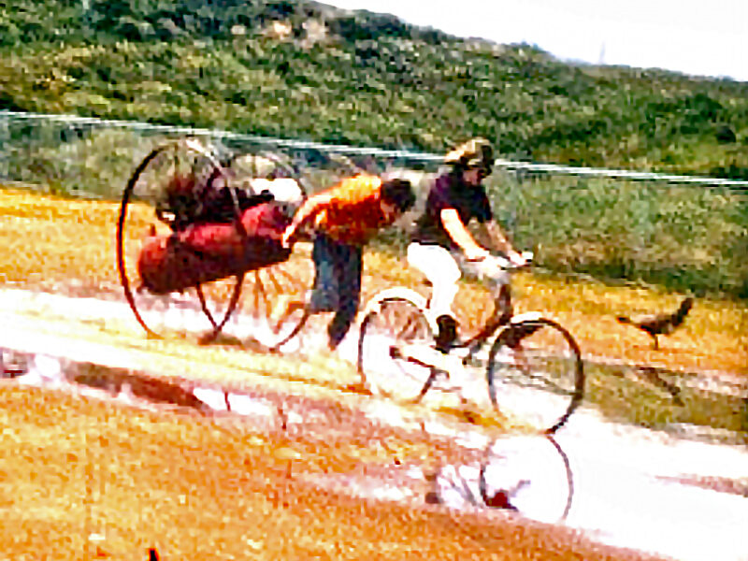
Photo: Clive Choate - Clive Choate and fire trolley racing Pat Casey

Clive Choate:
“Recreation activities were always popular and taught us the value of staff enthusiasm and participation with the students. Under the Kingston Barracks clock tower and in the Parade Ground, we enjoyed softball, touch rugby, cycling, exploring gun emplacements overlooking the coast, and racing the old fashion fire units”.

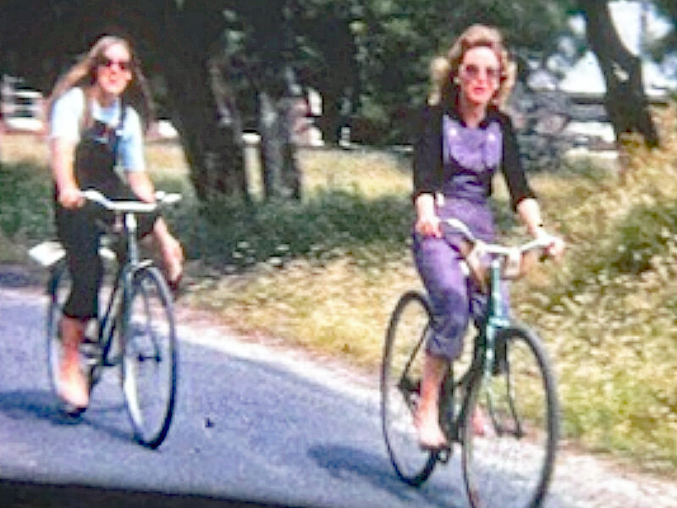
Photo: Clive Choate - Cycle Orienteering

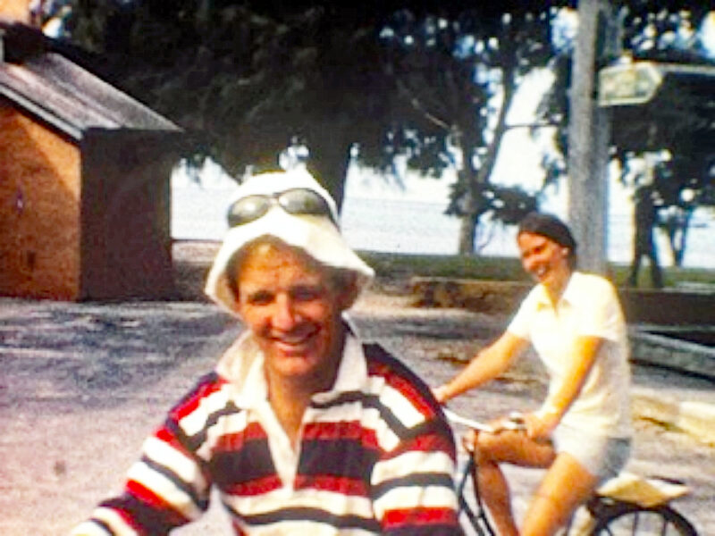
Photo: Clive Choate - Bruce Sinclair and Robyn Arnott

Clive Choate:
“Camps and what they offered trainee teachers as a tool for the future instruction and staff-student relationships were seen as very important. Our Mount Lawley College staff presented these experiences well. Camps were educational and enjoyable”.

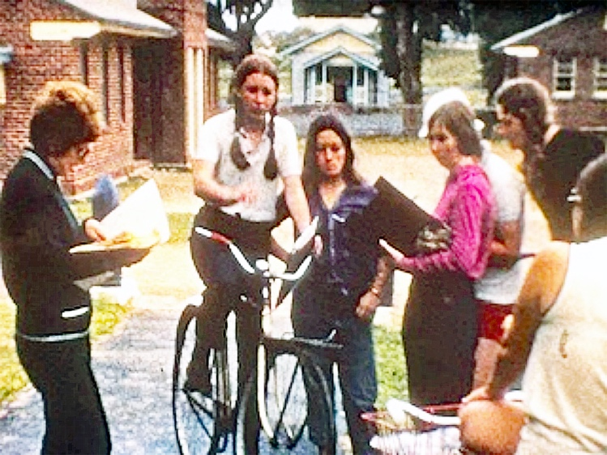
Photo: Clive Choate - Barbara Wadley with students

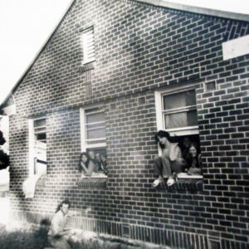
Photo: Neil Kidd - Peter, Coralie, Marie, Bobbie and Margaret at Rottnest Camp

Some other pictures of the Rottnest camps provided by Robert Neil Kidd, Terry Watt, are featured below.
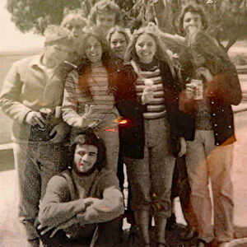
Photo: Neil Kidd - Back: Kingsley Iddon, Peter Ter Steeg, Robert Neil Kidd Centre; George Svich, Sue Ware, Sandy King, Bobbie Smith, Kerry?
Front: Leo Kenny

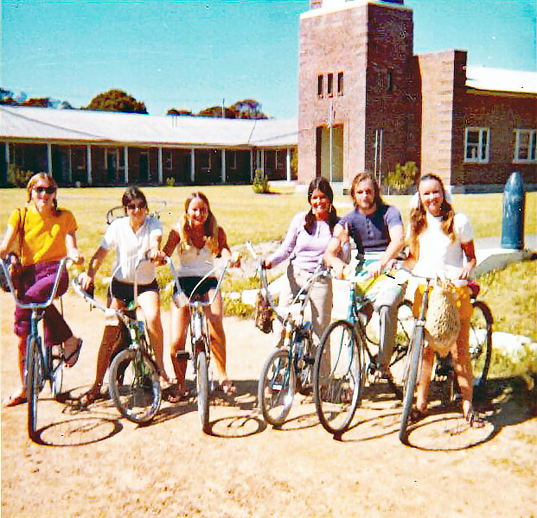
Photo: Terry Watt - Bike riding: Sue Sommers, Coralie Bufton,
Lois Whittle, Angela Kerr, Peter Douglas, Sue Caporn

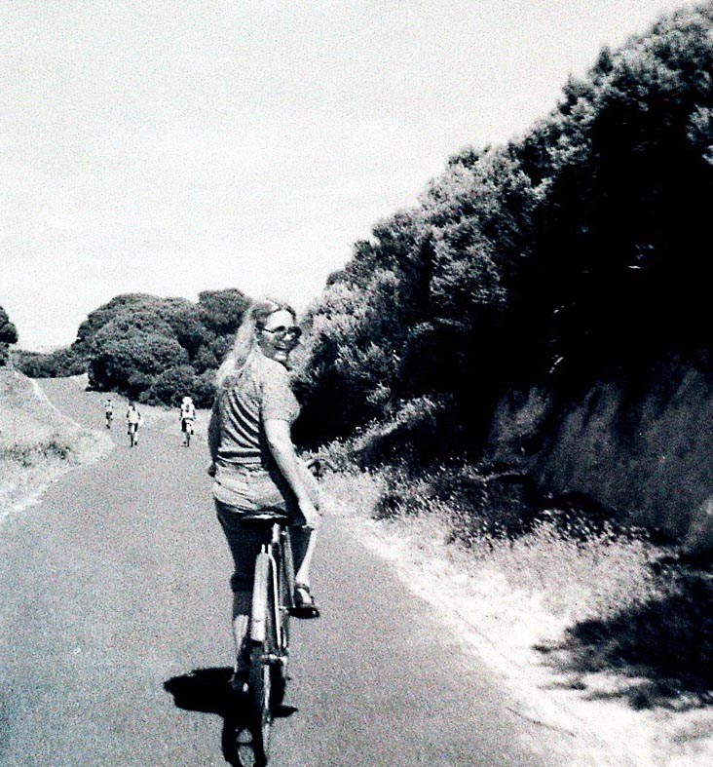
Photo: Neil Kidd – Bobbie on her bike

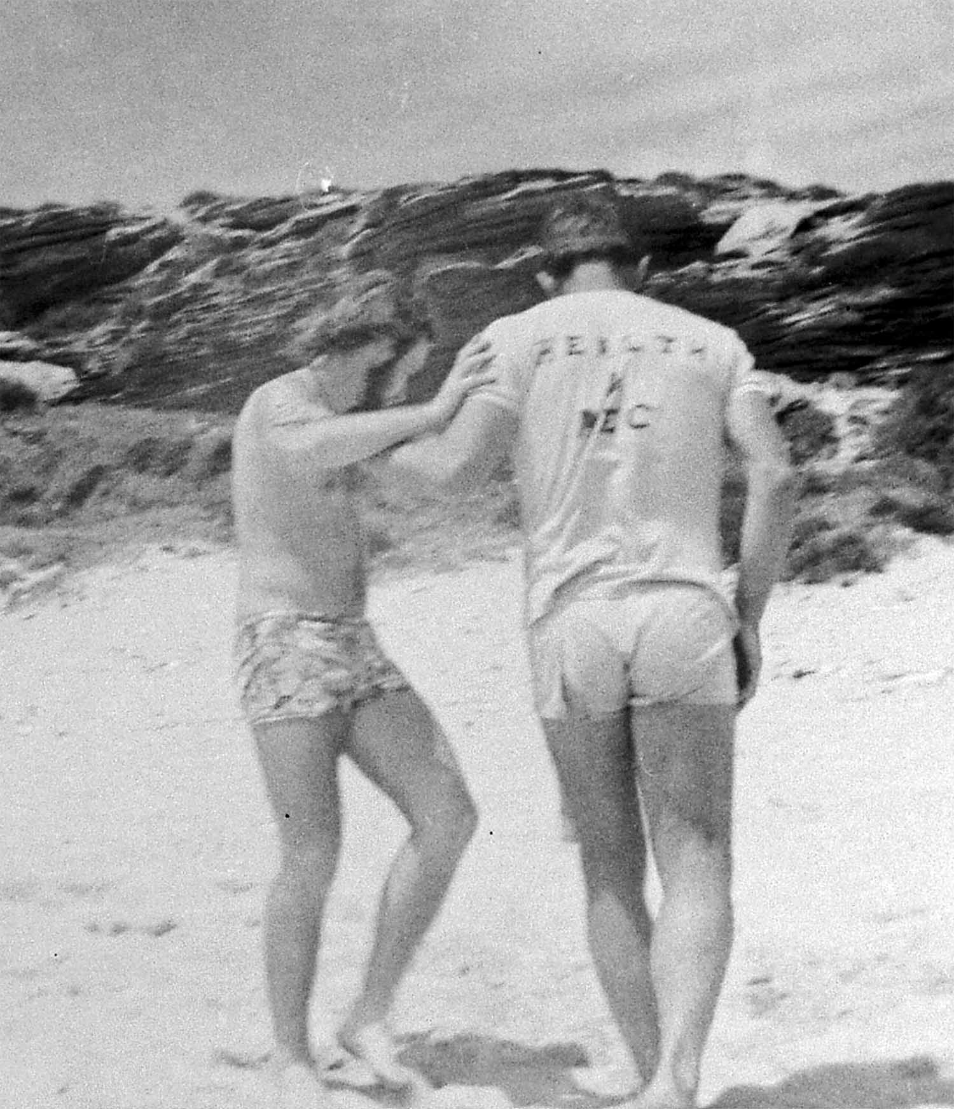 | 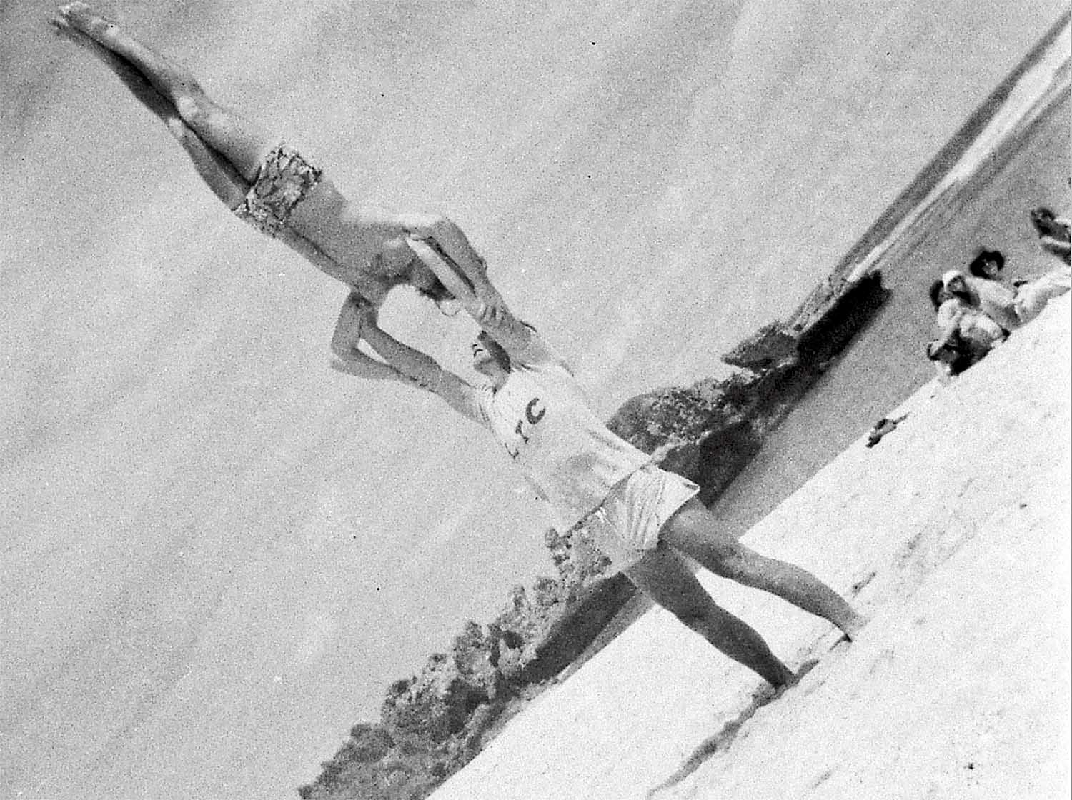
Photo: Neil Kidd – Beach acrobatics featuring Peter Douglas and Brian Churchward

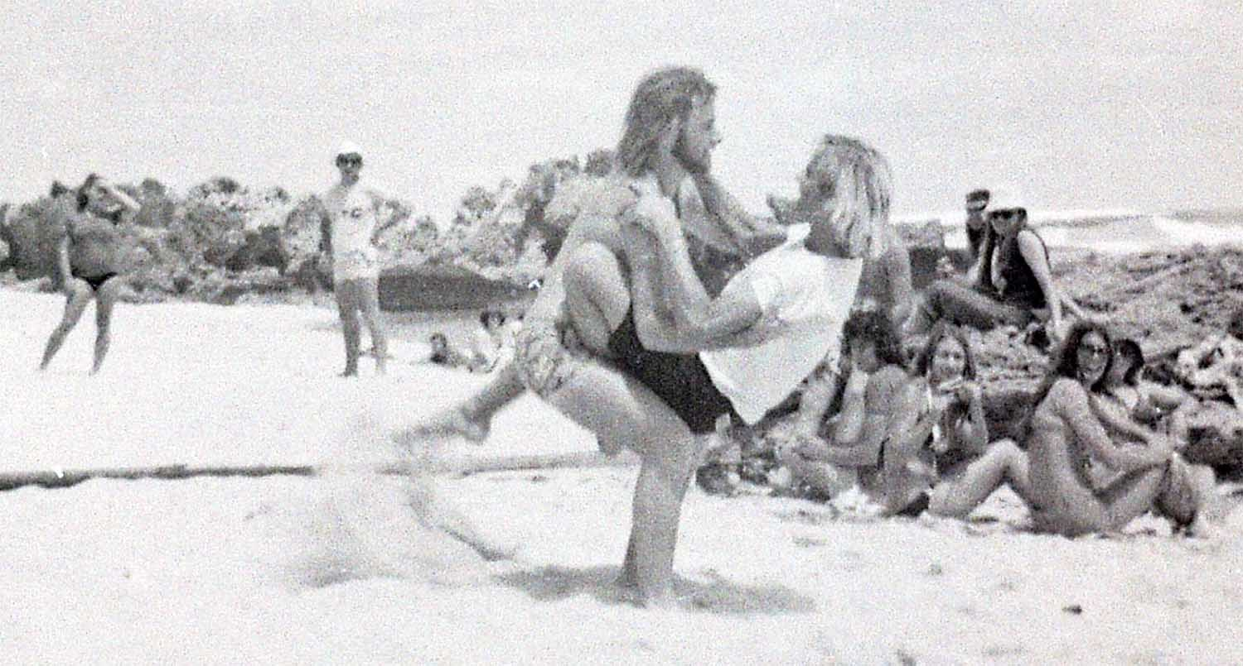
Photo: Neil Kidd – Beach frolics with Peter Douglas and Kingsley Iddon

The Maths and Science Department was responsible for four “option” camps: natural science at Pt Peron in May, a geology excursion to the Mingenew/Geraldton area in September and a maths option week to visit various installations in the metropolitan area. A further natural science camp was held at Margaret River during the penultimate week.

The natural science camp at Pt Peron involved Len McKenna plus 18 students. Although based at Pt Peron, private cars were used to explore many areas. Considerable work was done on the groyne at Naval Base, where a large number of specimens were collected and preserved for the college museum.

A day visit to Serpentine was conducted. The morning was spent studying the animal communities living under rocks and collecting scorpions for a research project of the W.A. Museum.

In the afternoon Cliff Brindley, who taught at H.M. Fremantle Prison, conducted a survey of the flora in the area. Many of the techniques taught would not have been possible during normal college option periods.

The geology camp involved Len McKenna, Tony Knight, Jeanette Connolly, Addie Hayes and Alan Jones, plus 30 students. Considerable fund raising was required for this trip, as well as each student was required to pay $7.00. A bus was hired from the Swanleigh Boy Scout Troop at a cost of nearly $200.00.

The third semester camp was accessed via car-pooling, as was the fourth semester camp at Bickley. The mobile camp to Geraldton was conducted per hired bus from the Swanleigh Boy Scouts and driven by Alan Jones.
There were also shorter weekend camps arranged by car-pooling.
Alan Jones, from the Prac Department was the volunteer bus driver and Tony Knight drove a private car. In the Mingenew area accommodation was provided at Coal Seam Homestead by the owner. For the rest of the trip “two-man” tents were hired from the P.E. Section of the Education Department.

The benefits were of immense thanks to the great wealth of stratigraphic, geomorphological and palaeontological examples afforded by the Mingenew/Geraldton district, plus the great diversity of mineralogical and petrographical features visited in the journey to and from the area.

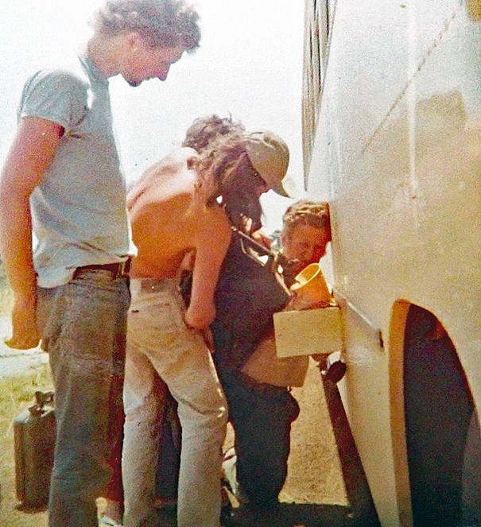
Photo: Neil Kidd - Len and students with a Jerry Can and funnel on the way to Geology camp

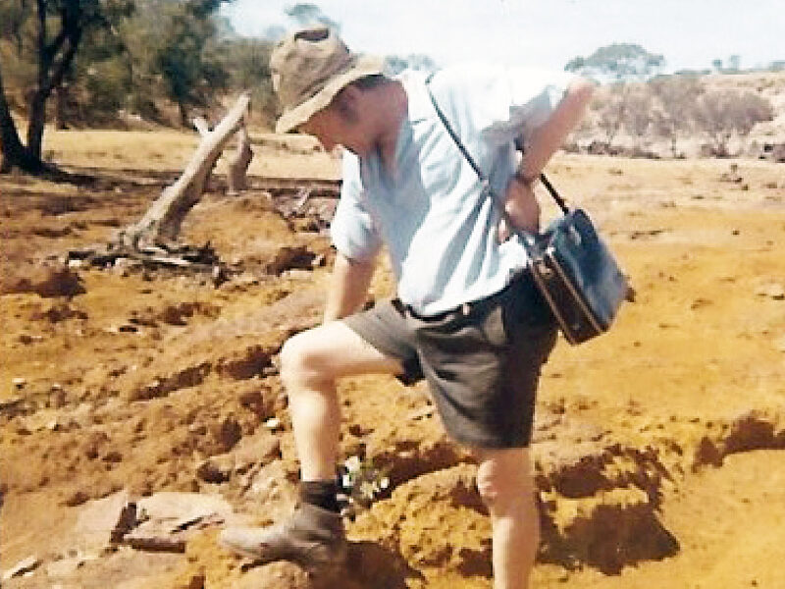
Photo: Neil Kidd - Len on a geology camp

The final natural science camp was held in the third term and staff consisted of Len McKenna, Tony Knight, Dick Lamb, Addie Hayes, plus 12 students.

During the penultimate week, a two-day camp was conducted in the Margaret River area. “Two-man” tents were hired from the P.E. Section of the Education Department. The purpose of this camp was to survey a small reef, as an example of the type of study, that could be undertaken for their third-year dissertation. After this camp, it was suggested that the purchase of a bus would assist greatly, as would purchases of cooking gear and “two-man” tents.

The maths option was run by Dick Lamb and guest lecturers.

Topics included: computers, share market analysis, seismic survey and simple navigation.

Students visited several installations in the metropolitan area. Practical sessions included an actual seismic survey to map the rock strata below Perry Lakes. On the final day a navigation exercise was conducted from a launch, travelling along the Swan River.

As in 1970, Yanchep Beach was a picnic day, which was dedicated to aquatic sports.

1972
In 1972, MLTC finally had a full intake, with students in 1st, 2nd, and 3rd year. According to MLTC records the first years had several camps consecutively run at Point Peron, Palm Beach and East Rockingham and a subsequent one later in Rottnest.

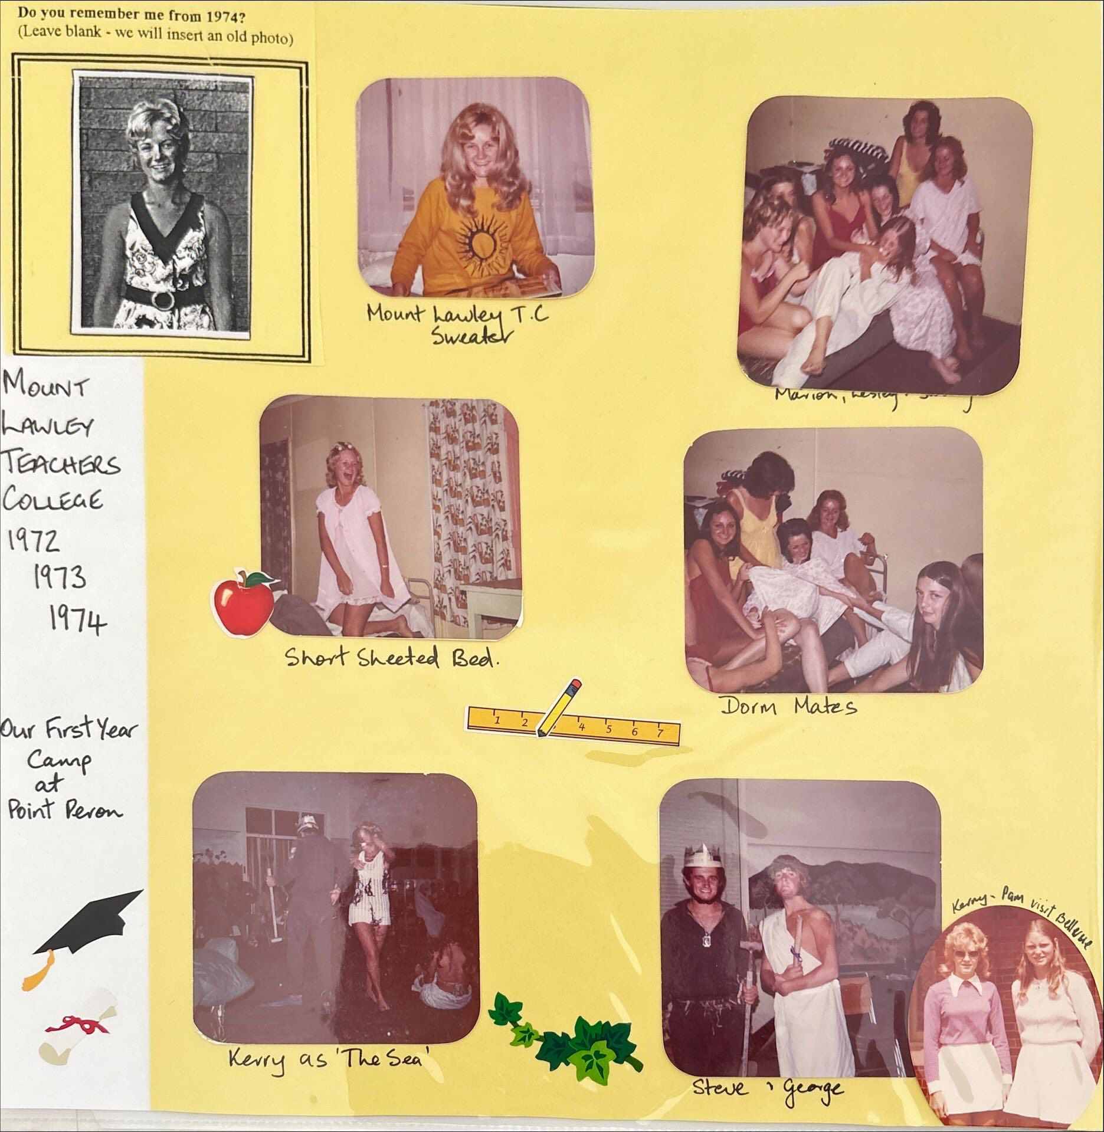
Photo: Kerry Paddon – 1972 intake first camp at Pt Peron

The second years had two campsites at Koombana Caravan Park chalets, and the Swan Brewery Holiday campsite in Point Peron. These involved cooking, cleaning, squash, tennis, a car trial, badminton, golf, horse riding.

By 1972, there was a single camp planned for first year students, prior to Easter, with a potential second camp in Rottnest in semester two.
Final year students from the 1970 intake, also had a single Rottnest Camp.
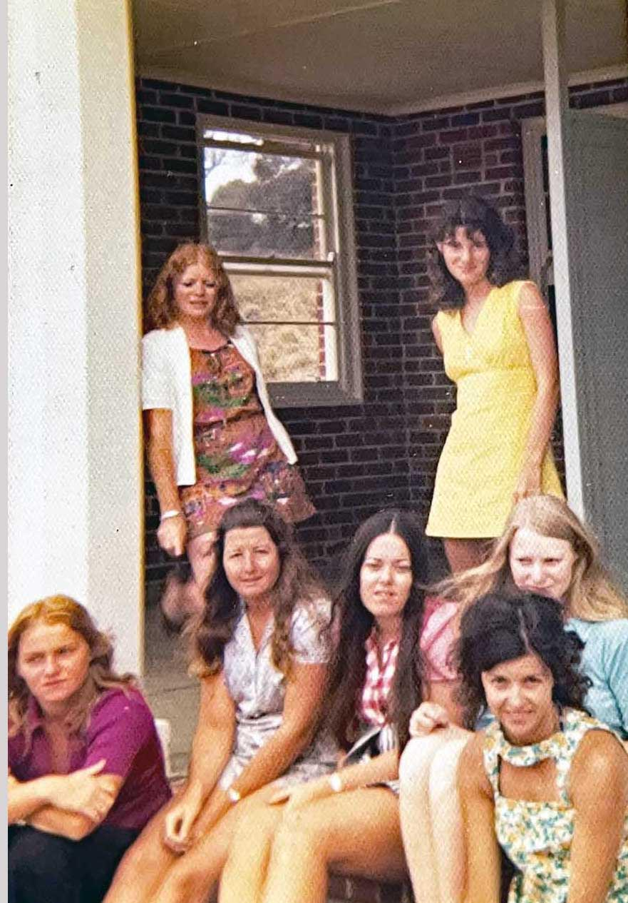
Photo: ??? Third year students enjoying the Rottnest camp.
Back row: Sue Hudson and Dianne Sweeney
Front row: ?, ?, ?, Kathy Lamb, Sabiha Masuk

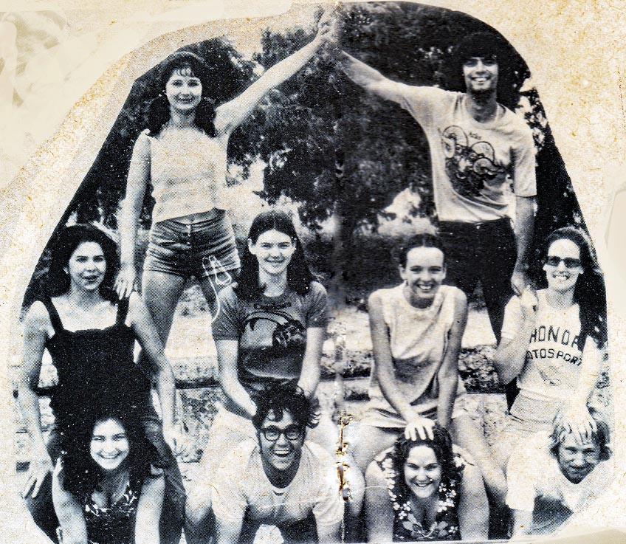
Photo MLTC provided by Annette Finlay – final camp for 3rd years
Top: Jenny Taylor, John Arena Middle: Maria Donovan, Annette Finlay,
Judi Lewis, Annette Rice Front: Nancy Turner, Ross Romeo, Michelle
Campbell, Henry Valincius

For students in their second year, there would be two “option studies” camps, such as the geology camp, with Len McKenna.
Sue Hasleby attended a geology camp in 1972: “We went to Mingenew and dug fossils and lived in a shearing shed. I was from Northampton so I was delighted to head north and meet up with my parents in Geraldton on our last night”.
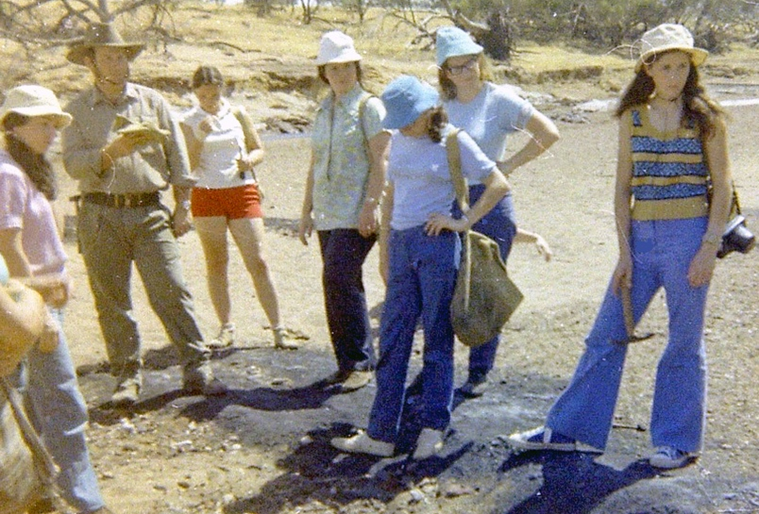
Photo: Neil Kidd – Students with Tony Knight

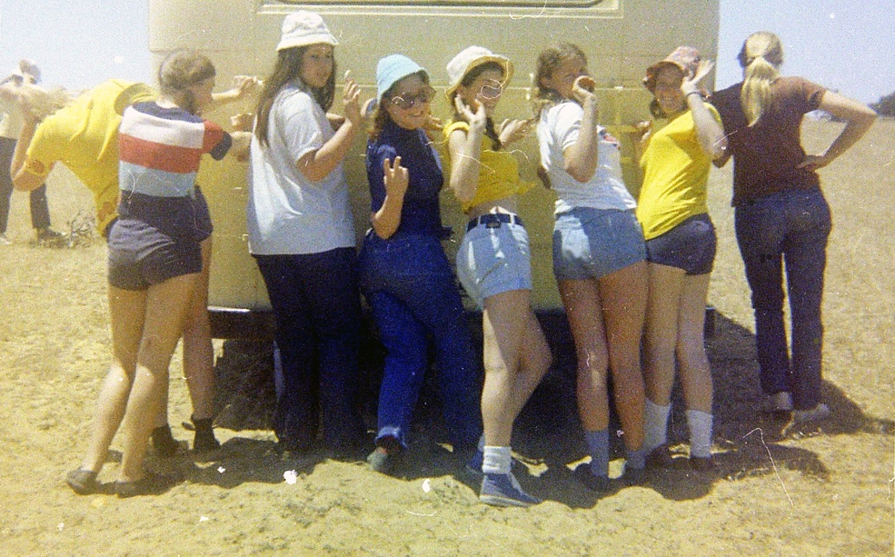
Photo: Neil Kidd – The girls pushing the bus

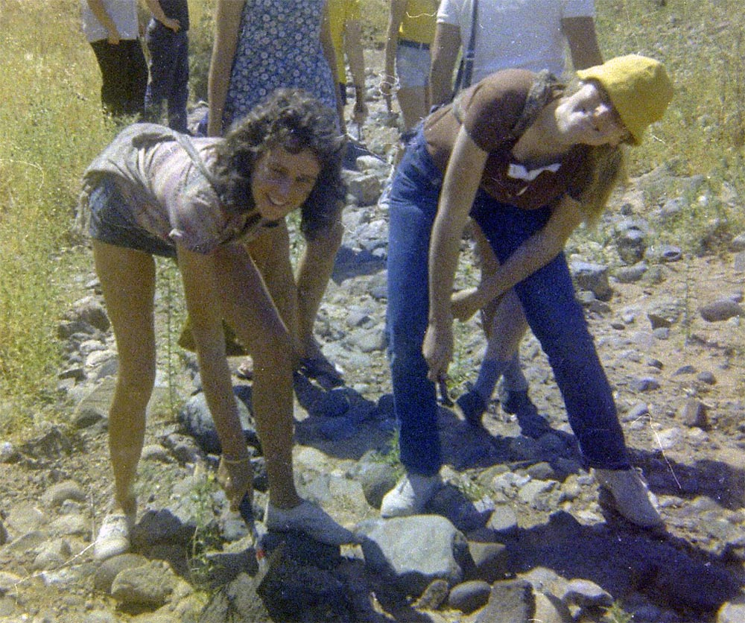
Photo: Neil Kidd – Monique Poelna and friend

Sue Hasleby: “I wasn't pushing. On the way back from Geraldton, we came down the Brand highway, which still had some gravel sections. I remember my name being called out – ‘Sue Hasleby, can you please come to the front?’ and I was asked - "how far to Cataby, we're nearly out of fuel?" As I was familiar with the road, I gave a very definitive answer -- Not far!!!
Just past Cataby, we stopped at the Lookout. It took a lot of cajoling and pushing to get us all out of the bus and check the view. The camp was at an end and we were all hellbent on just getting home”.
The third years went to Rottnest. The males were housed at tent land, while females lived at the Kingston Barracks. They did community service at Rottnest primary school and the Rottnest Board of Control. Some of the activities included: a bicycle rally, orienteering, cricket, swimming, hiking, tennis, mini golf, bike riding, fishing, volleyball and softball.

Day out at Trigg Beach

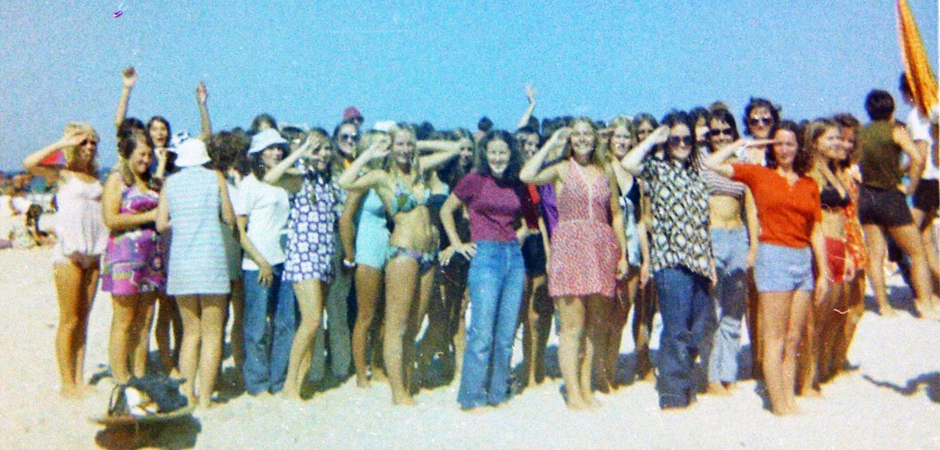
Photo: Neil Kidd – Everyone gathered on the beach for a cheeky shot

Jenni Waldron: “I remember being there that day … I had a black eye and bruises on my hips from a car accident a week or two earlier… not a good look in a bikini”!

Others who are easily identified are: Trish Harant looking great in a bikini, Laurie Bendat in blue jeans, Bobbie Smith in a dress, and Claire Pippet.

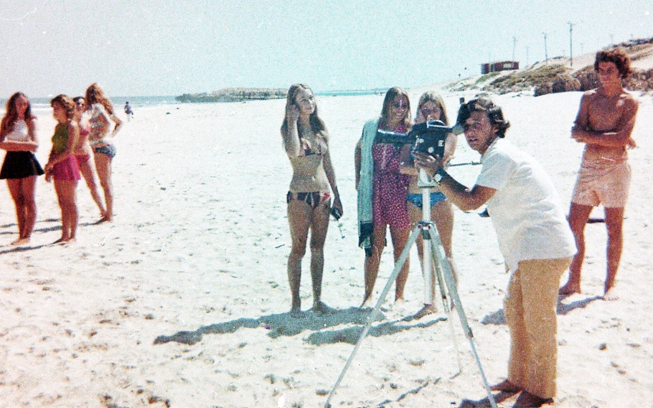
Photo: Neil Kidd – Loyd Bolgia making one of his epic movies – in shot Sandy King, Bobbie Smith, Robyn Clutterbuck and Bill Reid

The day would not have been complete without a little pole fighting.
As it was the hippy era, you will notice the very colourful and patterned men’s bathers.

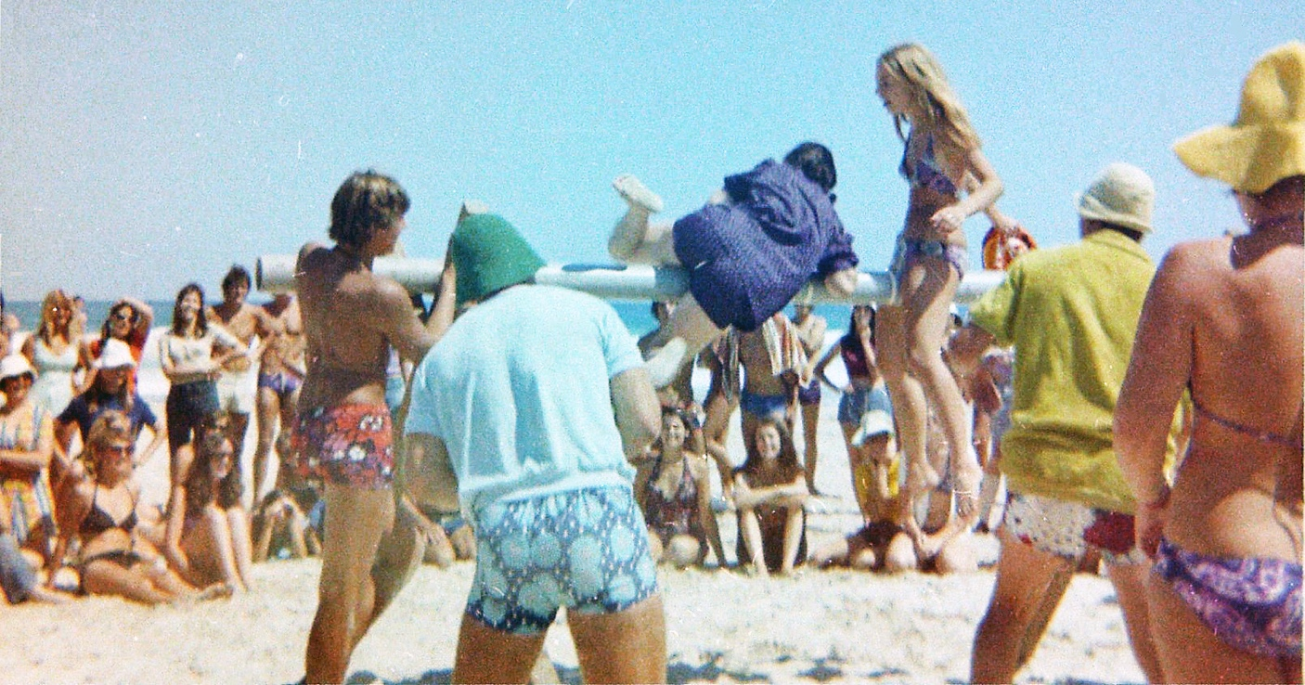
Photo: Neil Kidd – Pole fighting

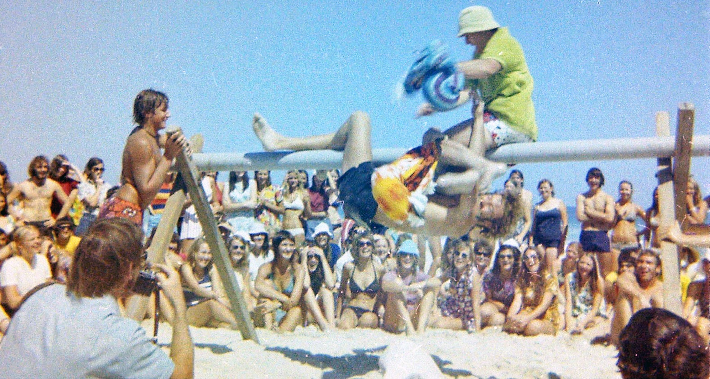
Photo: Neil Kidd – More pole fighting

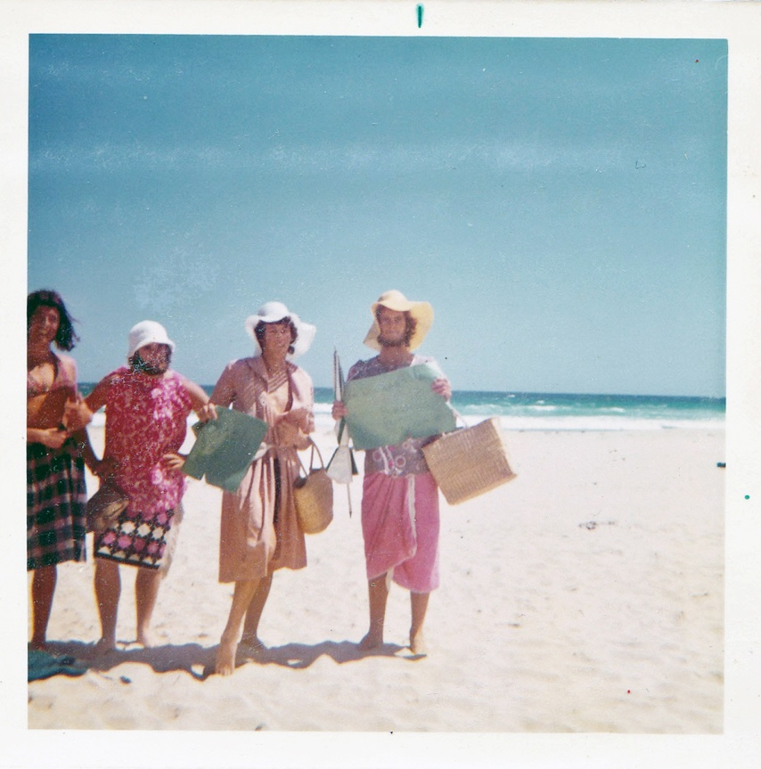
Photo Neil Kidd: Women’s libbers - Terry Watt, Peter Douglas, Bill Reid and Robert Neil Kidd with their placards!

At the 1972 Trigg’s Carnival these new members of 'Women's Liberation' came to the Rescue of exploited girls in the "beach girl competition". Although it was Robert’s idea, he missed out on a skirt!

1973
Rottnest

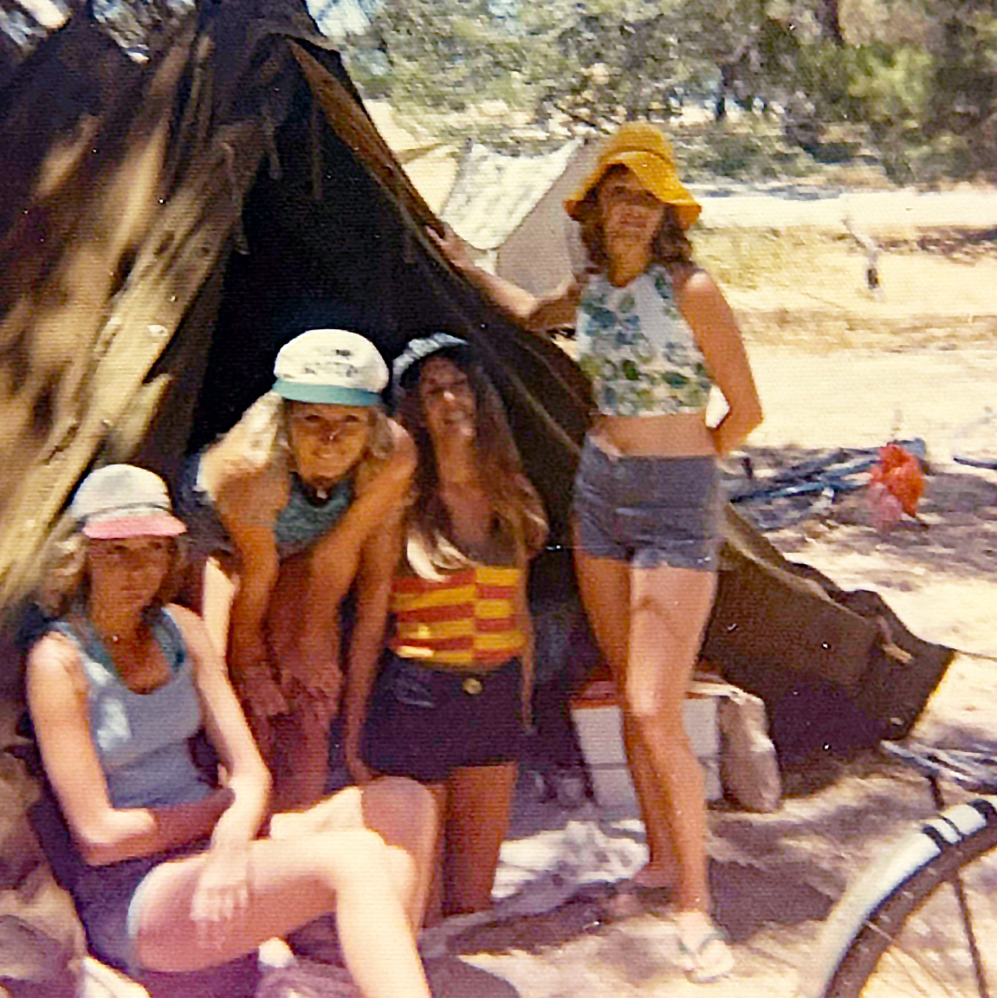
Photo: ??? Brenda Marwick, Trish Harant, Lorraine Smith and Claire Pippet

Geology camp
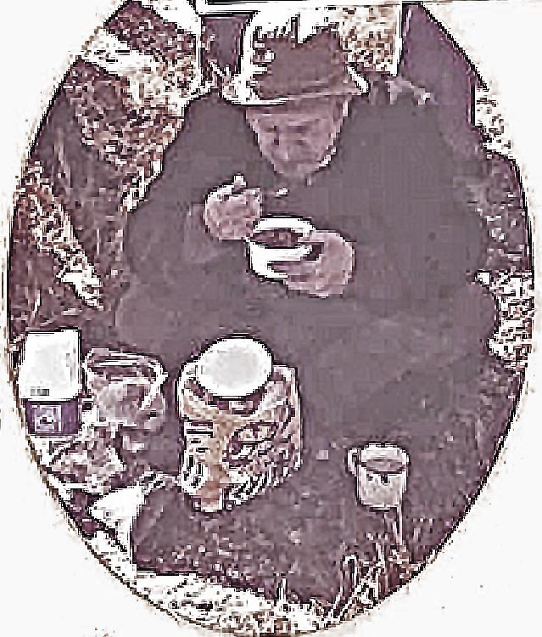
Photo: Kerry Paddon – Mr McKenna eating

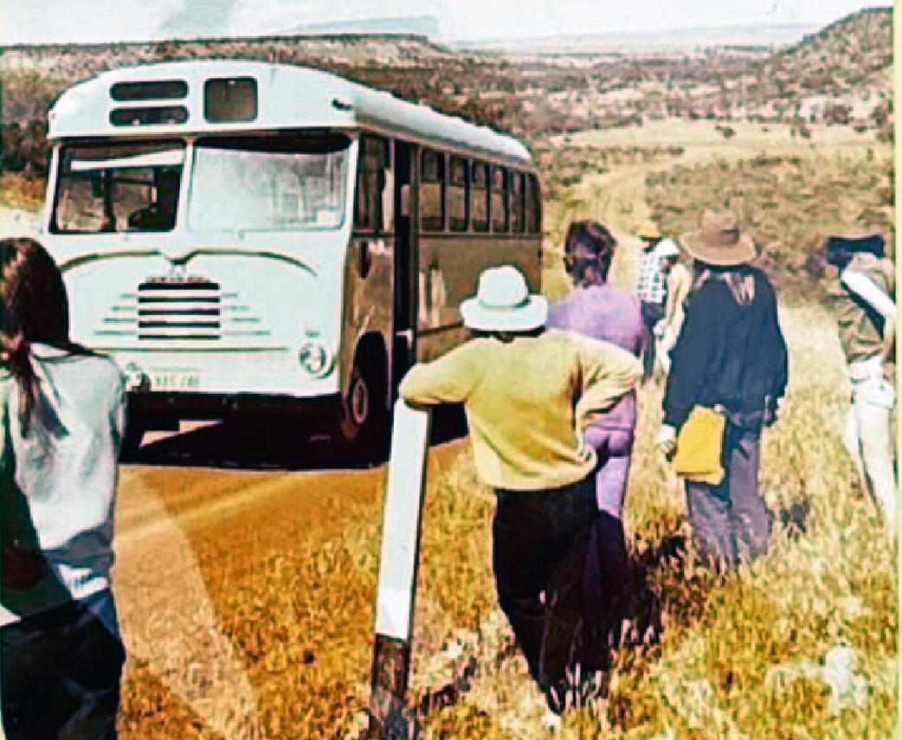
Photo: Kerry Paddon – Get out! The bus can’t get up the hill!

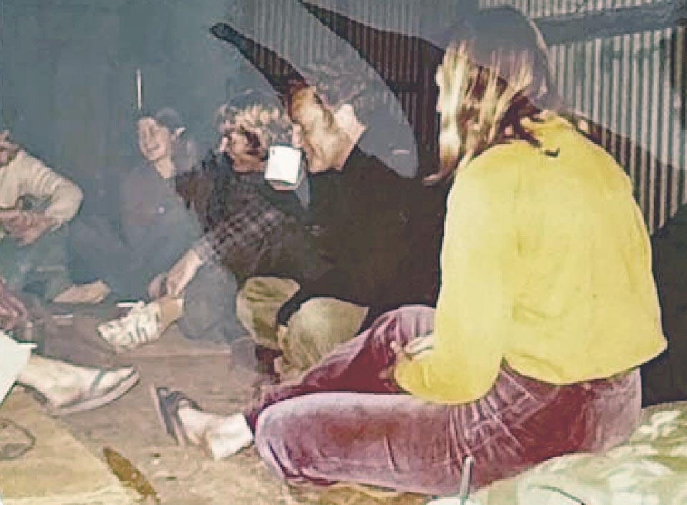
Photo: Kerry Paddon – Telling jokes before bed

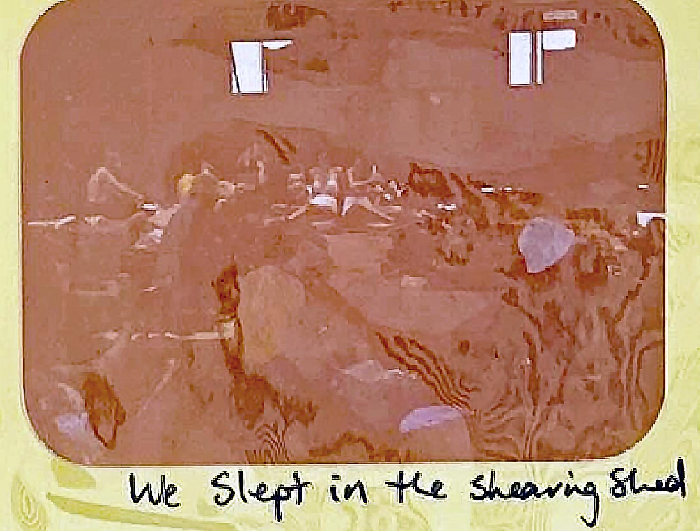
Photo: Kerry Paddon – sleeping in the shearing shed

1974
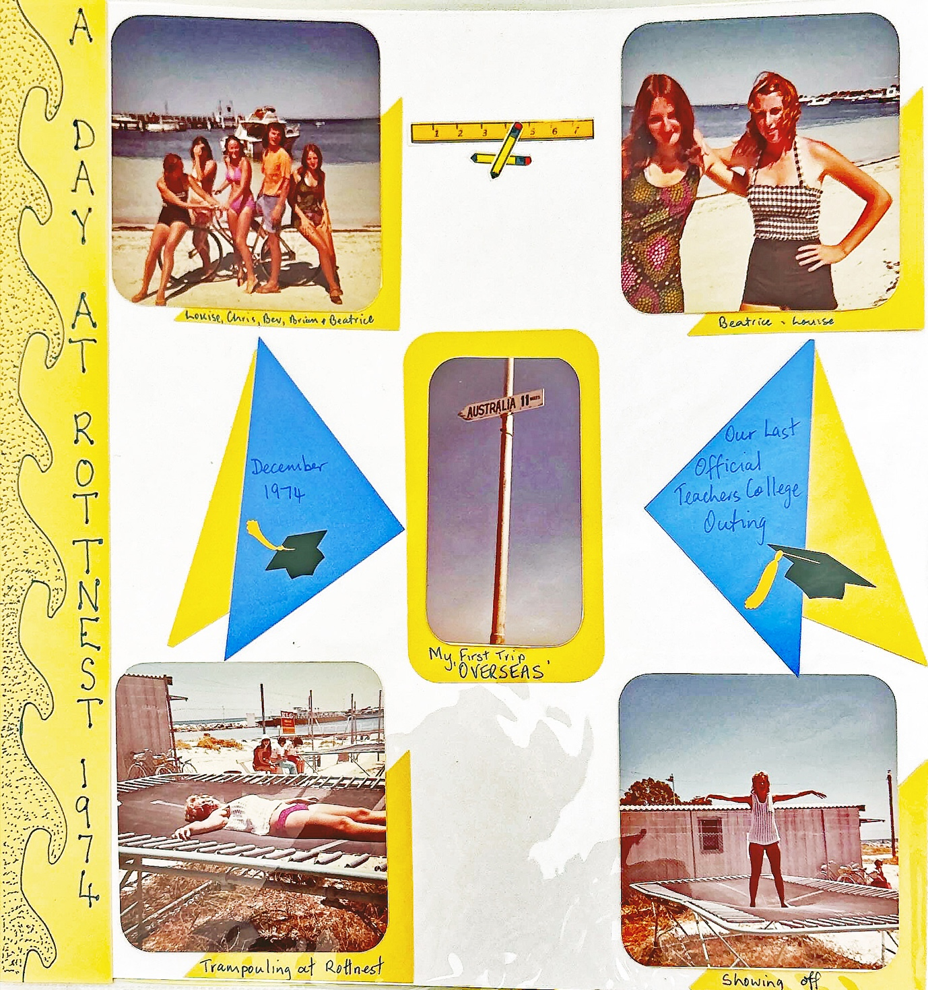
Photo: Kerry Paddon – Final Rottnest camp for the 1972 intake

A number of staff also attended the various camps including Alan Jones and Lew Eborall. In 1974, they stayed in tent city.

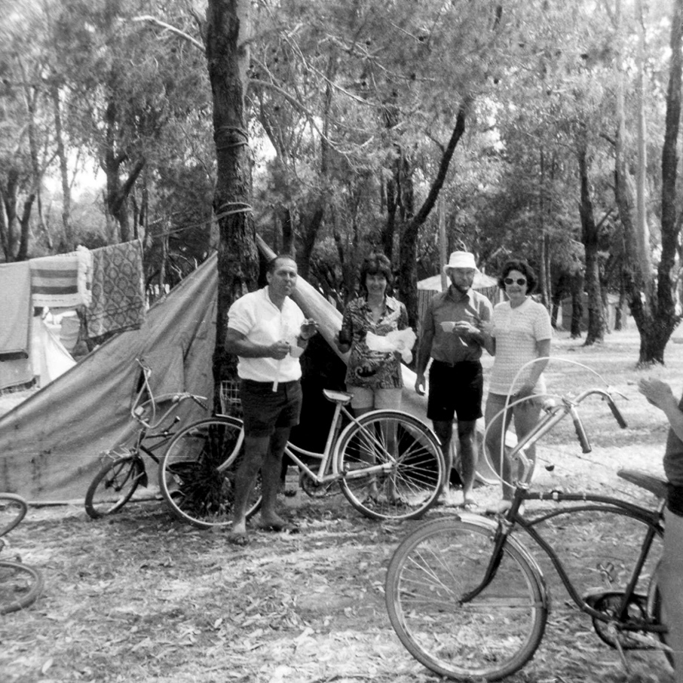
Photo: Tim K. Jones

Tim K. Jones says: “Circa 1974 college camp at Rottnest Tentland - Lew Eborall, Wendy and Allan Jones, and Barb Eborall with my leg and bike framing the photo. My funny memory of the trip was about the changing times and language. Mum and Dad had hired one of the upmarket huts and in the evening invited some students in for a chat and a drink.
I remember jaws dropping when Dad said he was taking it easy on the beers as he'd got really ‘stoned’ last night. He had the Dean Martin era vernacular and ‘stoned’ meant getting drunk. One of the students, foreseeing that the term might cause problems in the future, sagely advised Dad that there'd been a change in the lingo and it had become a drug reference”.

1975
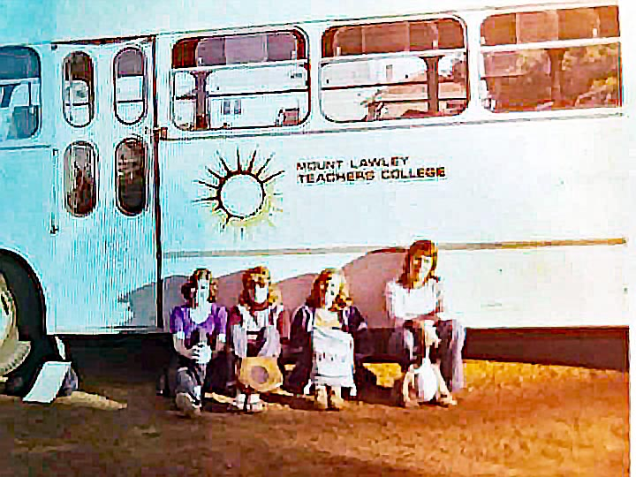
Photo: Martin Humphreys – on the way to 1975 first year social science camp at Toodyay

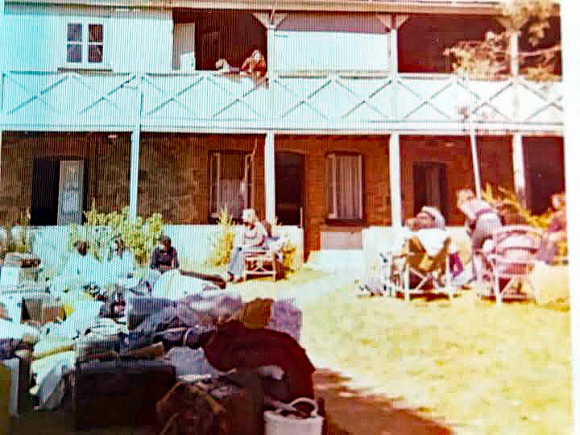

Photo: Martin Humphreys – accommodation at Toodyay camp

Debra Andrew: “We stayed in the old haunted hospital, and it was freezing. We found the graves of my great grandparents”.

Martin Humphreys: “We went to the cemetery to count pioneer graves and transcribe the tombstone engravings. I just remember that it was bloody cold”.

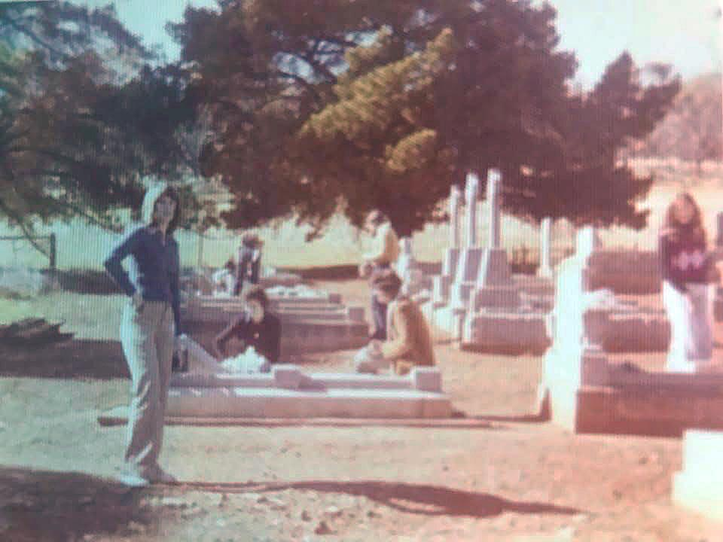

Photo: Martin Humphreys – at the Toodyay cemetery

Aquatics Festival – place and date unknown

The aquatic festival was well advertised, as only students can.

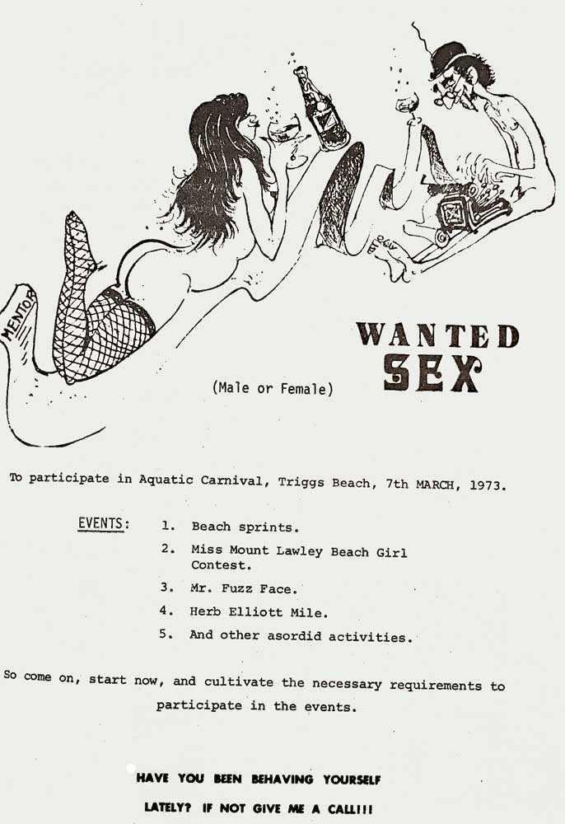
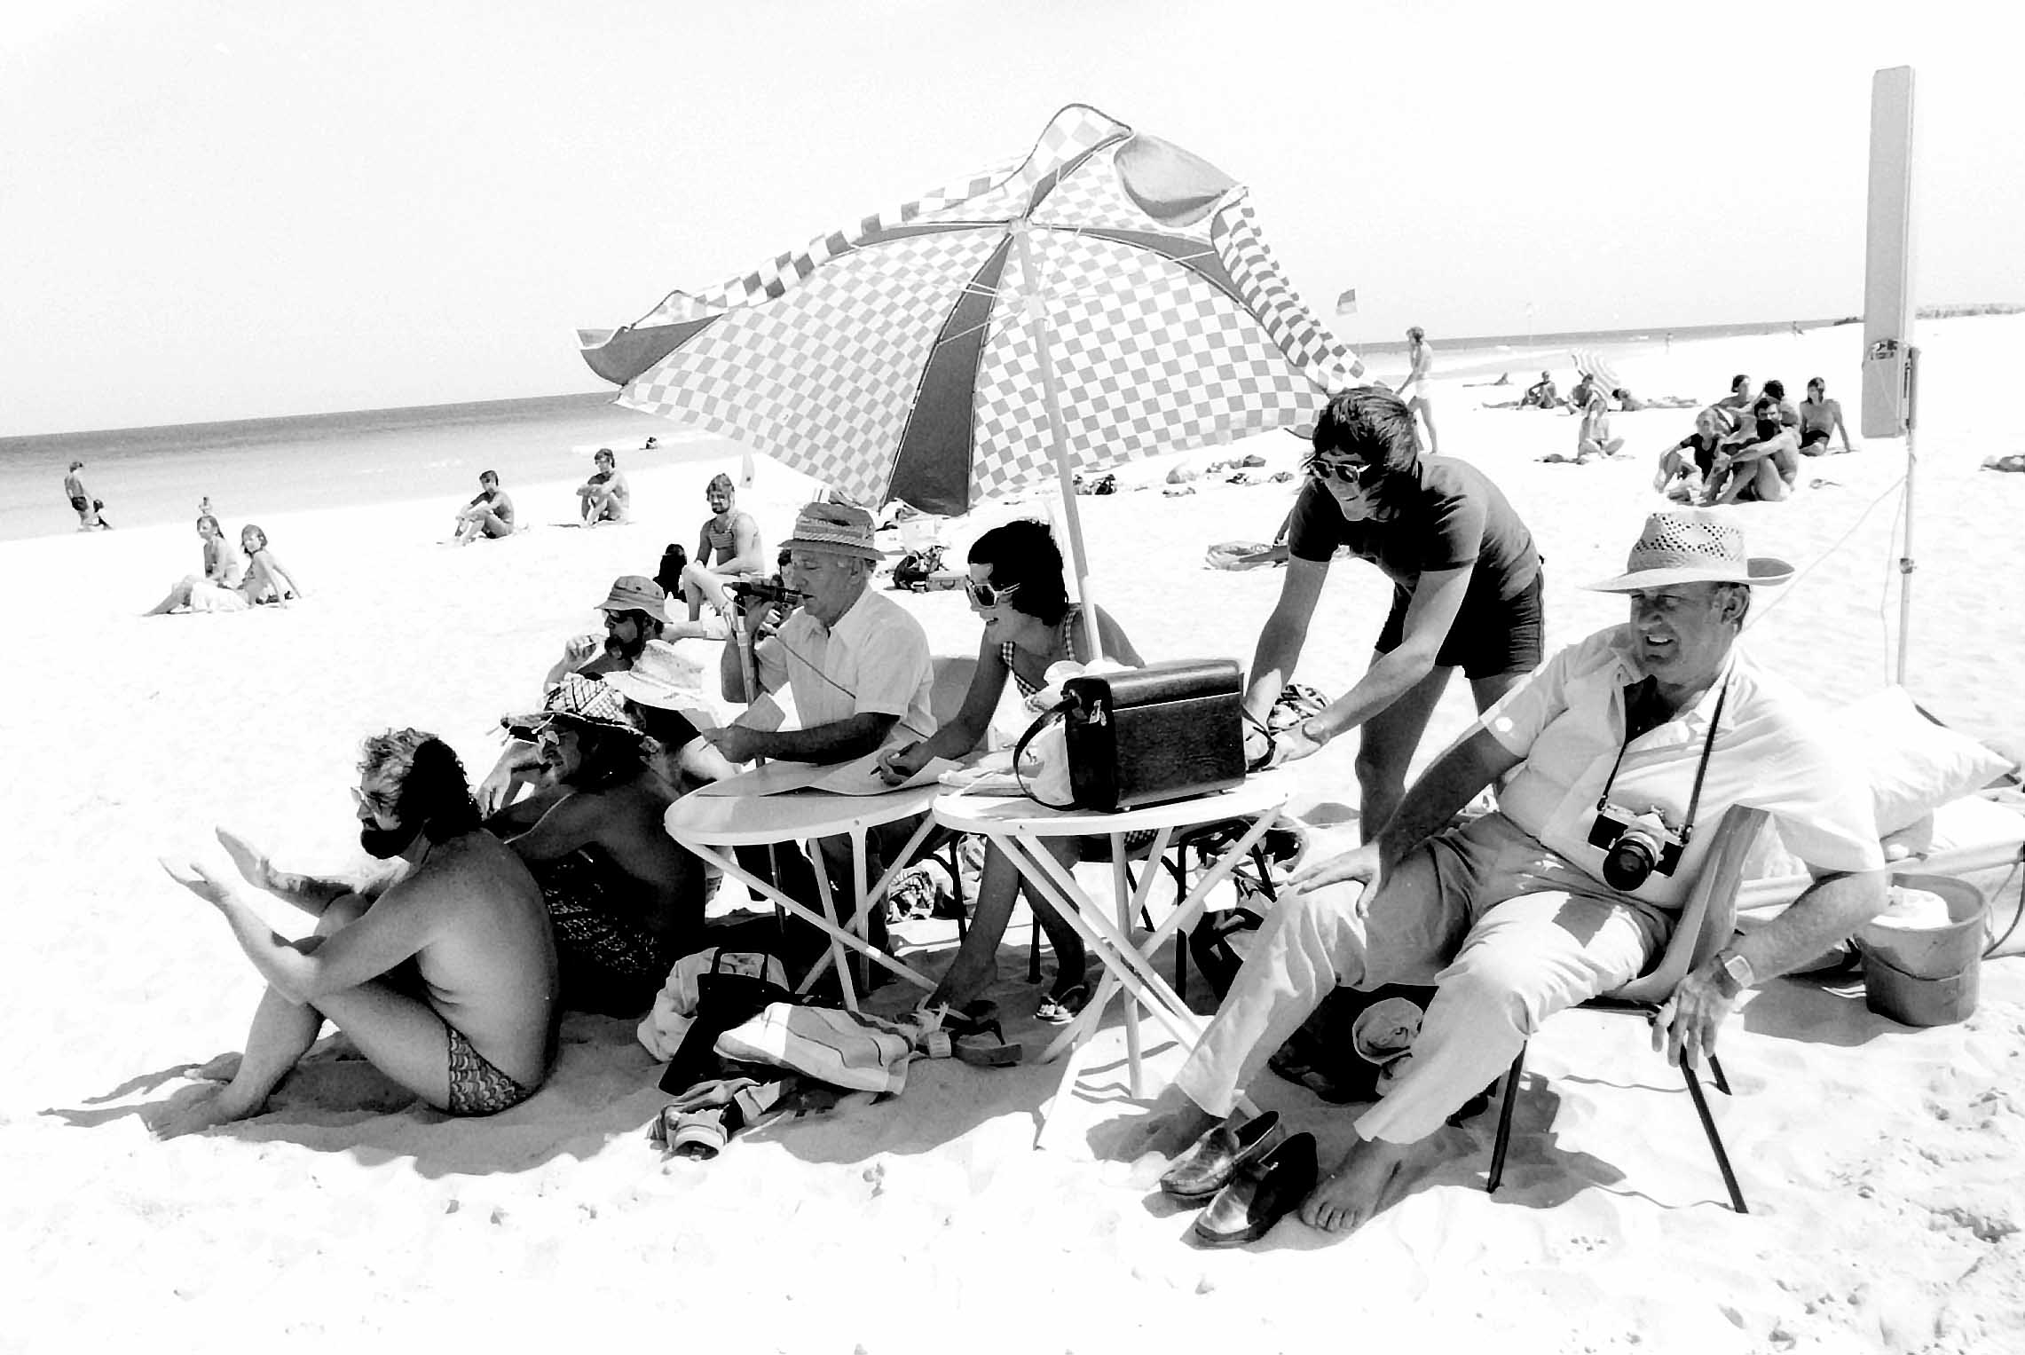
Photo: Sybe Jongeling – Aquatics Festival organisers

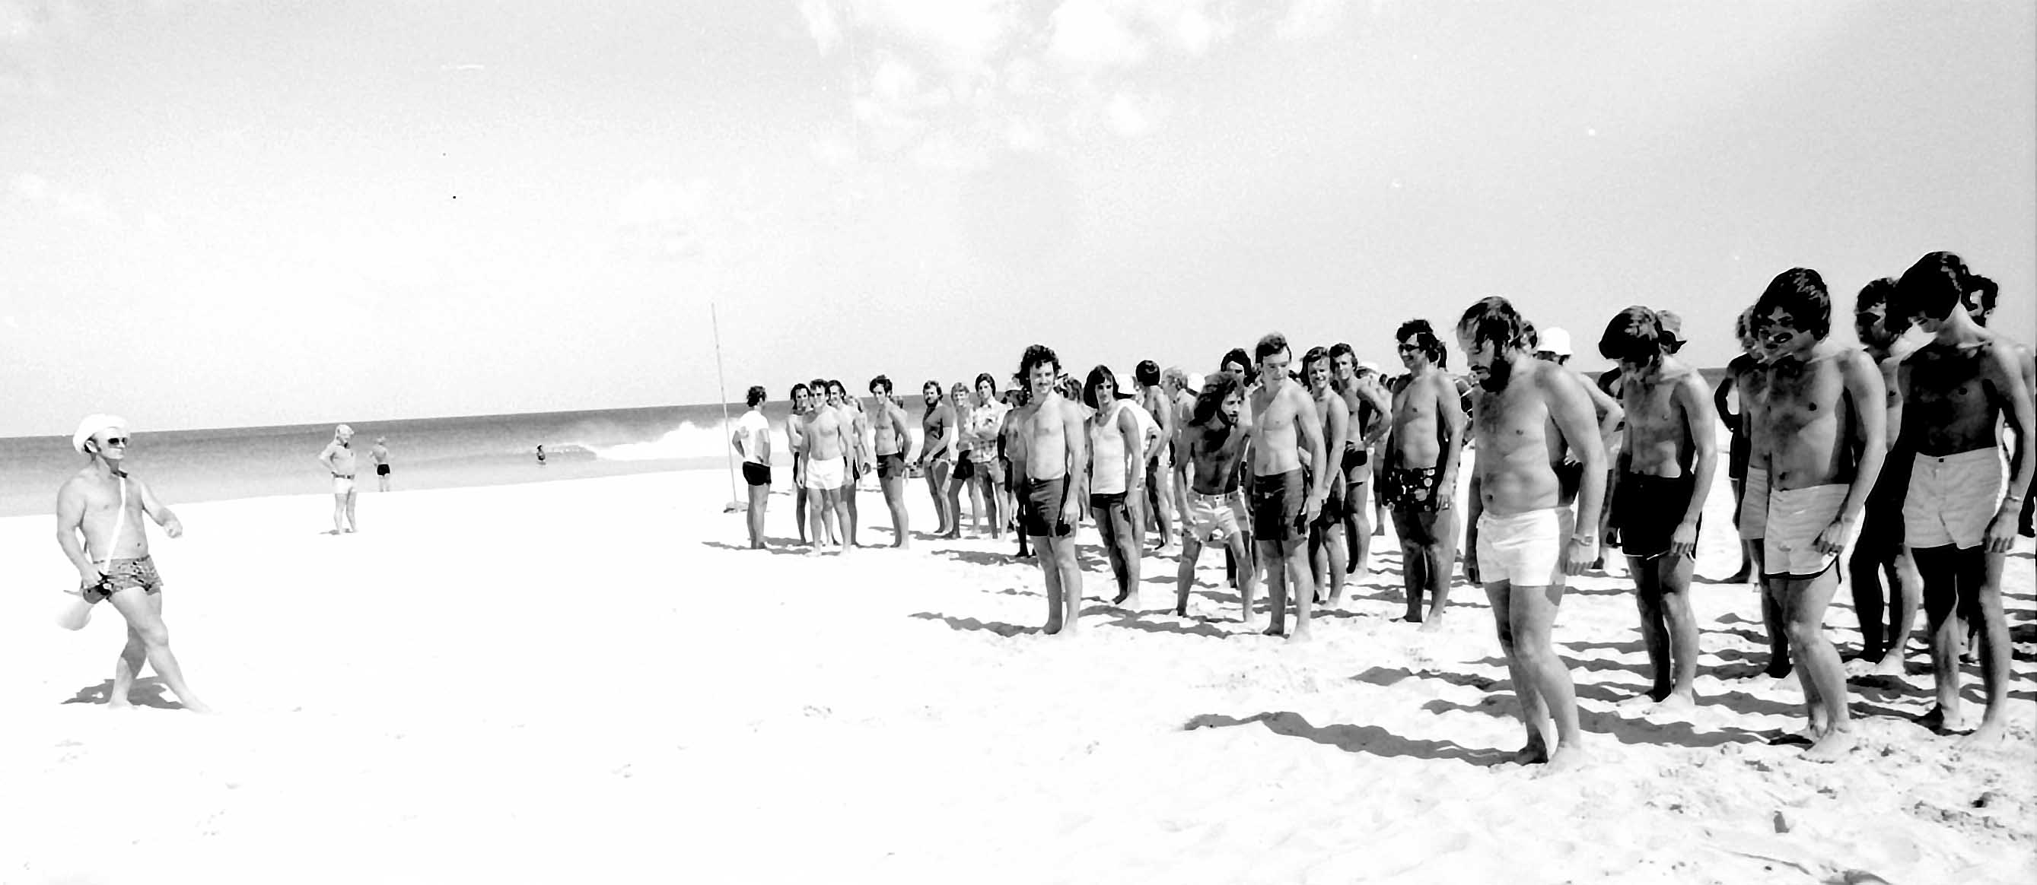
Photo: Sybe Jongeling – Bruce Sinclair organising the boys

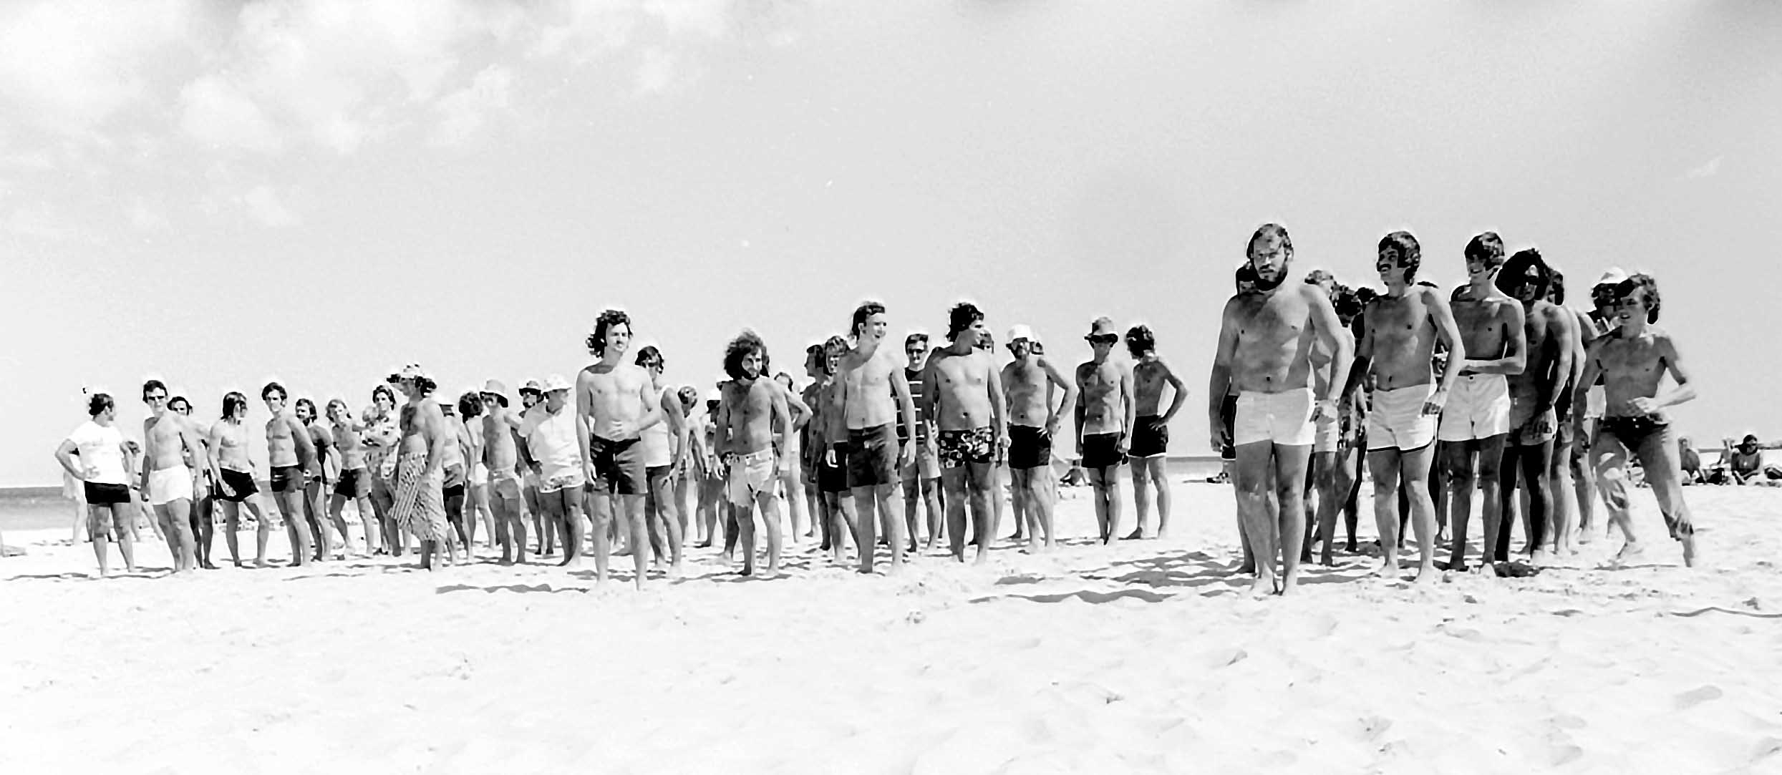

Photo: Sybe Jongeling – Boys team getting ready to compete

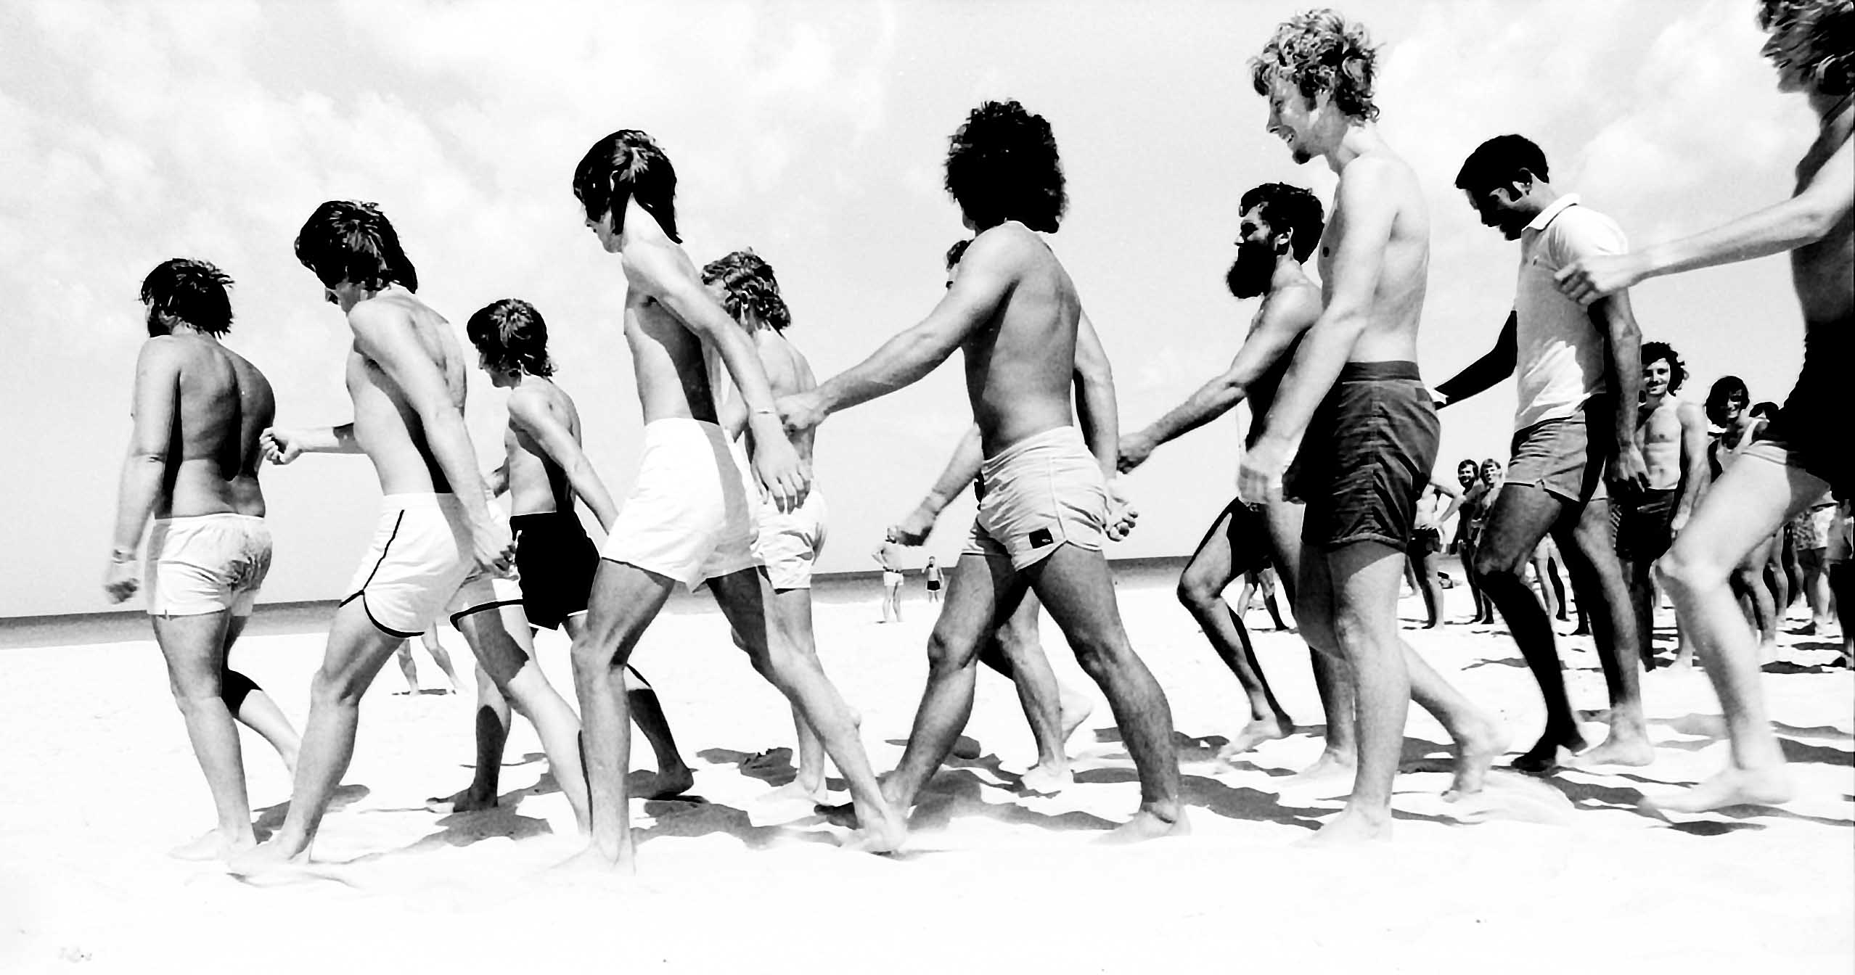
Photo: Sybe Jongeling – Boys team on the move

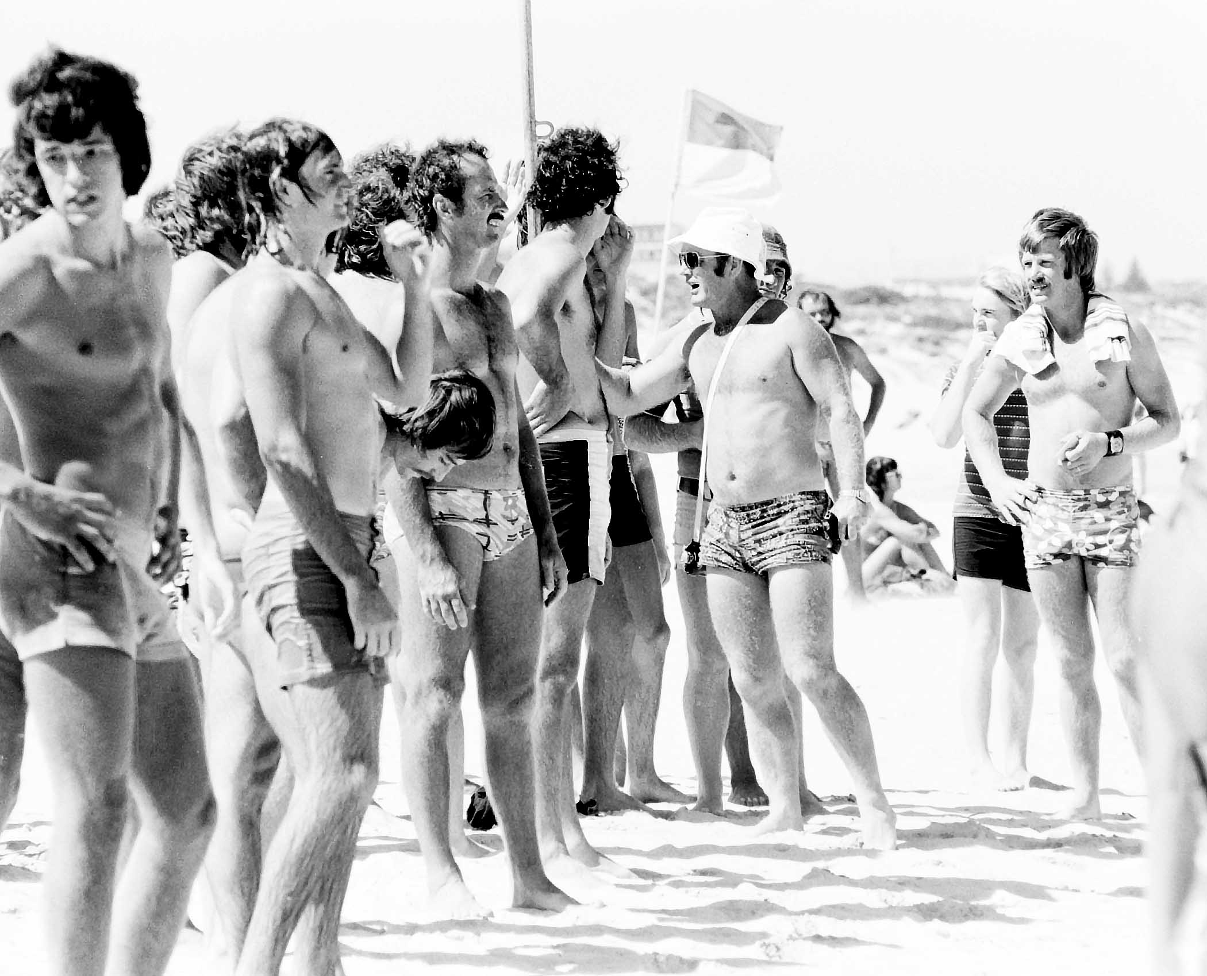
Photo: Sybe Jongeling – Boys team

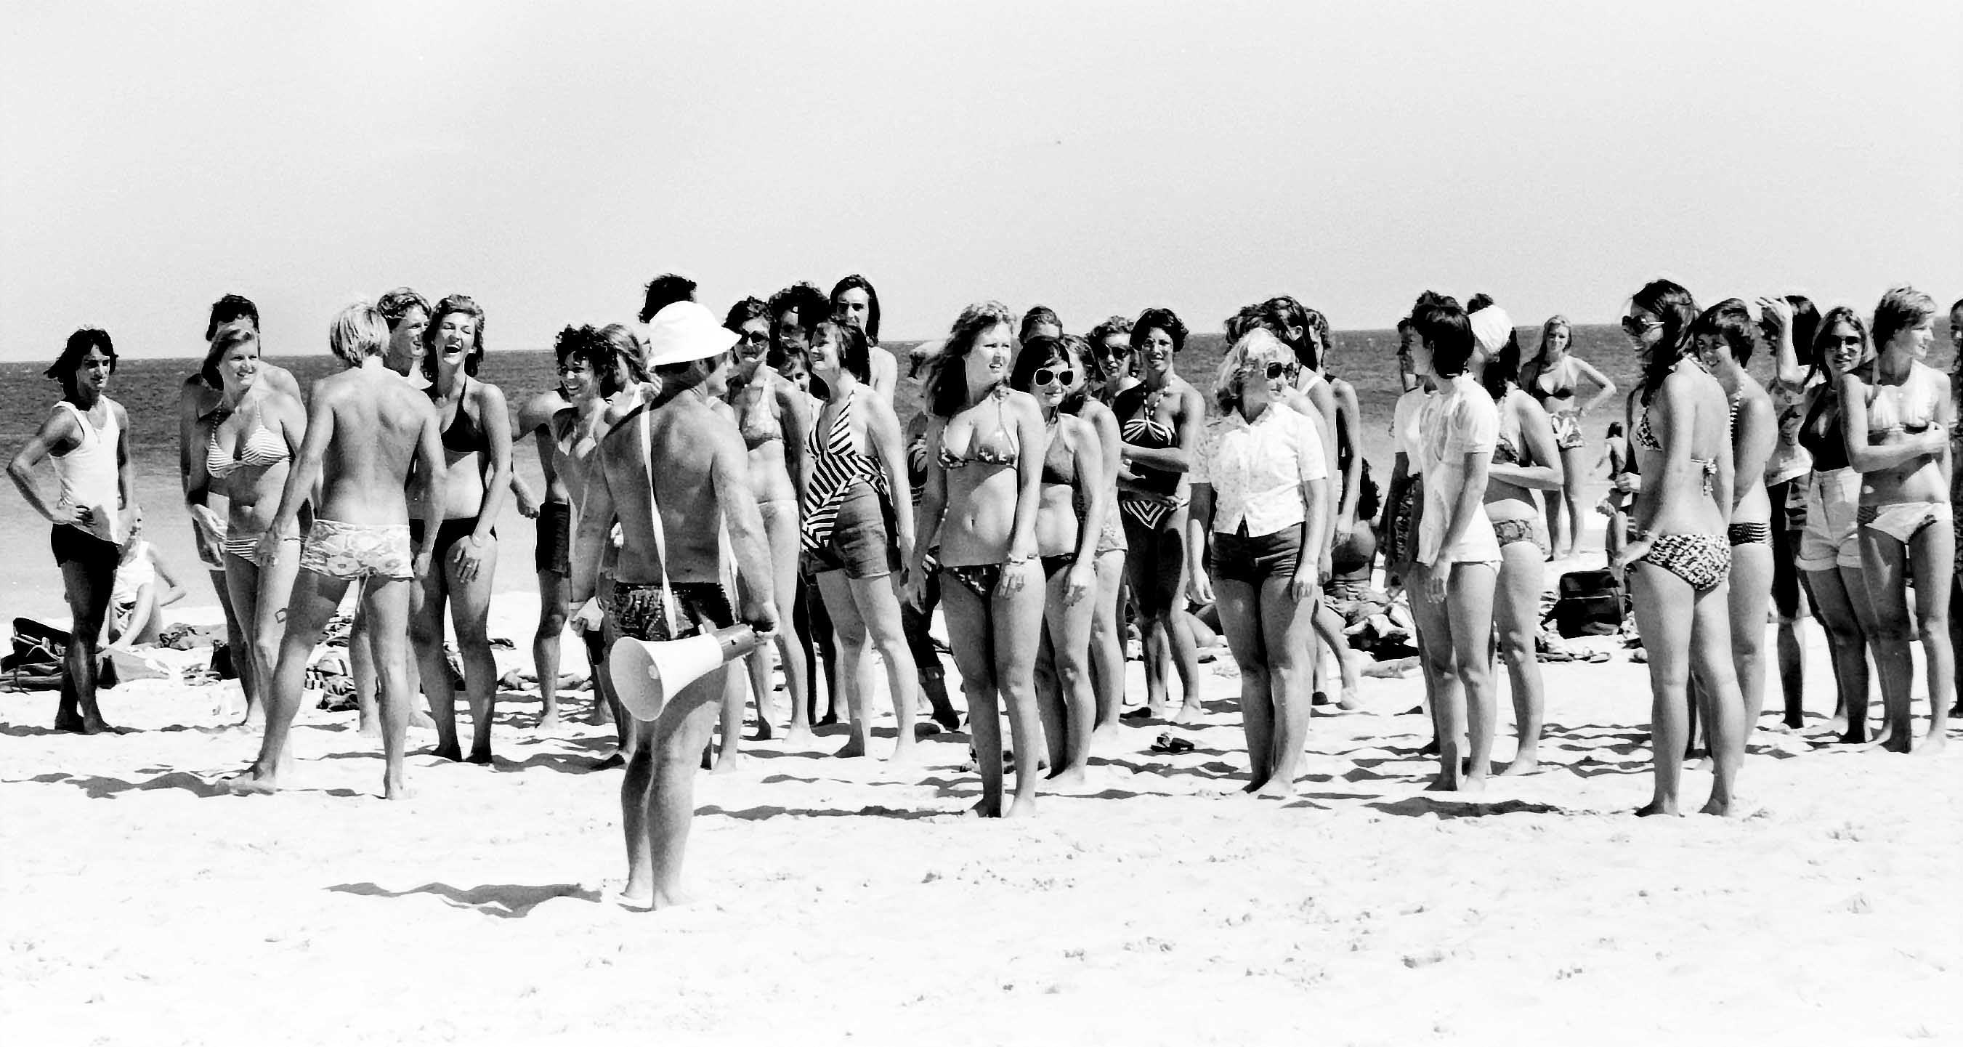
Photo: Sybe Jongeling – Marshalling the girls

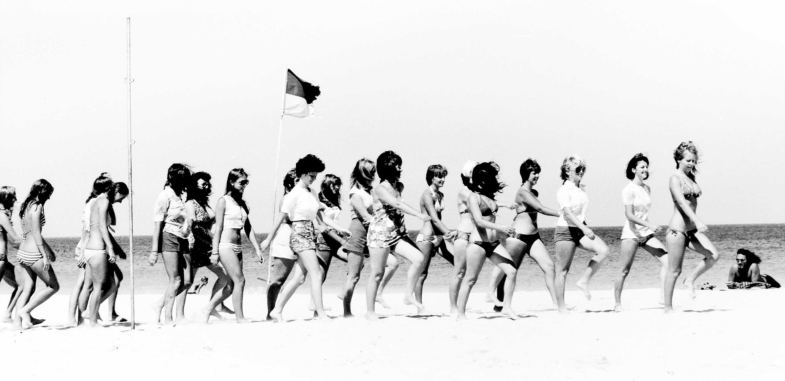
Photo: Sybe Jongeling – Girls on the move

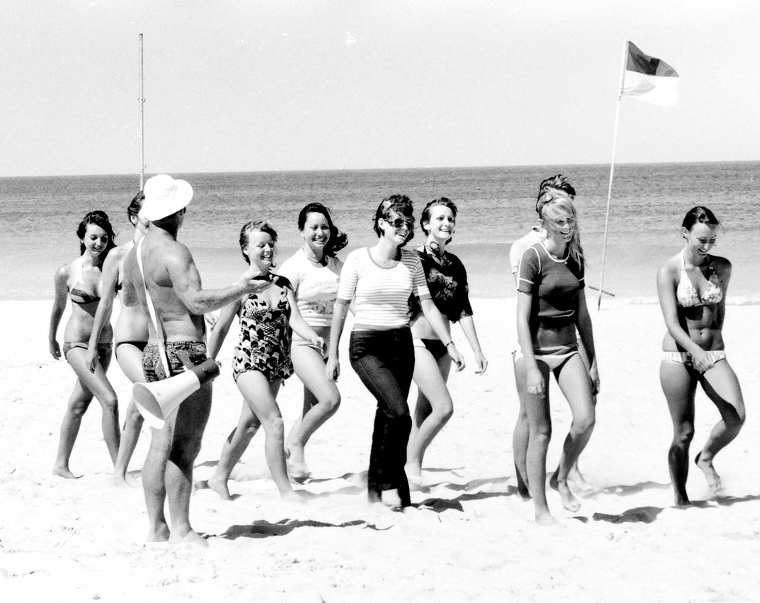
Photo: Sybe Jongeling – Girls team

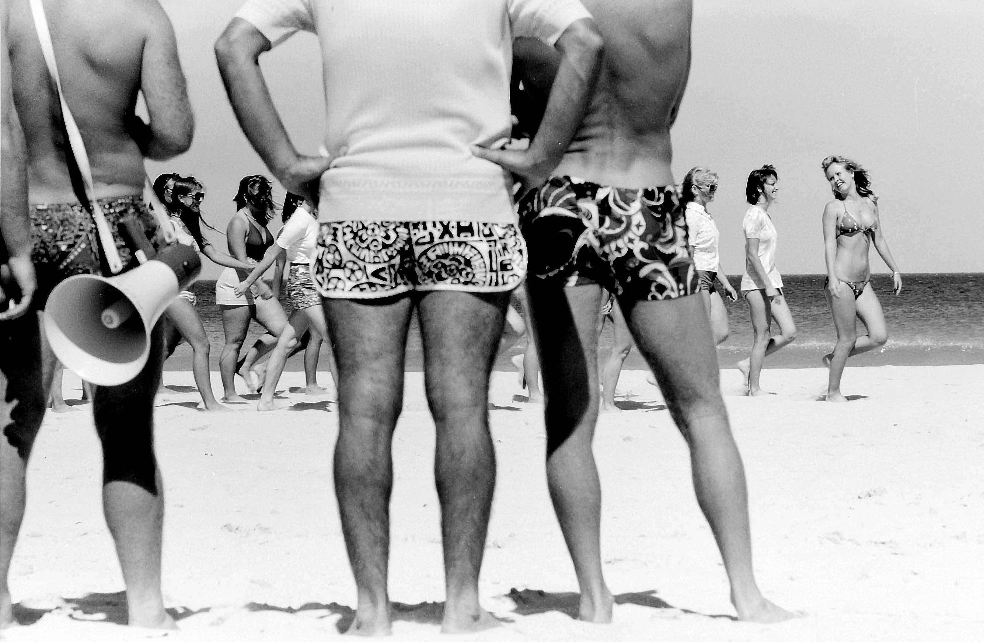
Photo: Sybe Jongeling – Adjudication team

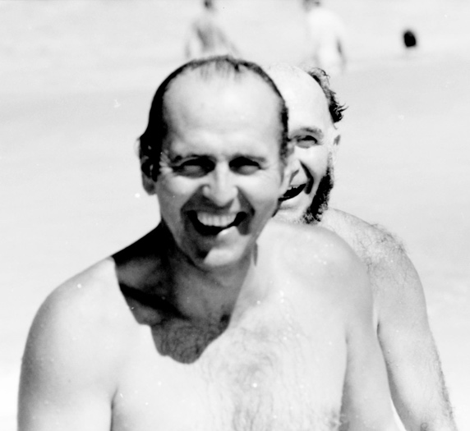 | 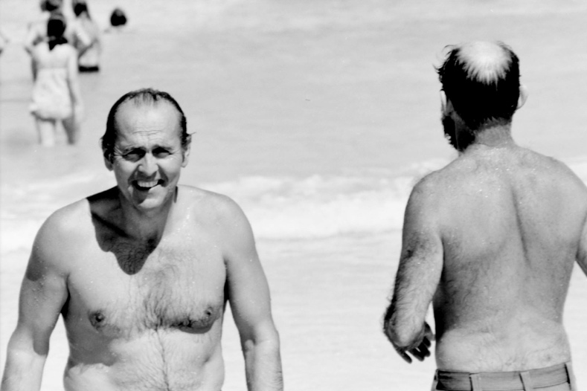
Photos: Sybe Jongeling - Lew Eborall and Alan Jones, taking a dip at the Aquatics Festival

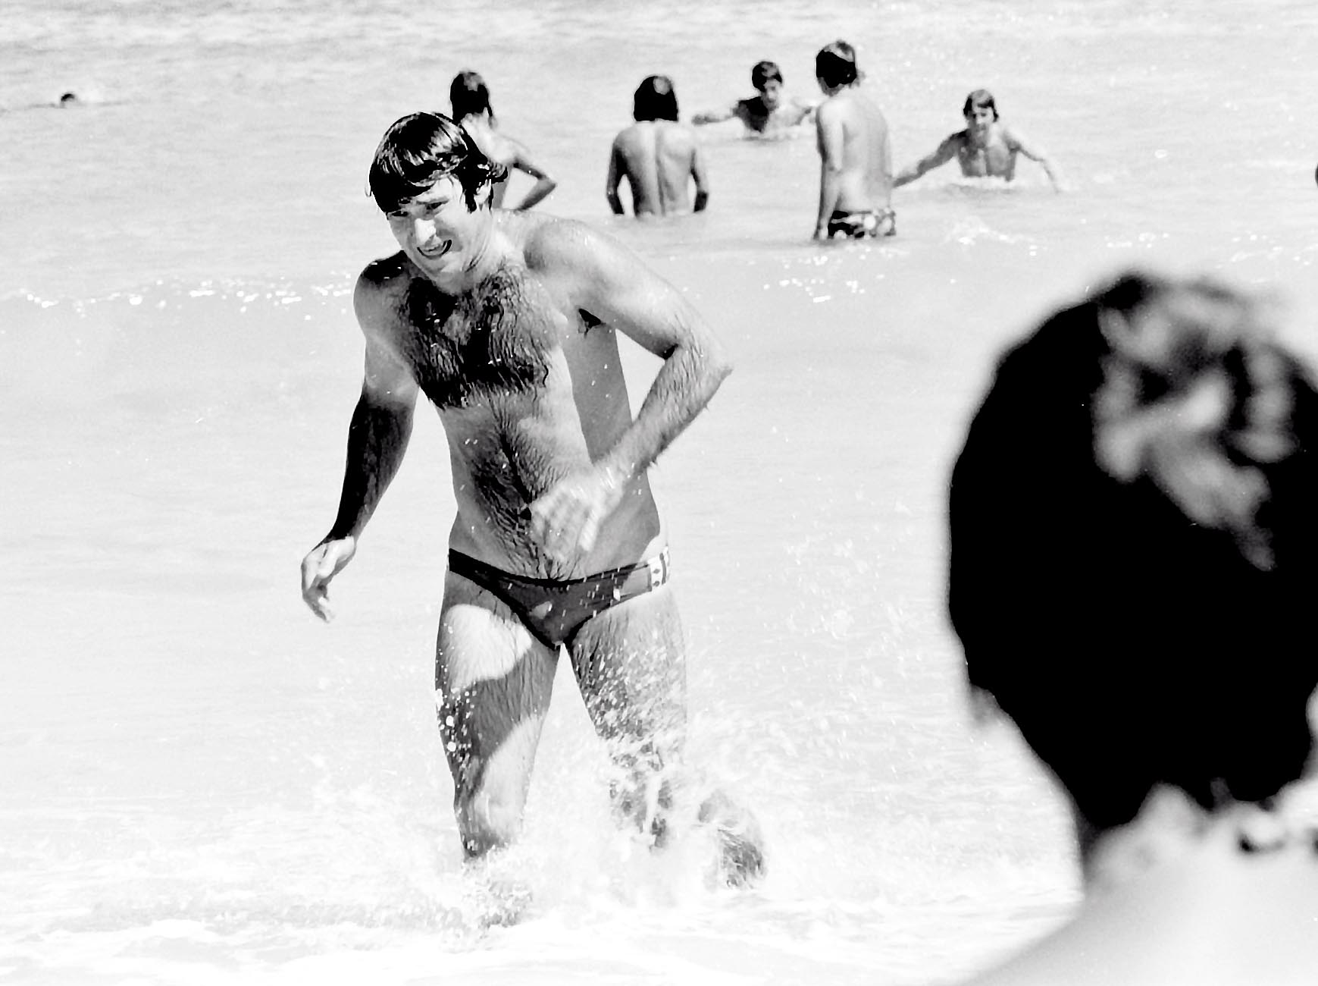
Photo: Sybe Jongeling - David Hough taking a swim at the Aquatics Festival

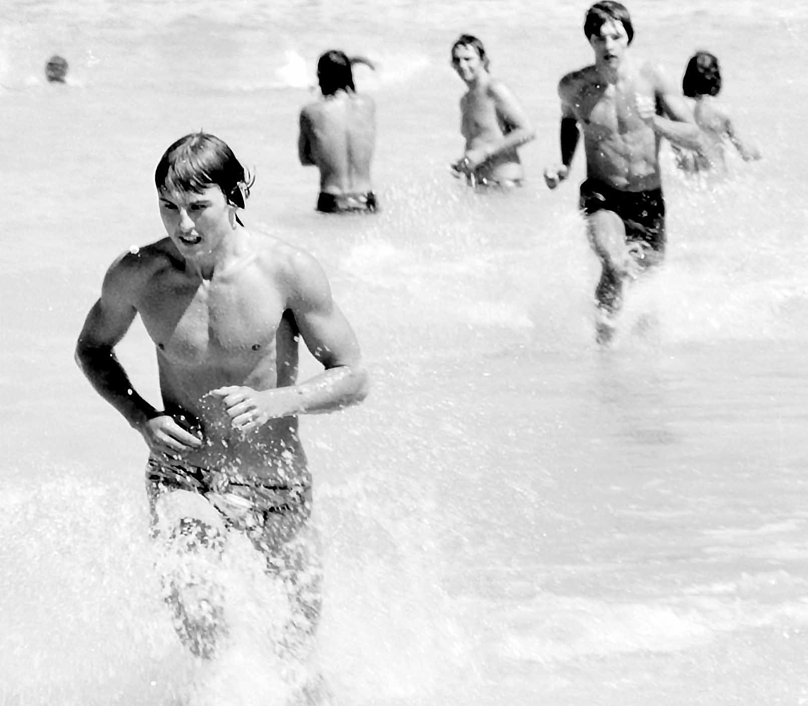 | 
Photo: Sybe Jongeling – Students in the water

Fairbridge, was a farm school near Pinjarra in Southwest Western Australia. However, there were branches of Fairbridge elsewhere, including Pt Peron. These camp pictures were presumably taken in 1972 or 1973 but not sure if these were at Pinjarra on Pt Peron.

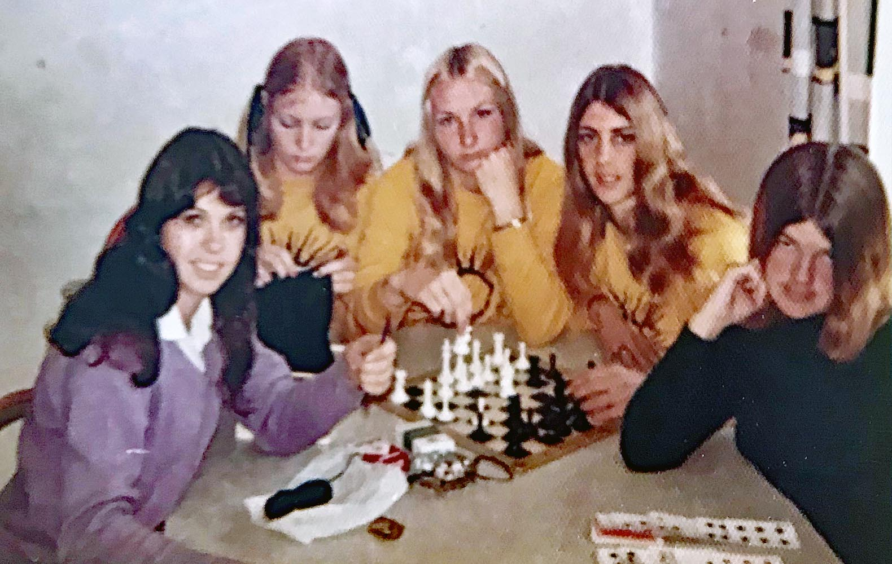

Photo: Robyn Clutterbuck - Coralie Bufton, Brenda Marwick, Trish Harant, Lorraine Smith, Robyn Clutterbuck

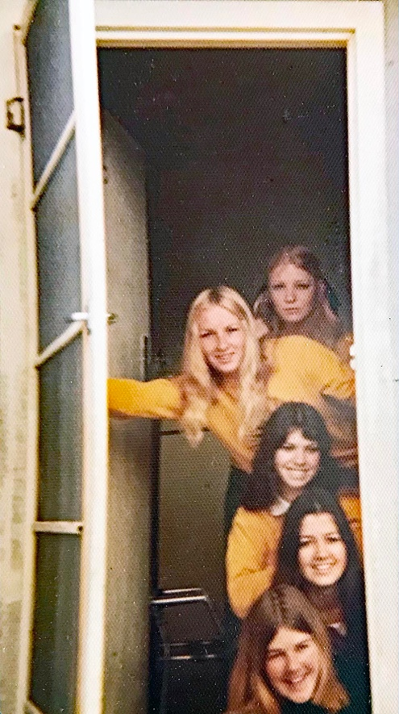

Photo: Robyn Clutterbuck – Brenda Marwick, Trish Harant, Coralie Bufton, Angela Kerr, Robyn Clutterbuck

Chapter 7 – Options
In second and third year of their course, students were given three options in the area of: Teaching, Academic and Personal Development.
These options permitted students to select and pursue studies in the various areas, in which they had special aptitude and interest. Some of these options had their own camps, such as the Geology camp, which are covered in the Camps chapter.

Teaching options focused on subject specific teaching methodologies. The purpose of these units was to provide students with a special teaching strength, which would allow a modicum of specialization, in the primary school.

These included: oral English, art education, primary English method, music education, physical education, educational communication, and education of an atypical child.

Academic options were to increase knowledge in specific subjects, which could also include a unit from UWA or WAIT. These units were designed to introduce students to formal study of a discipline, with the aim of using this to embark upon further studies, at a later date.

These included: educational measurement, geography, history, literature – American, British and European, Literature – Australian, Afro-Asian, Mathematics, sociology, child study, geology, UWA, and WAIT unit.

Personal development options were more informal and less curriculum- based units. These options aimed at developing students’ recreational and cultural interests, but underlying this, they could provide a valuable background for the classroom.

Some of the personal options included: art/craft, creative writing, dance, theatre arts, film and television studies, physical education, music, natural science, statistics, home economics, and health and recreation.

Sewing
In addition to the various options, female students were also required to do a compulsory sewing unit. They had a file and made samples.
The reason for this was that sewing was a compulsory primary curriculum unit, so students would be required to teach this when they went out as teachers.
Ruth Shean: “I have mentioned that we were generally a diligent group. When we did sewing, we were all required to prepare samples of knitting, crochet and embroidery. Most of us had done sufficient of this at school to be proficient, but set about dutifully working on our samples, often during other lessons. It is not difficult to sew, knit or crochet while listening. This became very popular, until large groups of students would happily proceed with their stitching work during all sorts of lectures. After a while, there was a polite request that we desist from such behaviour. I believe that some lecturers felt that we were not giving their topic our full attention”.
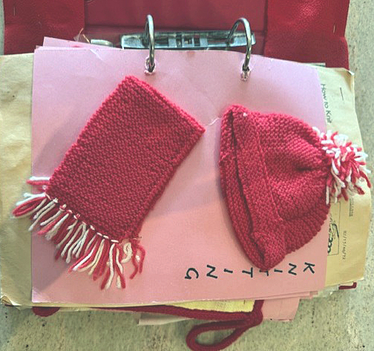 | 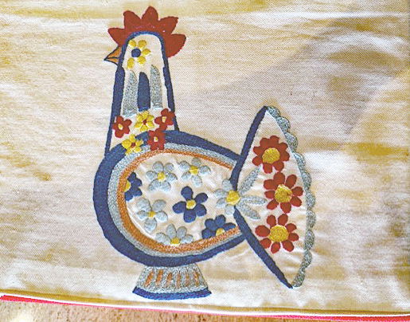
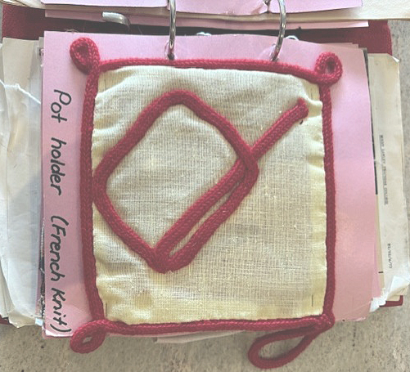 | 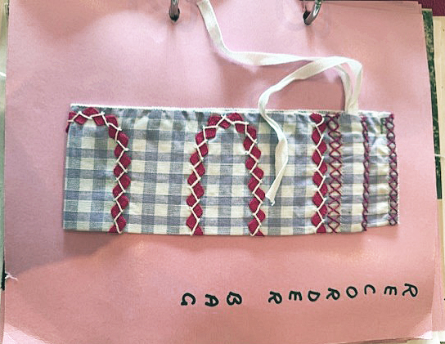
Photo Sue Hasleby – sewing samples from her file

Art and Craft
Bobbie Kidd: “I made a great, hand-stitched sheepskin coat for my major project! Oh, I’ve still got the smell of the Jandakot Wool Scourers in my nostrils after ALL these years…. ha ha!!🤭 There were specific criteria, being that it had to be totally done by hand. So, I designed the coat and made a pattern, cut the sheepskin into the various sections: back, front and sleeves. Then, I laboriously trimmed all 1/2” seams and then double-punched them with a leather punch. Then, using leather thonging, I over-lapped the seams and stitched them up, threading the thong through the double holes for strength! It was so warm that an Eskimo would have loved it”! 🤭
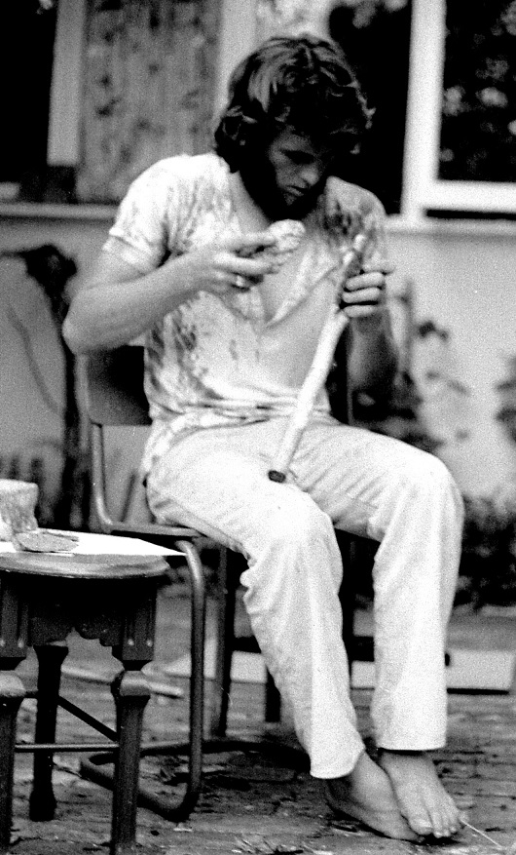
Photo: Neil Kidd – final art project

Film and TV
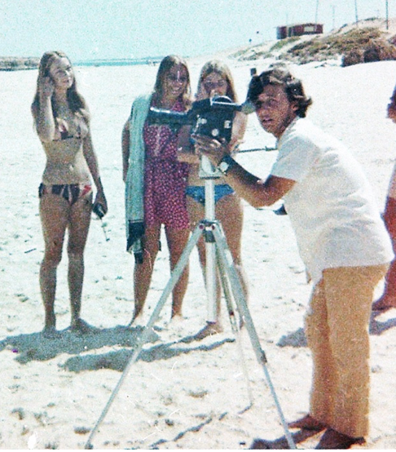
Photo: Neil Kidd – Loyd Bolgia making one of his epic movies
Ruth Shean:

“For all three years at Mount Lawley Teachers College, there were four of us who hung out together — Jo Nieuwkerk, Heidi Gfeller, Kathy Abe and me. We all took our study seriously during weekdays so that our time outside of college hours was our own. Where possible, we worked on group assignments. Lunchtimes were usually spent in the main courtyard, with the four of us working on the latest study project, or chatting about life”.

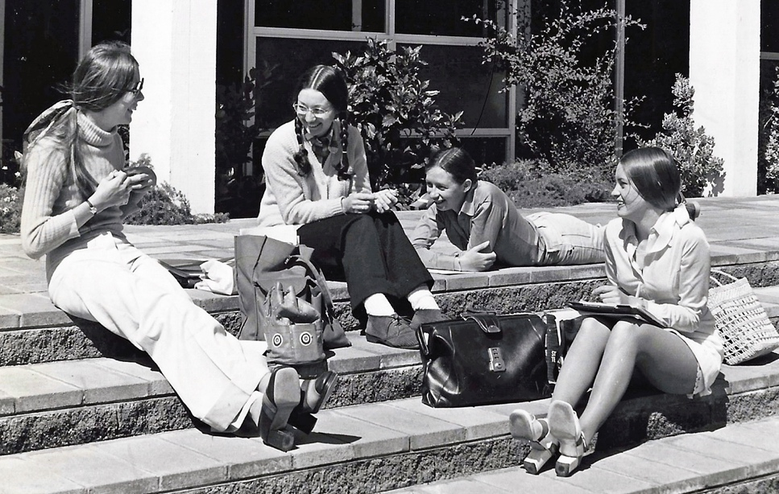
Photo: Ruth Shean – (from left) — Ruth Shean, Heidi Gfeller, Kathy Abe and Jo Nieuwkerk

“Another friend in our group was Loyd Bolgia. The photo above was taken by Loyd, and developed and printed by me. I think we are working — Jo had a notebook on her knee and Kathy has paper in front of her too. This was a common scene — lunchtimes, working in the courtyard. This is immediately through the front doors and into the courtyard behind.

Loyd and I were both part of a film and television elective. Loyd was good fun, and a very handy friend as he was always happy to take photographs as necessary and we’d both develop them later”.

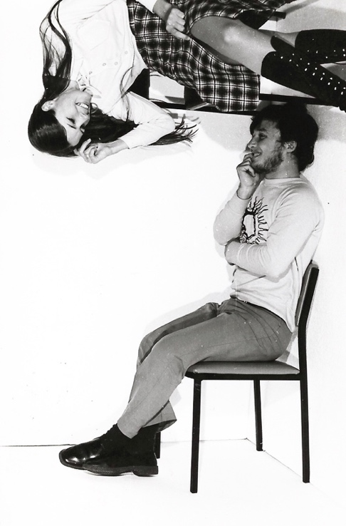
Photo: Ruth Shean – Ruth and Loyd special effects

“A group of us students would mess around with special effects, as we have done here. Loyd Bolgia (yes, Loyd is spelled that way) and I played round with some polystyrene to make some simple optical illusions. It wasn’t great photography but it WAS a lot of fun! The picture of Loyd and me at right angles was probably taken by Ross Mendrik who was also in our film and TV group”.

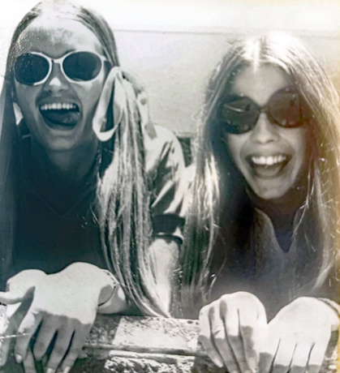
Photo: Ruth Shean – Ruth Shean and Jo Nieuwkerk pretending to be dogs

“The photograph of Jo and me being silly — I think we were pretending to be dogs hence our tongues hanging out”.

Sabiha Masuk: “We learnt how to develop photos and took photos of students. We also made short films. Les Smith, who has now passed sadly was great with photography. I had some great photos we took but can’t find them”.

Music
Bobbie Kidd: “I know I had the regular Music session with Jean Farrant, but as a group of us were already musicians, we were excused and formed a Recorder Ensemble, playing together upstairs (and probably smoking too, thinking Jean wouldn’t notice), whilst never actually learning HOW to teach Primary Music! So funny, cos that’s what I became for over 30 years”! 🤭🎶
It is assumed that Jeff Brownrigg, also took the music option, as he became a musician, songwriter, artist and photographer. Jeff always had leanings towards music and had played drums, trumpet and bugles back in high school. By the time he arrived at MLTC, he had a guitar in hand. While he was at MLTC he played gigs in the evening. After graduating, he taught for a while, before becoming a professional musician. You can hear a sample of his work on YouTube.
Bobbie Kidd: “I remember happily singing some ballads along with Jeff and Sue Ware, in between lessons, in our 2nd year. We girls were harmonising our sox off. They were the good ol’ days”! 
Ruth Shean: “He was a supreme musician. I remember seeing him playing in North Freo — was it at The Stoned Crow, just north of the bridge”?
Clive Choate: “I remember Jeff at Mt Lawley Teachers College. He was a great musician and I went to a few of his gigs at the time”.
PE
Margaret Saunders: “I did a Phys Ed option. Bruce Sinclair taught us golf. We also did swimming and had to do Life Saving certificates”.
Trish Rex: “I loved all the different sports we got to try - archery, rowing, horse riding, swimming, football, hockey. Fantastic option! We were being taught how to teach phys Ed. I think”.
Annette Finlay: “I did PE as a personal development option. It was great fun - rowing, volleyball, badminton, squash we tried everything”!

Theatre Arts
Jeff Sheahan: “I did Theatre Arts- started with the the wonderful’ Beggars Opera 1972 -The incredible Raymond Omedei directing. Also did several inter college festivals with Houghie as director. It inspired me to write 5 musicals for youth theatre groups.

Great memories of the lunchtime concerts in the upper lecture theatre too.

I remember singing Ain’t No Sunshine. Where is Jeff Brownrigg/the gorgeous Veronica Firenze these days?
Ah - wonderful memories”!!

Julie Hopkins: “I did Oral English and Theatre Arts with David Hough. I don’t know how he put up with me, but he did”.

David Hough directed a production of “Trojan Women” in 1974. This was a production, performed by staff and those students doing the Theatre Arts option.

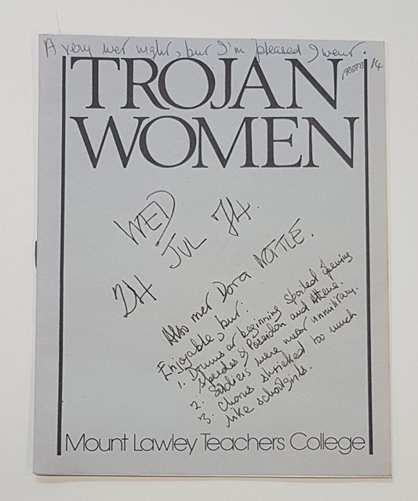 | 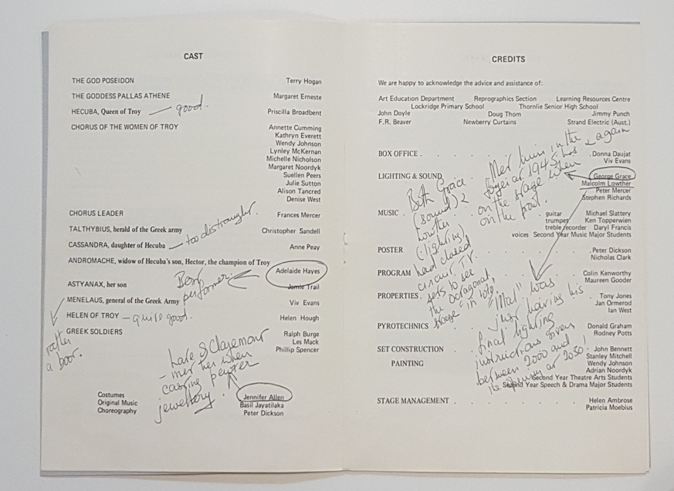
Photo: MLTC – Trojan Women production

Home Economics

Sue Hasleby: “I went off to Secondary Teachers College one afternoon a week to do Home Economics as an option. I remember making a cream crimpolene pant suit (may still have it) and learning various cooking tasks - bread, pizza, zabaglione, pavlova. We also learnt how to requisition for home Ec items including firewood for country schools, still using wood stoves!!!!!!! Supposedly we were then able to teach Home Ec up to 3rd year high if called upon”.

Chapter 8 – Sport
Some of the sports at MLTC included: football, hockey, basketball, volleyball, netball and cricket.
Ian Francis: “Campus life involved, sports and other clubs, for me particularly hockey – I was captain and coach of our hockey team for two years and sports president in my final year. In that same year, 1974, we won the 1D premiership, beating Curtin University. Campus life improved in my final year when the Ref and Gym were finished”.
Bobbie Kidd: “I played hockey and football too. I remember one of the girls crashing onto my left ‘ring finger’ and gave me a green stick fracture. I’ve still got the lump to prove it”!
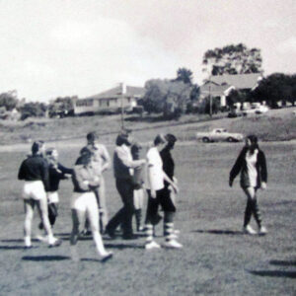
Photo: Neil Kidd - Girls playing football

Sue Hasleby: “Many of us did our bronze medallion at Inglewood pool. We were told we had passed - but the certificates were never passed on to us. We were very creative in PE classes. making weird shapes and ‘freezing’ on the park over the road near the pond”.
Neil Kidd:
“We did swimming at the pool on Alexander Drive. When the Royal Life Saving Society came to check our life saving progress. I was the only one in our group to proceed to the Intermediate Star as the others couldn't swim the required distances”.
Bobbie Kidd: “As I recall Neil, we did the test over 2 days, cos we couldn’t spend the full time needed on one day. Then, they disqualified us, for not having done it in one hit”! 🤣
Clive Choate: “Swimming was certainly a big part of the PE program at the pool nearby. They wanted us to get a Bronze medallion. We had teaching methods in PE where we all took lessons, including tabloid sports, hoop and cane work, movement to music and more.
I don't remember doing a lot of traditional team games, the activities were more challenge games like spry ball, tunnel ball, bean bag activities, and gross motor skill activities. I do remember we had a 1st Yr vs 2nd Yr football game where Mick Malone, Test cricketer and Subi Football Premiership player dominated for 2nd Yrs at CHF! We were creamed!”
Amongst our student cohort, we had a number of well-known sportsmen. Mick Malone was a former Australian cricketer who, made his first-class debut for WA in 1975. He played in one Test match and ten One Day Internationals between 1977 and 1982. Mick was also a keen football player at college.
Another of our students, Wayne Clark, also became a cricketer. He made his first-class debut for WA in 1974–75 and replaced fellow fast bowler, Mick Malone, for a game in 1975–76. However, he was not a regular member of the West Australian team until 1976–77and played 10 test matches and two – One Day Internationals between 1977 and 1979.
Maria Kingma: “I was in a MLTC netball team that played on Saturdays at Matthew’s Netball Centre. I remember we had a purple pleated skirt as part of the uniform (can’t remember what the top was). I had the skirt for years but finally donated it to the Good Sammies”.

Debra Andrew: “Between 1975-77, I played hockey, basketball and cricket for MLTC. We used to have a big Sports Dinner with awards”.
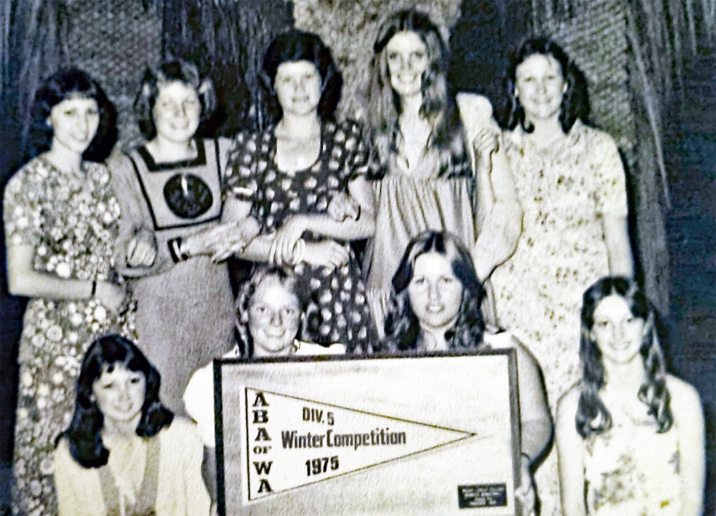

Photo: Debra Andrew – Sport competition

However, some people took sport fairly lightly.
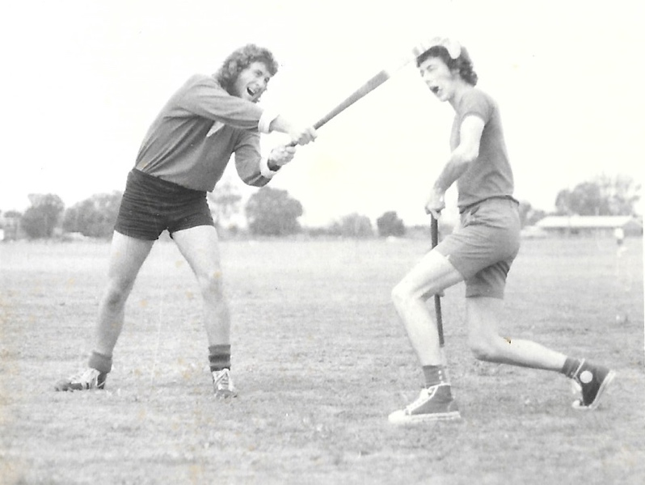
Photo: Neil Kidd – Robert (Neil) attacking Bill Reid

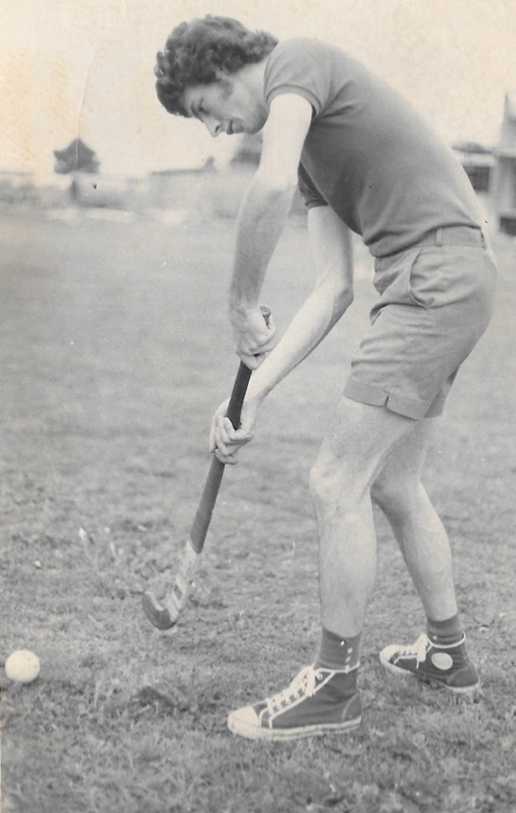
Photo: Neil Kidd – Bill Reid using the hockey stick as a golf club

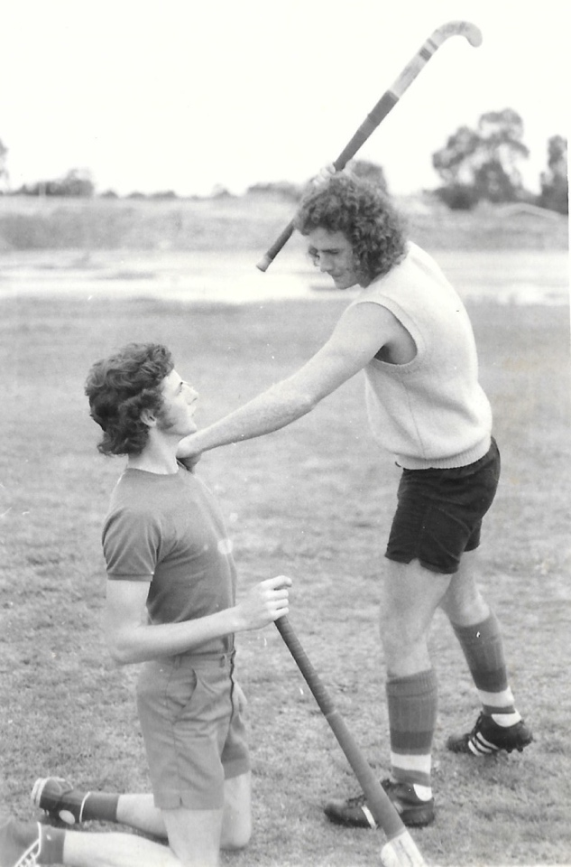
Photo: Neil Kidd – Bill McKenzie and Bill Reid mucking about
One of the more unusual sporting events was the ‘Fair Go” run against the WA Fire Brigade.
Clive Choate provides the following:
MLTC students were part of the ABC TV series “FAIR GO” in 1971
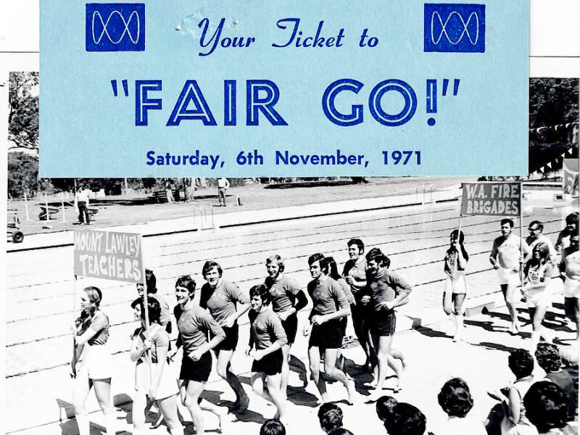
Photo: Clive Choate - (Pairs front to back) Rex Starling and Chris Rae, Clive Choate and Terry McNeill, Nik Djukic and Bob Ford, Terry Watt and Terry Coumbe, Ross Romeo and John Coccaro

Clive Choate: “MLTC Student Teachers run on during the opening ceremony in their contest with the WA Fire Brigade. The competition was held at Hale School pool and involved many different challenges: Putting up a tent blindfolded, surf reel races in the pool, obstacle races with a wheelbarrow and more. Young journalist Drew Morphett, who later became famous with AFL calling, hosted the competition”.
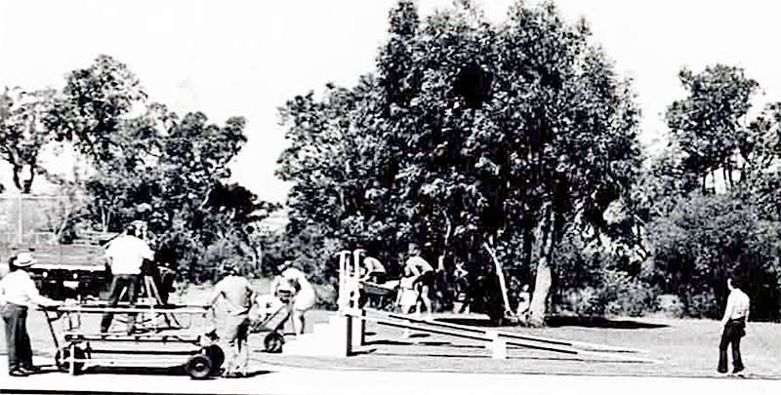
Photo: Clive Choate - Obstacle course with wheelbarrow – Commentator Drew Morphett on the right

Chapter 9 – The journey
The Mt Lawley Teachers College story is essentially a story of the coming of age. For the most part, the students were post war babies. Mostly they did not come from money and often, were the first in their families to be afforded a tertiary education. Tertiary education, before Gough Whitlam, was too expensive for most. There were a lot of women in the course, partially due to the fact that there were few professions open to women at this time.
Students were given a small stipend and bonded to the Education Department for three years. If you did not teach for the requisite number of years, you were expected to pay part or all of this money back. These are some of the thoughts of the students of this time.
Ruth Shean: “While we weren’t pub attendees at lunch time, we did enjoy the greater freedoms which went with post-school studies. Some lecturers regarded us as school kids — which we pretty much were — but others were very encouraging of our transition to a tertiary environment.
I have mentioned that we were generally a diligent group. When we did sewing, we were all required to prepare samples of knitting, crochet and embroidery. Most of us had done sufficient of this at school to be proficient, but set about dutifully working on our samples, often during other lessons. It is not difficult to sew, knit or crochet while listening. This became very popular, until large groups of students would happily proceed with their stitching work during all sorts of lectures. After a while, there was a polite request that we desist from such behaviour. I believe that some lecturers felt that we were not giving their topic our full attention.
There was a group of us girls who hung our together — Heidi Gfeller, Cathy Abe, Jo Nieuwkerk. I was of the view that if we worked as hard during the day as we possibly could, we would have more time to do the things that we wanted to do after hours. So, we were frequently found working together, during lunch times and other breaks. We were a collaborative team who worked really well together on grouped class assignments.
We would divide up the research, go off and do our own pieces of work, bring it back together and work out how best to join it up, then someone would write it up in a single hand. I don’t think that I ever had to do the handwriting, because I was as bad at writing as I was good at grammar. It was round about this time that I realised my study would be well served by my learning to type.
By the time I left MLTC, I was a proficient if unorthodox typist. To this day, my typing is still unorthodox, but fast and reasonably accurate.
We all did different majors so in our third year we didn’t share all of our class time together, but still hung out with each other for the most part. Add to that, we were all away the full term of long-term prac at the start of third year (1973 for us) so all the friendship groups broke up a little.
I did music and photography. I was already a pianist, but enjoyed recorder work and joined a recorder consort — for a brief period. I was not a talented recorder player because I never managed a mellow tone”.
Bobbie Smith: “I met and married the father of my two daughters, before our first teaching post in Pemberton”.
Neil (Robert) Kidd: “After three hectic years at MLTC we (Bobbie and I) thought a country posting would be a bit more relaxing but we were called upon to run the inaugural Karri Karnival at Pemberton in our first year out”!
Ruth Hutchison: “We were of the opinion you didn’t question why we had to do something – we just did as we were told. We didn’t have a course or people to compare the Mt Lawley course with. In hindsight I think we had the best 3-year course ever. It covered the important theory we needed but also a practical component, which meant we were very well-prepared teachers in our first year out. I’m not saying we knew everything, but we had a lot of resources to draw on.
Teacher support in the early 70s was not in the schools and you were really on your own. Today’s student teachers are getting all theory and very little practical at uni – then struggle in the first few years in the classroom”.
Marjorie Bly: “At the time there didn’t seem to be many career options open to women and one had to choose a career path so early. We generally had a choice of teaching, nursing, hairdressing, secretarial work or maybe becoming an air hostess. I was allocated to the ‘professional’ stream in first year high school so I got to do French and Social Studies B instead of typing and shorthand, eliminating secretarial work as an option. In addition, teaching was a fairly typical career path for members of my family back in the Netherlands so there was some expectation that I would follow suit.
During my time at Mt Lawley Teachers College, the legal drinking age dropped from 21 to 18 in 1970, so timely! There were Friday group lunches at the Knutsford Arms, with fellow students. Alcohol may have been drunk at these lunches and the following art lessons may have been enlivened by the predictable results, including fairly vague and incomprehensible answers to questions about the theory of art. Not sure if Mr McDiven ever cottoned on.
I remember the all-night assignment writing sessions after an active social life and still being functional the next day at college, or at least believing I was. I couldn’t do that now.
As a mechanic’s daughter I drove an old Vauxhall Victor that was always breaking down, usually at the most inconvenient moments. There was never a lack of students to ask for a push, though.
I existed, quite well I might add, on the $16 per week education allowance. The continuous assessment was so welcome after the stress of the previous year’s angst over the Leaving and Matriculation exams. Some of the other highlights of my time at Mt Lawley included: trying to learn the recorder with no musical talent. I usually ended up with the triangle during group music sessions. I liked the guitar playing option much better! I wasn’t any more talented but it didn’t sound as bad.
There was also a week-long geology trip in 1971, looking for and finding fossils, with Len McKenna. There was a sociology session based around ‘nature or nurture?’ and all the research up to that date couldn’t answer the question. It still resonates with me now for some reason. There was hearing about the possibility of being posted to Widgiemooltha if we didn’t study hard enough!
I remember watching drivers slipping and sliding around the oil slicks on the RAC driver training course at the rear of the college, on the other side of Central Ave. But above all, I remember doing my long prac at Como PS and discovering the teacher of my grade 5 class to be Miss Marsh – Fred or Colin’s sister. She looked very stern but was a great mentor”!

Demonstrations
Amazingly, Sue Hasleby retained her Demonstration notebook and has provided us with some of her notes, in exceptional handwriting.
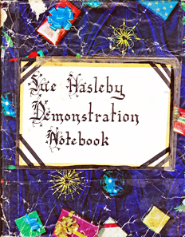
Demo Notes pdf

A radical change to the demonstration lesson organisation was introduced at the end of 1970. Instead of confining demonstration lessons to one or two schools, a pattern was adopted, based on the individual teaching strengths of the area. Ten schools participated in the scheme. Sue Hasleby indicated that some of these demonstration schools were: Mirrabooka, Yokine, Coolbinia, Tuart Hill, West Morley and Sutherland Street. Sue also provided examples of some of the notes she took. You can see these by clicking on the pdf.
The demonstration schools and 60 teachers participated to provide a more flexible pattern of lessons, a greater variety of teacher behaviour, less stress for participating teachers and generally fewer disruptions to the normal activities of the schools, teachers and pupils. A single demonstration lesson was conducted at each instance, which allowed for discussion and follow up micro teaching lessons.
In addition, this was bolstered up by the development of a CCTV system. The first stage of this CCTV system was completed in May, 1971, and the first video recording was made at MLTC, in June, using students from Coolbinia Primary. Shortly afterwards, this was followed by the first “outside” recording of a demonstration lesson made at West Morley Primary.
From 1971, Demonstrations were renamed “Teaching Workshops” and were conducted for everyone, one morning per week at a nearby school. These were general in nature, rather than specific. Their structure was a demonstration lesson followed by micro-teaching exercises with children at the school. On return to MLTC, there was a methods workshops and teaching peer groups with or without instant video replay.
Clive Choate: “We met at many nearby schools to observe lessons after which we sat down with the teacher who talked about the presentation. To facilitate this, two trainees would supervise the teacher’s class.
We observed a variety of lessons. One that stands out was quite a failure, but a good learning experience. The teacher of the Grade 7 class was explaining Pythagoras formulae. He had prepared well with squared graph paper and obviously gone to a lot of effort. But he’d made a mistake in the size of the squares and the length of the hypothenuse! His demonstration just did not work.
Under pressure, he couldn’t work it out as he taught the class in front of a dozen trainees spread around the room. In our evaluation he was flustered and didn’t have the answers. But our college lecturer broke the ice during the debrief and reinforced that not every lesson goes well! As we found out later in life! It was a good lesson for us.
One time at a demonstration lesson day, I along with Patricia Casey of our 1K group, was left behind to supervise the Grade 1 class after observing a lesson. The children had great activities to work on while their teacher discussed the presentation with the other trainees, in the conference room.
It was a cluttered but stimulating classroom with many displays and posters, and the students were diligent and highly motivated in busy work and enthralled by our supervision. There were kids at their desks, on the mats, quite a large class too. I felt quite bad when I accidently trod on one of the tiny Grade 1s and made her cry!!
We enjoyed teaching demonstration mornings. The variety was motivating and presenting teachers were very dedicated. It was a valuable part of our training.
As we gravitated back to college in Bradford Street, we also enjoyed a further ‘debrief’ at the Knutsford Arms which was our local watering hole for MLTC trainees”!

Rivka Finley: “Every week or second week, we would go to a nearby school and watch a teacher. We dissected this on our return. I remember one morning, after I had recently received my drivers’ licence. I had gone across the Freeway around 7ish in the morning, as I was not confident of my driving. I waited in the MLTC carpark, but it was virtually empty. Then, I remembered that we had a demo that morning. I tried for ages to cross the road from Bradford St hill to Alexander Drive, despite the lights. When I finally achieved the required result, and went to put the car into second gear, I found that it was in second gear”.
Micro teaching
Micro teaching was a concept originating from the Stanford University, in 1963. It was designed to improve teaching skills through a small, simulated, focused practice session. It involves teaching a short lesson to a small group of peers, followed by feedback, reflection, and re-teaching. The iterative cycle of planning, teaching, observing, providing feedback replanning, and re-teaching allowed professional development in a controlled environment.
The Department of Teaching Practice made considerable use of the recording facilities in their ‘micro-teaching’ program where students recorded segments of their own teaching in small group settings with school children from local surrounding primary schools. Micro-teaching formed an integral component of teacher education, and students could view and critique their own performance with constructive feedback from college staff and fellow students.
Micro teaching was an identifying feature of Mount Lawley Teachers College that differed from Graylands, Claremont and Secondary Teachers Colleges. In fact, the architecture of the college was built around it.
Annette Finlay: “The staff tried to introduce it in our last weeks of third year. We all revolted and wouldn’t go”!

Practicums
The Prac Department had a fluctuating staff population. This was largely due to the fact that MLTC was under the auspices of the Education Department of Western Australia, and therefore various teachers were seconded to this department for periods of 2-3 years. The constant in this arrangement, in the first four years, was Alan Jones, who was permanently assigned to MLTC. Lew Eborall was appointed in 1973 and John Love in 1974, and both of these joined Alan Jones as permanent staff until at least 1979.
The use of seconded staff supplied a variety of highly experienced teachers, who excelled in teaching and could impart their skills to the students. This also advantaged the staff involved, as it allowed them to continue employment with the Education Department and apply for promotional opportunities at the same time. Seven years after the opening of MLTC, Terry Watt and Gail Shannahan, two of the original MLTC students were employed in this role.
Before any Prac there was T.P.P.W. also known as Teaching Practice Preparation week. During this time, normal programs were suspended and assignments were arranged to allow students to concentrate on their preparation. The first day was devoted to meeting the staff and discuss the specific requirements of their teacher. Students were also able to receive their lessons a week prior, so they had a greater opportunity to prepare, with the help of MLTC staff.
By 1971, this was amended to T.P.W. or Teaching Practice Workshop. On the first day students visited their allotted school for a detailed briefing by headmasters and training teachers. The remainder of the preparation week was spent on:
- Method workshops with lecturers as resource people;
- Developing detailed lesson strategies;
- Preparing teaching aids and materials; and
- Building confidence and skills.
Teaching practices were important, and we looked forward to the school allocations which came from the basement at MLTC where Alistair Peacock and others presided. They were so important we traded our casual college gear for smart shirt and ties or suits, and the girls dressed up too.
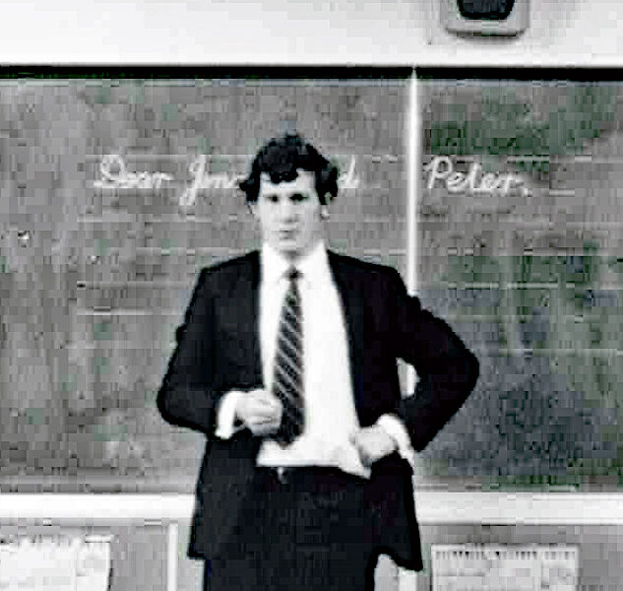
Photo: Clive Choate – Clive Choate on prac
Clive Choate: “I achieved notoriety too on my very first teaching practice. Being keen and enthusiastic, I arrived at the school early, found a good parking place and introduced myself to the staff room where we first assembled. From there we met our supervising teacher and went to their classroom to help ready the day”. “Would the owner of car XYZ please remove your vehicle from the car park immediately. You are in the principal’s car park”! “I sheepishly stole past the principal’s glares as I reversed my car and let him drive in. How did I know it was his spot? It wasn’t marked, but it was a great shady bay close to the office. I still got an ‘A’ for that practice though!
I enjoyed a teaching practice at Mt Hawthorn Primary with Grade 3s. We were told the principal never visited in the first week to mark us, but as I let the children in to start the day and my first ever lesson, the serious looking principal was the last one I introduced to five rows of desks where the students stood and we exchanged pleasantries. In those days we read the word, put it into a sentence and then gave them time to spell the word in their pads.
Music was always good fun and I entertained youngsters who appreciated my piano, violin, accordion and recorder skills. One of my mates at college was not musical and told Mr True his recorder didn’t work! He agreed, especially when he discovered my mate had drilled another hole underneath it! As I did my music lessons on prac, I had quite a cacophony of music coming from the room, so much so that the principal dropped in unannounced as did a few other teachers. I gave them all percussion instruments to join in!
Teaching music was fun! One practice saw my supervising teacher really struggling with a music lesson on the recorder. She was out of tune; timing wasn’t too good, she didn’t know the difference between a crotchet and a semiquaver, and it didn’t sound like the tune I could play quite well. But it was a case of saying, ‘no I’m not too sure about that song’ for fear of showing her up! You had to be a little circumspect on teaching practice!
Formal pracs demanded lessons well written up and many nights were spent outlining goals, how we were going to motivate the cherubs, equipment/teaching aids, content, evaluation and so on. Our Lesson Notebooks were closely scrutinised by our supervising staff.
I did a spelling lesson one time which I prepared meticulously with some interesting teaching aids of articles and cuttings. I highlighted in my lesson planning that they would be encouraged to have a go at difficult words, and not be embarrassed by having a go. Trouble was I spelt ‘embarrassed’ wrong in my lesson book with one ‘r’ and the supervising teacher delighted in crossing it with a red marker”!
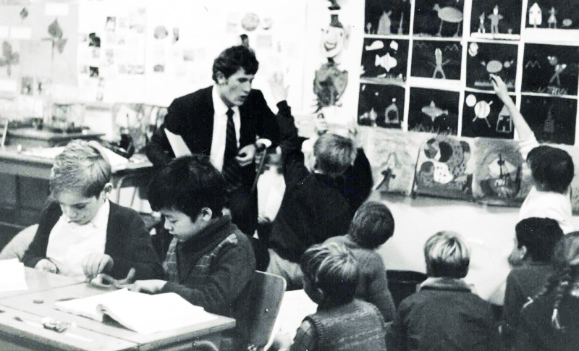
Photo: Clive Choate - Clive Choate on prac at East Vic Park Primary 1971

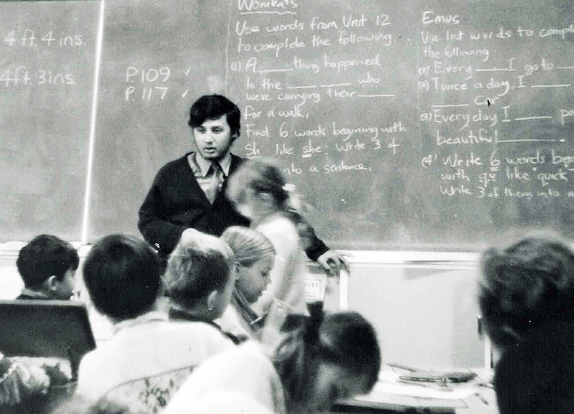
Photo: Clive Choate - Loyd Bolgia on prac at East Vic Park Primary 1971
Clive Choate: “We enjoyed our teaching practices. Towards the end of the academic year, we did a third practice where we could request a return to our own Primary School and do a week where we taught, helped, but didn’t have to endure a formal assessment. The hosting school loved the help and I had a wonderful time at Wandarra Primary School (now called Lake Monger) where I was a pupil in the late 1950s, teaching the kids who all knew me quite well. They delighted in calling me ‘Mr Choate’ which was different to our usual exchanges in backyard cricket in our neighbourhood”!
Sue Hasleby: “I was a country kid and did a country prac at Toodyay. Allan Jones called me in and asked if I wanted to go to Walkaway instead, but I stuck with Toodyay and celebrated my 19th birthday there. I have attached a newspaper cutting of this prac from July 1972” (see below).
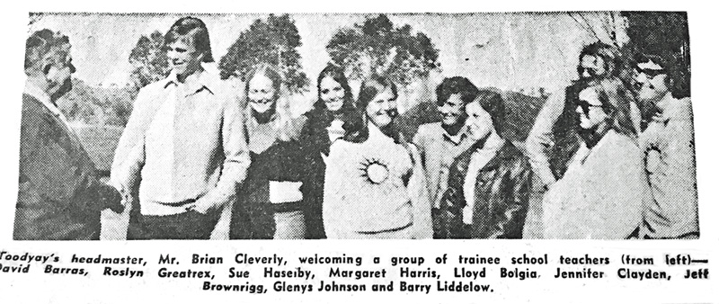
As you can see from Sue’s newspaper cutting, students did a country prac in their courses. You can also see Margaret and Barry proudly wearing their MLTC shirts!
Maria Kingma: “I did a country practice in 1971 at Yornup PS, a one teacher school. The school classroom is no longer there but the library is now a community space.

When John Accaro and I were dropped off at the bus stop opposite the school, no one was there to greet us. As we waved the bus goodbye I’m sure we could hear laughing coming from the bus.

Fortunately, we didn’t have to wait long for our host families to appear. I stayed with Peggy and Ross Campbell who were dairy farmers. I enjoyed the experience immensely.

I also did Pracs at Riverton PS, Lathlain Park PS, and Cannington PS (term prac 3rd year). I married in the January before my Term 1 prac in 1972 and at the end of my prac the headmaster told me point blank that married women teachers had no place in schools. His son was a lecturer at college. It really upset me but I got over over it! I don’t think a principal would dare say something like that in these days”!

Teresa Taverniti: “Country Prac - Coolgardie and Albany. Long Prac - East Maylands PS, now known as Maylands Peninsula Primary School. Weekly Dem Prac’s Coolbinia Primary.

Christine Hatzon: “I did a two week country prac in Merredin AND 13 weeks (ATP) in Pemberton. Seven of those weeks were in Neil Kidd’s Yr 6/7 class in 1985. I was soooo glad I went country! What a wonderful experience”.

Mark Chambers, a third-year student, did his prac in Blackstone. Blackstone is a remote location, east of the Warburton Ranges. It was without formal accommodation or teaching facilities. Students could end up doing a prac anywhere within Western Australia. The photo below, was in the Contact Magazine of Mount Lawley C.A.E, Volume 1, November 19, 1976.
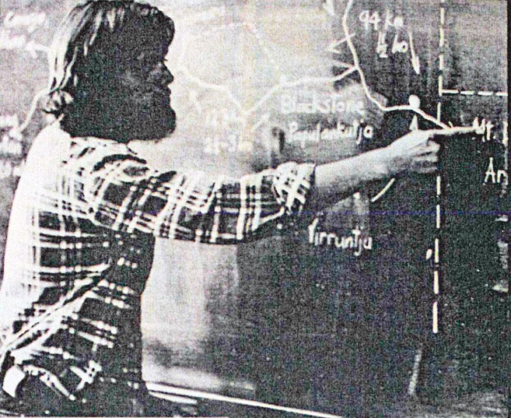
Photo Geoff Lovell - Mark Chambers speaking about his prac in Blackstone

Robyn Clutterbuck: “I did my first prac at Bayswater Primary where I previously attended for my final 2 years of Primary school. Interesting 😳 One of the teachers - was my Year 6 teacher and very prim and proper took offence to my lovely (made by myself) white summer midi skirt which became quite see- thru in the sunlight. She told me I needed to wear ‘a slip’ (petticoat) as you could see my panties and brassiere in the sunlight. Obviously NOT the correct dress code🤣😳
I did my long term prac at Kyilla in North Perth - very large migrant -Eastern Europe - population thus language challenges. My special project was a new student - Yugoslav I think - who I coached in English”.
Bobbie Smith: “I lived at Upper Swan briefly, so I had the greatest pleasure in teaching my little 6 year old sister in Year 1. Both she and her friend kept calling me ‘Bobbie’ at school, instead of Miss Smith and they were constantly in trouble!
I did my long-term Prac at Warriapendi in Balga. I had the BEST role models with the teachers in Junior Primary and copied every program I could by hand as there were no photocopiers for us to use. Fortunately for me, the Year 1teacher broke her leg, so they put me in her class for about 3 weeks on my own, as they couldn’t get a Relief teacher. Well, it was the best thing to happen for me and then fortunately I was appointed to a delightful class of 35 Year 1/2 students at Pemberton DHS for my 1st class and I was thoroughly prepared”!! ⭐️
Claire Pippet: “I was at Brentwood Primary, South Terrace in South Fremantle which had a huge migrant population and Melville Primary”.
Trish Harant: “I did a country prac in Three Springs. Stayed at my Aunty and Uncle’s house. Long term prac was at Guildford PS with Wayne Clark”.
Robert Neil Kidd: “I recently watched an 8 mm film which was part of my ASSISTANT TEACHER REPORT for long prac. at Attadale Primary School. Ties were expected. Men tended to wear shorts with long sox! [Minor prac. at Brentwood with Claire Pippet and Betty Granger.
Teaching prac students in long white socks - Bermuda shorts with long white socks, a short-sleeved shirt with a tie. Ties were expected. Men tended to wear shorts with long sox”!
Julie Hopkins: “Did we do weekly one day prac? It was North Beach P -country prac Greenbushes P, long prac Forrestfield P. I enjoyed all three. I think 3 of us girls were hosted by a private family at Greenbushes”.
Wilbur Klein: “Weekly Nollamara, Country Prac Nyabing and long Prac Northam Primary”.

Steven Salamon: “I did my Pracs at Mirrabooka (where I later taught), Booragoon and Westminster Primaries. Country prac at Greenbushes staying with the Principal. I remember attending a country dance in the town hall. The school sometimes shook as they set off explosives at the tin mine”.

Debra Andrew: “Meekatharra, Mt Magnet, Busselton and I think Nulagine. Bit sketchy as I went back and taught in some of these. I did maybe the first Indigenous/Aboriginal Studies sub major. Was amazing.” 

Susan Benador: “I started at East Vic Park then went overseas. When returned, I did a long stint at Bullsbrook, then eventually went into lecturing at ECU Churchlands and Joondalup for a couple of years”.

Part Time Jobs
Some of our student cohort were from the country, and though they had a living allowance as part of their bond, they needed to work part-time to help support themselves. As classes at MLTC were largely from 8 or 9am to 4 or 5pm, these part time jobs were often in the evening or in the weekend. From memory we got around $18 in 1st year to about $21 a year in 3rd year, as a bonded teacher. It was worth a lot more than now, but working part-time was probably necessary for most people. The country students were allowed an extra subsidy for housing.
Bobbie Kidd: “As a ‘country kid’, because my parents lived at Upper Swan, as I recall I got another $6/week Living Away from Home Allowance! 🥹
I was paying $10/week to my Aunty in Scarborough in 1973. Then when teaching at our first post in Pemberton, we paid $10/week RENT to the Fox family next door. We had an adjoining gate between the properties and were ‘surprised’ a couple of times in the early morning, when popping out off the back verandah, to the outside loo.
I think I was the first one to work at The Roman Forum and then ‘dragged’ in the others!! I left before having to wear the TOGA!! 🤣 I remember asking Marie, whom I think brought in Robyn and then Trish”.
Trish Harant: “I was a waitress at Roman Forum and Swimming Teacher in the holidays. I did have to wear the toga. Not easy going up those wonky stairs with a split up to your hip”.
Robyn Clutterbuck: “I worked at Roman Forum for most of my MLTC years. Marie Perrier (née Atrache) worked there too and Donna Dujat was a year behind us worked there too. I have a photo somewhere in my Toga 🤣”
Jo Mack: “I was a swimming instructor at Bayswater Pool and Army Reserve. Had been working as a shelf-stacker and bag-packer at Woolies Mount Lawley for years but they gave everyone the sack when we turned 17 because the rate of pay went up”.
Jenny Tod: “I waitressed at a coffee shop, which I didn't like, and served in my mum's fish and chip shop which was opposite the Shenton Park pub (the ‘Shents’). I did Sunday afternoon and evening. There was always a big rush for fish and chips after the Sunday session finished”! 🤣
Claire Pippet: “I was a waitress at Captain Stirling in East Fremantle, Coles, Ardross and Swimming Teaching in holidays”.
Sabiha Masuk: “I worked as an usherette at cinema city”.
Susan Benador: “I worked at David Jones in Swimwear dept on weekends and holidays fulltime. I also worked at Kings Park restaurant as a waitress”.
Marilyn J. Jackson: “I worked at Readers Mart - Sunday Times - answering Readers Mart callers and typing their advertisements. It was crazy, so busy”.
Wilbur Klein: “I did farm labouring during the breaks; harvest, hay and straw baling and carting; shearing shed work”.
Jan Bell: “I worked at the local Milk bar”.
Robert Neil Kidd: “I worked for 50c/hour at the local service station in Mt Pleasant. I think I started in high school! My mate was getting $1/hour down the road for less work”.
Looking back, it is difficult to imagine that $6.00 per week would be sufficient to fund appropriate student boarding.
Sue Hasleby: “I remember us country kids got $6 extra. In 2nd year I paid $10 rent at Yokine in two rooms (kitchen and bedroom and shared toilet shower laundry on back verandah) and then still had to buy my own food, and pay the bus to college. Thank goodness my boyfriend paid for our social life. I did do a little babysitting though. I got married in 3rd year”.
Bobbie Kidd: “I think I paid the same amount to my friend Karen’s mum, in Flinders St Yokine, in 1971, when I first had to board. We only lived 5 mins away from MLTC in Yokine, but my parents moved to Upper Swan at the same time, to run Ginger’s Service Station in the Great Northern Highway. I use to climb up a ladder and clean the windscreens of those huge Gascoyne Trading trucks…..aaarrggh, the good ol’ days, hey”?🤣
National Service
In 1964, the National Service Act introduced a scheme of selective conscription in Australia, designed to create an army of 40,000 full-time soldiers. Many of them were sent on active service to the war in Vietnam.
In 1971, the Vietnam War draft for Australian national servicemen continued via a birthday ballot, despite the impending withdrawal of combat troops announced in August 1971. National Service involved two ballots per year. Numbered marbles with specific birthdates were used to determine who was called up.
Temporary deferments were available to men on grounds of exceptional hardship or compassion, and to students, apprentices and trainees at universities, teachers' colleges and technical colleges to avoid interrupting training for primary qualifications or for apprenticeship.
Male students going to Mount Lawley Teachers’ College, in 1971, could be conscripted, based on their birthdays. Any of the males in the first and second intake were at risk. This was a lucky dip that no-one wanted to win! However, should MLTC student have been conscripted, they would have been allowed to complete their Teaching Certificate before their call up.
Clive Choate: “I was in the last ballot. We sat around the radio as they announced all the July birthdays where you had to serve. If you had started a course like teacher training, you could finish it before serving. My date wasn’t called up”.
Ken Wyatt: “My number was drawn and received my conscription enlistment papers to fill in and return. I had a medical and when Gough Whitlam was elected, I received a letter advising that I was no longer required. An interesting time in Australia given I had people I knew who were conscripted and served in Vietnam”.
Janet Gogerty: “I certainly remember the day when everyone was so happy, especially the boys, when we heard conscription was ending. All the way with LBJ, terrible idea”.
Terry Watt: “I was called up to National Service in 1971. I was in second year at Mount Lawley Teachers College,19 years of age and at my now wonderful wife of 51 years, Lois Whittle’s home in Morley on the night of the September ballot. There were two ballots a year, one in March and one in September for 19 year olds, who would turn 20 years of age in the following year.

The selection was by means of a lottery like ballot with wooden ballot balls with birth dates on them broadcast on television. A little like the “Oz Lotto” is now. My birthday, 19th August 1952 came out and I was officially conscripted. I would be a “Nasho” or National Serviceman, bound to two years of training and armed service overseas, in my case Vietnam, then 3 years of part time Army Reserve.

As someone who was at Teachers College or University I was not to proceed to National Service when I turned 20 but was to finish my course in1972 and head off for training, possibly as an officer, in 1973 or 1974.

I was a bit concerned as some 100 or so conscripts, Nashos, had already died in Vietnam.

I had been an Army Cadet in High School in Collie in years 9 and 10 and had some basic training. I could fire an Enfield 303 rifle, a Bren gun and an Owen machine gun but that was adolescent stuff. The thought of going into an overseas war I did not support was something else. Nevertheless, as a patriotic young Australian I was prepared to “do my bit” I did not attend Anti-Vietnam Rallies or become a ‘Conscientous Objector’. Some of my fellow students did. I just got on with my studies, trying not to dwell on the inevitable.

Luckily for Lois and I, Gough Whitlam was elected in December 1972 and almost immediately ended conscription. Getting Australia out of Vietnam was a major plank of his election campaign and he believed “Conscription by Lottery Draw” was not an attribute of a free nation.

Every time we listen to the Redgum song “I Was Only 19” when we are driving down south, Lois and I would think “that could have been me or us”. That song is on the same Spotify album as Eric Bogle’s “And the Band Played Waltzing Matilda”. Both songs have powerful, haunting and relevant lyrics”.

Terry to this day, listens to songs such as: “I Was Only 19” – around his age at the time of conscription and “The Band Played Waltzing Matilda”, both songs with negative vibes of the Vietnam war.
“So they gathered the crippled, the wounded, the maimed
And they shipped us back home to Australia
The legless, the armless, the blind, the insane”.

Thankfully for him and several others at MLTC, who were conscripted, when Gough Whitlam became Prime Minister in 1972, he was opposed to the idea of war and conscription. He ended Australia's involvement in the Vietnam War and withdrew Australia's remaining troops from Vietnam, thus Terry and the others never had to go and were acutely aware of their near miss.

Chapter 10 – Graduation
After first year, a number of students were allowed to either do a specialised subject, or move full-time to a course at UWA, WAIT or Secondary Teachers College.
1972 Graduates
The majority of people, who did not drop out of the course graduated. The first intake graduated at the end of 1972. In those days the papers reported graduations, as shown below.
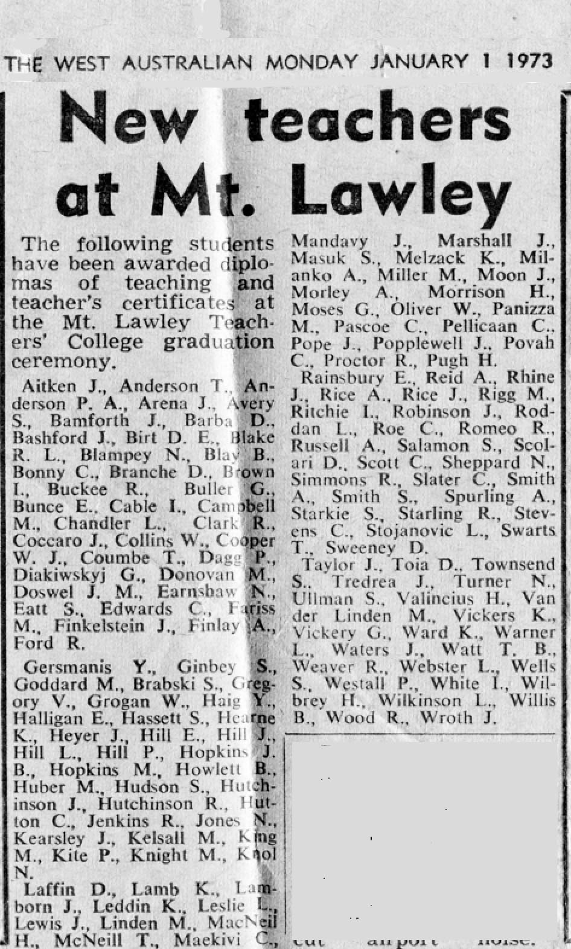
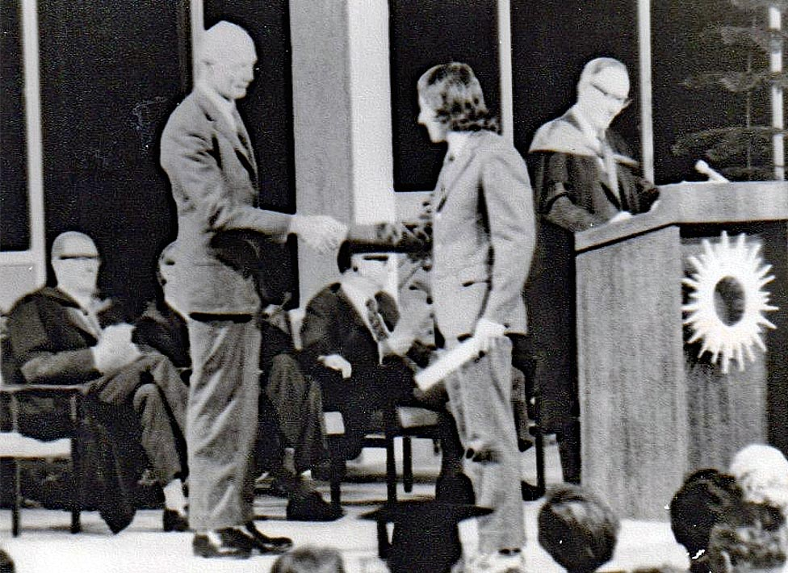
Photo: Terry Watt – Terry in the first group of graduates from MLTC
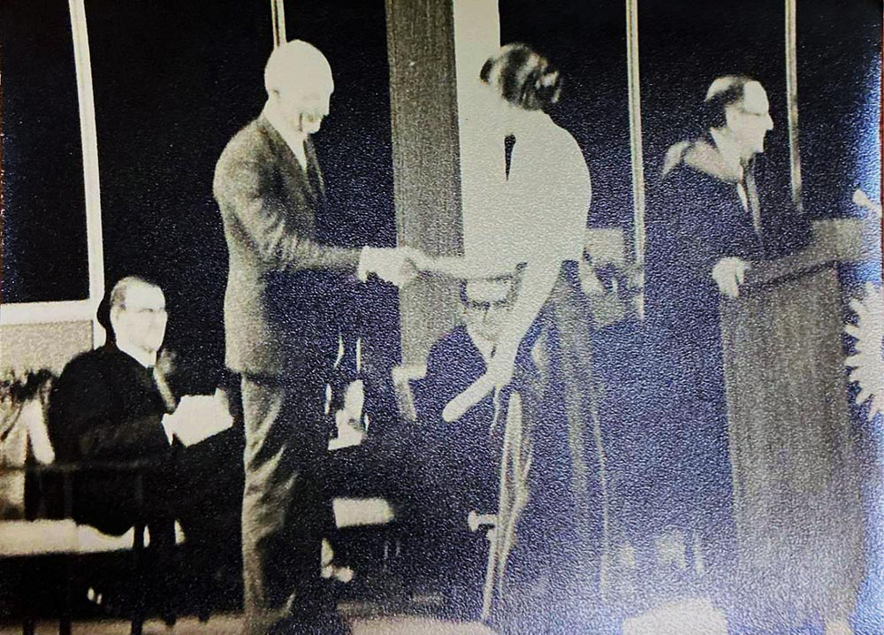
Photo: Annette Finlay – graduating

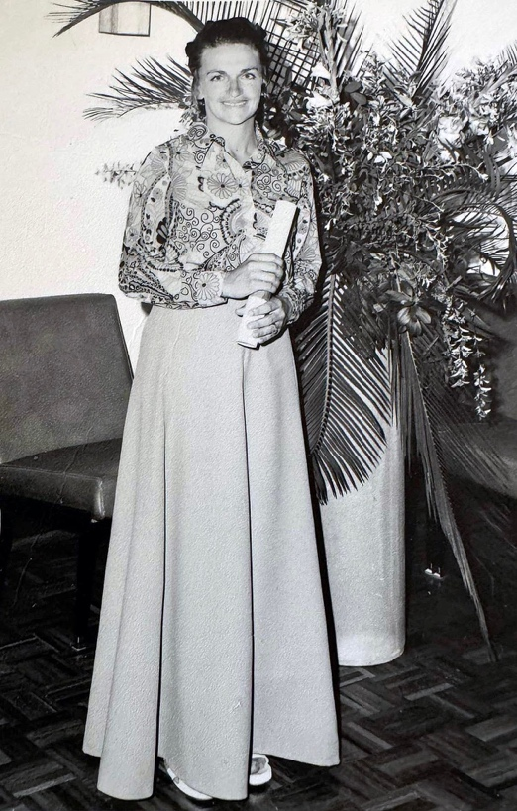
Photo: Maria Kingma - My Graduation photo taken after the ceremony - there was a professional photographer available - I was thinking lots of us would have had photos taken. I was wearing a hot pink skirt with a psychedelic brightly coloured top!
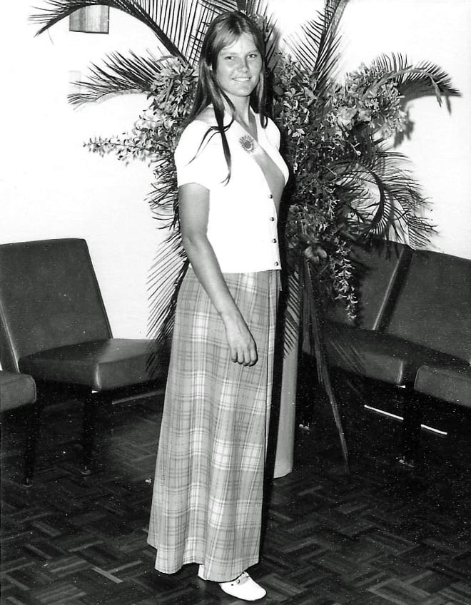
Photo: Margaret Harris – ushering at the 1972 graduation
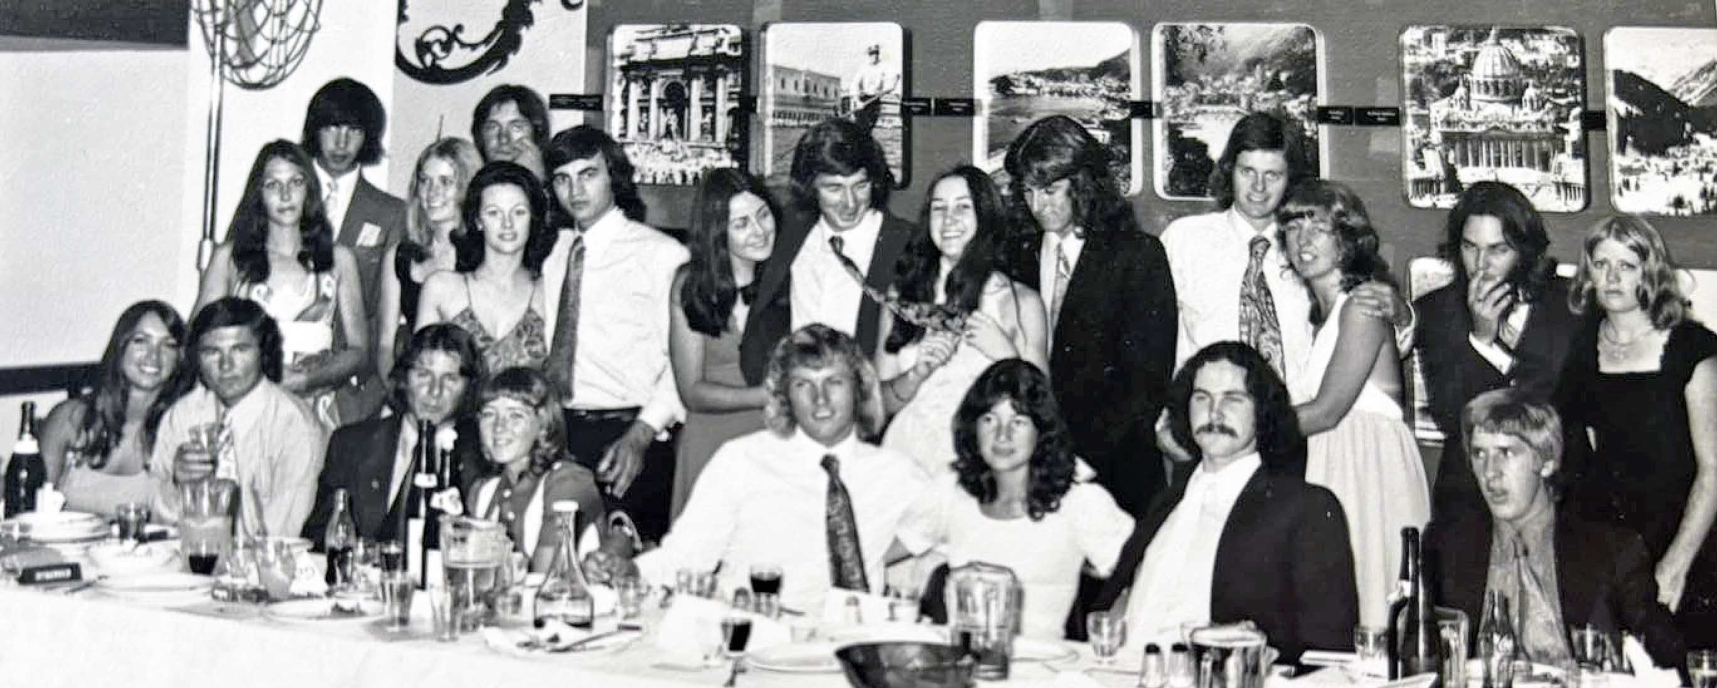
Photo: Claire Pippet – 1972 first intake - graduation dinner
1973 Graduates
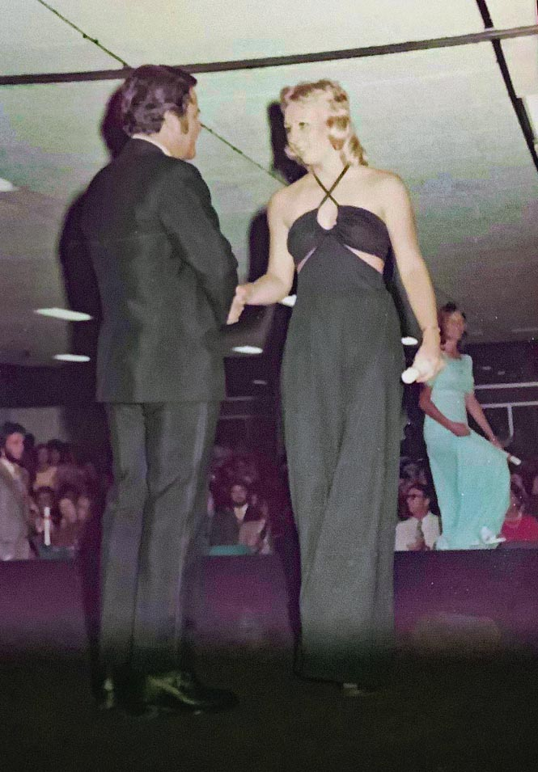
Photo: Trish Harant – graduating, followed by Margaret Harris and Robert (Neil) Kidd
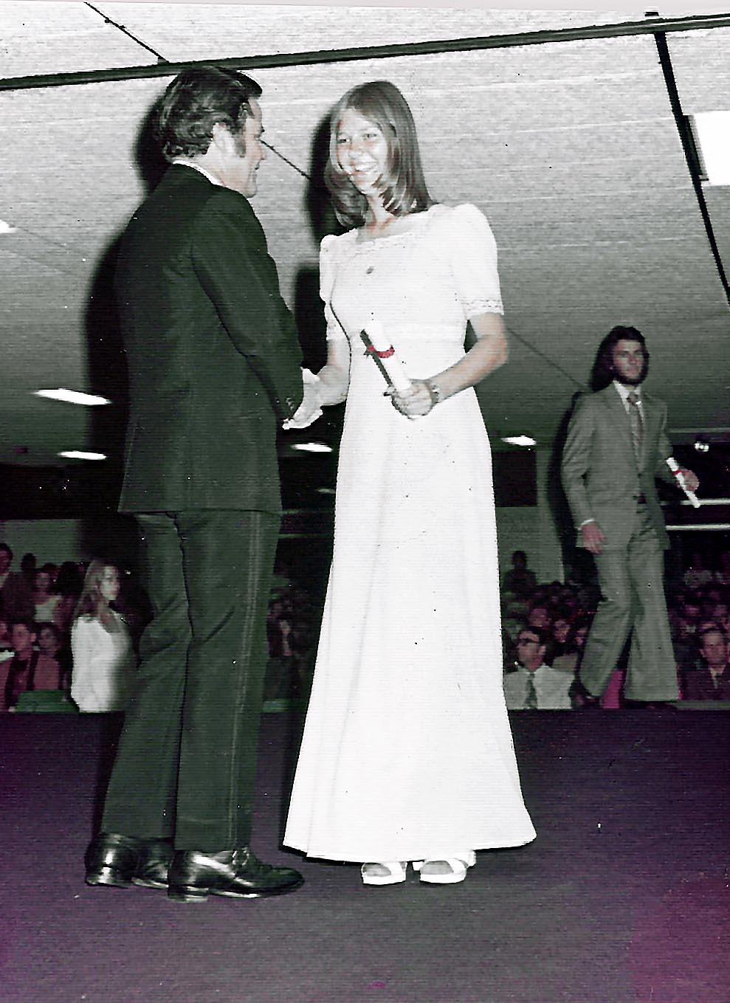
Photo: Margaret Harris – graduating on stage with Robert (Neil) Kidd and Sandy King in the background
Bobbie Smith: “Our great little Recorder Ensemble actually played at the Graduation & I can’t even remember doing that. The proof was seeing it listed on the program… ha ha”! 

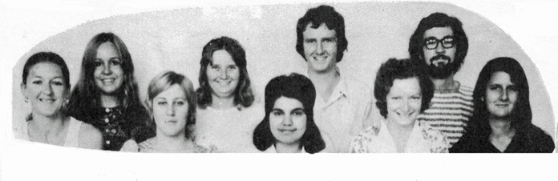 | 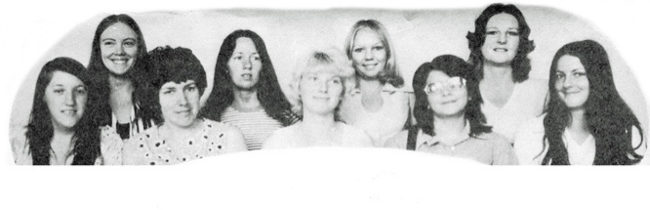
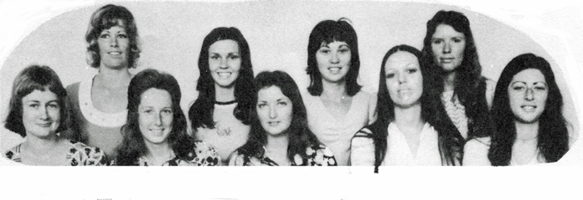 | 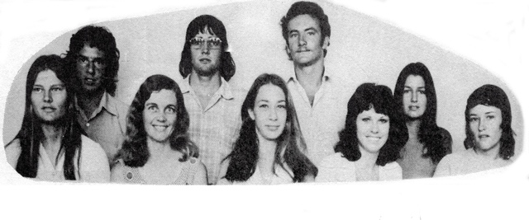
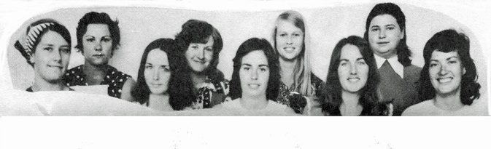 | 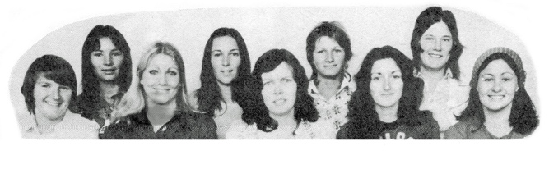
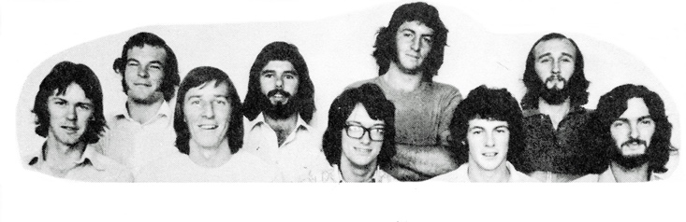 | 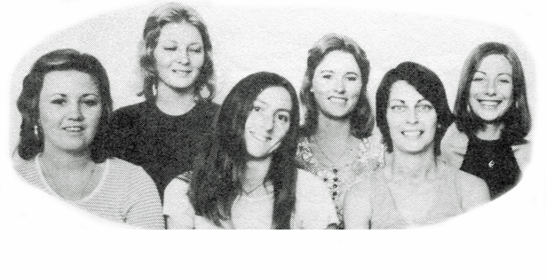
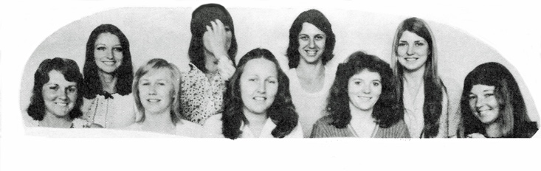 | 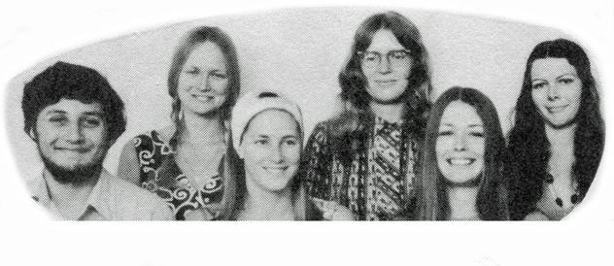
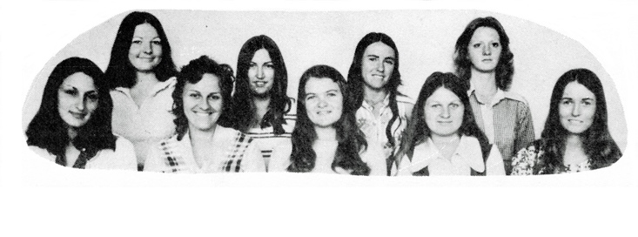 | 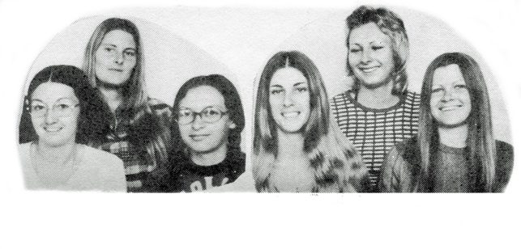
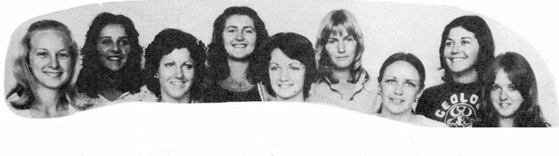 | 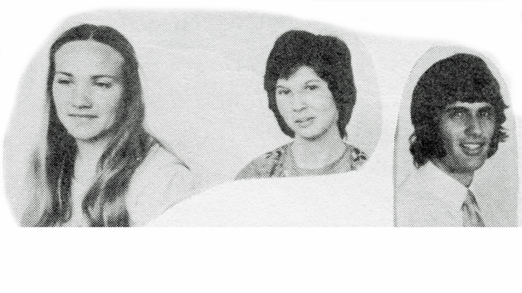
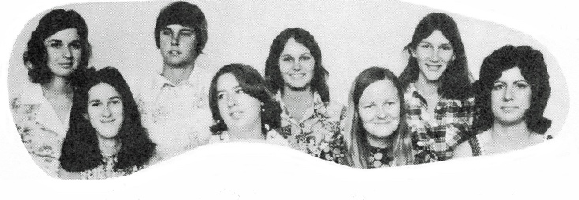 | 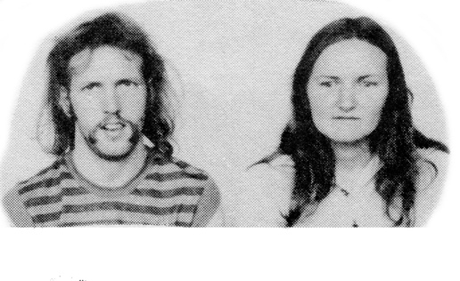
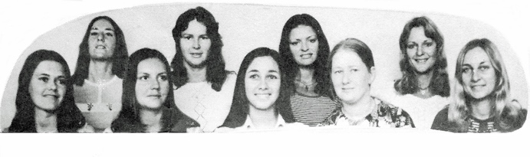 | 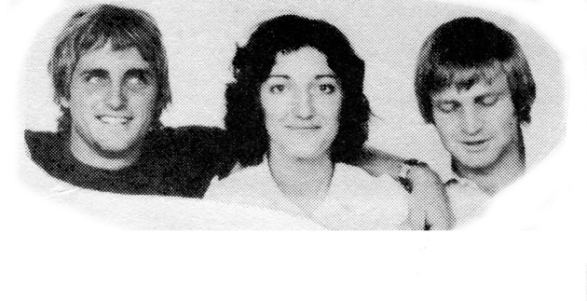

The list of graduates in 1973 is as follows:

Photos: ECU
Alan True: “Our musical achievements at Mt Lawley actually were quite many and varied but I’m most proud of the fact that I managed to get my way on Graduation Ceremonies. I was on the committee for what we were going to do at Graduation Ceremonies.
The first two were held on campus, and after that there were then too many graduands to accommodate at one time. They couldn’t possibly fit, so I said: ‘I want them to be in the Perth Concert Hall. It’s available and it’s much larger’. “So, all the teaching students were done on one evening, and all the others were done on the next. I said: ‘And I’ll play the organ, for free’.
We had to have music in each graduation and this has been established from the very first one, which was held in the courtyard, and the second one, which was held in the refectory, which was newly built. We soon developed a history of having multiple music items interspersed throughout each graduation ceremony. I’m very proud of that, because each of the staff members had a role to play, because they were all good at what they did.

One of the most memorable was done by Jean Farrant, where they got dance students from the Phys Ed Department and the choir from the Music Department doing a series of Negro Spirituals, chosen by Jean and the dancers did free modern dance to each of these. It brought the house down! It was absolutely marvellous! I still remember it vividly, after all this time.

The organ at the Perth Concert Hall was really quite a special instrument, installed in 1974, and I quickly became the organist for all the ceremonies. It eventually eventuated that I would play for several different ceremonies in a given year”.

Chapter 11 – Off we go
At the end of their course, students were sent out, often rather unready, to the country. They were usually placed in GEHA housing (Government Employee Housing Association). Groups of teachers were placed in the same house and had to do things like chop their own wood and look after themselves.
The GEHA housing was not necessarily the same throughout the state and in some cases none existed. This section talks about the various placements, the housing offered and the experiences of the first year of teaching.
Placements
Margaret Harris: “I have so many memories of Friday afternoon lectures with Mr Marsh in our final year. Some of our friends would go to the Knutsford for lunch and come back for the lecture. We would drive down to Dianella Plaza for our lunch. Those who had not been to the pub had the task of ensuring they kept quiet in class and were not giggling during the lecture.
I was, like most others, bonded for 3 years. This did not worry me as I had no plans to leave teaching. I actually received 2 offers of a school for my first placement. The first was at a primary school and the second was as a Physical Education teacher at Bridgetown High School. Of course I chose Bridgetown. I was so thankful that Bruce Sinclair, or someone else, had allowed me to be offered a PE teaching career”.
Clive Choate: “As a mature age student at MLTC, I loved my time there. I’d spent some years in Sydney playing rugby and working in surveying before returning to my home state of WA. The grounding for teaching and the friendships made at MLTC were excellent.
Anne Hetherington, Heidi Gfella, Patricia Casey, Ruth Shean, Elizabeth Lutterell, George Svich, Roslyn Greatrex and Roger Baggely were good friends. The rapport with staff in the classroom, on teaching practicums, at camps and other events prepared us well.

After first year, I was invited into the 3PU pathway where I studied the new B.PE degree full time at the University of WA while concurrently doing a Diploma of Teaching at Secondary Teachers College. I missed my friends at MLTC but still loved the teaching side of education.

I married Lynne Bamford, a geology student and maths teacher, whom I met at UWA when I joined the University Athletics Club. Track champion Grace Piccardi would know Lynne who was also a WA 100m champion. Lynne, like Margaret Harris (Saunders), went on in later years to race regularly overseas and was a 100m World Champion in the W40 age group. Marg is a good friend of ours and is still winning Masters’ Australian Titles today!

After 5 years teaching in the city, we transferred to Pinjarra SHS in 1980 where I was Head of PE. The school was a great country school with a rich history of Fairbridge Farm students, local farming children, Pinjarra town kids and Mandurah students finishing their last two years at a Senior High School. I taught PE, Maths and English.

In the early days we taught in gum boots and heavy weather gear as there was no gymnasium. Students were often late to school as the cows or horses got out. The Murray River was just metres from the school boundary and adventure canoeing and bush navigation were subjects. We conducted many camps through the Scarp and in the South-West bush and coastland.

The annual Senior High Schools Country week, held at McGilivray Oval in Shenton Park, was the sporting highlight of the year. The week-long festival saw us take students who hadn’t been to the City before. Some hadn’t even seen or been on the Swan River.

I remained at Pinjarra SHS for the next 32 years with roles of Head of Department and Deputy Principal. I interacted with many teachers in the Murray District and had numerous friends in both the Secondary and Primary sectors. In retirement now in Mandurah, I meet up with a group twice a week, most of whom were Primary Teachers.

I enjoyed many sporting competitions and interests with teachers, including triathlons around Australia, national canoe marathons and horse endurance events. I competed in the Blackwood Marathon Ironman (solo) race for 25 years straight, adventure races, and MTB events through the Kimberley and Central Desert. At 63 years I ran my first marathon in the sand at Uluru. Three years later I had run a marathon on all seven continents - the first West Australian to complete a marathon on all the continents, where the Antarctica race was at 80 degrees South on Union Glacier in heavy snow and ice. In neg 30oC, our sweat froze as we ran!

While I began my teacher training at MLTC and then transferred to UWA and STC as a 3PU student, I was always very grateful for the wonderful teacher training that got me started. The methods and applications were readily transferable, with a greater focus on teaching and promoting student motivation in so many different areas of learning.

My life has been rich, thanks to teaching! What a wonderful cohort of staff and students we were lucky to meet. Fond memories of MLTC”!

Often MLTC students worked together when teaching. Sometimes, these were people from the same years and other times people from other years.
Bobbie Kidd: “Neil Kidd and I taught at Pemberton together for nearly 10 years. Then after the birth of our 1st daughter, we were the 1st married couple to TANDEM TEACH in the south-west”! 👍🏆🤭
Lee and Mel Broun: “Mel and I married during college, started teaching in 1975 and retired end of 2016. We taught in the same school North Parmelia, then Mel at Hainsworth 1977/1982 and I at Camberwarra.
After that we taught in the same schools right up to retirement, team teaching together. We taught with Trish Rex, Elfria Sibma, Frank Scarfone, and Linda Maher at South Ballajura. Very fond memories.
We were with Elfria and Frank from the 1972 intake. Also, Mel taught with Sue Peggs at Hainsworth in 70s. Sue was from the 1971 intake”.
Trish Rex: “I had the great pleasure of working with Steven Salamon of the 1970 intake and also the lovely Lee and Mel Broun who were from the ‘72 intake. Lee and Mel Broun absolutely great memories at Sth Balla”.
Steven Salamon: “I Taught with Naomi Brown (nee Jones) at Mirrabooka and worked with Teresa Ferguson at Maylands Peninsula”.
Teresa Ferguson: “Steven Salamon I enjoyed working with you. You were one of the best Principals to work with”.
Kerry Paddon: “Sue White and I taught at Glen Forrest. Sue was there in 1974-1975. I joined her in 1975”.
Sue White: “Then Christine Winczeweski (Todd)came too”.
GEHA housing
GEHA Housing was set up to assist with recruitment and retention of essential public sector workers employed by the government, such as teachers, nurses and police, in regional areas. This accommodation attracted subsidies, and the rent was taken from your pay. However, not every small school around the state offered GEHA housing.
Claire Pippet: “No not in Doodlakine! They told me to stay at the pub when the farmers didn’t want to billet anymore”!
Robert Kidd: “After I graduated from Mount Lawley Teachers College with a Sociology award in 1973, my wife and I successfully applied for positions at Pemberton, which was a Junior [District] High School. We had ‘Decided to move to Pemberton while at Mt Lawley Teacher’s College so I wrote a letter to the Director General of Education!’ “I was proud and idealistic and ready to change the world!”
No house was supplied by the Government Employees Housing Authority (GEHA) but we managed to get a cute little old weatherboard and corrugated iron house to rent on the street behind the pub. The rent was $7 a week and we could book up any hardware we needed at the local hardware shop. We painted some rooms and even had some of my students over one weekend, to oil the outside boards!
In 1976, we were posted to Derby District High School and flew up, while our near new VW Kombi was sent on a truck. The heat was over-whelming and we had to make our way to the GEHA agent for our keys, then onto the school and house. This house was tidy, cyclone proof and just across the road from the school. The back yard was overgrown with Kangaroo Grass, but wisely I had brought up my Dad’s old Victa Lawnmower!
Only 2 years - in Derby - Lot 554 Knowsley Street; now named 12 Knowsley St. After the houses we lived in at Pemberton it seemed nice”.
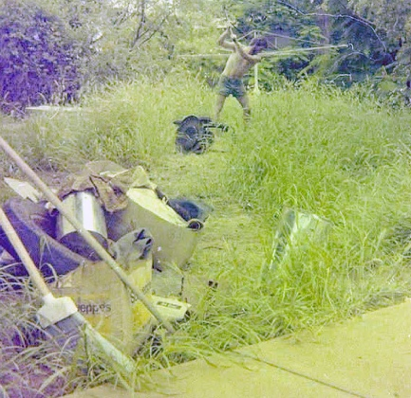
Photo: Neil Kidd - me trying to tame the backyard
Bobbie Kidd: “For our very 1st appointment to Pemberton, we had to find our own housing, in fact 2 places in 2 years. Then we had GEHA housing provided in Derby, followed by Northcliffe, after which we lived in a 27’ caravan whilst we built our own house, on our wonderful 58 acres in Pemby”! 
Wilbur Klein: “We inherited mostly poor places, not cared for. We built gardens, improved inside, landscaped, only to find too often the next tenants reverted to type and let it all go”.
Christine Hatzon: “Coolgardie for 2.5years. Big back yard … Borrowed a horse every few months to ‘mow’ the grass”!

Julie Hopkins: “Yes I did in Harvey 2 years 73 and 74. It was very new and comfortable. I don’t know who looked after it, we certainly didn’t. Lawns were done, firewood delivered. The 3 of us mostly went back to Perth on weekends”.

Margaret Harris: “I was appointed to Bridgetown High School and had to find my own accommodation in Bridgetown as GEHA had no rooms. One male was in one side of the duplex and other side had three females. So, I had just turned 20 years of age and drove down to Bridgetown the week before school began. I walked up and down the main street stopping at each shop and asking if they knew anyone who would rent me a room as I was about to start my teaching career.
I finally managed to find a room where I stayed for about six months before I moved into a flat near the school. At the start of the year, one other female was in a hotel for at least one week before she found board. I think maybe five female teachers had to board that year. I only stayed one year in Bridgetown as it was very small school and about half the staff were graduands in 1973. I was transferred to Margaret River High School for the next two years. Here I was able to live in a GEHA duplex”.
Trish Harant: “5 years in RobinsonSt, Cooke Point (Port Hedland). It was great once they fixed it up. It took one month to fix and repaint and refurbish it. They were going to put us up in a hotel but I said that they would have to work around us which they did beautifully”.
Ian Francis: “I had a room in a boarding house for a while in Moora then moved in with secondary teachers. It was ok. I spent 15 years in GEHA in Kununurra. It was really good.”

Annette Finlay: “I had GEHA in Newman, Cocos Islands, Geraldton, Bridgetown and Tom Price - mostly had really great housing”.

Lee and Mel Broun: “We had two years in South Hedland. No garden to worry about but the north west cockroaches were a sight to behold as they emerged at night”.

Sabiha Masuk: “Yes, in Wyndham”.

Janet Gogerty: “In my first and only year of teaching I boarded with a prison officer and his family in Fremantle, then I suddenly got moved to Merredin at Easter to cover maternity leave and stayed in a motel where I was the only female, but there was another new teacher who was a good bloke. Then at the local amateur dramatics one of the local stalwarts of the community offered me board to keep her company while her husband was working away. They were a lovely family”.

Robyn Clutterbuck: “Gairdner River (south of Jerramungup) - Long service relief for Principal thus had his house next to school. The acting Principal was very relieved I was a ‘practical girl’ as it had a wood chip hot water heater, which required chopping wood and a petrol power generator 50 m down the backyard, which had to be switched off at night before bed!
Also, the house not far up the road from the Wheat Bin and had a continuous mouse plague – I invested in a cat to help with the problem. A great posting but only for six months then transferred to Carey Park, Bunbury but had a car accident and ended up with a city posting”.

Rivka Finley: “After a year in the metropolitan area, I was posted to Katanning, in the wheatbelt area. I shared a house with two other girls, with whom I had nothing in common. My friends lived in a different GEHA house, but it was not possible to swap.
As I was the first person to arrive in my GEHA accommodation, I got my pick of rooms and picked one which had a fireplace or chimney. Either way, I was unused to country living and did not realise that in the wheatbelt area there are lots of rodents, all of which descended into my room.
When I went to bed at night, I could hear the skittering of their claws on the wooden floor and was petrified they would crawl over my face, while I was sleeping. I put down Ratsak, but then I had crazy rats walking around day and night and dying on the floor. In the end, because of the rats, the people I lived with and the fact they didn’t give me my requisite DOT time, I quit and left teaching forever”.

Chapter 12 – Where did we end up and how did MLTC help us?
Students entered Mount Lawley Teachers College, with the intent of teaching primary students. Some transferred to Secondary college to teach secondary students. Some people left teaching and others stayed. This section allows students to indicate where they found their place in the world and if MLTC helped them in their lives and various careers.
Often, the schools posted photos of the new teachers at the school in their local newspaper. This photo shows new teachers to Paraburdoo including MLTC graduates: Bruce Blay, Dianne Blay, Phillis Broadhurst and Kingsley Iddon. You can read more about these teachers in the Trove link, below.
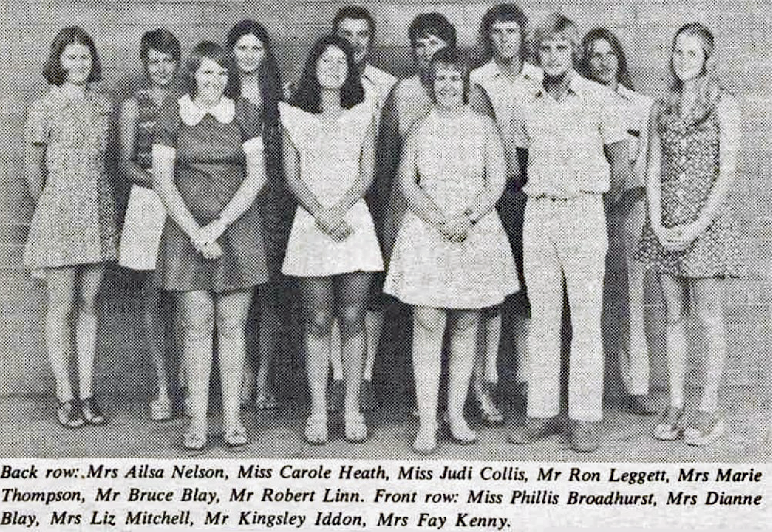
Photo: Hamersley News 11 April, 1974 https://trove.nla.gov.au/newspaper/article/214545816

Moved to another institution part of the way through the course
Rivka Finley: “I really loved my year at Mount Lawley Teachers’ College and vowed to return and work there. In the interim, I studied at STC and WAIT and ended up teaching at Mount Lawley Senior High and Katanning. I worked in ESL, but there was no training for this at all, but a big need as many ships from Italy, Greece and the former Yugoslavia, were arriving packed with new immigrants. I was given a series of books called Situational English, and left to my own devices.
The rats and mice in Katanning, curtailed my teaching career. The skills I learned at MLTC put me in good stead to work at Curtin in the ESL section. My materials were authentic and other teachers wanted them and also liked to team-teach with me. I taught ESL at TAFE in Queensland, when I was studying at UQ, as well as designing learning materials for the deaf at Griffith University.
Later, I finally made it back to MLTC, which was then ECU, where I worked for nearly 10 years, in the language laboratories, and ended up doing de facto teaching with staff, using the latest technologies. Before retirement, I did a 7-year stint at Curtin as a webmaster”.
Clive Choate: “After one year training at the MLTC, there was an opportunity for some to take a different pathway which led to Secondary teaching.
The 2S3 pathway saw students transfer to Secondary Teachers’ College in Hampden Road, Nedlands. The Diploma of Teaching course was completed at STC, but trainees also had an opportunity to enrol at UWA to complete a few University units before starting their teaching career two years later.

Another pathway was 3PU which gave the trainees an extra academic year. Students who already had a matriculation could go from MLTC to a full-time course at University. The ‘3’ indicated the additional 3 years. This was not a common pathway.

3PU Students enrolled full time at University and concurrently completed the Diploma of Teaching at Secondary Teachers’ College. As well as teaching in Secondary Schools, there was an advantage of graduating with a degree and being placed on a higher salary band.

Bruce Sinclair suggested I enrol in the new PE degree at UWA as a 3PU student. I always wanted to be a primary school teacher, but I was a keen PE student. After completing a B.PE and a Diploma of Teaching, I was appointed to Balga SHS for 3 years and then taught at Melville SHS.

I joined many teachers who raced from school to make the 4:15 pm lectures which went late into the evening. For the next 4 years after graduating, I was a part-time student completing a Diploma in Education and a B.Ed degree. It was difficult to stay awake sometimes after a busy day at school, and the lecture rooms saw, and heard, a few naps being taken”!

Got married and/or had children
Marjorie Bly
“I never taught formally – I married young and had children early. I did run a pre-school at Cocos (Keeling) Islands for a couple of years when my then-husband was posted there. I’ve also used the skills I learned to develop and present a range of public education seminars over the years.
I found my real calling when I ended up working for the National Archives years later – a perfect melding of my passion for history, archival records and helping people through research and education. (It was my pleasure to run a very successful practicum program for ECU Archives and Information Management students when I became Assistant Director in 2005).
My MLTC years formed a substantial part of that bridge between being a child and becoming a grown up. The new style of teacher education, a new building, new colleagues all played a role in how I matured. The times were reflective of that transformational change; the Vietnam War was happening, social change was all around us – the Pill, equal pay for equal work, universal health care, free university education, the ending of the Vietnam War and the end of conscription, to name a few.
It was an exciting time to be involved. I really value the life experience I gained during that part of my life”.
Had a pathway other than teaching
- Betty is a keen yachtswoman.
- Bill Reid has specialised in providing a consultancy service to public sector organisations for over 25 years.
- Gary Buller and Wilbur Klein, started out as teachers and both eventually became farmers.
- Jan Nylander worked in the computer industry.
- Ken Wyatt held various senior positions in the WA Department of Education, including Director of Aboriginal Education. He also served as Director of Aboriginal Health in New South Wales and Western Australia.
- Laurie Bendat – after her father, Jack died, took on the role of Director of the Bendat Family Foundation.
- Leo Kenny has over 30 years of international development experience in over 50 countries with UNAIDS, UNICEF, UNESCO and International development agencies and NGOs. He is also a keen sailor.
- Marjorie Bly became an archivist.
- Rivka Finley became a webmaster.
- Margaret Tyrer (Reverend) became one of the first women Ministers in the Presbytery of Perth, in the mid 1980s.
- Teina Waldeck became a marriage celebrant.
- Wayne Clark became an Australian Test cricketer.

Career teachers
Annette Finlay
Auriol Heary
Bobbie Kidd
Brian Ellam
Carol Povah
Christopher Alexander
Claire Pippet
Clive Choate: “After completing a B.PE and a Diploma of Teaching, I was appointed to Balga SHS for 3 years and then taught at Melville SHS”.
Don Barba
Garry Burgess
Ian Francis
Irene Brown – Junior Primary in New Zealand.
Jenny Tod
Joan An Myrtle
John Lamborn – Art teacher at Trinity.
Judith Weaire
Lee Hopkins
Lois Whittle
Margaret Harris
Martin Humphreys
Mel Broun
Neil Kidd
Paul Finklestein (Stein)
Robyn Strauch
Teresa Taverniti
Terry Coumbe
Terry Watt
Trevor Lynch
Trish Rex
Wilbur Klein

Secondment

Some of our teachers also took a secondment to a different area of teaching. Steven Salamon was seconded to Central Office and Annette Finlay was seconded to District Office.

Annette Finlay: “I was seconded to First Steps in 1997 and spend 15 months doing First Steps PD in the USA. I also did First Steps PD in every state in Australia, many Asian countries and in Peru. I was also seconded to SIDE after working at Kalgoorlie School of the Air.”

Steven Salamon: “I was seconded to distance Education to embed audio-visual material into the coursework in 1982. Central Office as a field officer for the Priority Country Areas Program in1985, Senior Education Officer with Social Justice Branch developing the Social Justice in Education Policy for Geographically Isolated Students. I was later appointed as Manager of the Education Technology Unit based at SIDE in Leederville”.

Heads and Deputies

Leo Kenny: “I was Deputy Head at Kelleberrin District High for a year”.

Clive Choate: “I was Deputy Principal of Pinjarra SHS for 2 years. Very interesting job! Had some very interesting bomb hoaxes! Much preferred being back in the classroom”.

Sue Hasleby: “Acting deputy Bullsbrook District High School for a short stint - I too, preferred the classroom where I felt I was much more useful”.

Wilbur Klein: “One teacher school Glem Hill. Principal of Jameson, Warburton, Wiluna, Cooke Point Primary, Fitzroy Crossing DHS, Jameson, Tjuntjuntjara. Kenmpre Park Anangu School. Had a great time. Very fortunate”.

Maria Kingma: “Deputy at Westfield, Park PS.
I went to Trayning Ps on the rural Principals scheme, then did several acting positions in country schools. Level 4 Deputy Norseman DHS, Principal Wiluna RCS, Principal Jerramungup DHS, Principal Calingari PS, Principal Bassendean PS, and Principal and Associate Principal Weld Square PS”.

Neil Kidd: “Acting Deputy at Northcliffe District High School for two years”.

Steven Salamon: “I became a Principal at Maylands Peninsula Primary School after being the Manager of the Education Technology Unit based on the grounds of SIDE supporting the delivery of education to country schools and remote students. Prior to that I was the State Co-ordinator of the Priority Country Areas Program delivering broader curriculum offerings to Country Schools and Geographically Isolated Students. I acted as a Post Compulsory Secondary School Principal”.

Those we have lost
Jeffery Aitkin?
Russell Barrington
Christine Brown
Jeff Brownrigg
Sue Caporn
Sharon Delmege
Maria Donovan
Susan Ginbey
Richard Lee
Anthony Maher
Elizabeth Mateljan
Paula Mylosavljevic
Margaret Needham
Fay Pole
Jane Shales
Les Smith
Peter Ter Steeg
Sue Ware
Sue Ullman

Chapter 13 – Students later years
Mostly the student experience focuses on the inaugural years of MLTC. However, the Education Department lost jurisdiction over Mt Lawley in 1974, and the college was rebranded as Mt Lawley College of Advanced Education, which eventuated in Edith Cowan University in 1991. These are the stories of those who attended in the changing times after MLTC disappeared.
Peter Blake 1974-76:
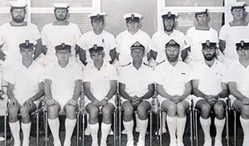
Photo: Peter Blake

Peter Blake:
“After the Vietnam War the Military was having difficulty recruiting, especially professionals (doctors, lawyers, dentists and teachers). Apparently, Navy Office thought it would be a good idea to train sailors they already had and so a new branch was created – ‘Academic Instructor’ as distinct from ‘Instructor Officer’. Originally conducted at Frankston Teachers College in Victoria for the 2yr Trained Primary Teachers Certificate the scheme relocated to Mount Lawley Teachers College for the 3yr Diploma of Teaching in 1971.
The MLTC co-ordinator and mentor at the time was Dick Lamb, who was himself an ex-sailor. It was anticipated AI’s would teach Junior Recruits at HMAS Leeuwin in Fremantle. Most of us were Vietnam Veterans and of various seniority which provided an example to the young men at Leeuwin.
The first intake of AI’s was in 1972 and then the program continued until 1979 with four sailors each intake. Entry to the scheme required four Yr 12 subjects (which I undertook via night school 1972-73 in Frankston whilst posted to HMAS Cerberus) for those who hadn’t achieved Yr 12 on initial recruitment into the Navy. AI’s attended MLTC full time but on campus holidays taught at Leeuwin. As Leading Seamen and Petty Officers (depending on rank at transfer) we were employed for usual Naval duties (the attached shows me as a senior Petty Officer as part of a Royal Guard of Junior Recruits on parade at Perth Airport to farewell the Governor General, Sir John Kerr, on route to his new appointment in Paris).
As time passed and our numbers increased AI’s were posted to other training establishments around Australia – I was posted to the Royal Australian Navy School of Training Technology (RANSTT) as an instructor on the Instructor Training Course. Some AI’s completed their BEd. and went on to become Instructor Officers and extended their careers in the Navy. Others ‘paid off’ to pursue teaching or other careers in civilian life. After discharge I combined my trade background (I originally joined as an apprentice) and teaching qualification to eventually become HOD of Manual Arts at Guildford Grammar School.
Whilst at MLTC we participated in many facets of college life (I played volleyball under Phys Ed. lecturer Rod Ellis at Inter Collegiate Games and with the WA Volleyball Assoc. We were not the run-of-the- mill mature age students with our short hair and I am not aware of any of us who regretted our MLTC experience. Many of us were of similar age to many of the lecturers but out of respect I always called them Mr, Mrs or Miss. I hope this gives some insight into what was an interesting albeit short lived scheme that offered those so inclined an opportunity to gain a valuable qualification and life experience – I wouldn’t have missed it for quids”!
Norman Hammond:
“Commencement in teaching in 1980, the year of my Graduation, was incredibly satisfying with an excellent class of 35 children. Upon completing that year and transferring to Kojonup District High School as Agricultural Teacher (secondary), 10 of my Year 5 former students visited for a weekend. This set the stage for close links with students and ex-students for the next 37 years.
Moving into primary teacher also at Kojonup (due to permanency needs), I had Year 3 in the morning and Years 9-10 Agricultural Studies in the afternoon. Transferring after 3 years, to Karratha SHS as the Youth Education Officer, this was the most enlightening time thus far, with a radio program, intense team events and many informal events for the next 3 years. Karratha changed my life’s extra-curricular direction. Then, the next transfer was Lesmurdie SHS as Youth Education Officer, followed by Primary teaching at Falls Road Primary School in Lesmurdie. My last transfer was to Kelmscott SHS as the Primary Agricultural Awareness Coordinator with over 3000 visiting children to our school farm annually, for 25 years.
This role enabled flexibility in my activities, with 3 Canadian conferences, 4 eastern-state conferences, 2 snowfield excursions, a temporary management position both at Point Peron Camp School and Merredin Residential College.
I was able to have time-out, driving for the 2000 Olympic Torch Relay (100 days), the 2006 Melbourne Queens Baton (50 days) and the 2018 Gold Coast Queens Baton Relay (70 days)- in 2000, I had the honour of being a torch-bearer, as also was the case in 2018 with the Queens Baton, in recognition for continued community service. (This service included a gardening service for 8 years, a Red Cross Soup van stint monthly for 9 years, and a food pickup weekly (from Bakers Delight) for 8 years).
Highlights within the 38 years were the 30+ leadership camps, many gruelling team events in the Pilbara (Black Rock Stakes: 17 teams over 25 years, most involving 5 days away and bus-travel of 4000 kms), Kalgoorlie and South-west areas, as well as long-distance Drug-Free Lifestyle Runs (coordinating these 670/553/398 km runs).
I have found much satisfaction, in linking many of these events with students and ex-students, seeing the lasting rapport and the maturing development of these individuals. Certainly, my teaching roles were paramount, and I am very appreciative of the start of this adventure, upon graduating from Mount Lawley College of Advanced Education”.

Chapter 14 – Conclusion and acknowledgements
I would like to acknowledge all the people who contributed to making this book. We will continue to grow this, in order to give as many students as possible a voice in it. I wish to also acknowledge the work of my editorial committee: Marjorie Bly, Neil Kidd and Terry Watt.

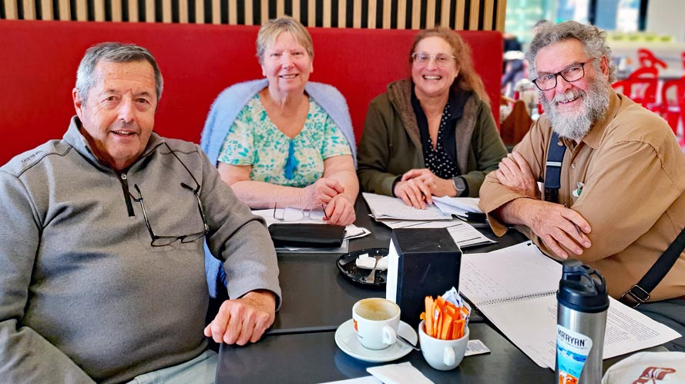
Photo: Rivka Finley – Terry Watt, Marjorie Bly, Rivka, and Neil Kidd

In conclusion, this has been a marvellous project allowing us to reach back through the ages and re-experience the magic of the MLTC experience.
In doing so, we have reconnected with old friends and made new friends.

In January, 2025 we had our first meetup. I was a little nervous. I had only gone to MLTC for one year and was not sure anyone would even recognise me. However, for some reason, we had an over-representation of my class 1J and it was a delightful experience.

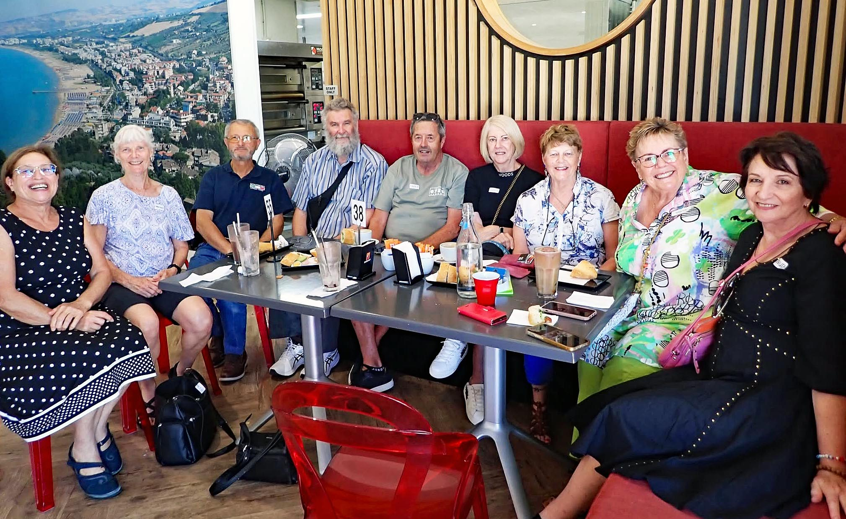
Photo: Rivka Finley - First Meetup
We have had a number of meetups since then, and one where Sybe and his wife, Dawn, graced us with their presence.

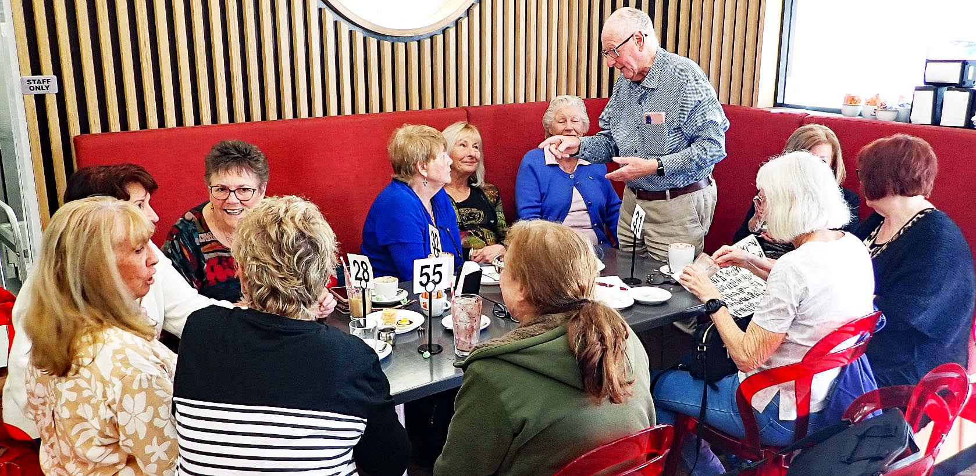
Photo: Rivka Finley - Second Meetup

We have had the book launch, and the last hurrah, where we connected with each other and widened our friendship circles.

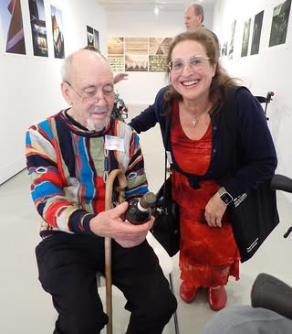 | 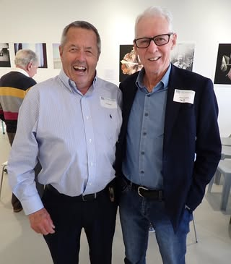
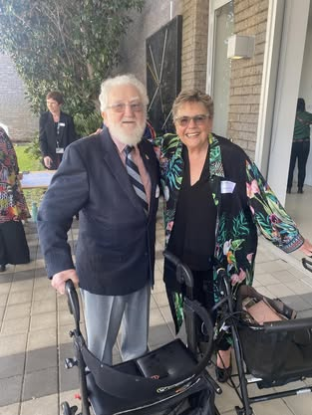 | 
Photo: Rivka Finley - At the book launch

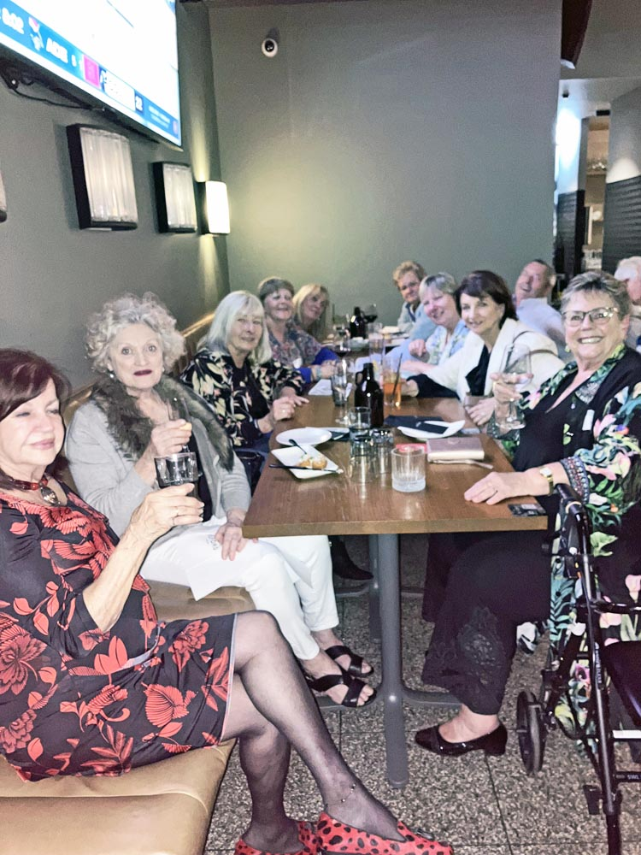
Photo: Rivka Finley - Dinner after the book launch

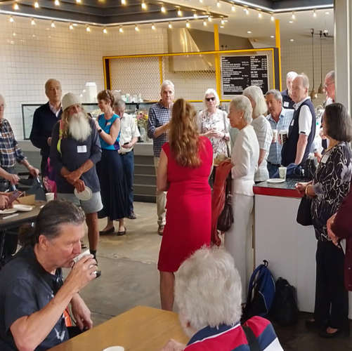 | 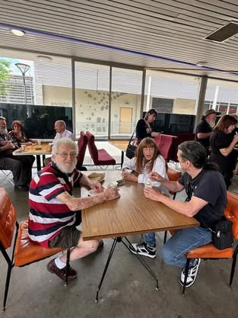 | 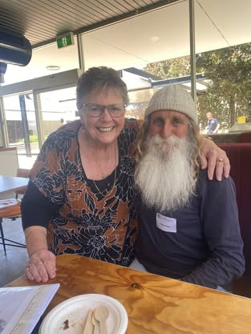
 | 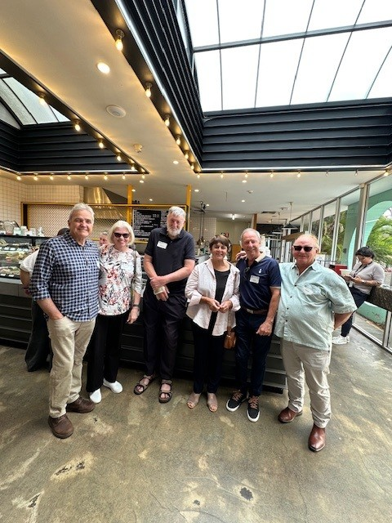 | 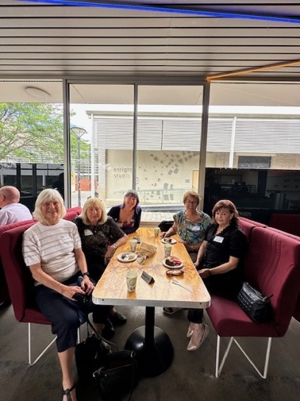
Photo: Rivka Finley - At the last hurrah

